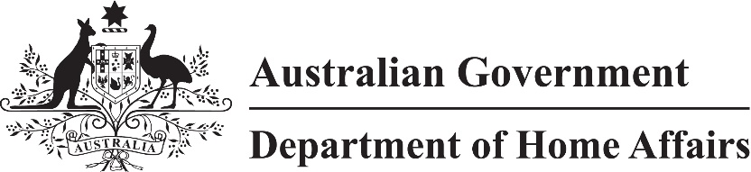

LIN 21/038

Migration (COVID-19 Pandemic event for Subclass 408 (Temporary Activity) visa and visa application charge for Temporary Activity (Class CG) visa) Amendment Instrument (No. 2) (LIN 21/038) 2021

I, Anna Lutz, delegate of the Minister make this instrument under the *Migration Regulations 1994.*

Dated 13 May 2021

Senior Executive Service Band One

Skilled Visa Branch, Immigration Programs Division

Department of Home Affairs

1 Name

This instrument is Migration (COVID-19 Pandemic event for Subclass 408 (Temporary Activity) visa *and visa application charge for Temporary Activity (Class CG) visa) Amendment* *Instrument (No. 2) (*LIN 21/038) 2021.

2 Commencement

This instrument commences on the day after it is registered on the Federal Register of Legislation.

3 Amendment

Schedule 1 amends *Migration (LIN 20/229: COVID-19 Pandemic event for Subclass 408 (Temporary Activity) visa and visa application charge for Temporary Activity (Class CG visa) Instrument 2020*.

Schedule 1 Amendment

(s.3)

[1] After section 6A, in Part 1

insert

6B Application of amendments made by LIN 21/038

The amendments made by *Migration (COVID-19 Pandemic event for Subclass 408 (Temporary Activity) visa and visa application charge for Temporary Activity (Class CG) visa) Amendment* *Instrument (No. 2) (LIN 21/038) 2021* apply to the following applications for a visa:

(a) an application made, but not finally determined, before the commencement of that instrument;

(b) an application made on or after the commencement of that instrument.

[2] Subparagraph 8(1)(c)(i)

**o**mit

28 days

insert

90 days

[3] Subparagraph 8(3)(c)(vi)

substitute

(vi) health care sector; or

(vii) tourism and hospitality sector; and