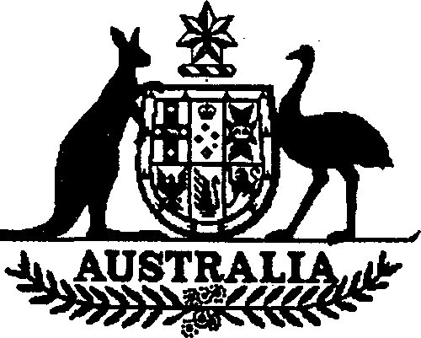

**Charter of the United Nations (Anti­  
terrorism — Persons and Entities) List 2002 (No 3)**

I, ALEXANDER DOWNER, Minister for Foreign Affairs, issue this List under subregulation 7 (1) of the *Charter of the United Nations (Anti-terrorism Measures) Regulations 2001.*

Dated 28th May 2002

Alexander Downer  
Minister for Foreign Affairs

# Name of List

This List is the *Charter of the United Nations (Anti-terrorism — Persons and Entities) List 2002 (No 3).*

# Commencement

This List commences on gazettal.

# Persons, entities and assets

For subregulation 7 (1) of the *Charter of the* *United Nations (Anti-terrorism Measures) Regulations 2001*, the persons and entities in Schedule 1 are listed.

*Note* Under subregulation 7 (1), the Minister must be satisfied that a person or entity is mentioned in paragraph 1 (c) of Resolution 1373 (2001) of the Security Council of the United Nations.

**Schedule 1 Persons and entities**

(section 3)

THE AID ORGANISATION OF THE ULEMA (a.k.a. AL RASHID TRUST; a.k.a. AL RASHEED TRUST; a.k.a. AL-RASHEED TRUST; a.k.a. AL-RASHID TRUST);

Pakistan

AL-FAWAZ, Khalid (a.k.a. AL-FAUWAZ, Khaled; a.k.a. AL-FAWWAZ, Khalid;

a.k.a. AL FAWWAZ, Khalik; a.k.a. AL-FAWWAZ, Khaled; a.k.a. AL FAWWAZ, Khaled); DOB 25 August 1962; Address: 55 Hawarden Hill, Brooke Road, London NW2 7BR, United Kingdom

AL-MASRI, Abu Hamza (a.k.a. AL-MISRI, Abu Hamza); DOB 15 April 1958; Address: 9 Albourne Road, Shepherd’s Bush, London W12 0LW, United Kingdom; 8 Adie Road, Hammersmith, London W6 0PW, United Kingdom

APAOLAZA SANCHO, Ivan; DOB 10 November 1971; POB Beasain (Guipuzcoa), Spain

AOUADI, Mohamed Ben Belgacem (a.k.a. AOUADI, Mohamed Ben Belkacem); DOB 11 December 1974; POB Tunisia; Address: Via A Masina no.7, Milan, Italy

BABBAR KHALSA (aka BABBA KHALSA, BABBA KHALSA INTERNTIONAL)

BEN HENI, Lased; DOB 5 February 1969; POB Libya

BERASATEGUI ESCUDERO, Ismael; DOB 15 June 1969; POB Eibar (Guipuzcoa), Spain

BOUCHOUCHA, Mokhtar (a.k.a. BUSHUSHA, Mokhtar); DOB 13 October 1969; POB Tunisia; Address: Via Milano no.38, Spinadesco (CR), Italy

CHARAABI, Tarek (a.k.a. SHARAABI, Tarek); DOB 31 March 1970; POB Tunisia; Address: Viale Bligny no.42, Milan, Italy+

ES SAYED, Abdelkader Mahmoud (a.k.a. ES SAYED, Kader); DOB 26 December 1962; POB Egypt; Address: Via del Fosso di Centocelle n.66, Rome, Italy

ESSID, Sami Ben Khemais; DOB 10 February 1968; POB Tunisia; Address: Via Dubini no.3, Gallarate (VA), Italy

GALLASTEGUI SODUPE, Lexuri; DOB 18 June 1969; POB Bilbao (Biscay), Spain INTERNATIONAL SIKH YOUTH FEDERATION (ISYF)

2 *Charter of the United Nations (Anti-terrorism* — *Persons and Entities) List 2002*

NASREDDIN, Ahmed Idris (a.k.a. NASREDDIN, Ahmed Idriss; a.k.a. NASREDDIN, Hajd Ahmed; NASREDDINE, Ahmed Idriss); DOB 22 November 1929; POB Adi Ugri, Ethiopia; Address: Corso Sempione 69, 20149 Milan, Italy; 1 Via delle Scuole, 6900 Lugano, Switzerland; Piazzale Biancamano, Milan, Italy; Rue de Cap Spartel, Tangiers, Morocco ·

PALACIOS ALDAY, Gorka; DOB 17 October 1974 or 1975; POB Baracaldo (Biscay), Spain

QUINTANA ZORROZUA, Asier; DOB 27 February 1968; POB Bilbao (Biscay), Spain

RUBENACH ROIG, Juan Luis; DOB 18 September 1963 or 1964; POB Bilbao (Biscay), Spain

ZUBIAGA BRAVO, Manex; DOB 14 August 1979; POB Getxo (Biscay), Spain

*Charter of the United Nations (Anti-terrorism* — *Persons and Entities) List 2002*

3