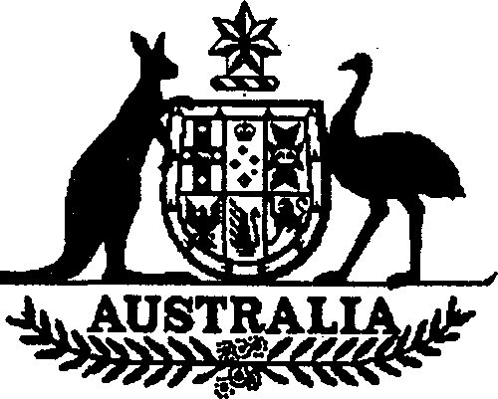

**Charter of the United Nations (Anti­ terrorism — Persons and Entities) List 2002 (No. 4)**

I, ALEXANDER DOWNER, Minister for Foreign Affairs, issue this List under subregulation 7 (1) of the *Charter of the United Nations (Anti-terrorism Measures) Regulations 2001.*

Dated 21st October2002

Alexander Downer  
Minister for Foreign Affairs

# Name of List

This List is the *Charter of the United Nations (Anti-terrorism* — *Persons and Entities) List 2002 (No. 4).*

# Commencement

This List commences on gazettal.

# Persons, entities and assets

For subregulation 7 (1) of the *Charter of the United Nations (Anti-terrorism Measures) Regulations 2001,* the entities in Schedule 1 are listed.

*Note* Under subregulation 7 (1), the Minister must be satisfied that an entity is mentioned in paragraph 1 (c) of Resolution 1373 (2001) of the Security Council of the United Nations.

**Schedule 1 Entities**

JEMAAH ISLAMIYAH aka JEMA’AH ISLAMIYAH aka JEMAAH ISLAMIYA

NEW PEOPLES ARMY (NPA)/COMMUNIST PARTY OF THE PHILIPPINES

JOSE MARIA SISON, DOB: 8 February 1938; POB: Ilocos Sur, Northern Luzon, Philippines

EASTERN TURKISTAN ISLAMIC MOVEMENT (ETIM)

WA’EL HAMZA JULAIDAN aka WA’IL HAMZA JULAIDAN aka WA’EL HAMZA JULAYDAN aka WA’IL HAMZA JULAIDAN aka WA’EL HAMZA JALAIDAN aka WA’IL HAMZA JALAIDAN aka WA’EL HAMZA JALADIN aka WA’IL HAMZA JALADIN aka ABU AL-HASAN AL MADANI; DOB: 22 January

1958; POB: Al-Madinah, Saudi Arabia; Saudi Passport No: A-992535;

MOUNIR EL MOTASSADEQ; DOB: 3 April 1974, POB: Marrakech, Morocco SAID BAHAJI; DOB: 15 July 1975, POB: Haselunne, Niedersachsen, Germany

RAMZI MOHAMED ABDELLAH OMAR aka RAMZI MOHAMED ABDULLAH BINALSHIBH aka RAMZI MOHAMED ABDULLAH BINALSHEIDAH SOWIE

aka RAMZI BIN AL SHEIBH, DOB: 16 September 1973, POB: Khartoum, Sudan

ZAKARIYA ESSABAR, DOB: 4 MARCH 1977; POB: Essouria, Morocco GLOBAL RELIEF FOUNDATION INC., 9935 South 76th Avenue, Unit 1,

Bridgeview, Illinois 60455, USA; P.O. Box 1406, Bridgeview, Illinois 60455, USA;

FONDATION SECOURS MONDIAL aka FONDATION SECOURS MONDIAL, BELGIQUE A.S.B.L. aka FONDATION SECOURS MONDIAL VZW aka FSM aka STICHTING WERELDHULP – BELGIE V.Z.W. aka FONDATION SECOURS MONDIAL – KOSOVO aka FONDATION SECOURS MONDIAL “WORLD RELIEF”

Vaatjesstraat, 29, 2580 Putte, Belgium

Rue des Bataves 69, 1040 Etterbeek, Brussels, Belgium

P.O. Box 6, 1040 Etterbeek 2, Brussels, Belgium

Mula Mustafe Baseskije Street No.72, Sarajevo, Bosnia Put Mladih Muslimana Street 30/A, Sarajevo, Bosnia Rr. Skenderbeu 76, Lagjja Sefa, Gjakova, Kosovo

Ylli Morina Road, Djakovica, Kosovo

2 *Charter of the United Nations (Anti-terrorism* — *Persons and Entities) List 200 (No. 2)*