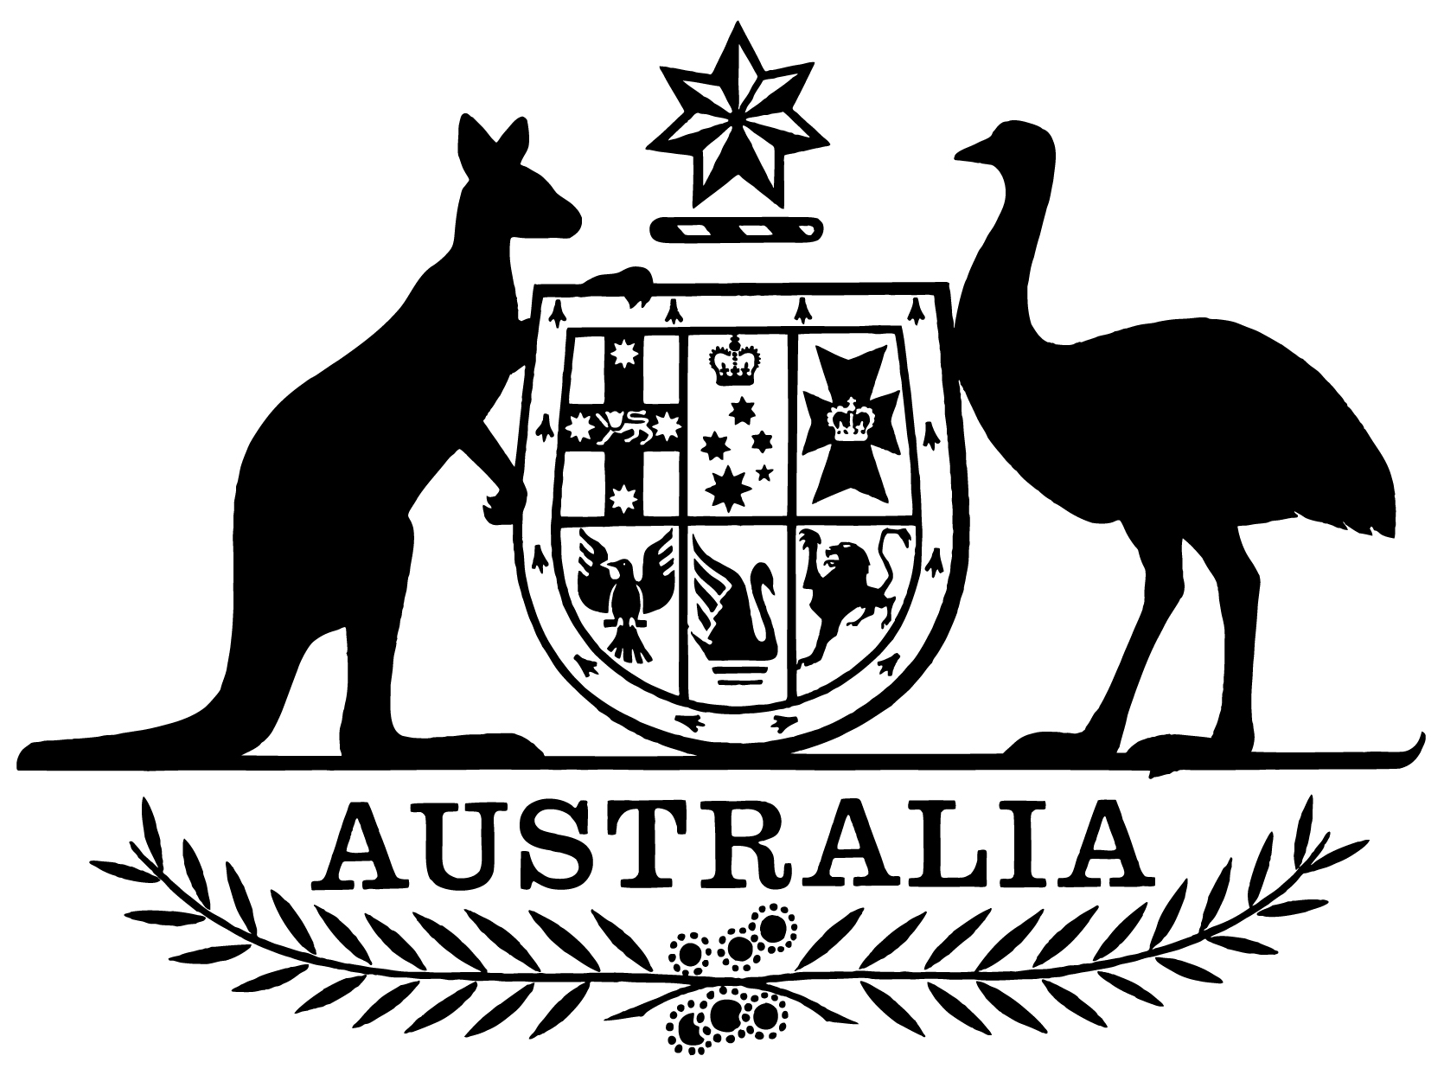

***Statement of Expectations for the Board of the Civil Aviation Safety Authority for the Period 1 July 2021 to 30 June 2023***

I,Michael McCormack, Minister for Infrastructure, Transport and Regional Development, make the following instrument.

Dated 21 June 2021

Michael McCormack

Minister for Infrastructure, Transport and Regional Development

1. **Overview**

This instrument is the *Statement of Expectations for the Board of the Civil Aviation Safety Authority for the period 1 July 2021 to 30 June 2023*.

This Statement of Expectations (SOE) applies in respect of the period commencing   
1 July 2021 and ending 30 June 2023, and replaces the previous SOE issued on 4 July 2019.

This SOE serves as a notice to the Board of the Civil Aviation Safety Authority (CASA) under section 12A of the *Civil Aviation Act 1988* (the Act) and formalises my expectations concerning the operations and performance of CASA.

CASA should perform its functions in accordance with the Act, the *Airspace Act 2007* and the *Public Governance, Performance and Accountability Act 2013* (PGPA Act) as well as other relevant legislation.

I reiterate the Government’s expectation that CASA’s resources be used in an efficient, effective, economical and ethical way, following best practice principles and guidelines.

I also expect that the conduct and values of CASA’s Board and staff should be consistent with that of the Australian Public Service.

1. **Governance**

I expect that the Board and the Director of Aviation Safety (DAS) will continue to work to enable the effective operation of CASA as the national aviation safety regulator.

I expect the Board to be responsible for the matters set out in the Act, including in particular, CASA’s strategic direction, risk management and corporate planning.

I also expect the Board to facilitate effective interaction between CASA and all stakeholders.

Subject to the Act, I expect the DAS, as the CEO of CASA, to be responsible for managing the operations of CASA, its organisational capacity, and the performance of its statutory functions. This includes the development and implementation of effective and efficient regulation, executive-decision making, and all day-to-day operational, financial, personnel and administrative activities.

I expect the Board to keep the Secretary of the Department of Infrastructure, Transport, Regional Development and Communications (Department) and myself fully informed of CASA’s actions in relation to the requirements stated in this SOE, and promptly advise of any events or issues that may materially impact on the operations of CASA, including through quarterly progress reports from the Board against the Corporate Plan and this SOE.

I expect CASA to perform its functions consistent with Australia’s international obligations where appropriate, including the requirements of the International Civil Aviation Organization (ICAO).

1. **Regulatory Approach**

I expect CASA will continue its regulatory approach, in accordance with its regulatory philosophy, with:

1. a focus on the safety of air navigation as the highest priority;
2. consideration of the economic and cost impacts on individuals, businesses and the community; and
3. a pragmatic, practical and proportionate approach to regulation as it applies to different industry sectors.
4. **Key Initiatives**

I expect CASA, in conducting its responsibilities as the aviation safety regulator, will focus on the following key initiatives:

1. continue effective engagement with industry in the lead up to the implementation of the flight operations suite of regulations.
2. support Airservices Australia (Airservices) and the Department of Defence (Defence) in the implementation of the OneSKY project through timely approval and certification, in addition to the continuing regulatory oversight of Australia’s existing air traffic management system.
3. work closely with the Department and Airservices to ensure the integration of Remotely Piloted Aircraft Systems (RPAS) into Australian airspace, including regulatory oversight of the safety aspects of unmanned aviation operations. This includes supporting the development and progression of initiatives outlined in the National Emerging Aviation Technologies (NEAT) Policy Statement.
4. support Airservices in its development and implementation of a new Flight Information Management System (FIMS) to underpin Australia’s Unmanned Traffic Management (UTM) ecosystem, through timely regulatory review.
5. provide regulatory oversight for major aerodrome infrastructure projects, including significant new runway projects, as well as providing authoritative and timely advice to me and the Department on matters related to leased federal airport developments.
6. ensure sufficient resources are applied to the regulatory oversight of the development of Western Sydney Airport and associated airspace in order to support the safe and on-time delivery of regulatory decisions required for the project.
7. continue to share safety information consistent with the Safety Information Policy Statement agreed with the Australian Transport Safety Bureau (ATSB).
8. work collaboratively with the Department and Airservices on modernising airspace management, including, as the regulator, leading the development of an Australian future airspace framework consistent with the Government’s airspace policy objectives, and shaping Australia’s future airspace policy and regulatory framework.
9. work collaboratively with Geoscience Australia and Airservices to help ensure CASA’s regulatory oversight enables safe and timely implementation of satellite-based augmentation systems in the aviation environment.
10. work collaboratively with the Australian Space Agency to facilitate the advancement of Australia’s space policies and industry through timely decision-making and the provision of advice.
11. continue to ensure CASA’s training and recruitment strategies provide the organisation with the skills and expertise to meet the current and emerging challenges in aviation safety regulation.
12. **Stakeholder Engagement**

I expect CASA will continue to:

1. undertake effective and appropriate engagement with Government, commercial, industrial, consumer and other relevant stakeholders and bodies, recognising the various sectors that encapsulate the aviation industry, and undertake effective and ongoing engagement with those various sectors.
2. communicate clearly and regularly with relevant Government agencies, industry and other key stakeholders regarding CASA’s activities and functions.
3. work closely with the Department and other Government agencies, including the ATSB, Airservices and Defence, to deliver integrated and comprehensive safety advice to the Government, the aviation industry and the community.