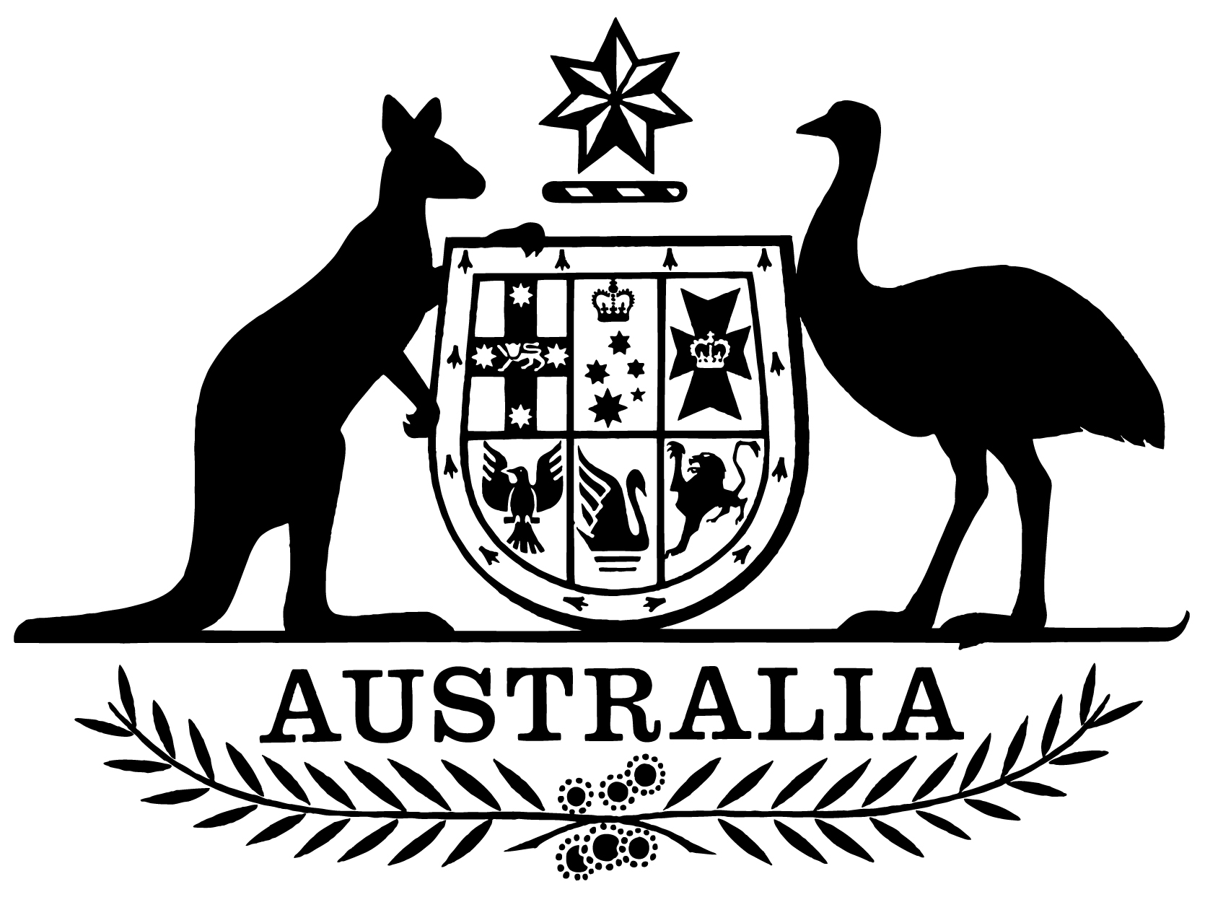

***Statement of Expectations for Airservices Australia for the Period 1 July 2021 to 30 June 2023***

I,Michael McCormack, Minister for Infrastructure, Transport and Regional Development, make the following instrument.

Dated 21 June 2021

Michael McCormack

Minister for Infrastructure, Transport and Regional Development

1. **Overview**

This instrument is the *Statement of Expectations for Airservices Australia for the period 1 July 2021 to 30 June 2023*.

This Statement of Expectations (SOE) applies in respect of the period commencing 1 July 2021 and ending 30 June 2023, and replaces the previous SOE issued on 4 July 2019.

This SOE serves as a notice to Airservices Australia (Airservices) under section 17 of the *Air Services Act 1995* (the Act) and formalises my expectations concerning the operations and performance of Airservices.

Airservices should perform its functions in accordance with the Act, the *Public Governance, Performance and Accountability Act 2013* (PGPA Act) as well as other relevant legislation.

I reiterate the Government’s expectations that Airservices’ resources be used in an efficient, effective, economical and ethical way, following best practice principles and guidelines.

1. **Governance**

I expect that the Board and the Chief Executive Officer (CEO) will continue to work to enable Airservices to operate as a world-best-practice Air Traffic Control (ATC) and Aviation Rescue and Fire Fighting Service (ARFFS) provider.

I expect the Board to ensure Airservices has the necessary resources and capabilities in place to effectively manage Airservices’ strategic direction, risks and corporate planning in accordance with section 21 of the Act.

I expect the CEO to be responsible for managing the operations of Airservices, its organisational capacity and the exercise of its functions in accordance with section 35 of the Act.

I expect the Board to keep the Secretary of the Department of Infrastructure, Transport, Regional Development and Communications (Department) and myself fully informed of Airservices’ actions in relation to the requirements stated in this SOE, and promptly advise of any events or issues that may materially impact on the operations of Airservices, including through quarterly progress reports from the Board against the Corporate Plan and this SOE.

I expect Airservices to perform its functions consistent with Australia’s international obligations where appropriate, including the requirements of the International Civil Aviation Organization (ICAO).

1. **Key Initiatives**

I expect Airservices, in conducting its responsibilities as the air navigation and aviation rescue and fire fighting services provider, will focus on the following key initiatives:

1. progress the timely, on-budget and effective implementation of the OneSKY Australia Program and the Civil Military Air Traffic Management System (CMATS), and advise me on the progress of the project, including early identification of risks to delivery, and achievement of program milestones.
2. work closely with the Department and the Civil Aviation Safety Authority (CASA) to ensure the integration of Remotely Piloted Aircraft Systems (RPAS) into Australian airspace. This includes supporting the development and progression of initiatives outlined in the National Emerging Aviation Technologies (NEAT) Policy Statement, including supporting trials that further the Government’s policy objectives.
3. develop and implement a flight information management system (FIMS) consistent with the Government’s policy objectives, Government decisions on Unmanned Aircraft System Traffic Management (UTM) architecture and the approach outlined in the NEAT Policy Statement.
4. work with the Department and CASA on modernising airspace management, consistent with the Australian Airspace Policy Statement, including:
   * shaping Australia’s future airspace protection policy and regulatory framework;
   * regularly reviewing instrument flight procedures to ensure they are current and reflect changing aircraft navigational capabilities;
   * enhancing the safety and efficiency of Australian controlled airspace including at major regional airports; and
   * continuing to apply adequate resources to manage airspace planning and design for Western Sydney Airport.
5. assist in implementing the Government’s environmental initiatives including:

* minimising the impact of aircraft operations on communities where practicable;
* supporting the ongoing role of the independent Aircraft Noise Ombudsman (ANO) and implementation of agreed recommendations made by the ANO;
* appropriate resourcing of the Airservices Noise Complaints and Information Service to continue to improve the flow and quality of information to noise affected communities;
* ongoing commitment to the Sydney Airport Long Term Operating Plan as required by the Ministerial direction dated 30 July 1997 ([F2009B00158](https://www.legislation.gov.au/Details/F2009B00158));
* providing and reporting against an annual environment work program which outlines Airservices’ ongoing and new initiatives in managing, monitoring and alleviating, where safe and practicable, environmental effects of aircraft operations; and
* working with the Department and industry on issues related to environmental contamination, including taking action on per- and poly-fluoroalkyl substances (PFAS) in line with Government expectations on this issue.

1. continue to work with the Department and CASA on implementing the Government’s approach to ARFFS.
2. commence an independent review of Airservices’ implementation and governance relating to the recommendations of the Broderick Review, by June 2022.
3. ensure that necessary steps are taken in minimising the financial impacts of COVID-19 in accordance with the ‘One Airservices’ Business Plan.

**Stakeholder Engagement**

I expect Airservices will continue to:

1. undertake effective and productive engagement with the community and industry based on mutual understanding and respect.
2. communicate clearly and regularly with the Department and CASA, industry and the community on the development and implementation of significant changes to air navigation and ARFFS.
3. proactively provide information, assistance and advice to Government agencies for policy formulation, implementation activities and regulation purposes.
4. contribute in the coordinated approach to airport planning, including appropriate participation in planning coordination forums, community aviation consultation groups and the National Airports Safeguarding Advisory Group.
5. work closely with the Department and other Government agencies, including the Australian Transport Safety Bureau, CASA and the Department of Defence to deliver integrated and comprehensive advice to the Government, the aviation industry and the community.