

Australian Renewable Energy Agency (General Funding Strategy) Determination 2021

I, ANGUS TAYLOR, Minister for Energy and Emissions Reduction, make the following Determination under sub-section 20(2) of the *Australian Renewable Energy Agency Act 2011*.

Dated: 25 August 2021

ANGUS TAYLOR

Minister for Energy and Emissions Reduction

Contents

1 Name 1

2 Commencement 1

3 Authority 1

4 Definitions 1

5 Repeals 1

6 Approval of General Funding Strategy 1

Schedule 1—General Funding Strategy 2021/22 – 2023/24 2

1 Name

This instrument is the *Australian Renewable Energy Agency (General Funding Strategy) Determination 2021*.

2 Commencement

This instrument commences from the time it is made.

3 Authority

This instrument is made under sub-section 20(2) of the Act.

4 Definitions

In this instrument:

***Act*** means the *Australian Renewable Energy Agency Act 2011*.

5 Repeals

This instrument, on the day it comes into force, repeals the *Australian Renewable Energy Agency (General Funding Strategy) Determination 2019*.

6 Approval of General Funding Strategy

For the purposes of sub-section 20(2) of the Act, the General Funding Strategy at Schedule 1 is approved and made on the date of signature of this instrument.

Schedule 1—General Funding Strategy 2021/22 – 2023/24

1 Introduction

The Australian Renewable Energy Agency (ARENA) is a statutory agency established by the Australian Government on 1 July 2012 by the *Australian Renewable Energy Agency Act 2011* (Cth) (ARENA Act), which provides for funding until 30 June 2022. In the Federal Budget 2020-21, ARENA was funded an additional amount of $1.62 billion, including baseline funding of $1.43 billion, over the ten years to 2032.

This General Funding Strategy (GFS) guides how ARENA provides financial assistance for eligible activities, in accordance with the ARENA Act, its Regulation and the requirements of the *Public Governance, Performance and Accountability Act 2013* (PGPA Act).

ARENA is required to develop and publish a general funding strategy that states its principal objectives and priorities for the provision of financial assistance covering a period of three financial years.

The GFS is reviewed each year, updated if necessary, and provided to the Minister for Energy and Emissions Reduction for approval. This GFS remains in force until a subsequent version is approved by the Minister. ARENA may only provide financial assistance for new activities in accordance with the GFS.

2 ARENA’s objective

ARENA, as established by the ARENA Act, has the main object of improving the competitiveness of renewable energy technologies and increasing the supply of renewable energy in Australia.

The *ARENA (Implementing the Technology Roadmap) Regulations 2021* (The Regulation) expands ARENA’s functions to include investment in projects that will support the achievement of the five stretch goals set out in the 1st *Low Emissions Technology Statement* (related to the Government’s priority low emission technologies, including low emissions aluminium and steel, carbon capture and storage, clean hydrogen, energy storage and soil carbon technologies), and provides the statutory power to fully deliver programs announced in the 2020-21 Budget.

ARENA’s purpose is to support the global transition to net zero emissions by maximising the pace of pre-commercial innovation, to the benefit of Australian consumers, businesses and workers. We achieve our purpose through the provision of financial support to innovative projects and companies, and by sharing knowledge with the industry and the public.

3 Overall Strategy

ARENA provides financial assistance to recipients for projects that are aligned to ARENA’s strategic priorities. We seek to enable a pathway to commercialisation and we are prepared to take risks on new ideas and technologies that are not yet proven, while considering whether the solution being tested has the potential to reach commercial maturity.

When considering the provision of financial assistance, ARENA has regard to positive externalities through changes beyond the funded project that will lead to benefits in the long term. When making funding decisions ARENA assesses additionality, which is whether proposed projects would achieve outcomes that would not otherwise occur without our funding. To determine additionality, ARENA considers what level of funding is required for a project to proceed, or whether the commercial market is able to fund the project without such assistance. In answering this question we also consider whether our support will bring forward innovation that might otherwise be delayed or take longer to mature.

In general, ARENA provides its financial assistance in the form of grants. In certain circumstances, where there is the possibility of upside from a project in the future, ARENA may negotiate a recoupment mechanism which sees some or all of its grant funding returned in the event that the upside scenario eventuates. In so doing, ARENA ensures that funding continues to represent value for the Australian taxpayer.

The Government has announced that ARENA will have the ability to provide financial assistance in the form of concessional debt and equity, up to an amount of $50 million. These broader forms of financial assistance will enable ARENA to support early stage businesses and also maximise value for money for taxpayers. ARENA will make use of these instruments alongside, or in addition to, grants, to provide the most appropriate type of funding to innovative projects on a case-by-case basis.

We invest throughout the innovation chain, balancing investment in emerging commercial technologies with research, development and demonstration to address long-term needs. We also collaborate with industry and share knowledge to accelerate learning, thereby reducing future costs.

4 Strategy Focus: Investment Priorities

ARENA’s priorities reflect an overarching vision to reduce emissions by lowering the cost and increasing the availability of low emissions technologies including renewable energy, to grow the share of renewables in the electricity mix, support fuel-switching and electrification where possible, become more flexible in when we use electricity, and support the development of technology solutions for hard-to-abate sectors where a pathway to lower emissions is expensive or currently not feasible.

Through these priorities, ARENA also supports the Technology Investment Roadmap and the targeted programs from the 2020-21 Federal Budget, and will play an important role in the delivery of priority technologies set as part of the first Low Emissions Technology Statement.

1. **Optimise the transition to renewable electricity**

As the electricity system shifts to a greater proportion of renewable generation, it needs to remain affordable, secure and reliable. Cost effective energy storage is critical and ARENA aims to support technologies and projects that have the potential to reduce the mean cost of stored electricity used for the purposes of firming in Australia to below $100 per MWh. The development of new, renewable or low emission energy industries — such as clean hydrogen production and low emissions metals — requires further reductions in the cost of renewable electricity generation and integration of large-scale renewable energy assets. In addition, the transition to higher adoption of renewables coupled with increasing electrification, including for electric vehicles and industrial loads, requires a system-wide focus on energy storage and demand flexibility.

1. **Commercialise clean hydrogen**

Clean hydrogen produced using renewable energy or with substantial carbon capture and storage (CCS) could play a significant role in lowering emissions in Australia’s heavy industry and transport sectors as well as representing a potentially significant export opportunity. ARENA is looking to support projects that help pave the way to producing clean hydrogen in Australia at a mean cost below $2 per kg. ARENA will support industry to find innovative solutions that could assist Australia in establishing a viable hydrogen industry and, through this, become a significant clean energy exporter. This will require innovation across the full hydrogen value chain, including investigating new forms of low-cost production, scaling up the supply side of the industry, and demonstrating a variety of end uses in the domestic and export sectors. ARENA will liaise with other agencies[1] and organisations looking to provide funding to clean hydrogen projects to enable co-ordinated Government support for this emerging industry.

1. **Support the transition to low emissions metals**

ARENA will support solutions in the metals sector that have the potential to enable the production of low emissions metals and their precursors in Australia at internationally competitive prices. These solutions might include electrification, integrating renewables, fuel switching to clean hydrogen, etc. In this priority we will focus on accelerating the transition to a low emissions:

* steel value chain with the goal of reducing the mean cost of manufacturing low emissions steel in Australia to below $900 per tonne
* aluminium value chain with the goal of reducing the mean cost of manufacturing low emissions aluminium in Australia to below $2700 per tonne.

1. **Scale up CCS and reduce the cost of soil carbon measurement**

Carbon capture and storage (CCS) and soil carbon technologies could play a significant role in global efforts to achieve net zero. ARENA will consult with industry and look to support research, development and demonstration projects that have the potential to:

* reduce the mean cost of carbon dioxide compression, hub transport and storage in Australia to below $20 per CO2e tonne
* reduce the mean cost of measuring soil carbon in Australia to below $3 per hectare per year.

1. **Deliver targeted programs from the 2020-21 Federal Budget**

We will deliver the targeted programs outlined in the 2020-21 Federal Budget:

> The Future Fuels Fund

> The Industrial Energy Transformation Studies Program

> The Regional Australia Microgrids Pilot Program

> The Freight Efficiency Assistance Grants[2]

> The Freight Energy Productivity Trial Program2

We will also engage with the Government on the delivery of its International Partnerships Program, as well as the delivery of other Government programs that are consistent with ARENA’s objectives and strategic priorities.

ARENA is also focused on maximising the benefits from past and ongoing projects. Knowledge sharing through the collection, storage, analysis, curation and sharing of information, experience and know-how gained from these and related projects is a priority for ARENA. Collaboration across the full project lifecycle is critical to success, so ARENA brings together key stakeholders to share knowledge both during the front-end design stage and as projects reveal insights.

5 Relationship to Corporate Plan

This General Funding Strategy, required under the ARENA Act, covers ARENA’s strategy (objectives and priorities) for making new investments over the current and upcoming two financial years.

ARENA’s Corporate Plan, required under the PGPA Act, is ARENA’s primary planning document and is prepared on an annual basis. The Corporate Plan includes ARENA’s strategy as a whole, covering the full suite of activities (including making new investments and maximising benefits from existing financial assistance contracts); the context within which ARENA operates; the organisational capability that underpins delivery; how we will assess and report performance; and our identification of strategic risks and how they are managed.

The General Funding Strategy and Corporate Plan have overlapping scopes, however, the GFS’s scope is narrower than that of the Corporate Plan.

6 Performance Reporting

ARENA’s Corporate Plan sets out our approach to performance reporting, which demonstrates that financial assistance is being allocated in accordance with the strategy, that private sector capital is ensuring taxpayers’ dollars are spent effectively, that technologies are progressing towards commercial readiness, and that projects are leading to industry learning that will be reflected in increases in supply of renewable energy. We also track whether knowledge sharing is informing industry decisions, accelerating learning and helping to lower costs.

Figure 1 Supporting innovation and commercialisation

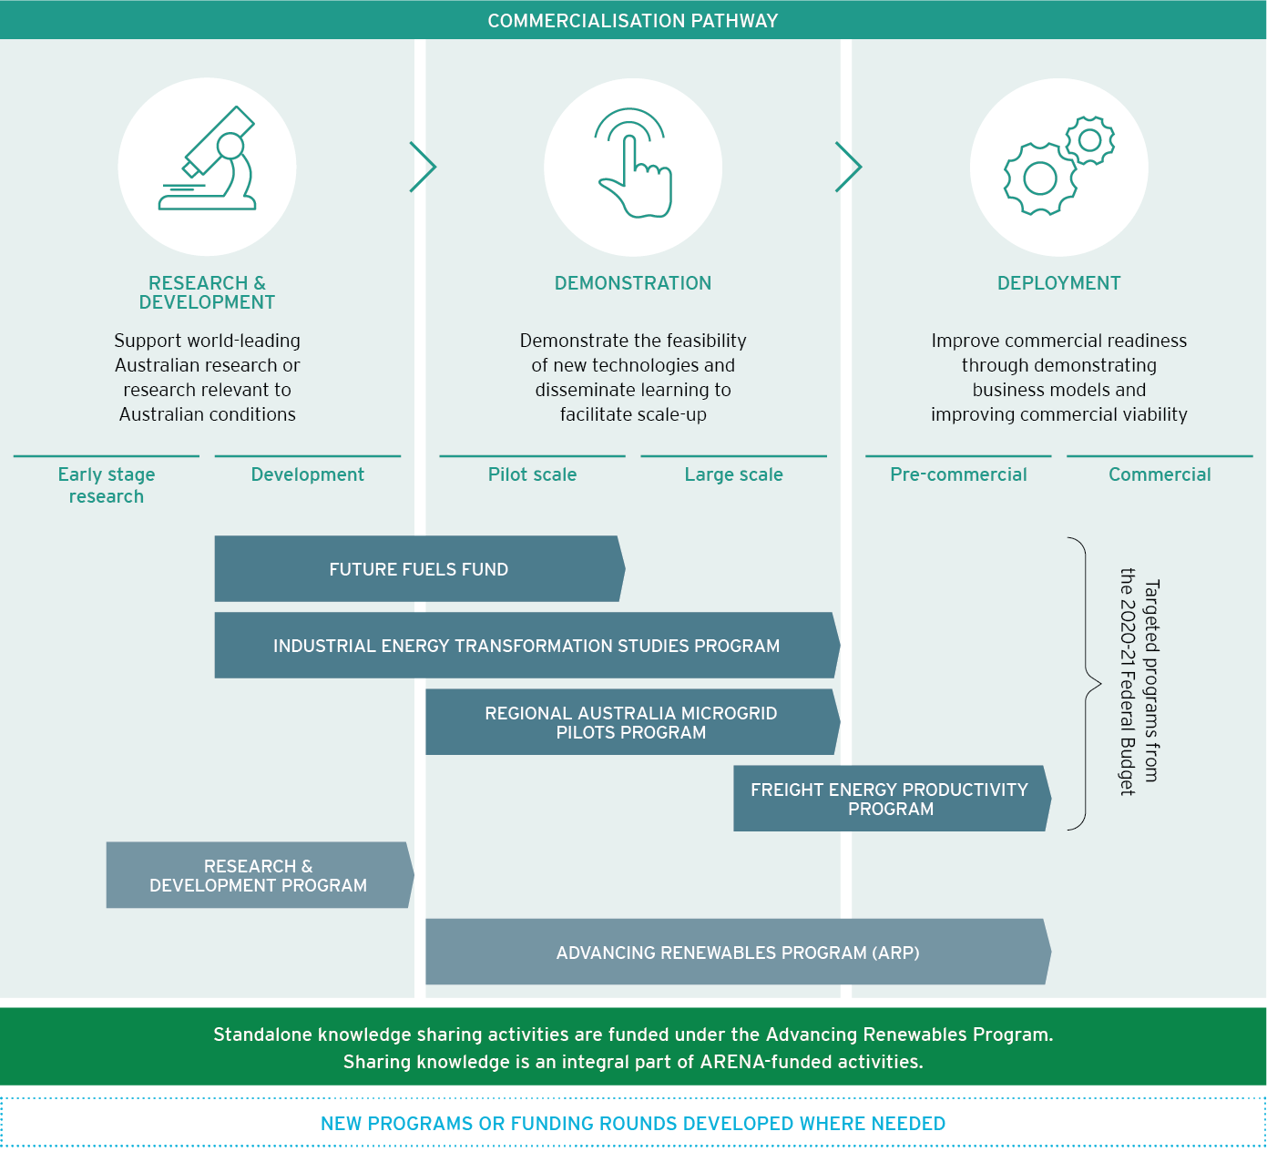

Figure 2 A partnership across the innovation chain

1. The Department of Industry, Science, Energy and Resources (DISER) is administering the $275.5 million Hydrogen Hubs Program and the $565.8 million International Partnerships Program, both of which are looking to support clean hydrogen projects in Australia.
2. The Freight Energy Productivity Program has been split into these two programs since the 2020-21 Federal Budget.