**RESERVE BANK OF AUSTRALIA** 65 Martin Place

Sydney NSW 2000

GPO Box3947

Sydney NSW 2001

+61 2 95519507

[lowep@rba.gov.au](mailto:lowep@rba.gov.au)

Philip Lowe GOVERNOR

Environment Protection and Biodiversity Conservation Act 1999

**RESERVE BANK OF AUSTRALIA HEAD OFFICE, 65 MARTIN PLACE, SYDNEY HERITAGE MANAGEMENT PLAN AMENDMENT 2021 (No. 1)**

The Reserve Bank of Australia makes the following instrument under section 3415 (2) of the

*Environment Protection and Biodiversity Conservation Act 1999.*

I, Philip Lowe, Governor of the Reserve Bank of Australia, acting pursuant to s341S(l) of the *Environment Protection and Biodiversity Conservation Act 1999,* make this amendment to the Reserve Bank of Australia Head Office, 65 Martin Place Sydney Heritage Management Plan. This amendment to the heritage management plan will commence the day after it is registered as a legislative instrument in accordance with the *Legislative Instruments Act 2003.*

Dated ***19*** October, 2021.

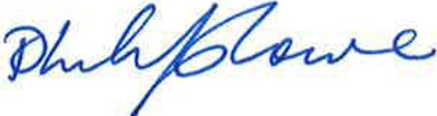

Philip Lowe Governor

*Reserve Bank of Australia Head Office, 65 Martin Place, Sydney Heritage Management Plan Amendment 2021 {No. 1}*

Section 1

# Name

This is the *Reserve Bank of Australia Head Office, 65 Martin Place, Sydney Heritage Management Plan Amendment 2021 (No. 1)*.

# Commencement

This instrument commences at the start of the day after the day it is registered on the Federal Register of Legislation.

Note: The Federal Register of Legislation may be accessed free of charge at [www.legislation.gov.au](http://www.legislation.gov.au/)

# Authority

This instrument is made under section 341S (2) of the *Environment Protection and Biodiversity Conservation Act 1999.*

# Amendments

The instrument that is specified in Schedule 1 is amended as set out in the applicable items in that Schedule.

Schedule 1

# Schedule 1—Amendments

***Reserve Bank of Australia Head Office, 65 Martin Place, Sydney Heritage Management Plan 2020 (F2020L01031)***

**1** omit the following words from the unnumbered page that immediately follows the covering page and immediately precedes the page headed ‘EXECUTIVE SUMMARY’ and numbered i. :

‘This document remains the property of NBRS & PARTNERS Pty Ltd.

The document may only be used for the purposes for which it was produced. Unauthorised use of the document in any form whatsoever is prohibited.’