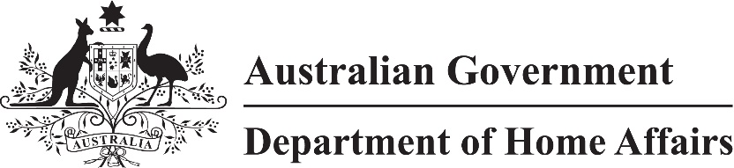

LIN 22/002

Migration (Places and currencies for paying of fees) Instrument (LIN 22/002) 2022

I, Stephanie Cargill, delegate of the Minister, under paragraphs 5.36(1)(a) and (b) of the *Migration Regulations 1994*:

(a) specify each place mentioned in an item in Schedule 1; and

(b) specify any currency mentioned in an item of Schedule 1 for the place mentioned in that item; and

(c) repeal *Migration (Places and Currencies for Paying of Fees) Instrument (LIN 21/004) 2021 (No. 2)* (F2021L00739)*.*

This instrument commences on 1 January 2022.

Dated 14 December 2021

Stephanie Cargill

Chief Finance Officer

Finance Division

Department of Home Affairs

Schedule 1 Places and currencies

| Item | Place | Currency |
| --- | --- | --- |
| 1 | Australia | Australian Dollar |
| 2 | Bahrain | Bahraini Dinar |
| 3 | Bangladesh | Bangladeshi Taka |
| 4 | Bhutan | 1. Bhutanese Ngultrum; or |
| 1. Indian Rupee |
| 5 | Brazil | Brazilian Real |
| 6 | Brunei | Brunei Dollar |
| 7 | Cambodia | US Dollar |
| 8 | Canada | Canadian Dollar |
| 9 | Chile | 1. Chilean Peso; or |
| 1. US Dollar |
| 10 | China | Chinese Renminbi Yuan |
| 11 | Colombia | Colombian Peso |
| 12 | Cyprus | Euro |
| 13 | Egypt | 1. Egyptian Pound; or |
| 1. US Dollar |
| 14 | Fiji | Fiji Dollar |
| 15 | Germany | Euro |
| 16 | Greece | Euro |
| 17 | Hong Kong | Hong Kong Dollar |
| 18 | India | Indian Rupee |
| 19 | Indonesia | Indonesian Rupiah |
| 20 | Iraq | 1. Jordanian Dinar; or |
| 1. US Dollar |
| 21 | Israel | Israeli New Shekel |
| 22 | Japan | Japanese Yen |
| 23 | Jordan | Jordanian Dinar |
| 24 | Kenya | Kenyan Shilling |
| 25 | Kiribati | Australian Dollar |
| 26 | Korea, Republic of | Korean Won |
| 27 | Kuwait | Kuwaiti Dinar |
| 28 | Lao People's Democratic Republic | US Dollar |
| 29 | Lebanon | US Dollar |
| 30 | Malaysia | Malaysian Ringgit |
| 31 | Mauritius | Mauritius Rupee |
| 32 | Mongolia | Mongolian Tugrik |
| 33 | Myanmar | US Dollar |
| 34 | Nauru | Australian Dollar |
| 35 | Nepal | 1. Nepalese Rupee; or |
| 1. Indian Rupee |
| 36 | New Caledonia | Central Pacific Franc |
| 37 | New Zealand | New Zealand Dollar |
| 38 | Oman | Omani Riyal |
| 39 | Pakistan | Pakistan Rupee |
| 40 | Palestinian Authority | Israeli New Shekel |
| 41 | Papua New Guinea | Papua New Guinea Kina |
| 42 | Philippines | Philippine Peso |
| 43 | Qatar | Qatari Riyal |
| 44 | Russian Federation | 1. Euro; or |
| 1. Australian Dollar |
| 45 | Samoa | Samoan Tala |
| 46 | Saudi Arabia | Saudi Arabian Riyal |
| 47 | Serbia | 1. Euro; or |
| 1. Australian Dollar |
| 48 | Singapore | Singapore Dollar |
| 49 | Solomon Islands | Solomon Islands Dollar |
| 50 | South Africa | South African Rand |
| 51 | Sri Lanka | Sri Lanka Rupee |
| 52 | Syrian Arab Republic | Jordanian Dinar |
| 53 | Thailand | Thai Baht |
| 54 | Timor Leste | US Dollar |
| 55 | Tonga | Tongan Pa'anga |
| 56 | Turkey | Turkish Lira |
| 57 | United Arab Emirates | United Arab Emirates Dirham |
| 58 | United Kingdom | British Pound |
| 59 | United States | Australian Dollar |
| 60 | Vanuatu | Vanuatu Vatu |
| 61 | Vietnam | Vietnamese Dong |
| 62 | Zimbabwe | US Dollar |