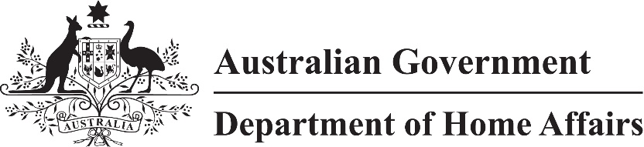

LIN 21/085

Migration (Arrangements for Work and Holiday (Subclass 462) Visa Applications) Amendment Instrument (LIN 21/085) 2021

I, Paul Denman, delegate of the Minister, make this instrument under the following provisions of the *Migration Regulations 1994* (the Regulations):

(a) subregulation 2.07(5);

(b) paragraph 1224A(3)(a) of Schedule 1;

(c) subparagraph 1224A(3)(b)(iii) of Schedule 1;

(d) paragraph 462.221(c) of Schedule 2.

Dated 13 December 2021

Paul Denman  
Acting Senior Executive Service Band One  
Immigration Programs Division  
Department of Home Affairs

1 Name

This instrument is the Migration (Arrangements for Work and Holiday (Subclass 462) Visa Applications) Amendment *Instrument (LIN 21/085) 2021*.

2 Commencement

This instrument commences on 1 January 2022.

3 Amendment

Schedule 1 amends *Migration (Arrangements for Work and Holiday (Subclass 462) Visa Applications) Instrument (LIN 21/019) 2021.*

Schedule 1 Amendment

(section 3)

1 Section 3, definition of *authorising email*

substitute

***written notice*** means an email from the Department inviting a person to make an application using a form and in a manner other than an Internet form through ImmiAccount including instructions about how to return the form to the Department.

2 Subsection 4(2), table

after

|  |
| --- |
| Spain |

insert

|  |
| --- |
| Switzerland |

3 Subsection 4(3), table

omit

|  |
| --- |
| Ecuador |
| Greece |

4 Subsection 4(3), table

after

|  |
| --- |
| Spain |

insert

|  |
| --- |
| Switzerland |

5 Subsection 4(3), table

after

|  |
| --- |
| United States of America |

insert

|  |
| --- |
| Uruguay |

6 Schedule 1, item 1

omit each occurrence of

an authorising email

insert

a written notice

7 Schedule 1, item 1

omit each occurrence of

authorising email

insert

written notice

8 Schedule 2, after item 20

insert

|  |  |  |
| --- | --- | --- |
| 20A | Switzerland | (a) successful completion of at least 2 years of study following compulsory schooling. |