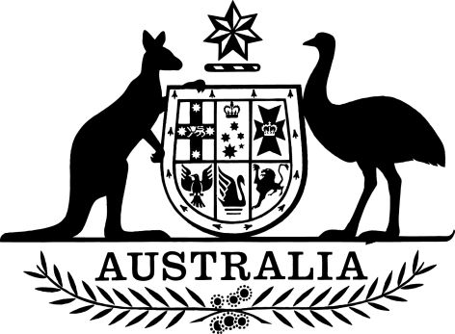

Great Barrier Reef Marine Park (Declaration of No-Anchoring Areas —Townsville/Whitsunday Management Area) Notifiable Instrument 2021
I, Joshua Thomas, Chief Executive Officer of the Great Barrier Reef Marine Park Authority (the Authority), acting under paragraph 5(2)(b) of the Great Barrier Reef Marine Park Regulations 2019 (the Regulations) as delegate of the Authority, and having had regard to the matters in subsection 5(3) of the Regulations, declare that on the date of commencement of the Great Barrier Reef Marine Park Amendment (No-Anchoring Areas) Regulations 2021:
- The Great Barrier Reef Marine Park (Declaration of Whitsundays No-Anchoring Areas) Notifiable Instrument 2020, dated 13 July 2020, is revoked; and
- Each of the areas shown on the maps in Schedules 1, 2 and 3, inshore or enclosed by the no-anchoring area boundary line, is a no-anchoring area for the purposes of the definition of no-anchoring area in subsection 5(1) of the Regulations.

Dated 21 May 2021

Joshua Thomas
Chief Executive Officer
Great Barrier Reef Marine Park Authority

Contents

Schedule 1 — Orpheus and Magnetic Islands no-anchoring areas |  | 3
 | Overview Map | 3
 | 1a — Pioneer Bay, Orpheus Island | 4
 | 1b — Yanks Jetty, Orpheus Island | 4
 | 1c — Florence Bay, Magnetic Island | 5
 | 1d — Arthur Bay, Magnetic Island | 5
 | 1e — Picnic Bay, Magnetic | 6
Schedule 2 — Bowen no-anchoring area |  | 7
 | 2a — Horseshoe Bay, Bowen | 7
Schedule 3 — Whitsunday Planning Area no-anchoring areas |  | 8
 | Overview Map | 8
 | 3a — Bait Reef | 9
 | 3b — Blue Pearl Bay, Hayman Island | 9
 | 3c — Black Island | 10
 | 3d — Langford Island | 10
 | 3e — East and West Butterfly Bay, Hook Island | 11
 | 3f — Maureen’s Cove, Hook Island | 11
 | 3g — Luncheon Bay and Manta Ray Bay, Hook Island | 12
 | 3h — Pinnacle Bay, Hook Island | 12
 | 3i — Crayfish Beach — Mackerel Bay South, Hook Island | 13
 | 3j — Saba Bay, Hook Island | 13
 | 3k — False Nara, Hook Island | 14
 | 3l — Caves Cove, Hook Island | 14
 | 3m — South Stonehaven/ Baird Point, Hook Island | 15
 | 3n — Cockatoo Point/ North Stonehaven, Hook Island | 15
 | 3o — Cairn Beach, Whitsunday Island | 16
 | 3p — Cateran Bay, Border Island | 16
 | 3q — Dumbell Island | 17
 | 3r — Sunlover’s Bay, Daydream Island | 17
 | 3s — Sandy Bay, South Molle Island | 18
 | 3t — Chalkies Beach, Haslewood Island | 18

Schedule 1—Orpheus and Magnetic Islands no-anchoring areas
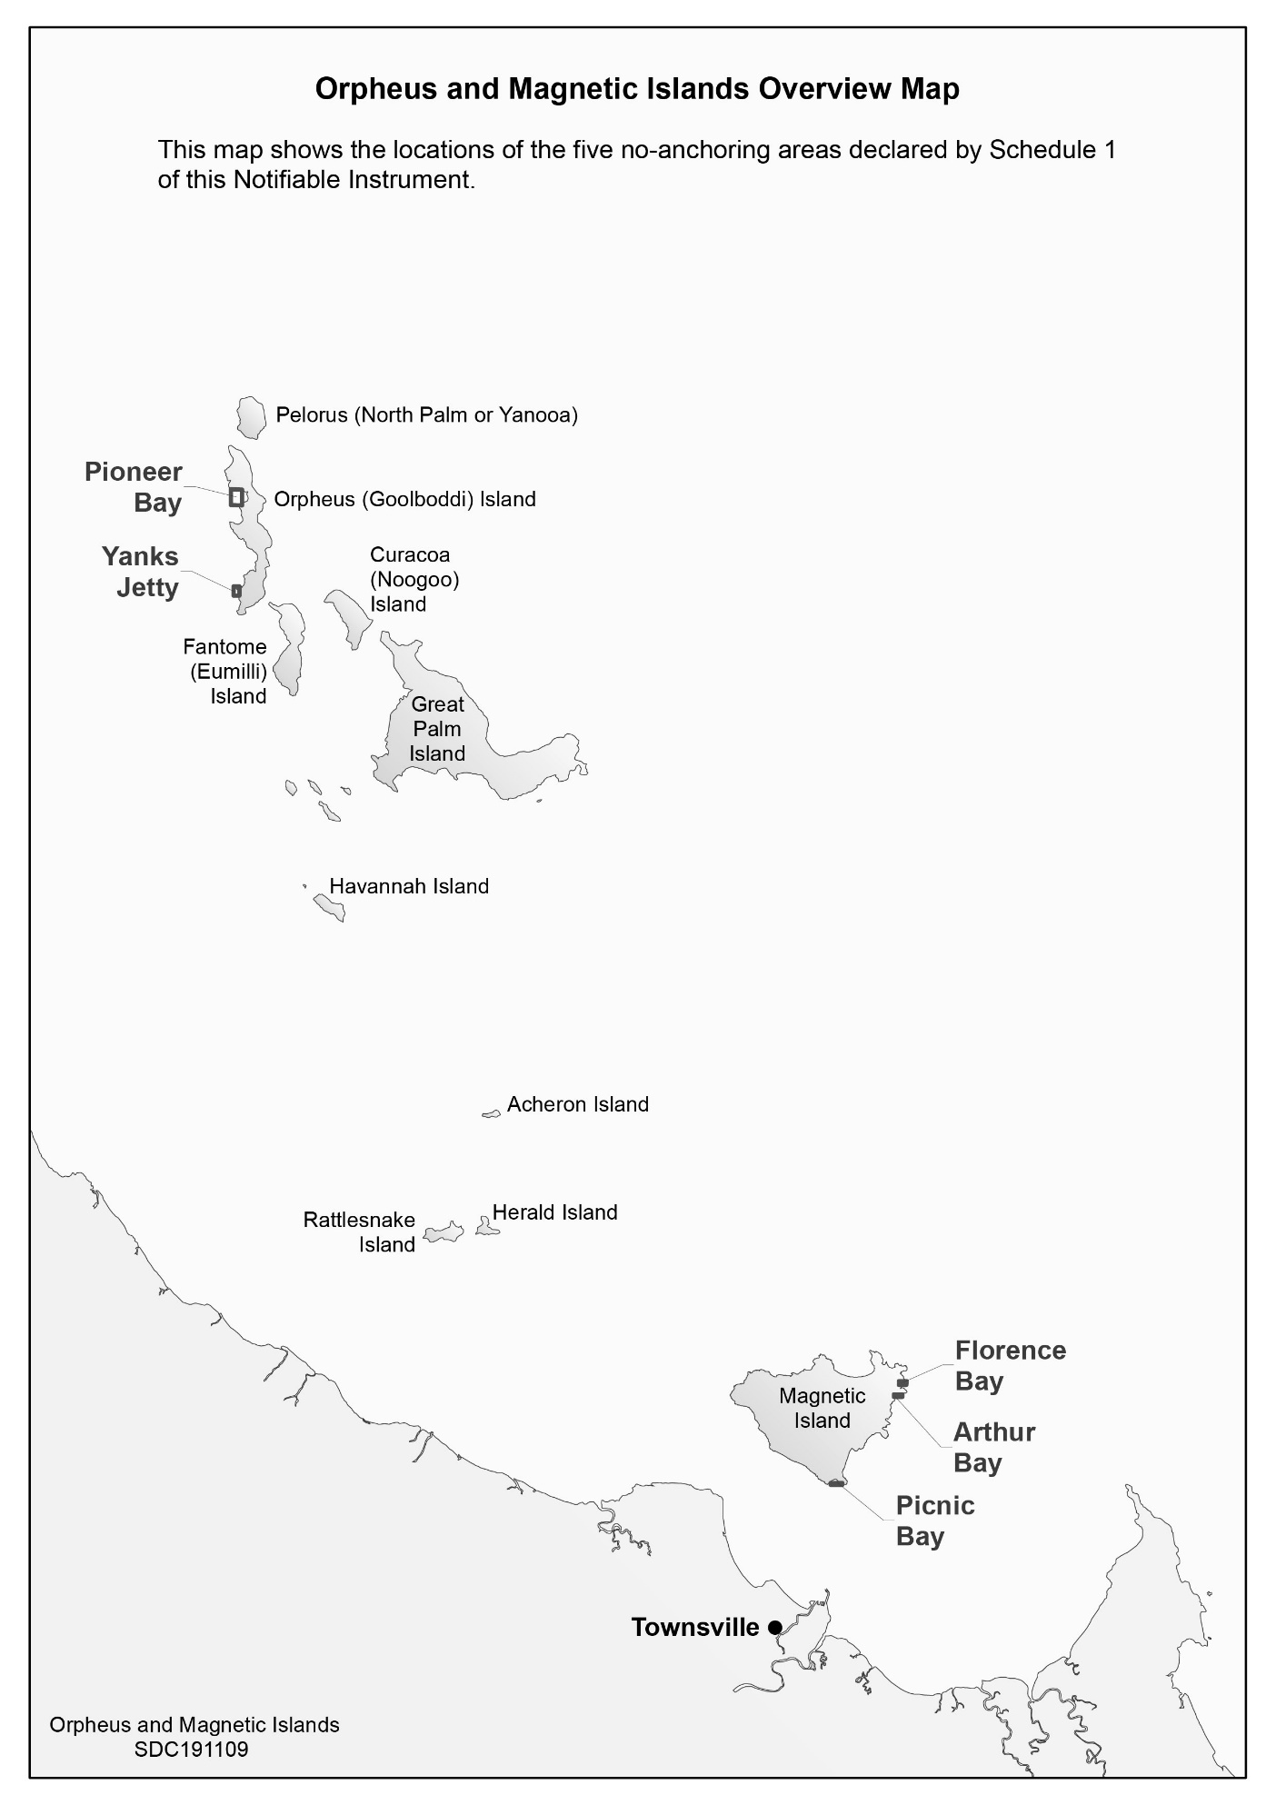

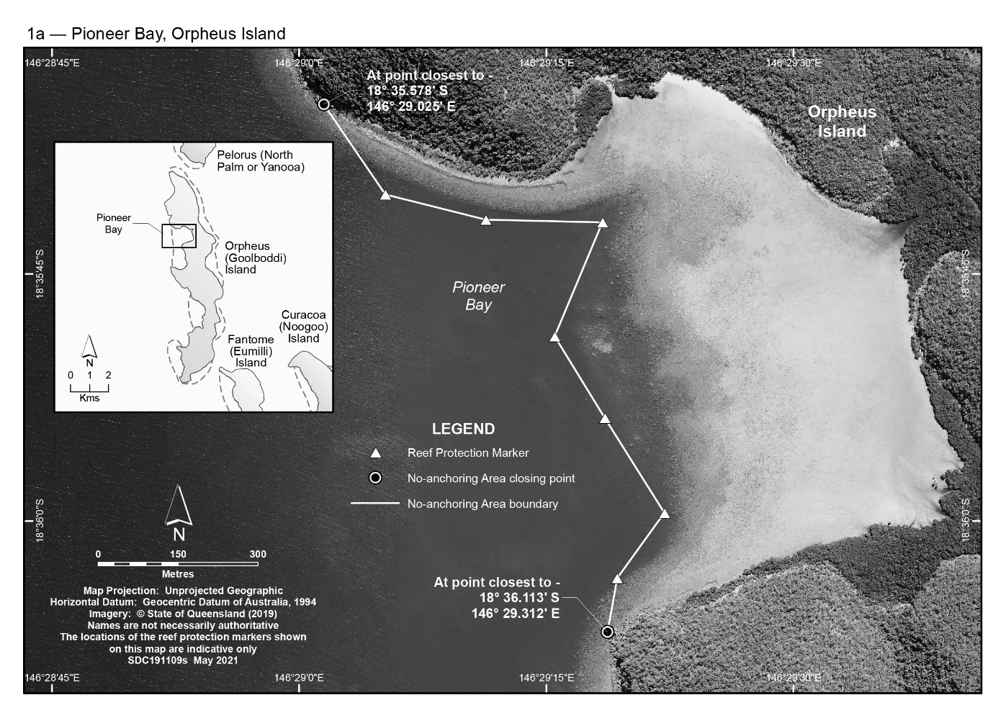
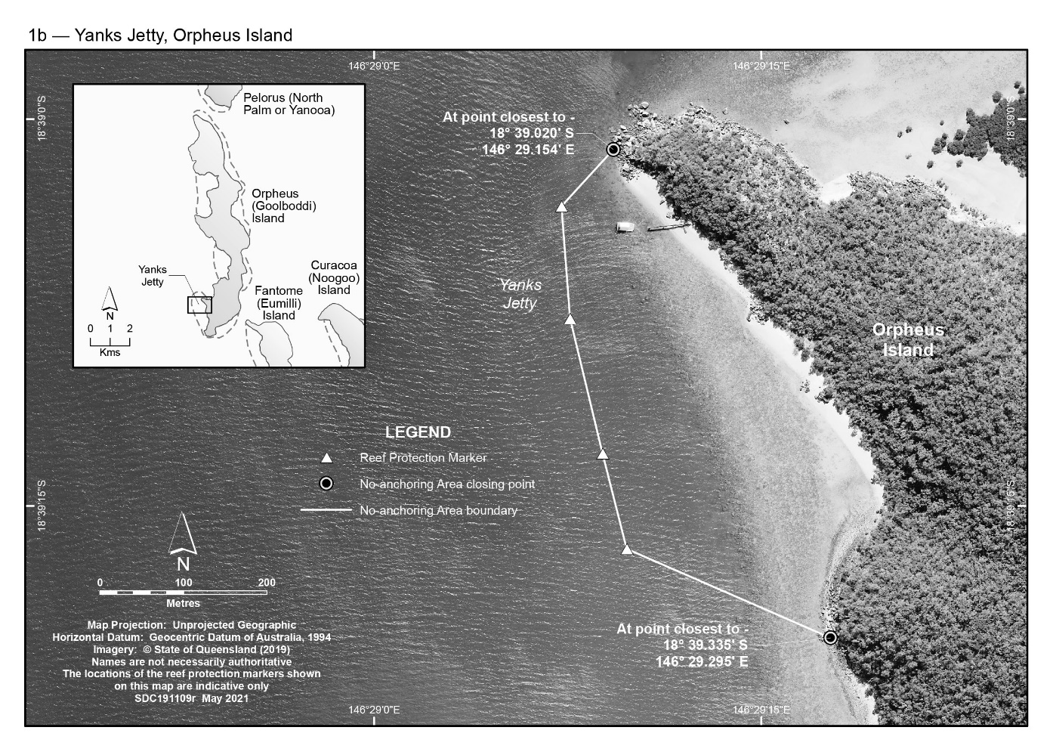

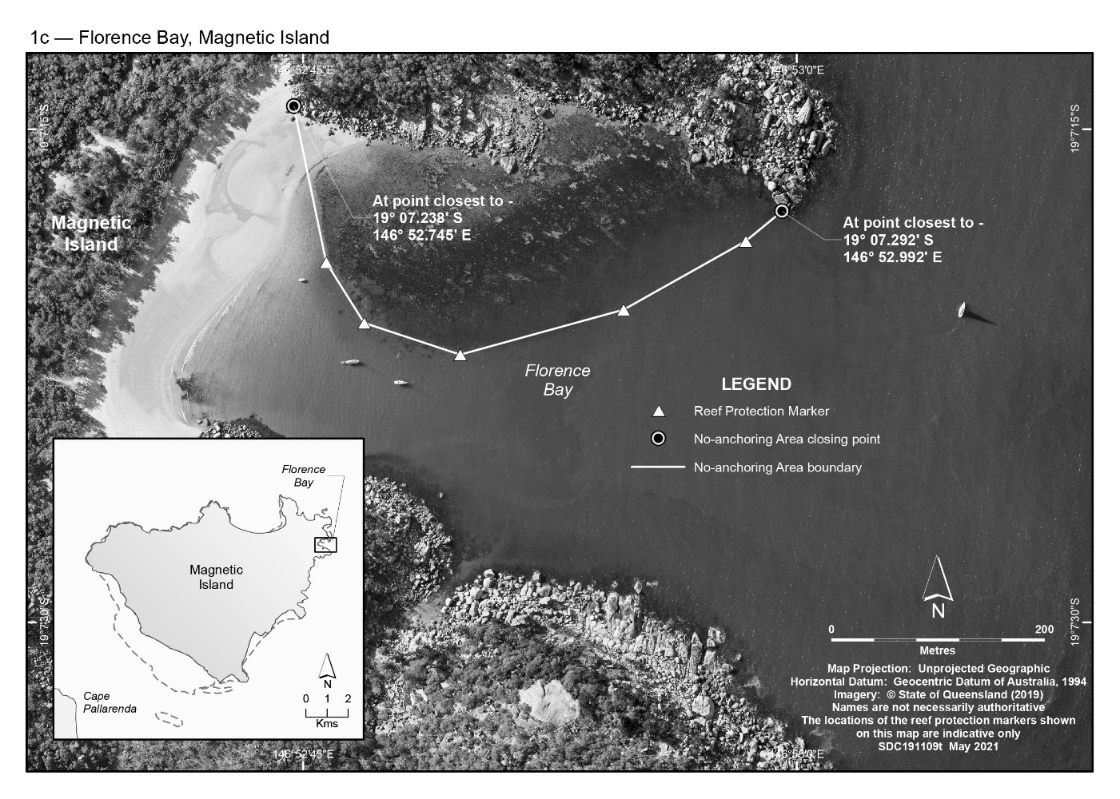

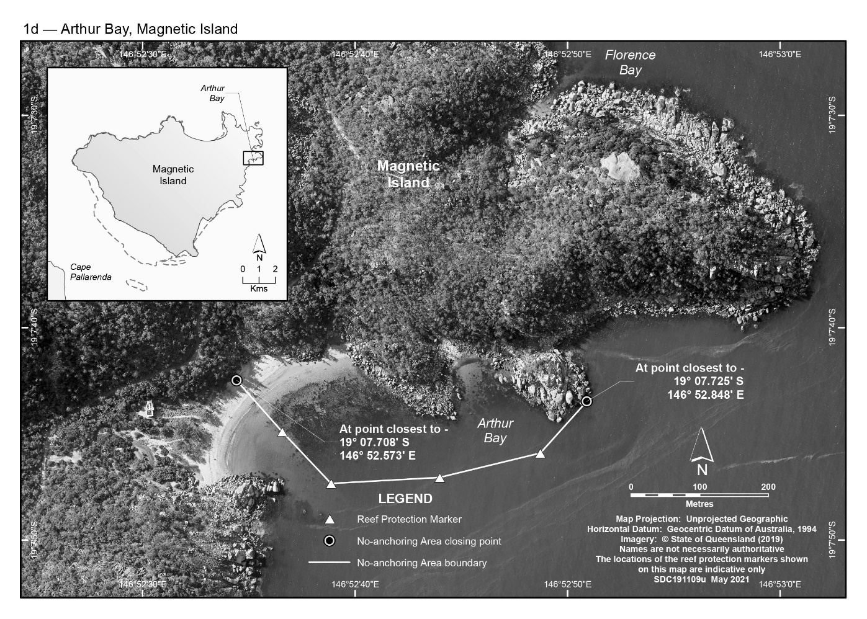

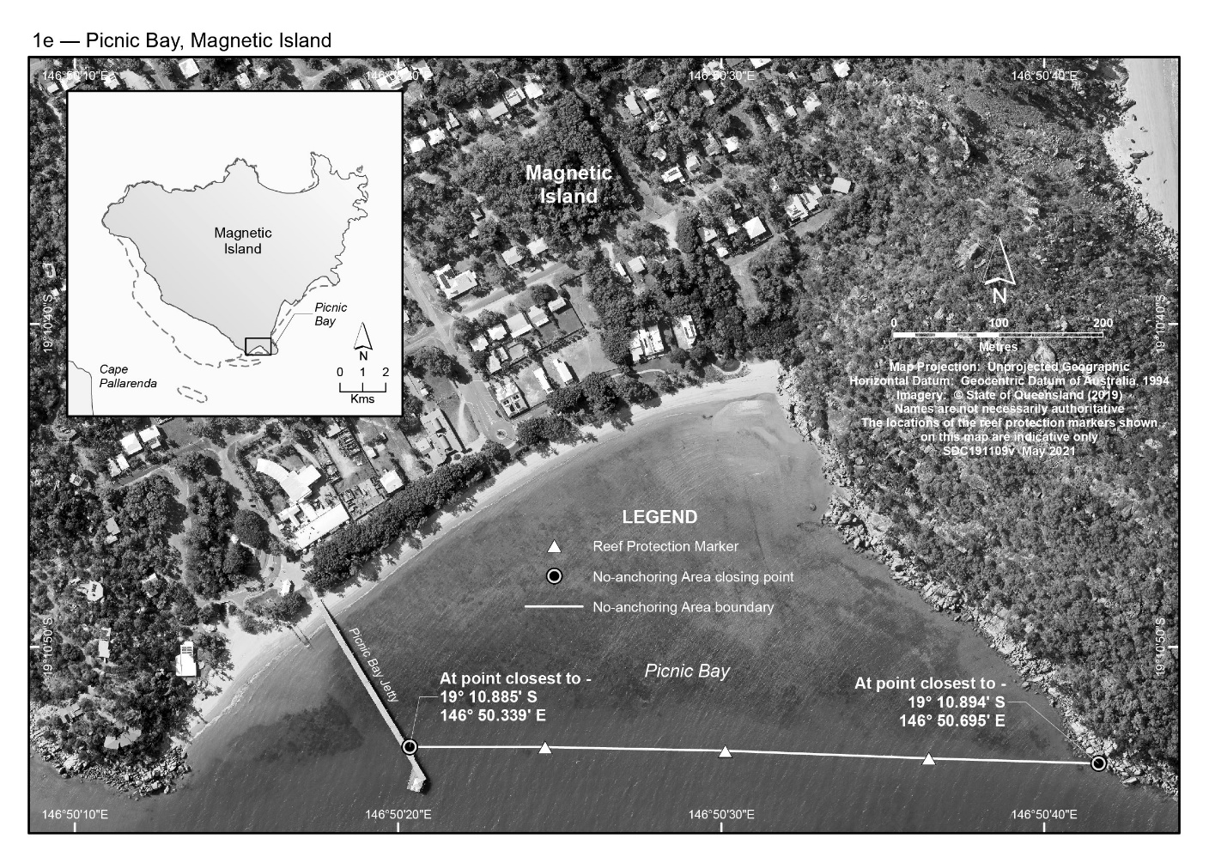

Schedule 2—Bowen no-anchoring area

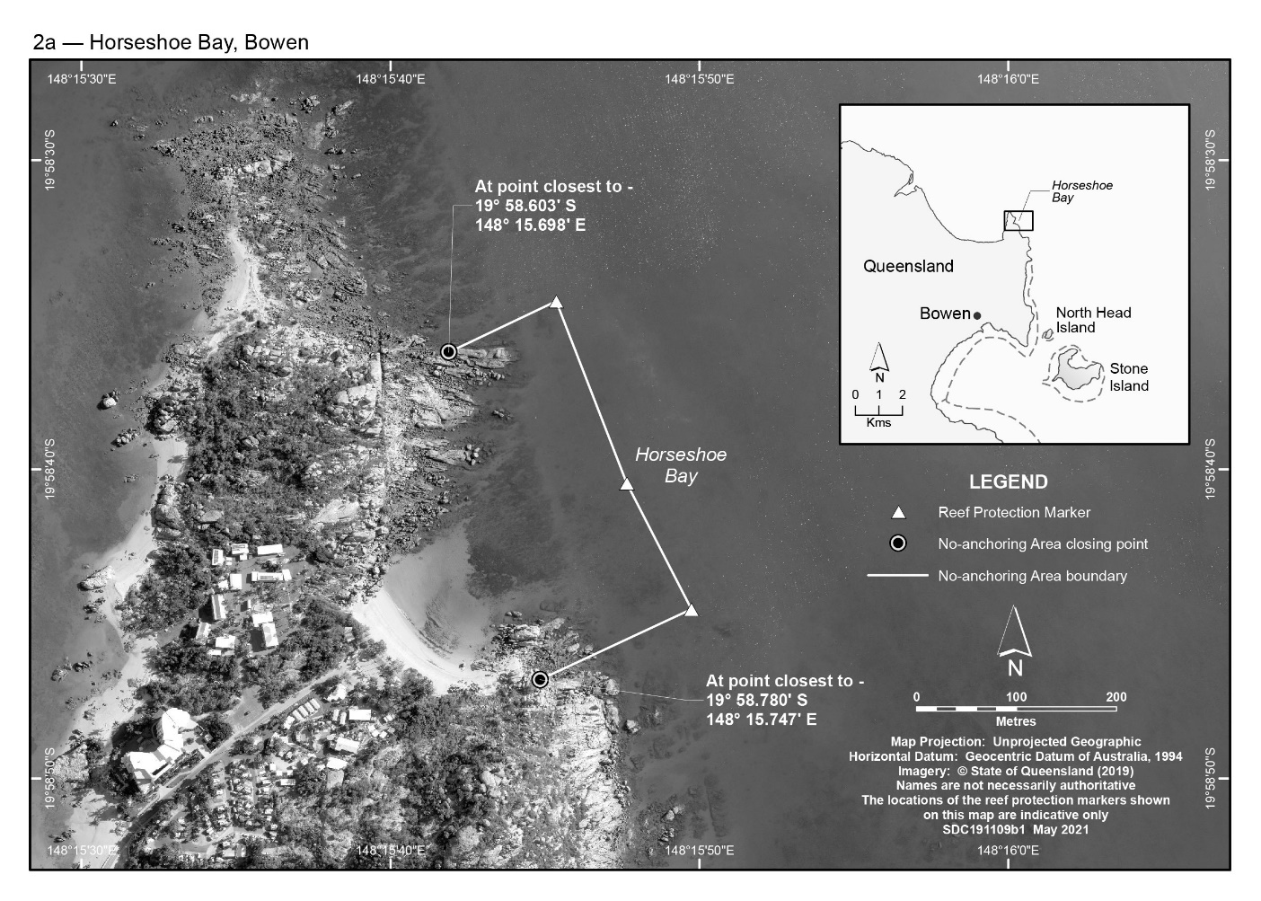

Schedule 3—Whitsunday Planning Area no-anchoring areas
