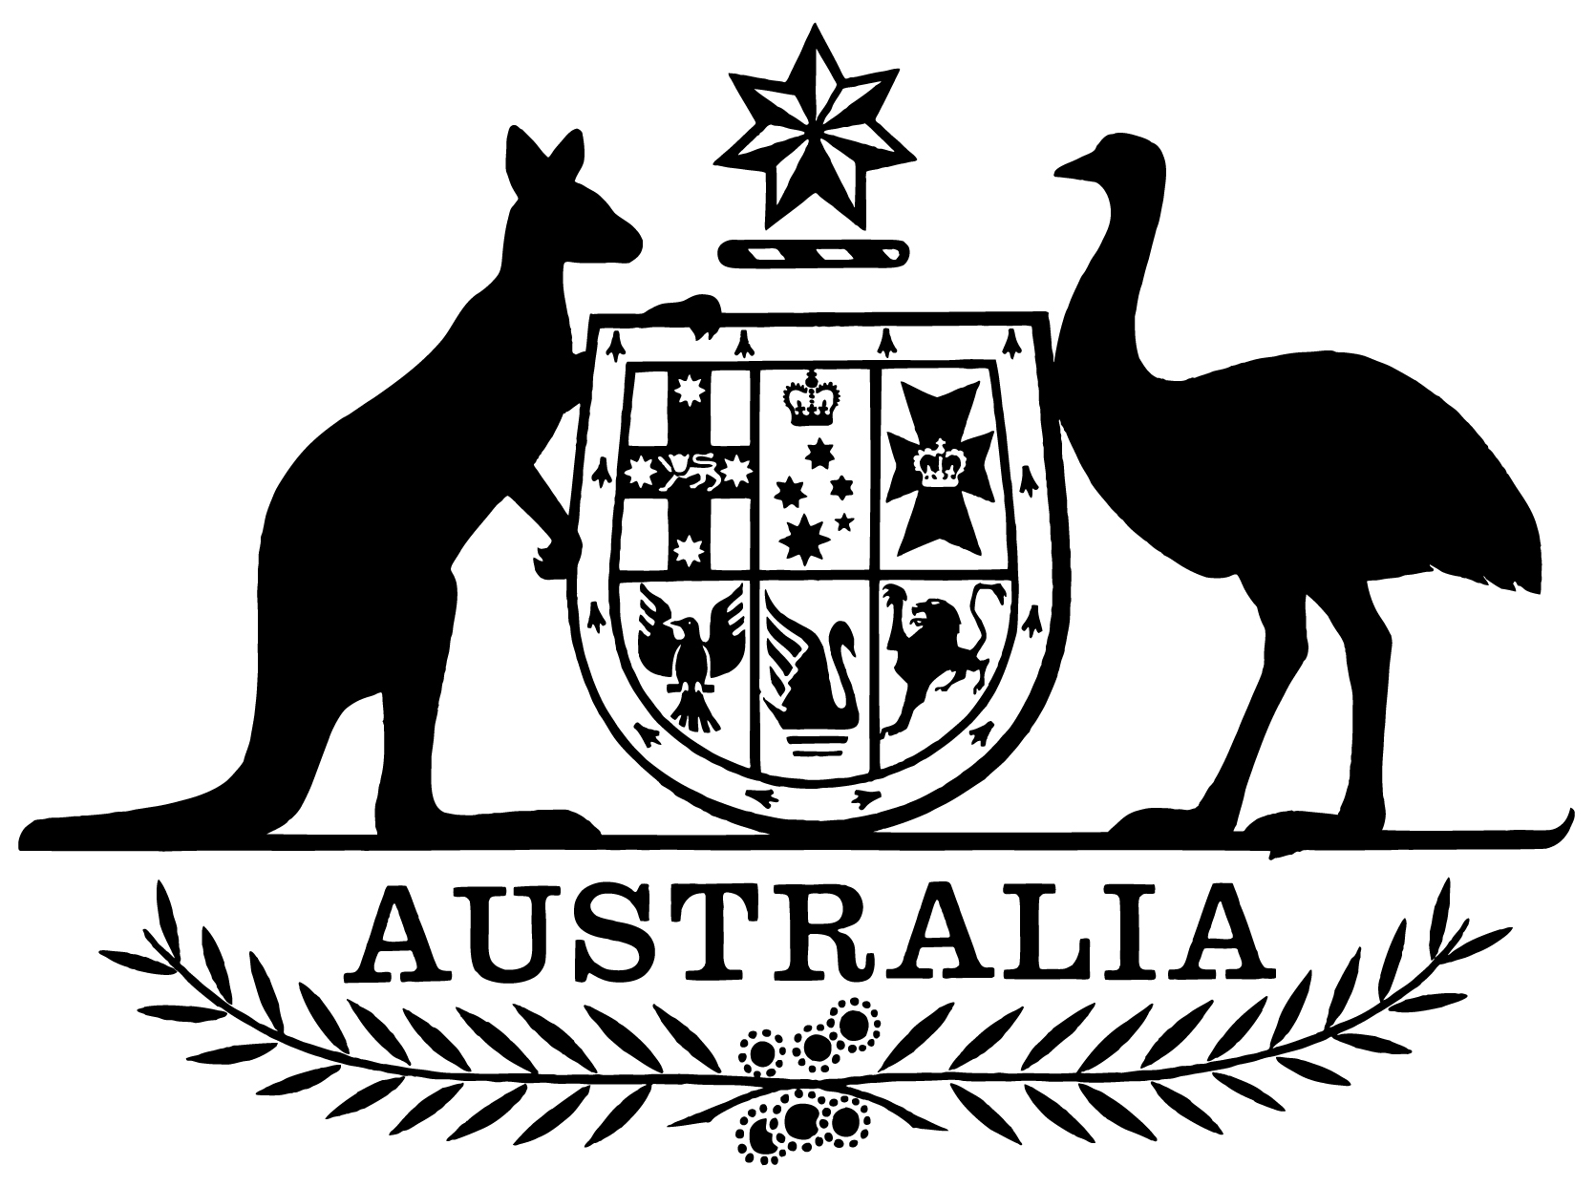

***Statement of Expectations for the Australian Transport Safety Bureau for the Period 1 July 2021 to 30 June 2023***

I,Michael McCormack, Minister for Infrastructure, Transport and Regional Development, make the following instrument.

Dated 21 June 2021

Michael McCormack

Minister for Infrastructure, Transport and Regional Development

1. **Overview**

This instrument is the *Statement of Expectations for the Australian Transport Safety Bureau for the period 1 July 2021 to 30 June 2023*.

This Statement of Expectations (SOE) applies in respect of the period from 1 July 2021 to 30 June 2023, and replaces the previous SOE issued on 18 July 2019. This instrument puts in place a new SOE, which represents a notice of strategic direction to the Australian Transport Safety Bureau (ATSB) under section 12AE of the *Transport Safety Investigation Act 2003* (the Act).

This SOE formalises my expectations concerning the operations and performance of the ATSB.

The ATSB should perform its functions in accordance with the Act and the *Public Governance, Performance and Accountability Act 2013* (PGPA Act) as well as other relevant legislation.

I reiterate the Government’s expectations that the ATSB’s resources be used in an efficient, effective, economical and ethical way, following best practice principles and guidelines.

I also expect that the conduct and values of the ATSB should be consistent with that of the Australian Public Service.

1. **Governance**

I expect that the Chief Commissioner and Commissioners will continue to work to enable the effective operation of the ATSB as the national transport safety investigator in accordance with the Act.

I expect that in performing its functions, the ATSB will provide timely advice to Government when the costs of necessary investigation activities are likely to exceed established ATSB budget levels, so that consideration can be given to the need for budget supplementation.

I expect that the Chief Commissioner will keep the Secretary of the Department of Infrastructure, Transport, Regional Development and Communications (Department) and myself informed of the ATSB’s actions in relation to the requirements stated in this SOE and promptly advise about any events or issues that may impact on the operations of the ATSB, including through the provision of timely quarterly progress reports against the Corporate Plan and this SOE.

I expect the ATSB to perform its functions consistent with Australia’s international obligations where appropriate, including the requirements of the International Civil Aviation Organization.

I also expect the ATSB to implement any recommendations of the Australian National Audit Office and continue to work towards the timely finalisation of investigations to support continuous improvement in transport safety.

1. **Approach to delivering core functions**

I expect the ATSB, in conducting its responsibilities as the national transport safety investigator, will continue to:

(a) focus on transport safety as the highest priority;

(b) give priority to transport safety investigations that have the highest risk or potential to deliver the greatest public benefit through systemic improvements to transport safety;

(c) while retaining operational independence, remain an active and effective participant in the transport policy and regulatory framework, working effectively with the Department and other stakeholders, including the Civil Aviation Safety Authority (CASA), Airservices Australia (Airservices), the Australian Maritime Safety Authority (AMSA), the Office of the National Rail Safety Regulator (ONRSR), the Department of Defence and the transport industry;

(d) be a global leader in transport safety investigation, research and analysis, and foster public awareness and education on transport safety, to influence positive safety action; and

(e) continually review investigation policies and practices to ensure that the ATSB retains its reputation as a best practice safety investigation agency and its influence on the national and international safety agenda.

1. **Key Initiatives**

I expect the ATSB, in conducting its responsibilities as the national transport safety investigator, will focus on the following key transport initiatives:

(a) implement effective workforce planning, ensuring the ATSB has the skills and expertise to meet current and emerging challenges in transport safety investigation;

(b) provide for a centre of excellence for transport safety investigation including through the development of the ATSB’s partnerships with educational institutions;

(c) collaborate with other countries to improve accident investigation capability and consistency with international protocols;

(d) support the Government’s transport safety objectives in the Asia-Pacific region;

(e) finalise the implementation of the measures announced in Budget 2020/21, designed to support core functions of the ATSB, including its accommodation footprint, updates to its ICT infrastructure and the development of an integrated aviation data sharing platform (the latter being led by the Bureau of Infrastructure and Transport Research Economics);

(f) enhance its research activities into areas which provide the most significant prospects of improving transport safety for the greatest public benefit;

(g) engage closely with aviation, rail and maritime regulators to ensure that arrangements are in place for the appropriate sharing and use of safety information by the ATSB and each regulator, and that these arrangements are transparent to industry and consistent with a strong reporting culture;

(h) support the Department and the States and Territories to ensure the national rail safety regulation and investigation reforms provide an effective framework for rail safety investigation; and

(i) be prepared to provide input into Government inquiries reviewing the ATSB’s jurisdiction across different modes of transport.

1. **Stakeholder Engagement**

I expect the ATSB will continue, while maintaining its independence, to:

1. undertake effective and ongoing engagement with industry to create cooperative relationships based on a foundation of mutual understanding and respect;
2. work closely with the Department and other Government agencies, including CASA, Airservices, the Department of Defence, AMSA and ONRSR to deliver integrated and comprehensive safety advice to the Government, industry and the community and fulfil Australia’s commitments to capability initiatives in the Asia Pacific; and
3. communicate with stakeholders regularly with targeted messaging through appropriate mediums for the respective stakeholders, to influence positive safety action.