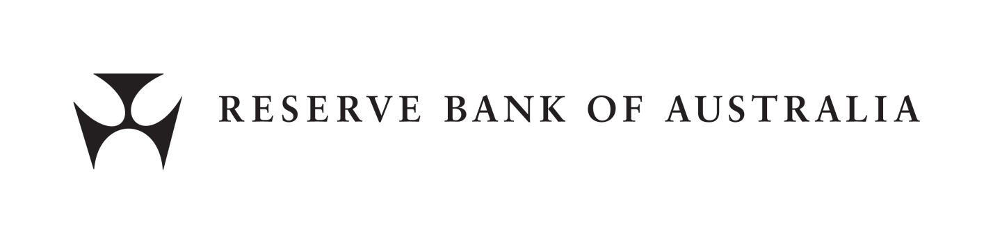

*Payment Systems (Regulation) Act 1998*

Exemption No. 1 of 2021

Exemption from Paragraphs 11 and 12 of the Access Regime for the ATM System

The Reserve Bank of Australia, under paragraph 16 of the Access Regime for the ATM System (**Access Regime**), exempts each participant in the ATM system from the application of paragraphs 11 and 12 of the Access Regime to the extent specified below in respect of any number of one-way arrangements entered into by the participant.

Terms defined in the Access Regime have the same meaning when used in this exemption.

Paragraph 11(i) of the Access Regime prevents the payment of an interchange fee under a one-way arrangement, unless the interchange fee is being paid by a participant with a one-way arrangement to access one, and only one, other participant’s ATMs and the interchange fee is paid in respect of that arrangement. Where a participant pays an interchange fee in a one-way arrangement, paragraph 12 of the Access Regime prevents that participant from receiving an interchange fee from any other participant in the ATM system, unless both of those participants are members of an ATM sub-network and the interchange fee is the common interchange fee payable between members of the sub-network.

This exemption, granted following approval by the Payments System Board, exempts from the application of paragraphs 11 and 12 of the Access Regime any interchange fee (however described) paid or payable by an ATM Issuer to an ATM Acquirer in respect of any one-way arrangement.

For the avoidance of doubt, this exemption permits an ATM Issuer to enter into a one-way arrangement with more than one ATM Acquirer and to pay interchange fees in respect of each one-way arrangement entered into by the ATM Issuer, irrespective of whether that ATM Issuer, as an ATM Acquirer, receives any interchange fees from any other ATM Issuer under one or more separate one-way arrangements.

In granting this exemption, the Reserve Bank of Australia has had regard to:

1. whether granting the exemption is in the public interest;
2. the interests of current participants in the system;
3. the interests of people who, in the future, may want access to the system; and
4. any other matters the Reserve Bank of Australia considers relevant.

This exemption takes effect on and from 19 October 2021.

Signed

Philip Lowe  
Governor  
Reserve Bank of Australia

19 October 2021