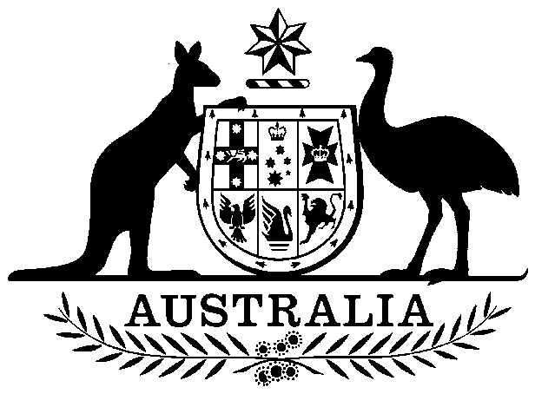

**COMMONWEALTH OF AUSTRALIA**

*Environment Protection and Biodiversity Conservation Act 1999*

**DECLARATION OF AN APPROVED WILDLIFE TRADE MANAGEMENT PLAN – SUSTAINABLE KANGAROO HARVEST NSW 2022–26**

I, SUSSAN LEY, Minister for the Environment:

(a) having noted the public comments received in response to an invitation under section 303FR

(b) being satisfied as to those matters set out in section 303FO

declare the *Wildlife Trade Management Plan for the Commercial Harvest of Kangaroos in New South Wales 2022–26* (the **Plan**) is an **approved wildlife trade management plan** for the purposes of section 303FO of the *Environment Protection and Biodiversity Conservation Act 1999*.

Unless amended or revoked, this declaration has effect subject to the following conditions applied under section 303FT:

1. Commercial harvesting of kangaroos in New South Wales must be conducted in accordance with the *Wildlife Trade Management Plan for the Commercial Harvest of Kangaroos in New South Wales 2022–26* (the Plan)*.*
2. This declaration is valid for five years from 1 January 2022 until 31 December 2026.
3. The NSW Department of Planning, Industry and Environment must inform the Department of Agriculture, Water and the Environment of any changes to kangaroo management arrangements in New South Wales that affect this declaration.
4. The quota report referred to in Action 7.1 of the Plan must be submitted to the Department of Agriculture, Water and the Environment by 30 November each year.
5. The annual report referred to in Action 7.1 of the Plan must be submitted to the Department of Agriculture, Water and the Environment by 31 March each year. The annual report will cover the preceding calendar year.

Dated this 20th day of December 2021

Sussan Ley

Minister for the Environment