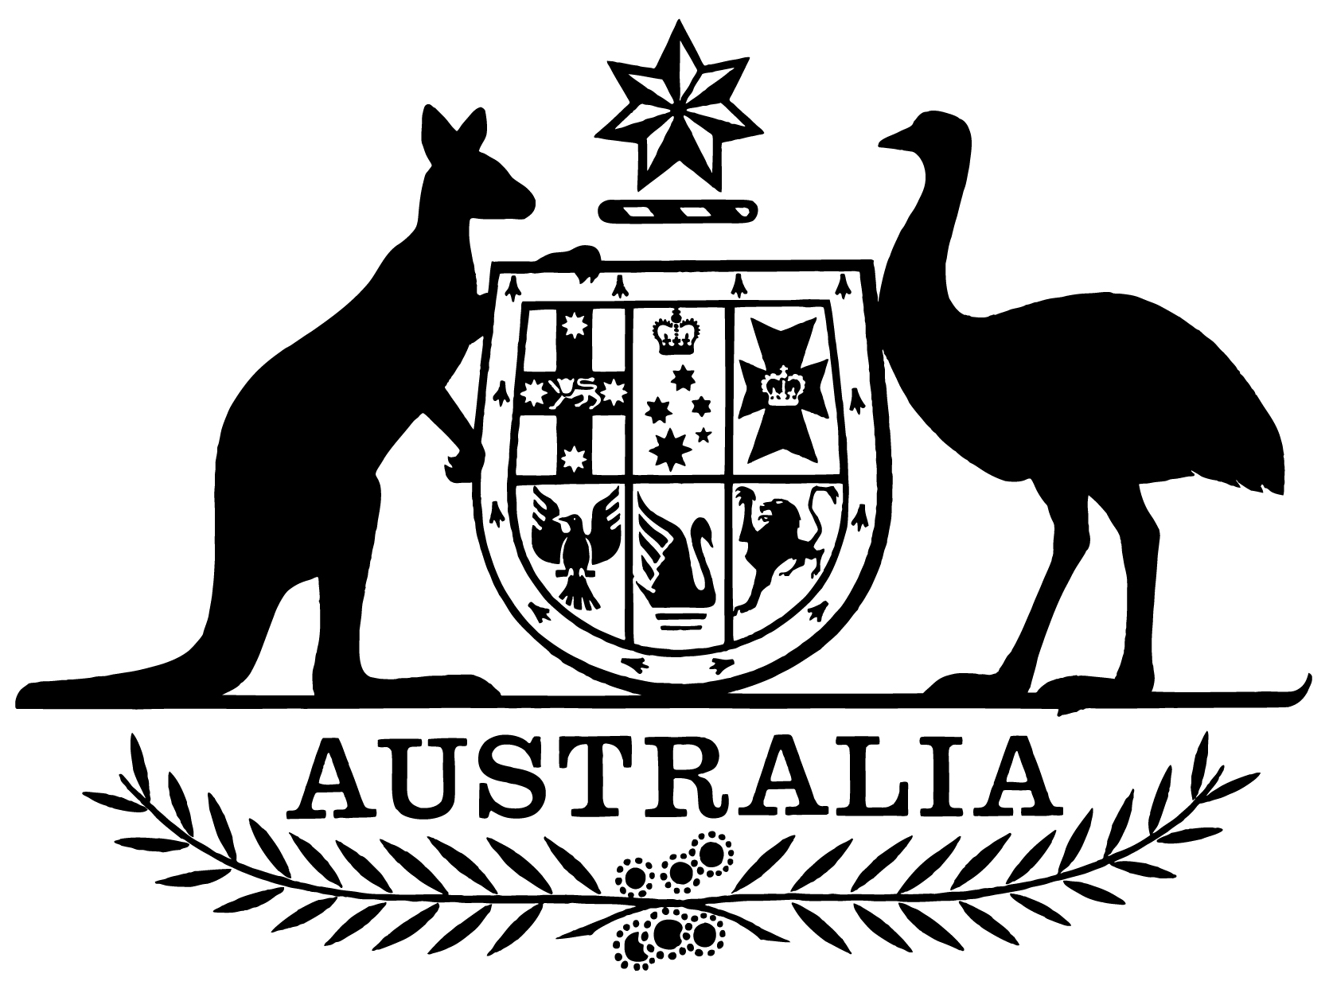

***Statement of Expectations for the Board of the Civil Aviation Safety Authority for the Period 31 January 2022 to 30 June 2023***

I,Barnaby Joyce, Minister for Infrastructure, Transport and Regional Development, make the following instrument under subsection 12A(1) of the *Civil Aviation Act 1988*.

Dated: 13 January 2022

Barnaby Joyce

Minister for Infrastructure, Transport and Regional Development

1. **Overview**

This instrument is the *Statement of Expectations for the Board of the Civil Aviation Safety Authority for the period 31 January 2022 to 30 June 2023*.

This Statement of Expectations (SoE) applies in respect of the period commencing   
31 January 2022 and ending 30 June 2023, and replaces the previous SoE issued on 21 June 2021.

This SoE serves as a notice to the Board of the Civil Aviation Safety Authority (CASA) under section 12A of the *Civil Aviation Act 1988* (the Act) and formalises my expectations concerning the operations and performance of CASA.

A safe, economically sustainable and well-regulated aviation sector is critical to Australia’s national productivity and keeping Australians connected to each other and the world. The Government considers that CASA plays an important role in ensuring that the aviation sector delivers economic and social benefits to all Australians through safe operations. CASA’s role and performance should keep pace with the sector, including emerging technologies and, without compromising safety outcomes, facilitate opportunities for the sector to sustain itself, grow and innovate. Acting as a decisive and responsive regulator, CASA will balance the benefits of reducing the regulatory burden on the sector with helping to ensure the delivery of safety and public interest outcomes.

I am issuing this SoE to CASA, consistent with regulatory best practice, and relevant legislative frameworks, while taking into account its statutory independence. The Government expects that CASA will respond with a Statement of Intent within three months of the date of this SoE.

1. **An Effective and Efficient Organisation**

CASA should perform its functions in accordance with the Act, the *Airspace Act 2007* and the *Public Governance, Performance and Accountability Act 2013* as well as other relevant legislation.

I reiterate the Government’s expectation that CASA’s resources be used in an efficient, effective, economical and ethical way, following best practice principles and guidelines.

I also expect that the conduct and values of CASA’s Board and staff should be consistent with those of the Australian Public Service.

1. **Governance**

CASA was established as an independent body to administer the regulatory frameworks that are within its remit. However, CASA performs its statutory functions as part of the Australian Government and is accountable to the Parliament, and ultimately the public, through the responsible Minister, the Parliamentary Committee process, its corporate plan and the tabling of its annual report. I expect that CASA will perform its functions in a manner which supports Government policy, particularly the Government’s deregulation agenda and consistent with the principles espoused in the Government’s Regulator Performance Guide.

I expect that the Board and the Director of Aviation Safety (DAS) will continue to work to enable the effective operation of CASA as the national aviation safety regulator.

I expect the Board to be responsible for the matters set out in the Act, including in particular, CASA’s strategic direction, risk management and corporate planning.

I also expect the Board to facilitate effective interaction between CASA and all stakeholders. I expect the CASA Board to be transparent in carrying out its functions, for example by publishing on the CASA website a communique of matters discussed at each Board meeting.

Subject to the Act, I expect the DAS, as the CEO of CASA, to be responsible for managing the operations of CASA, its organisational capacity, and the performance of its statutory functions. This includes leading the day to day development and implementation of effective and efficient regulation, executive-decision making, and operational, financial, personnel and administrative activities.

I expect the Board to keep me and the Secretary of the Department of Infrastructure, Transport, Regional Development and Communications (the Department) fully informed of CASA’s actions in relation to the requirements stated in this SoE, and promptly advise of any events or issues that may materially impact on the operations of CASA, including through concise quarterly progress reports from the Board against the Corporate Plan and this SoE.

I ask that CASA also keep me informed in relation to its public submissions, its media releases and major speeches and any information for which the Government is accountable to the Parliament. I further expect CASA to fully cooperate with Parliamentary Committees and other Commonwealth public accountability measures, including but not limited to the Senate Estimates process.

I expect CASA to perform its functions consistent with Australia’s international obligations where appropriate, including the requirements of the International Civil Aviation Organization (ICAO).

1. **Regulatory Approach**

I expect CASA will implement its regulatory approach in accordance with its regulatory philosophy.

The Act stipulates that CASA must regard the safety of air navigation as the most important consideration. Safety management requires a systems-based approach, including risk based and evidence driven decision making by CASA (including well documented safety cases) as well as industry.

CASA’s regulatory approach should be scalable to the size and complexity of each aviation activity and take into account the differing risks associated with different industry sectors and categories of operations.

My expectation is that CASA will perform its functions in a manner consistent with the Act and has appropriate regard to the economic and cost impacts of its decisions and actions on individuals, businesses and the community. I also expect that CASA will take a pragmatic, practical and proportionate approach to regulation as it applies to different industry sectors.

In support of this regulatory approach, and my views regarding CASA’s strategic direction and the manner in which it should perform its functions, I expect that CASA will:

1. review its regulatory philosophy and update it if required, in consultation with the aviation sector, by the end of 2022.
2. fully consider the impact of new regulations on general aviation, with a particular focus on regional and remote Australia. All Explanatory Statements drafted by CASA for subordinate legislation should identify the impact on the various categories of operations as well as on communities in regional and remote Australia served by those operations and how these impacts have been considered.
3. review its consultation framework with interested and affected members of the aviation community to support a collaborative approach to developing fit for purpose regulatory amendments and addressing key safety issues. The outcomes of this review should be provided to me by 30 June 2022.
4. release an exposure draft of proposed regulations for industry consultation before regulations are put to me for approval unless a delay would have an immediate impact on aviation safety.
5. review its client services standards and ensure there are key performance indicators, such as processing times, for all client delivery functions published on its website by 30 June 2022.
6. following a review, seek to publish by 1 May 2022 a work plan of measures being developed that will reduce, where appropriate, the regulatory burden on general aviation.
7. by 30 September each year, provide me with an annual report on CASA’s forward regulatory program and how the views of the aviation community have been taken into account when prioritising which amendments should be progressed.
8. **Key Initiatives**

I expect CASA, in performing its functions as the aviation safety regulator, will:

1. continue effective engagement with industry concerning the implementation of the flight operations suite of regulations.
2. support Airservices Australia (Airservices) and the Department of Defence (Defence) in the implementation of the OneSKY project through timely approval and certification, in addition to the continuing regulatory oversight of Australia’s existing air traffic management system.
3. work closely with the Department and Airservices to enable the integration of Remotely Piloted Aircraft Systems (RPAS) into Australian airspace, including regulatory oversight of the safety aspects of unmanned aviation operations. This includes supporting the development and progression of initiatives outlined in the National Emerging Aviation Technologies (NEAT) Policy Statement.
4. support Airservices in its development and implementation of a new Flight Information Management System (FIMS) to underpin Australia’s Unmanned Traffic Management (UTM) ecosystem, through timely regulatory review.
5. provide regulatory oversight for major aerodrome infrastructure projects, including significant new runway projects, as well as providing authoritative and timely advice to me and the Department on matters related to leased federal airport developments.
6. ensure sufficient resources are applied to the regulatory oversight of the development of Western Sydney Airport and associated airspace in order to support the safe and on-time delivery of regulatory decisions required for the project.
7. continue to share safety information consistent with the Safety Information Policy Statement agreed with the Australian Transport Safety Bureau (ATSB).
8. work collaboratively with the Department and Airservices on modernising airspace management, including, as the regulator, leading the development of the Australian Future Airspace Framework consistent with the Government’s airspace policy objectives, and shaping Australia’s future airspace policy and regulatory framework.
9. work collaboratively with Geoscience Australia and Airservices to help ensure CASA’s regulatory oversight enables safe and timely implementation of satellite-based augmentation systems in the aviation environment.
10. work collaboratively with the Australian Space Agency to facilitate the advancement of Australia’s space policies and industry through timely decision-making and the provision of advice.
11. continue working with the Department in preparing advice to Government on the long-term funding of CASA to provide for its ongoing financial viability, and in examining opportunities to reduce costs of regulation in the aviation industry.
12. undertake suitable workforce planning, and provide me an update on this work by 30 June 2022, with detailed consideration of how CASA will maintain a suitable workforce to meet emerging aviation challenges, and how to address key cultural improvements with respect to professionalism, probity, transparency and accountability.
13. working with the Department, CASA will pursue, within its legislative responsibilities, appropriate mutual recognition and bilateral arrangements to support the recognition of Australian designs, innovation and certification in comparable jurisdictions, and the minimisation of red tape in transitioning between jurisdictions (including where possible, automatic recognition of licences and approvals).
14. identify effective mechanisms to help ensure that flight instruction and related services are more widely, readily and efficiently available, especially in remote and regional areas of Australia.
15. **Stakeholder Engagement**

I expect CASA will be transparent and responsive communicators, implementing regulations in a modern and collaborative way. In particular, I expect CASA to:

1. undertake effective and appropriate engagement with Government, commercial, industrial, consumer and other relevant stakeholders and bodies, including in consideration of its regulatory development program.
2. recognise the various sectors that comprise the aviation industry and undertake effective and ongoing engagement with those various sectors.
3. communicate clearly and regularly with relevant Government agencies, industry and other key stakeholders regarding CASA’s activities and functions.
4. work closely with the Department and other Government agencies, including the ATSB, Airservices and Defence, to deliver integrated and comprehensive safety advice to the Government, the aviation industry and the community.