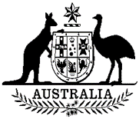

**Commonwealth of Australia**

List of Threatened Species Amendment (*Phascolarctos cinereus* (combined populations of Queensland, New South Wales and the Australian Capital Territory) (280)) Instrument 2022

I, SUSSAN LEY, Minister for the Environment, under paragraph 184(c) of the *Environment Protection and Biodiversity Conservation Act 1999*, amend the list of threatened species made under section 178 of that Act by:

### Transferring the following species by deleting it from the **Vulnerable** category on the List and including it in the **Endangered** category on the List:

* *Phascolarctos cinereus* (combined populations of Queensland, New South Wales and the Australian Capital Territory)

This instrument commences the day after registration.

SUSSAN LEY

...................................................................................

Minister for the Environment

Dated ..10 / 2 / 22….