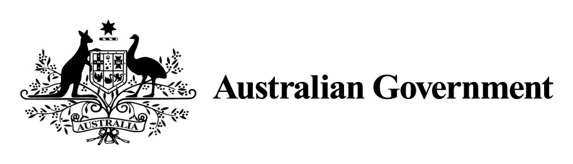

1. ***National Land Transport Act 2014***
2. **VARIATION OF THE ROADS TO RECOVERY LIST 2019**
3. **Instrument No. 2022/1**
4. **I, ROBYN LEGG,** Assistant Secretary, NSW, ACT and Targeted Roads, Department of Infrastructure, Transport, Regional Development and Communications,under Sections 88(2) and (3) of the *National Land Transport Act 2014* (the Act), vary the *Roads to Recovery List 2019* which was made by the Minister on 31 October 2018, and amended by Instrument No. 2019/2 made on 1 July 2019, 2019/3 made on 29 July 2019, Instrument No. 2019/4 made on 27 September 2019, Instrument No. 2019/5 made on 23 November 2019, Instrument No. 2020/1 made on 12 February 2020 and Instrument 2021/1 made on 4 March 2021 as follows:
5. **Name of variation**
6. This variation instrument is the Roads to Recovery List 2019 Variation Instrument No. 2022/1.
7. **Variation**
8. (a) In Schedule 1 of the List, in the part relating to South Australia:

omit the name specified in Column 1 of Schedule 1 for the funding recipient name ‘Gerard Reserve Council Inc’ and replace the omitted name with ‘Gerard Community Council Aboriginal Corporation’.

1. (b) In Schedule 1 of the List, in the part relating to South Australia:

omit the name specified in Column 1 of Schedule 1 for the funding recipient name ‘District Council of Mount Barker’ and replace the omitted name with ‘Mount Barker District Council’.

1. **Commencement**
2. This instrument commences on the day after registration.
3. Dated: 9 February 2022
4. Robyn Legg

Assistant Secretary

1. NSW, ACT and Targeted Roads
2. Infrastructure Investment Division
3. Department of Infrastructure, Transport, Regional Development and Communications

**Schedule to Instrument 2022/1**

1. **Schedule 1**

|  |  |  |
| --- | --- | --- |
| **Item** | **Column 1 - Funding recipients** | **Column 2 – Funding amounts** |
| **South Australia** | | |
| 443 | Gerard Community Council Aboriginal Corporation | $101,483 |
| 460 | Mount Barker District Council | $2,971,279 |