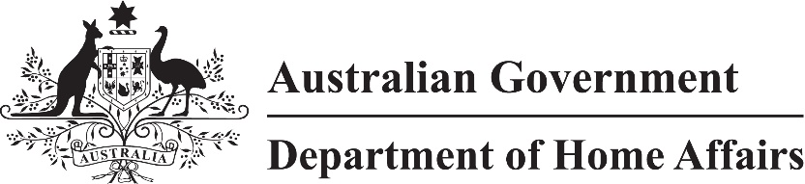

LIN 22/005

Migration (Arrangements for Visitor (Class FA) visa applications) Amendment Instrument (LIN 22/005) 2022

I, Alison Garrod, delegate of the Minister, make this instrument under subregulation 2.07(5) of the *Migration Regulations 1994* (the Regulations)*.*

Dated 2 March 2022

Alison Garrod

Acting Senior Executive Service Band 1

Immigration Programs Division

Department of Home Affairs

1 Name

This instrument is the Migration (Arrangements for Visitor (Class FA) visa applications) Amendment Instrument *(LIN 22/005) 2022*.

2 Commencement

This instrument commences on 5 March 2022.

3 Amendment

Schedule 1 amends *Migration (arrangements for Visitor (Class FA) visa applications) Instrument (LIN 21/056) 2021*.

Schedule 1 Amendment

(section 3)

[1] Section 1

omit

*arrangements*

insert

*Arrangements*

[2] Section 3, note

substitute

*Note* Terms defined in the *Migration Act 1958* and the Regulations have the same meaning in this instrument, including ***criminal justice visa*** and ***substantive visa***.

[3] Section 5

substitute

5 Making an application in the Tourist stream

(1) For subitem 1236(1) and item 1 of the table in subitem 1236(3) of Schedule 1 to the Regulations, this section specifies requirements for making an application for a Tourist stream visa.

(2) The application must be made using form 1419 (Internet) through ImmiAccount, indicating the application is for a Tourist stream visa only.

(3) However, if a person has received a written notice, an application may be made using form 1419 in accordance with the instructions in the written notice.

(4) An application by an applicant in Australia must be made before, or within 28 days after, the day the applicant ceases to hold a substantive visa or a criminal justice visa.