Commonwealth Coat of Arms

Woomera Prohibited Area Rule 2014 Determination of Exclusion Periods for Amber Zone 1 and Amber Zone 2 for Financial Year 2021 – 2022 Amendment No.2

*Woomera Prohibited Area Rule 2014*

I, Taylor Seawright, Acting Director Woomera Prohibited Area Coordination Office, as a delegate of the Minister for Defence, amend the Woomera Prohibited Area Rule 2014 Determination of Exclusion Periods for Amber Zone 1 and Amber Zone 2 for Financial Year 2021 – 2022 as set out in the Schedule.

Dated 3 March 2022

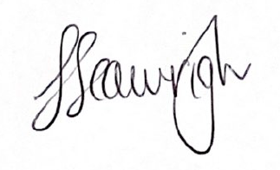

Taylor Seawright

Acting Director Woomera Prohibited Area Coordination Office

**Schedule**

Amend the *Woomera Prohibited Area Rule 2014 Determination of Exclusion Periods for Amber Zone 1 and Amber Zone 2 for Financial Year 2021 – 2022* by omitting from the Schedule the Exclusion Periods listed in the table below.

|  |  |
| --- | --- |
| Exclusion Period | Zone to which the Exclusion Period applies |
| 7 March to 13 March 2022 | Amber Zone 1 |
| 14 March to 20 March 2022 | Amber Zone 1 |
| 21 March to 27 March 2022 | Amber Zone 1 |
| 28 March to 3 April 2022 | Amber Zone 1 |
| 4 April to 10 April 2022 | Amber Zone 1 |
| 21 March to 27 March 2022 | Amber Zone 2 |
| 28 March to 3 April 2022 | Amber Zone 2 |
| 4 April to 10 April 2022 | Amber Zone 2 |