I, PHILIPPA JILLIAN SPENCE, Director of Aviation Safety, on behalf of CASA, make this instrument under regulation 101.028 of the Civil Aviation Safety Regulations 1998.
[Signed P. Spence]
Pip Spence
Director of Aviation Safety
30 March 2022
Part 101 Manual of Standards (Miscellaneous Revisions) Amendment Instrument 2022 (No. 1)
1 Name of instrument
This instrument is the Part 101 Manual of Standards (Miscellaneous Revisions) Amendment Instrument 2022 (No. 1).
2 Commencement
This instrument commences on 1 April 2022.
3 Amendment of the Part 101 Manual of Standards
Schedule 1 amends the Part 101 (Unmanned Aircraft and Rockets) Manual of Standards Instrument 2019.
Schedule 1 Amendments
[1] Section 1.03, the Table, Item 1A
omit
10 April 2022
insert
10 April 2024
[2] Subsection 1.04 (2), definition of tethered operation
repeal and substitute
tethered operation means use of an RPA in circumstances in which an RPA is flown while securely attached to a lead that:
(a) is no longer than 150 ft, unless a provision of this MOS provides for a longer lead; and
(b) makes it impossible for the RPA to escape and fly away during normal, abnormal or emergency operations.
[3] Subsection 1.04 (2)
insert
measurement point means any point on the actual or notional centreline of a runway between the 2 threshold centrepoints.
test flight, for an RPA or model aircraft, means a flight of the aircraft solely to test all or any of the following to determine that they or it is in working order and in a condition for safe operation:
(a) the aircraft;
(b) the aircraft system;
(c) any equipment associated with the aircraft or the aircraft system.
threshold, for a runway, means the beginning of that portion of the runway usable for landing.
Note This definition also applies to a runway that is a grass landing strip, whether or not the threshold is marked with markers.
threshold centrepoint, for a runway, means the point on the threshold of the runway at which the centreline of the runway intersects (or would insect if there were a centreline) the threshold.
[4] Section 2.04
repeal and substitute
2.04 Aeronautical radio
Note CASA is developing guidance material for RePL training organisations which will include guidance on aerial radio operator certificates (AROCs) and General English Language Proficiency (GELP).
[5] Subsection 2.06 (1), the Note
repeal
[6] Section 4.01, the chapeau
omit
Division
insert
Chapter
[7] Section 4.02, the chapeau
omit
Division
insert
Chapter
[8] Section 4.02
omit
section 4.06 (wherever occurring)
insert
section 4.05
[9] Section 4.02, paragraph (a) of definition of no-fly zone of a controlled aerodrome
omit
of the movement area
insert
, in any direction, from the measurement point of any runway
[10] Section 4.02, paragraph (b) of definition of no-fly zone of a controlled aerodrome
omit
of the movement area
insert
, in any direction, from the measurement point of any runway
[11] Section 4.02, definition of RPA
omit
Division
insert
Chapter
[12] Section 4.04, the heading
repeal and substitute
4.04 Approval to operate an RPA in a no-fly zone of a controlled aerodrome — tethered and indoors operations
[13] Subsection 4.04 (3), including the Note
repeal and substitute
(3) For a tethered operation in the no-fly zone of a controlled aerodrome, the certified RPA operator must:
(a) use a tether that is no longer than 150 ft; and
(b) ensure that the RPA is not operated higher than 150 ft above the aerodrome elevation; and
Note The aerodrome elevation can be determined from the aerodrome obstacle limitation data (OLS data).
(c) conduct the tethered operation in accordance with the operator’s documented practices and procedures for operations under this Chapter; and
(d) submit a notification to ATC before the operation of the RPA; and
(e) ensure that the RPA is flown in accordance with any instructions issued by ATC; and
(f) ensure that:
(i) the RPA is flown within the area that is shaded grey for the controlled aerodrome; or
(ii) if the RPA is flown within the area that is shaded black for the controlled aerodrome, the RPA is not flown within 3 NM from the measurement point of any runway of the controlled aerodrome.
Note The designation of controlled aerodromes and controlled airspace is made in the Determination of airspace and controlled aerodromes etc., as in force from time to time. This is a legislative instrument revised and reissued by CASA approximately every 6 months. Controlled aerodrome information in the Determination in force at any particular time is also published by Airservices Australia in the Designated Airspace Handbook.
[14] Section 4.05
repeal and substitute
4.05 Approach and departure paths — controlled aerodromes
(1) Figure 4.05 (1)-1 shows the approach and departure paths of a controlled aerodrome.
Note Figure 4.05 (1)-2 illustrates 1 example of a multi-runway scenario to which the requirements in this Chapter apply in the same way as for a single runway. Application of the requirements does not affect the black-shaded areas but produces overlapping grey-shaded areas, and what would otherwise be a grey-shaded area becomes a black-shaded area because of the intersection of the runways.
(2) As shown in Figure 4.05 (1)-1, the approach and departure path is up to 400 ft, as follows:
(a) anywhere on or from the ground upwards in the area that is the runway or the runway strip;
(b) anywhere in the following areas which are the approach and departure paths for the controlled aerodrome:
(i) subject to subparagraph (ii) — on or from the ground upwards in the area that is shaded black to a distance of 7 km from the end of the runway strip;
(ii) anywhere from 300 ft (90 m) above the ground (referenced to the aerodrome elevation) in the area that is between 7 km and 8.5 km from the end of the runway strip (the area that is crosshatched);
(c) anywhere from 150 ft (45 m) above the ground (referenced to the aerodrome elevation) in the area that is shaded grey.
(3) The area that is shaded black, which shows the approach and departure paths and the ground below them, is described as comprising the following:
(a) a symmetrical trapezoids with the shorter side coincident with the ends of a nominal 100 m wide runway strip and extending out at an angle of 15 degrees on either side to a distance of 8.5 km;
(b) a rectangle extending 500 m on either side of the runway centreline and overlying the runway strip until it intersects the trapezoids of the approach and departure paths.
(4) The area that is shaded grey is an area that extends 3 NM in all directions from the measurement point.
[15] Section 4.05, Figure 4.05 (1)-1 and Figure 4.05 (1)-2
repeal and substitute
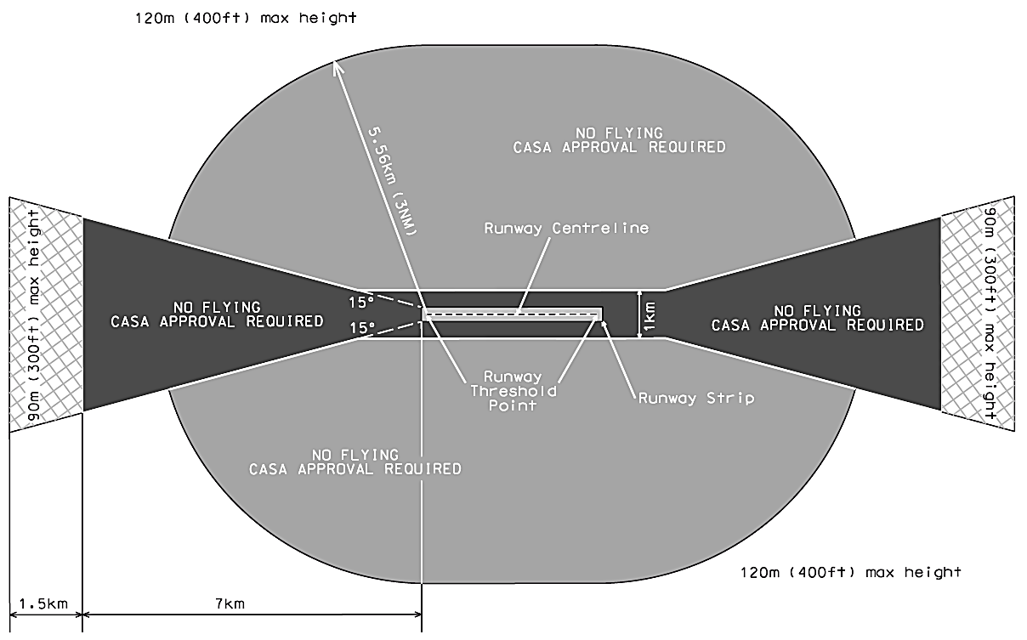Figure 4.05 (1)-1 Controlled aerodromes approach and departure paths (shows matters, but shape only illustrates matters)
[16] Section 4.05, Figure 4.05 (1)-3: Intersecting runways (illustrates matters), the caption
repeal and substitute
Figure 4.05 (1)-2: Intersecting runways (illustrates matters)
[17] Paragraph 5.11 (2) (c)
omit
of the movement area
insert
, in any direction, from the measurement point of any runway
[18] Section 9.01
omit
101.247 (1)
insert
101.066
[19] Section 9.02, paragraph (b) of definition of no-fly zone of an HLS
omit
diameter of 1.5 NM
insert
a radius of 0.75 NM
[20] Section 9.02, paragraph (a) of definition of no-fly zone of a non-controlled aerodrome
omit
of the movement area
insert
, in any direction, from the measurement point of any runway
[21] Section 9.02, paragraph (b) of definition of no-fly zone of a non-controlled aerodrome
omit
of the movement area
insert
, in any direction, from the measurement point of any runway
[22] Section 9.02, definition of no-fly zone of a non-controlled aerodrome
insert
Note If the runway is a grass landing strip, the threshold centrepoint of the runway is the point on the threshold of the runway at which the notional centreline of the runway would insect the threshold.
[23] Section 9.05, the heading
repeal and substitute
9.05 Approval to operate an RPA in a no-fly zone of a non-controlled aerodrome — tethered and indoors operations
[24] Subsection 9.05 (3)
repeal and substitute
(3) For a tethered operation in the no-fly zone of a non-controlled aerodrome, the certified RPA operator must:
(a) use a tether that is no longer than 150 ft; and
(b) ensure that the RPA is not operated higher than 150 ft above the aerodrome elevation; and
Note The aerodrome elevation can be determined from the aerodrome obstacle limitation data (OLS data).
(c) conduct the tethered operation in accordance with the operator’s documented practices and procedures for operations under this Division; and
(d) ensure that:
(i) the RPA is flown within the area that is shaded grey for the non-controlled aerodrome; or
(ii) if the RPA is flown within the area that is shaded black for the non-controlled aerodrome, the RPA is not flown within 3 NM from the measurement point of any runway of the non-controlled aerodrome.
[25] Section 9.06
repeal and substitute
9.06 Approach and departure paths — non-controlled aerodromes
(1) Figure 9.06 (1)-1 shows the approach and departure paths of a non-controlled certified aerodrome.
Note Figure 9.06 (1)-2 illustrates a cross-runways scenario to which the requirements in this Division apply in the same way as for a single runway. Application of the requirements does not affect the black-shaded areas but produces overlapping grey-shaded areas, and what would otherwise be a grey-shaded area becomes a black-shaded area because of the intersection of the runways.
(2) As shown in Figure 9.06 (1)-1, the approach and departure path is up to 400 ft, as follows:
(a) anywhere on or from the ground upwards in the area that is the runway or the runway strip;
(b) anywhere in the following areas which are the approach and departure paths for the non-controlled aerodrome:
(i) on or from the ground upwards in the area that is shaded black to a distance of 7 km from the end of the runway strip;
(ii) anywhere from 150 ft (45 m) above the ground (referenced to the aerodrome elevation) in the area that is shaded grey.
(3) The area that is shaded black, which shows the approach and departure paths and the ground below them, is described as comprising the following:
(a) a symmetrical trapezoids with the shorter side coincident with the ends of a nominal 100 m wide runway strip and extending out at an angle of 15 degrees on either side to a distance of 8.5 km;
(b) a rectangle extending 500 m on either side of the runway centreline and overlying the runway strip until it intersects the trapezoids of the approach and departure paths.
(4) The area that is shaded grey is an area that extends 3 NM in all directions from the measurement point.
[26] Section 9.06, Figure 9.06 (1)-1 and Figure 9.06 (1)-2
repeal and substitute
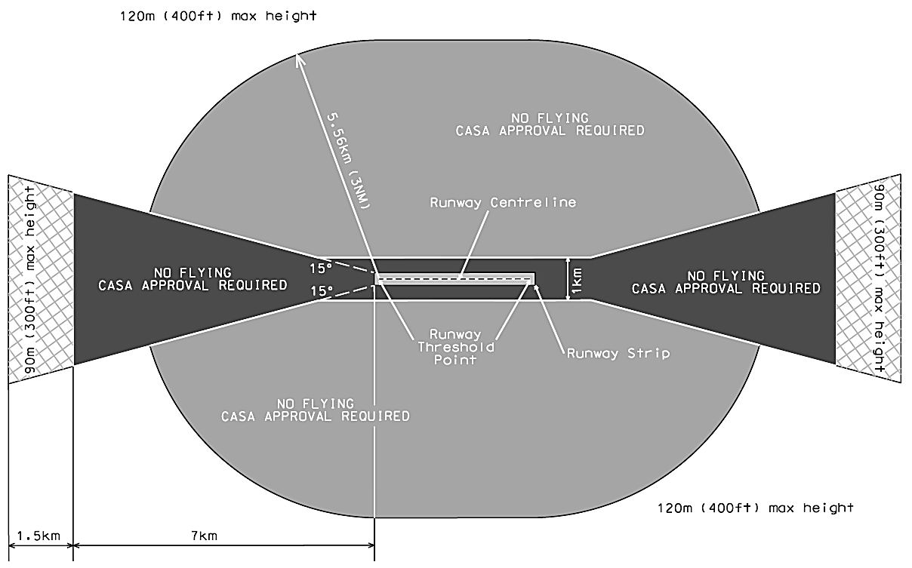
Figure 9.06 (1)-1 Non-controlled aerodromes approach and departure paths (shows matters, but shape only illustrates matters)
[27] Section 9.06, Figure 9.06 (1)-3: Intersecting runways (illustrates matters), the caption
repeal and substitute
Figure 9.06 (1)-2: Intersecting runways (illustrates matters)
[28] Chapter 10, the heading
repeal and substitute
CHAPTER 10 RECORD KEEPING FOR CERTAIN RPA AND MODEL AIRCRAFT
[29] After section 10.17
insert
10.18 Model aircraft — information required
(1) For paragraph 101.028 (b) of CASR, this section applies to a person who has registered a model aircraft.
(2) If:
(a) the person has used their myCASA account to give CASA any personal or commercial identification, or contact details, or any other information; and
(b) any of the details or information changes;
then the person must use their myCASA account to update the details or information not more than 21 days after the change.
(3) A person must, as soon as practicable, give CASA specified operational information about the registered model aircraft, if CASA:
(a) considers that the information is necessary for the purposes of aviation safety; and
(b) requests the information in writing; and
(c) explains in the request why the information is necessary for aviation safety.
[30] Chapter 11
repeal and substitute
CHAPTER 11 TEST FLIGHTS
Division 11.1 Circumstances in which an RPA or model aircraft may be operated for test flights without registration
11.01 Purpose
For subregulation 101.099B (1) of CASR, this Division prescribes the circumstances in which:
(a) an RPA or a model aircraft that is not required to be registered under Division 47.C.1 of CASR, and is not registered under Division 47.C.2, may be operated for the purposes of a test flight; and
Note 1 For operations, all RPA are required to be registered, generally under Division 47.C.2, unless specifically excluded by CASA (see subregulation 47.015 (1B)) or unless conducting a test flight in accordance with this Chapter.
Note 2 In general terms, from a prescribed date, a model aircraft must be registered under Division 47.C.2 of CASR unless it is a glider; or it has a gross weight of no more than 250 g; or (c) it has a gross weight of more than 250 g, but is operated only indoors and/or in a prescribed area (see subregulation 101.374B (3)) or unless conducting a test flight in accordance with this Chapter.
(b) an aircraft that is registered as a model aircraft under Division 47.C.2 (a relevant model aircraft) may be operated as an RPA for the purposes of a test flight.
11.02 Circumstances
(1) For paragraph 11.01 (1) (a), the circumstances are when the RPA or a model aircraft (the relevant aircraft) is operated for any of the following purposes, provided that the operation is relevant to the development, manufacture, repair or maintenance of the relevant aircraft or its aircraft system (the relevant system), or of equipment associated with the relevant aircraft or its aircraft system (relevant equipment):
(a) a test flight conducted by, or at the request of, the manufacturer developing the relevant aircraft, system or equipment, and for the purpose of such development;
(b) a test flight, following the manufacture of the relevant aircraft, system or equipment, that is conducted:
(i) by, or at the request of, the manufacturer of the relevant aircraft, system or equipment; and
(ii) before it is provided to the initial purchaser of the relevant aircraft, system or equipment;
(c) a test flight following the fitting of relevant equipment to a relevant aircraft or system, that is conducted by, or at the request of, the person who fitted the equipment;
(d) a test flight before or after repair or maintenance of the relevant aircraft, system or equipment, that is conducted by, or at the request of, the person who carried out, or will carry out, the maintenance or repair.
(2) For paragraph 11.01 (1) (b), the circumstances are when the relevant model aircraft is operated for any of the purposes mentioned in subsection (1).
Division 11.2 Requirements relating to the operation of an RPA or a model aircraft that is operated for test flights without registration
11.03 Purpose
For subregulation 101.099B (3) of CASR, this Division prescribes the requirements relating to the operation of an RPA or a model aircraft mentioned in subsection 11.01 (1) (a relevant aircraft) for the purposes of a test flight.
11.03 Requirements
(1) For section 11.03, the person who operates a relevant aircraft for a test flight (the relevant operator) must prepare a written record of the test flight (the record) that includes the following:
(a) the serial number of the relevant aircraft flown;
(b) the name, address and ARN (if any) of the owner of relevant aircraft;
(c) the time and date of the test flight;
(d) the location of the test flight;
(e) the reason for the test flight;
Note See section 11.02 for the permitted reasons.
(f) any accident, incident or malfunction that occurred during the test flight;
(g) the name of the relevant operator.
(2) The relevant operator must prepare the record as soon as possible after the test flight is completed, and must sign and date the record.
(3) The relevant operator, or the employer of the relevant operator (the keeper) must keep the record, securely and retrievably, for 3 years from the date of the test flight (a current record).
(4) The keeper must give to CASA, on written request, a complete and legible hard or soft copy of a current record.
(5) Neither the relevant operator nor the employer of the relevant operator may disclose a current record, or the information in a current record, to a person other than CASA unless:
(a) the disclosure has the consent of the owner of the relevant aircraft; or
(b) the disclosure is required by law.
[31] Item 3 of Unit 2 in Appendix 1 of Schedule 4
repeal and substitute
3 | NOTAMs  (a) obtaining NOTAMs for operational areas;  (b) decoding NOTAMs. | A
 | NOTAM publication  (c) Submitting a NOTAM for publication. | C
[32] Item 4 of Unit 2 in Appendix 1 of Schedule 4
repeal and substitute
4 | Form of the earth, aeronautical charts and maps  (a) features on an aeronautical chart (other than airspace);  (b) cardinal and ordinal points of the compass;  (c) latitude and longitude;  (d) depiction of height and elevation on charts;  (e) distance on the earth and in charts;  (f) magnetic variation;  (g) relationship between magnetic heading and magnetic bearing. | A
5 | Electronic flight bag  (a) electronic maps and charts;  (b) CASA verified drone safety app. | C
[33] Subparagraph (a) (i) in item 8 of Unit 6, Appendix 1 of Schedule 4
repeal and substitute
(i) the location at an aerodrome of each runway threshold, each runway threshold centrepoint, and the movement areas;
[34] The heading in column 1 of Item 1 of Unit 23 in Appendix 2 of Schedule 5
omit
Enter and recover from stall
insert
Enter and recover from stall (if applicable to the RPA)
[35] Paragraphs (b) and (c) in column 3 of Item 1 of Unit 23 in Appendix 2 of Schedule 5
repeal and substitute
(b) the RPA at high and low heights.
[36] Paragraphs (e) and (f) in column 1 of Item 1 of Unit 27 in Appendix 3 of Schedule 5
repeal and substitute
(e) perform an 8-point pirouette pausing at each point without GPS hold;
(f) perform a 360-degree level turn without GPS hold.
[37] Paragraphs (b) and (c) in column 3 of Item 1 of Unit 32 in Appendix 4 of Schedule 5
repeal and substitute
(b) the RPA at high and low heights.
[38] The heading in column 1 of Item 2 of Unit 34 in Appendix 5 of Schedule 5
omit
Launch and hover
insert
Launch and hover (if applicable to the RPA)
[39] Paragraph (b) in column 2 of Item 2 of Unit 34 in Appendix 5 of Schedule 5
omit
for at least 10 seconds,
[40] The heading in column 1 of Item 1 of Unit 37 in Appendix 5 of Schedule 5
omit
Enter and recover from stall in other than vertical flight
insert
Enter and recover from stall in other than vertical flight (if applicable to the RPA)
[41] Paragraphs (b) and (c) in column 3 of Item 4 of Unit 37 in Appendix 5 of Schedule 5
repeal and substitute
(b) the RPA at high and low heights.
[42] Item 1, Column 3, in section 3 of Appendix 1 of Schedule 6
omit
Complete a JSA
insert
1 Complete a JSA
[43] Item 1, Column 3, in section 3 of Appendix 1 of Schedule 6
omit
(a) assembly,
insert
2 The following:
(a) assembly,
[44] Item 1, Column 4, in section 3 of Appendix 1 of Schedule 6
omit
The JSA addresses
insert
- The JSA addresses
[45] Item 1, Column 4, in section 3 of Appendix 1 of Schedule 6
omit
(a) familiarisation
insert
- The following:
(a) familiarisation
[46] Item 2, Column 3, in section 3 of Appendix 1 of Schedule 6
omit
Electric-powered RPA
insert
1 Electric-powered RPA
[47] Item 2, Column 3, in section 3 of Appendix 1 of Schedule 6
omit
Very small or small RPA with liquid-fuel system
insert
2 Very small or small RPA with liquid-fuel system
[48] Item 2, Column 4, in section 3 of Appendix 1 of Schedule 6
omit
(a) the calculated RPA
insert
1 The following:
(a) the calculated RPA
[49] Item 2, Column 4, in section 3 of Appendix 1 of Schedule 6
omit
(a) the calculated RPA (second occurring)
insert
2 The following:
(a) the calculated RPA
[50] Item 7, Column 3, in section 3 of Appendix 1 of Schedule 6
omit
Complete standard
insert
1 Complete standard
[51] Item 7, Column 3, in section 3 of Appendix 1 of Schedule 6
omit
Complete steep
insert
2 Complete steep
[52] Item 7, Column 4, in section 3 of Appendix 1 of Schedule 6
omit
(a) turns should be (first occurring)
insert
1 The following:
(a) turns should be
[53] Item 7, Column 4, in section 3 of Appendix 1 of Schedule 6
omit
(a) turns should be (second occurring)
insert
2 The following:
(a) turns should be
[54] Item 9, Column 3, in section 3 of Appendix 1 of Schedule 6
omit
Inward and
insert
1 Inward and
[55] Item 9, Column 3, in section 3 of Appendix 1 of Schedule 6
omit
Demonstrate the
insert
2 Demonstrate the
[56] Item 9, Column 3, in section 3 of Appendix 1 of Schedule 6
omit
Simulate a
insert
3 Simulate a
[57] Item 9, Column 3, in section 3 of Appendix 1 of Schedule 6
omit
[The manoeuvre
insert
Note The manoeuvre
[58] Item 9, Column 3, in section 3 of Appendix 1 of Schedule 6
omit
if applicable.]
insert
if applicable.
[59] Item 9, Column 4, in section 3 of Appendix 1 of Schedule 6
omit
(a) accurate altitude
insert
1 The following:
(a) accurate altitude
[60] Item 9, Column 4, in section 3 of Appendix 1 of Schedule 6
omit
Familiar with
insert
2 Familiar with
[61] Item 9, Column 4, in section 3 of Appendix 1 of Schedule 6
omit
(a) maintain safe
insert
3 The following:
(a) maintain safe
[62] Item 10, Column 3, in section 3 of Appendix 1 of Schedule 6
omit
Glide approach/simulated “dead stick
insert
1 Glide approach/simulated “dead stick
[63] Item 10, Column 3, in section 3 of Appendix 1 of Schedule 6
omit
Demonstrate/simulate
insert
2 Demonstrate/simulate
[64] Item 10, Column 3, in section 3 of Appendix 1 of Schedule 6
omit
Recover from
insert
3 Recover from
[65] Item 10, Column 4, in section 3 of Appendix 1 of Schedule 6
omit
(a) uses elevators
insert
1 The following:
(a) uses elevators
[66] Item 10, Column 4, in section 3 of Appendix 1 of Schedule 6
omit
(a) familiar with
insert
2 The following:
(a) familiar with
[67] Item 10, Column 4, in section 3 of Appendix 1 of Schedule 6
omit
(a) correct recovery
insert
3 The following:
(a) correct recovery
[68] Item 1, Column 3, in section 3 of Appendix 2 of Schedule 6
omit
Complete a JSA
insert
1 Complete a JSA
[69] Item 1, Column 3, in section 3 of Appendix 2 of Schedule 6
omit
(a) assembly
insert
2 The following:
(a) assembly
[70] Item 1, Column 4, in section 3 of Appendix 2 of Schedule 6
omit
The JSA addresses
insert
1 The JSA addresses
[71] Item 1, Column 4, in section 3 of Appendix 2 of Schedule 6
omit
(a) familiar with
insert
2 The following:
(a) familiar with
[72] Item 2, Column 3, in section 3 of Appendix 2 of Schedule 6
omit
Electric -powered RPA
insert
1 Electric -powered RPA
[73] Item 2, Column 3, in section 3 of Appendix 2 of Schedule 6
omit
Very small or small RPA with liquid-fuel system
insert
2 Very small or small RPA with liquid-fuel system
[74] Item 2, Column 4, in section 3 of Appendix 2 of Schedule 6
omit
(a) the calculated RPA (first occurring)
insert
1 The following:
(a) the calculated RPA
[75] Item 2, Column 4, in section 3 of Appendix 2 of Schedule 6
omit
(a) the calculated RPA (second occurring)
insert
2 The following:
(a) the calculated RPA
[76] Item 7, Column 3, in section 3 of Appendix 2 of Schedule 6
omit
Without GPS hold
insert
1 Without GPS hold
[77] Item 7, Column 3, in section 3 of Appendix 2 of Schedule 6
omit
(a) lift-off to height of 5 m
insert
2 The following:
(a) lift-off to height of 5 m
[78] Item 7, Column 4, in section 3 of Appendix 2 of Schedule 6
omit
(a) controlled ascent (first occurring)
insert
1 The following:
(a) controlled ascent
[79] Item 7, Column 4, in section 3 of Appendix 2 of Schedule 6
omit
(a) controlled ascent (second occurring)
insert
2 The following:
(a) controlled ascent
[80] Item 8, Column 3, in section 3 of Appendix 2 of Schedule 6
omit
Figure of 8
insert
1 Figure of 8
[81] Item 8, Column 3, in section 3 of Appendix 2 of Schedule 6
omit
Vertical rectangle
insert
2 Vertical rectangle
[82] Item 8, Column 3, in section 3 of Appendix 2 of Schedule 6
omit
[First movement
insert
Note First movement
[83] Item 8, Column 3, in section 3 of Appendix 2 of Schedule 6
omit
marker cones.]
insert
marker cones.
[84] Item 8, Column 3, in section 3 of Appendix 2 of Schedule 6
omit
Simulate
insert
3 Simulate
[85] Item 8, Column 4, in section 3 of Appendix 2 of Schedule 6
omit
(a) turns should be
insert
1 The following:
(a) turns should be
[86] Item 8, Column 4, in section 3 of Appendix 2 of Schedule 6
omit
(a) smooth flying (second occurring)
insert
2 The following:
(a) smooth flying
[87] Item 8, Column 4, in section 3 of Appendix 2 of Schedule 6
omit
(a) maintains safe
insert
3 The following:
(a) maintains safe
[88] Item 9, Column 3, in section 3 of Appendix 2 of Schedule 6
omit
From normal
insert
1 From normal
[89] Item 9, Column 3, in section 3 of Appendix 2 of Schedule 6
omit
(a) simulated emergency
insert
2 The following:
(a) simulated emergency
[90] Item 9, Column 4, in section 3 of Appendix 2 of Schedule 6
omit
Applicant manoeuvres
insert
1 Applicant manoeuvres
[91] Item 9, Column 4, in section 3 of Appendix 2 of Schedule 6
omit
Applicant demonstrates
insert
2 Applicant demonstrates
[92] Item 1, Column 3, in section 3 of Appendix 3 of Schedule 6
omit
Complete a JSA
insert
1 Complete a JSA
[93] Item 1, Column 3, in section 3 of Appendix 3 of Schedule 6
omit
(a) assembly and
insert
2 The following:
(a) assembly and
[94] Item 1, Column 4, in section 3 of Appendix 3 of Schedule 6
omit
The JSA addresses
insert
1 The JSA addresses
[95] Item 1, Column 4, in section 3 of Appendix 3 of Schedule 6
omit
(a) familiar with
insert
2 The following:
(a) familiar with
[96] Item 2, Column 3, in section 3 of Appendix 3 of Schedule 6
omit
Electric-powered RPA
insert
1 Electric-powered RPA
[97] Item 2, Column 3, in section 3 of Appendix 3 of Schedule 6
omit
Very small or small RPA with liquid-fuel system
insert
2 Very small or small RPA with liquid-fuel system
[98] Item 2, Column 4, in section 3 of Appendix 3 of Schedule 6
omit
(a) the calculated RPA (first occurring)
insert
1 The following:
(a) the calculated RPA
[99] Item 2, Column 4, in section 3 of Appendix 3 of Schedule 6
omit
(a) the calculated RPA (second occurring)
insert
2 The following:
(a) the calculated RPA
[100] Item 8, Column 3, in section 3 of Appendix 3 of Schedule 6
omit
(a) lift-off (first occurring)
insert
1 The following:
(a) lift-off
[101] Item 8, Column 3, in section 3 of Appendix 3 of Schedule 6
omit
(a) lift-off (second occurring)
insert
2 The following:
(a) lift-off
[102] Item 8, Column 4, in section 3 of Appendix 3 of Schedule 6
omit
(a) controlled ascent (first occurring)
insert
1 The following:
(a) controlled ascent
[103] Item 8, Column 4, in section 3 of Appendix 3 of Schedule 6
omit
(a) controlled ascent (second occurring)
insert
2 The following:
(a) controlled ascent
[104] Item 9, Column 3, in section 3 of Appendix 3 of Schedule 6
omit
Figure of 8
insert
1 Figure of 8
[105] Item 9, Column 3, in section 3 of Appendix 3 of Schedule 6
omit
Vertical rectangle
insert
2 Vertical rectangle
[106] Item 9, Column 3, in section 3 of Appendix 3 of Schedule 6
omit
Simulate
insert
3 Simulate
[107] Item 9, Column 4, in section 3 of Appendix 3 of Schedule 6
omit
(a) turns should be
insert
1 The following:
(a) turns should be
[108] Item 9, Column 4, in section 3 of Appendix 3 of Schedule 6
omit
(a) smooth flying
insert
2 The following:
(a) smooth flying
[109] Item 9, Column 4, in section 3 of Appendix 3 of Schedule 6
omit
(a) maintains safe
insert
3 The following:
(a) maintains safe
[110] Item 10, Column 3, in section 3 of Appendix 3 of Schedule 6
omit
From normal
insert
1 From normal
[111] Item 10, Column 3, in section 3 of Appendix 3 of Schedule 6
omit
(a) simulated emergency
insert
2 The following:
(a) simulated emergency
[112] Item 10, Column 4, in section 3 of Appendix 3 of Schedule 6
omit
Applicant manoeuvres
insert
1 Applicant manoeuvres
[113] Item 10, Column 4, in section 3 of Appendix 3 of Schedule 6
omit
Applicant demonstrates
insert
2 Applicant demonstrates
[114] Item 1, Column 3, in section 3 of Appendix 4 of Schedule 6
omit
Complete a JSA
insert
1 Complete a JSA
[115] Item 1, Column 3, in section 3 of Appendix 4 of Schedule 6
omit
(a) assembly and
insert
2 The following:
(a) assembly and
[116] Item 1, Column 4, in section 3 of Appendix 4 of Schedule 6
omit
The JSA addresses
insert
1 The JSA addresses
[117] Item 1, Column 4, in section 3 of Appendix 4 of Schedule 6
omit
(a) familiar with
insert
2 The following:
(a) familiar with
[118] Item 2, Column 3, in section 3 of Appendix 4 of Schedule 6
omit
Electric-powered RPA
insert
1 Electric-powered RPA
[119] Item 2, Column 3, in section 3 of Appendix 4 of Schedule 6
omit
Very small or small RPA with liquid-fuel system
insert
2 Very small or small RPA with liquid-fuel system
[120] Item 2, Column 4, in section 3 of Appendix 4 of Schedule 6
omit
(a) the calculated RPA (first occurring)
insert
1 The following:
(a) the calculated RPA
[121] Item 2, Column 4, in section 3 of Appendix 4 of Schedule 6
omit
(a) the calculated RPA (second occurring)
insert
2 The following:
(a) the calculated RPA
[122] Item 6, Column 3, in section 3 of Appendix 4 of Schedule 6
omit
(a) start
insert
1 The following:
(a) start
[123] Item 6, Column 3, in section 3 of Appendix 4 of Schedule 6
omit
Without GPS hold
insert
2 Without GPS hold
[124] Item 6, Column 4, in section 3 of Appendix 4 of Schedule 6
omit
(a) controlled ascent (first occurring)
insert
1 The following:
(a) controlled ascent
[125] Item 6, Column 4, in section 3 of Appendix 4 of Schedule 6
omit
(a) controlled ascent (second occurring)
insert
2 The following:
(a) controlled ascent
[126] Item 7, Column 3, in section 3 of Appendix 4 of Schedule 6
omit
Manual transitional
insert
1 Manual transitional
[127] Item 7, Column 3, in section 3 of Appendix 4 of Schedule 6
omit
Automated transitional flight
insert
2 Automated transitional flight
[128] Item 7, Column 4, in section 3 of Appendix 4 of Schedule 6
omit
(a) the RPA remains (first occurring)
insert
1 The following:
(a) the RPA remains
[129] Item 7, Column 4, in section 3 of Appendix 4 of Schedule 6
omit
(a) the RPA remains (second occurring)
insert
2 The following:
(a) the RPA remains
[130] Item 8, Column 3, in section 3 of Appendix 4 of Schedule 6
omit
Climb the aircraft
insert
1 Climb the aircraft
[131] Item 8, Column 3, in section 3 of Appendix 4 of Schedule 6
omit
Complete standard
insert
2 Complete standard
[132] Item 8, Column 3, in section 3 of Appendix 4 of Schedule 6
omit
Complete steep turns
insert
3 Complete steep turns
[133] Item 8, Column 4, in section 3 of Appendix 4 of Schedule 6
omit
(a) maintains correct
insert
1 The following:
(a) maintains correct
[134] Item 8, Column 4, in section 3 of Appendix 4 of Schedule 6
omit
(a) turns should be (first occurring)
insert
2 The following:
(a) turns should be
[135] Item 8, Column 4, in section 3 of Appendix 4 of Schedule 6
omit
(a) turns should be (second occurring)
insert
3 The following:
(a) turns should be
[136] Item 9, Column 3, in section 3 of Appendix 4 of Schedule 6
omit
Inward and outward
insert
1 Inward and outward
[137] Item 9, Column 3, in section 3 of Appendix 4 of Schedule 6
omit
Demonstrate
insert
2 Demonstrate
[138] Item 9, Column 3, in section 3 of Appendix 4 of Schedule 6
omit
Simulate
insert
3 Simulate
[139] Item 9, Column 4, in section 3 of Appendix 4 of Schedule 6
omit
(a) accurate altitude
insert
1 The following:
(a) accurate altitude
[140] Item 9, Column 4, in section 3 of Appendix 4 of Schedule 6
omit
Familiar with
insert
2 Familiar with
[141] Item 9, Column 4, in section 3 of Appendix 4 of Schedule 6
omit
(a) maintains safe
insert
3 The following:
(a) maintains safe
[142] Item 10, Column 3, in section 3 of Appendix 4 of Schedule 6
omit
Demonstrate/simulate
insert
1 Demonstrate/simulate
[143] Item 10, Column 3, in section 3 of Appendix 4 of Schedule 6
omit
Recover from
insert
2 Recover from
[144] Item 10, Column 3, in section 3 of Appendix 4 of Schedule 6
omit
(a) recover the RPA
insert
3 The following:
(a) recover the RPA
[145] Item 10, Column 3, in section 3 of Appendix 4 of Schedule 6
omit
Glide approach/simulated
insert
4 Glide approach/simulated
[146] Item 10, Column 4, in section 3 of Appendix 4 of Schedule 6
omit
(a) familiar with
insert
1 The following:
(a) familiar with
[147] Item 10, Column 4, in section 3 of Appendix 4 of Schedule 6
omit
(a) correct recovery
insert
2 The following:
(a) correct recovery
[148] Item 10, Column 4, in section 3 of Appendix 4 of Schedule 6
omit
(a) implements recovery
insert
3 The following:
(a) implements recovery
[149] Item 10, Column 4, in section 3 of Appendix 4 of Schedule 6
omit
(a) uses elevators
insert
4 The following:
(a) uses elevators

