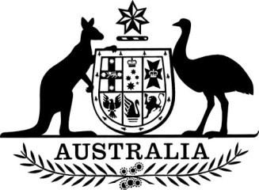

**Carbon Credits (Carbon Farming Initiative—Commercial and Public Lighting—Revocation) Instrument 2022**

I, Angus Taylor, Minister for Industry, Energy and Emissions Reduction, make the following legislative instrument.

Dated: 4 April 2022

Angus Taylor

Minister for Industry, Energy and Emissions Reduction

Contents

1  Name........................................................................................................................................ 3

2  Commencement........................................................................................................................ 3

3  Authority.................................................................................................................................. 3

4  Interpretation............................................................................................................................ 3

5  Revocation of methodology determination............................................................................... 3

**1  Name**

This is the *Carbon Credits (Carbon Farming Initiative—Commercial and Public Lighting—Revocation) Instrument 2022*.

**2  Commencement**

This instrument commences on the day after it is registered.

**3  Authority**

This instrument is made under subsection 123(1) of the *Carbon Credits (Carbon Farming Initiative) Act 2011*.

**4  Interpretation**

 In this instrument:

***Act***means the *Carbon Credits (Carbon Farming Initiative) Act 2011*.

**5  Revocation of methodology determination**

The *Carbon Credits (Carbon Farming Initiative—Commercial and Public Lighting) Methodology Determination 2015* made under subsection 106(1) of the Act is revoked.