I, PHILIPPA JILLIAN SPENCE, Director of Aviation Safety, on behalf of CASA, make this instrument under regulation 101.028 of the Civil Aviation Safety Regulations 1998.
[Signed P. Spence]
Pip Spence
Director of Aviation Safety
25 May 2022
Part 101 Manual of Standards (Modified Licensing Standards for Advancing RPA Technology, and Other Matters) Amendment Instrument 2022 (No. 1)
1 Name of instrument
This instrument is the Part 101 Manual of Standards (Modified Licensing Standards for Advancing RPA Technology, and Other Matters) Amendment Instrument 2022 (No. 1).
2 Commencement
This instrument commences on the day after it is registered.
3 Amendment of the Part 101 Manual of Standards
Schedule 1 amends the Part 101 (Unmanned Aircraft and Rockets) Manual of Standards 2019.
Schedule 1 Amendments
[1] Paragraph 1.06 (2) (a)
repeal and substitute
(a) the Civil Aviation Act 1988 or the regulations; or
[2] Paragraph 2.05 (4) (a)
omit
provided for in section 2.21, 2.23 or 2.25;
insert
provided for in section 2.22, 2.23, 2.24 or 2.25;
[3] Paragraph 2.05 (7) (b)
omit
more than 5 years
insert
not more than 5 years
[4] Paragraph 2.06 (6) (a)
omit
provided for in section 2.21, 2.23 or 2.25;
insert
provided for in section 2.22, 2.23, 2.24 or 2.25;
[5] Division 2.2, after section 2.06
insert
2.06A Alternative practical competency standards for advancing technology in medium and large RPA only
(1) Despite section 2.06, a practical training course for a particular medium RPA or large RPA may be comprised of some or all of the following (the relevant practical competency units and standards):
(a) part only of the units of practical competency that would, but for this subsection, be required under subsection 2.06 (6) to be completed for the RPA;
(b) all or part of another set of units of practical competency, being units that would, but for this subsection, otherwise not be required to be completed;
(c) alterative practical competency standards, behaviours, and flight test standards, including where appropriate, tolerances and variables, approved by CASA that are specifically devised and applicable in relation to a particular type or kind of medium RPA or large RPA.
(2) However, subsection (1) does not apply unless, for the relevant practical competency units and standards, CASA approves that their completion:
(a) is necessary for establishing the competency of a person to hold a RePL for the RPA because unique, unusual, or other characteristics in the system design or other features of the RPA (the innovative RPA system design) make completion of the units of practical competency otherwise prescribed for the RPA under subsection 2.06 (6) impossible or impracticable to meet; and
(b) will enable the person to achieve an acceptable level of competency for the operation of the RPA; and
(c) will not have any adverse effects on aviation safety.
(3) CASA may grant an approval under subsection (2):
(a) on written application by an approved RePL training organisation that:
(i) conducts a RePL training course; and
(ii) provides CASA with a detailed safety case; or
Note A safety case should include a description of the unique, unusual, or other characteristics in the system design or other features of the RPA which make completion of the units of practical competency otherwise prescribed for the RPA under subsection 2.06 (6) impossible or impracticable to meet. It should also describe any alternative practical competency standards, flight test standards , tolerances, or variables that the training organisation considers would substitute or compensate for the practical competency standards, flight test standards, tolerances, or variables prescribed in the MOS that cannot be met.
(b) on CASA’s own initiative.
Note For these CASA approvals, see Division 2.04A.
[6] Subsection 2.18 (2)
omit
To complete the RePL
insert
Subject to sections 2.18A and 2.19AB, to complete the RePL
[7] Division 2.4, after section 2.18
insert
2.18A Assessment of alternative practical competency standards for advancing technology in medium and large RPA
(1) Despite section 2.18, to complete the RePL training course component for the operation of an RPA to which section 2.06A applies, the applicant must be assessed as competent in the relevant practical competency units and standards.
(2) The assessment must be as follows:
(a) for the relevant RPA category (including with or without a liquid-fuel system, as the case requires);
(b) conducted:
(i) for the automated operation mode; or
(ii) for both the automated operation mode and the manual mode;
as the case requires for the RePL that the applicant is applying for (the relevant RePL).
(3) To be assessed as competent, the applicant must:
(a) demonstrate to a RePL training instructor all of the behaviours for the relevant practical competency units and standards, unless CASA approves in writing that the innovative RPA system design makes demonstration for a particular item impossible or impracticable; and
(b) satisfy the RePL training instructor that each of the behaviours referred to in paragraph (a) has been demonstrated within the relevant tolerances, and across the range of variables (if any), mentioned for the item, unless CASA approves in writing that the innovative RPA system design makes demonstration for a particular tolerance or variable impossible or impracticable; and
(c) having satisfied the requirements of paragraphs (a) and (b), pass a RePL training course flight test in the relevant RPA, conducted, in accordance with the documented practices and procedures of the RePL training organisation, by an examiner.
(4) For subsection (3), a behaviour must be demonstrated:
(a) for the relevant RPA category and the relevant RePL; and
(b) across as many of the range of variables as the operating conditions and innovative RPA system design reasonably permit.
(5) If a variable was not selected for demonstration because operating conditions made it impossible in practice to demonstrate the variable, the RePL training instructor must:
(a) require the applicant to provide:
(i) a satisfactory computerised simulation of the flight characteristics of the RPA under the variable, using a computerised simulation system that meets the standards and requirements set out in the operator’s documented practices and procedures; or
(ii) a detailed oral explanation of the variable, accompanied by indicative manual use of the RPA’s functional elements, or a description of such use; and
(b) certify in writing to the RePL training organisation, in accordance with the organisation’s documented practices and procedures, that:
(i) operating conditions made it impossible in practice to demonstrate the variable; and
(ii) for reasons stated in the certification, it would be unreasonable to require that the variable be demonstrated on another occasion.
(6) For paragraph (3) (b), a behaviour demonstrated outside a relevant tolerance may be considered to have been demonstrated within the tolerance if the RePL training instructor:
(a) is satisfied that:
(i) the only reason for failure to demonstrate the behaviour is the unavoidable impact of the relevant operating conditions; and
(ii) in the circumstances, the behaviour that was demonstrated was not so far outside the tolerance as to indicate a lack of competence in the relevant operating conditions; and
(b) certifies to the RePL training organisation, in accordance with the organisation’s documented practices and procedures, that paragraph (a) was the case.
(7) The training course flight test for the relevant RPA mentioned in paragraph (3) (c) must be in accordance with some or all of the relevant flight test standards in Schedule 6 as CASA approves in writing, and any other relevant standards that CASA specifically approves for a particular type or kind of medium RPA or large RPA.

CHAPTER 2 RePL TRAINING COURSE
Division 2.4A Approvals for alternative practical competency standards and assessments — innovative RPA system designs for medium and large RPA
2.18B Approvals for innovative RPA system designs for medium and large RPA
(1) A CASA approval under subsection 2.06A (2) (including subsection 2.06A (2) as applied by section 2.19AB) must be in writing, and must identify the relevant practical competency units and standards that must be completed.
(2) An approval under paragraph 2.18A (3) (a) or (b) (including paragraph 2.18A (3) (a) or (b) as applied by section 2.19AB) must identify (as the case requires):
(a) each item of the relevant practical competency units that it is impossible or impracticable to demonstrate; and
(b) each tolerance or variable that it is impossible or impractical to demonstrate.
(3) An approval under subsection 2.18A (7) must identify any relevant flight test standards that it is impossible or impracticable to meet.
(4) An approval mentioned in this section may be expressed to apply in relation to a RePL training organisation, in respect of a particular RePL applicant, or a class of such applicants, for the medium RPA or large RPA for the operation of which the relevant applicant proposes to seek a RePL.
(5) Each approval mentioned in this section that is for a particular RePL training organisation, must:
(a) be contained in a single instrument for the organisation; and
(b) may only be granted if CASA considers that it will preserve an acceptable level of aviation safety.
Note A CASA decision to grant or refuse to grant an approval is subject to judicial review under the Administrative Decisions (Judicial Review) Act 1977. A decision to refuse to grant an approval is subject to merits review by the Administrative Appeals Tribunal under section 31 of the Civil Aviation Act 1988.
[8] After section 2.19AA
insert
2.19AB Approvals for upgrades for medium and large RPA with innovative RPA system designs
(1) Despite sections 2.22, 2.23, 2.24 and 2.25, section 2.06A applies, with appropriate changes, to a practical training course for an upgrade to a particular medium RPA or large RPA, in accordance with subsection (2).
(2) In paragraphs 2.06A (1) (a) and (2) (a), for the mention of “subsection 2.06 (6)”, read “Division 2.5”.
(3) Despite section 2.18, section 2.18A applies, with appropriate changes, to a practical training course for an upgrade to a particular medium RPA or large RPA in accordance with subsection (4).
(4) In subsection 2.18A (1), for each mention of “section 2.06A”, read “section 2.22, 2.23, 2.24 or 2.25, as affected by the application of section 2.06A,”.
Note The expression “with appropriate changes” is used as a plain English translation for the application of the legal interpretation concept embodied in the former legal phrase “mutatis mutandis”.
[9] Subparagraph 2.21 (2) (c) (ii)
omit
more than 5 years
insert
not more than 5 years
[10] Subsection 2.21 (4), including the Note
repeal and substitute
(4) For subsection (2), the examination must comply with the requirements set out in the operator’s documented practices and procedures dealing with the following for the examination:
(a) the content, including the variation and security of relevant questions;
(b) the pass mark, including procedures for knowledge deficiency reporting and re-examination;
(c) notifications and certifications for applicants, and record keeping.
Note Examinations may be oral or written but must be supported by appropriate records in accordance with the operator’s documented practices and procedures.
[11] Subparagraph 2.21 (5) (c) (ii)
omit
more than 5 years
insert
not more than 5 years
[12] Subsection 2.22 (2)
omit
Without affecting subsection (3), if
insert
If
[13] Subsections 2.22 (3) and (4)
repeal and substitute
(3) Without affecting subsection (2), the aeronautical knowledge and practical competency components of the RePL training course (including examination and assessment) must comply with the requirements in subsections 2.21 (2) to (7) as if they applied for the relevant RPA.
[14] Subparagraph 2.23 (2) (c) (ii)
omit
more than 5 years
insert
not more than 5 years
[15] Subparagraph 2.23 (5) (c) (ii)
omit
more than 5 years
insert
not more than 5 years
[16] Subsection 2.24 (2)
omit
Without affecting subsection (3), if
insert
If
[17] Subsections 2.24 (3) and (4)
repeal and substitute
(3) Without affecting subsection (2), the aeronautical knowledge and practical competency components of the RePL training course (including examination and assessment) must comply with the requirements in subsections 2.25 (2) to (7) as if they applied for the relevant RPA.
[18] Subparagraph 2.25 (2) (c) (ii)
omit
more than 5 years
insert
not more than 5 years
[19] Subparagraph 2.25 (5) (c) (ii)
omit
more than 5 years
insert
not more than 5 years
[20] Subsection 2.31 (2)
omit
The competency standards
insert
Subject to any variation expressly permitted by this section, the competency standards
[21] After subsection 2.31 (2)
insert
(2A) If the RePL mentioned in subsection (2) is the subject of a CASA approval under subsection 2.18B (3), the competency standards for the flight test may be those in the relevant Appendix as varied by the CASA approval made under subsection 2.18B (3) which identifies:
(a) any relevant flight test standards in the relevant Appendix that it is impossible or impracticable for the relevant medium RPA or large RPA to meet; and
(b) the flight test standards specified by CASA that are to be met.
[22] After subsection 2.31 (3)
insert
(3A) Subsection (3) applies subject to the effect of any CASA approval under subsection (2A).
[23] After subsection 2.31 (6)
insert
(6A) Subsection (6) applies subject to the effect of any CASA approval under subsection (2A).
[24] Paragraph 2.31 (7) (b)
omit
subsection (6).
insert
subsection (6), or subsection (6) as affected by the effect of any CASA approval under subsection (2A).
[25] Paragraph 2.31 (8) (e)
omit
clause 3 of the relevant Appendix,
insert
clause 3 of the relevant Appendix, or that clause 3 as affected by the effect of any CASA approval under subsection (2A),
[26] Subsection 2.31 (10)
omit
the practical competencies mentioned in subsection 2.18 (2)
insert
the practical competencies mentioned in subsection 2.18 (2), or that subsection as affected by the effect of any CASA approval under subsection (2A),
[27] Section 9.06, Figure 9.06 (1)-1, including the caption
repeal and substitute
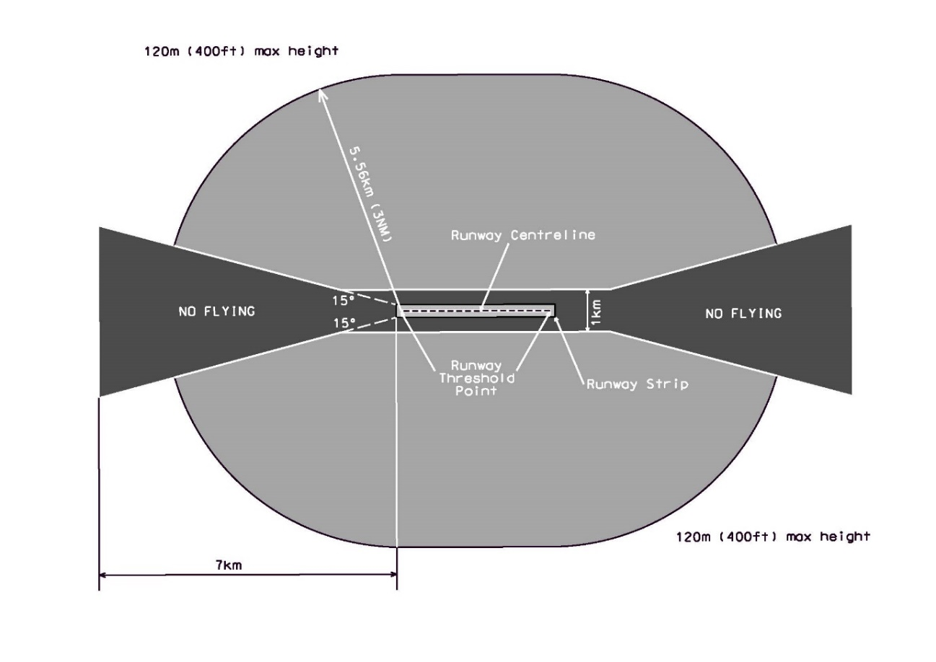
Figure 9.06 (1)-1 Non-controlled aerodromes approach and departure paths (shows matters, but shape only illustrates matters)
[28] Section 11.03, second occurring, the heading
repeal and substitute
11.04 Requirements

