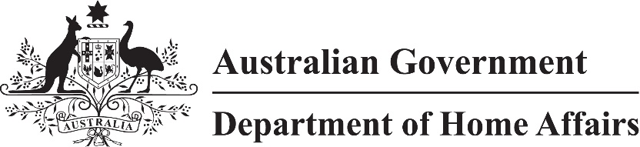

LIN 22/060

Migration (Arrangements for Refugee and Humanitarian (Class XB) visas) Amendment Instrument (LIN 22/060) 2022

I, Andrew Kiley, delegate of the Minister, make this instrument under subregulation 2.07(5) of the *Migration Regulations 1994* (the Regulations)*.*

Dated 6 June 2022

Andrew Kiley

Senior Executive Service Band One  
Refugee, Humanitarian and Settlement Division  
Department of Home Affairs

1 Name

This instrument is the Migration (Arrangements for Refugee and Humanitarian (Class XB) visas) Amendment Instrument (*LIN 22/060*) 2022.

2 Commencement

This instrument commences on 10 June 2022.

3 Amendments to LIN 20/169

Schedule 1 amends *Migration (Arrangements for Protection, Refugee and Humanitarian Visas) Instrument (LIN 20/169) 2020*.

Schedule 1 Amendment

(section 3)

[1] Section 8, table, item 1, column 3, paragraph (b)

omit