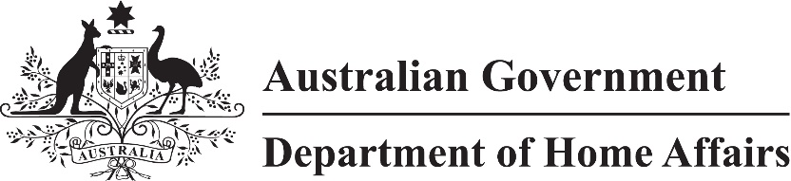
LIN 22/051
Migration (Arrangements for subclass 417 visa applications) Instrument (LIN 22/051) 2022
I, Paul Denman, delegate of the Minister, make this instrument under subregulation 2.07(5) of the Migration Regulations 1994 (the Regulations).
Dated 23 June 2022
Paul Denman
Acting Senior Executive Service Band One
Immigration Programs Division
Department of Home Affairs

1 Name
This instrument is the Migration (Arrangements for subclass 417 visa applications) Instrument (LIN 22/051) 2022.

2 Commencement
This instrument commences on 1 July 2022.

3 Definitions
In this instrument:
ImmiAccount means the interactive portal for online services available through the Department’s website at https://immi.homeaffairs.gov.au.
written notice means an email from the Department authorising an applicant for a Working Holiday (Subclass 417) visa to submit Form 1150 to WHM.invited.applications@homeaffairs.gov.au.

4 Repeal
Migration (LIN 19/183: Arrangements for Working Holiday Visa Applications) Instrument 2019 (F2019L00903) is repealed.

5 Form, place and manner of making application
(1) For subitem 1225(3) of Schedule 1 to the Regulations, an applicant:
(a) must hold a passport that:
(i) is issued by a country or region mentioned in an item of Schedule 1; and
(ii) satisfies the conditions mentioned in the item; or
(b) must:
(i) be in Australia; and
(ii) have held a passport that:
(A) was issued by a country or region mentioned in an item of Schedule 1, when the applicant entered Australia; and
(B) satisfied the conditions mentioned in the item, when the applicant entered Australia; and
(C) expired after the applicant entered Australia.
Note See Regulations, Schedule 2, paragraph 417.211(1A)(a).
(2) For subitems 1225(1) and (3) of Schedule 1 to the Regulations, an application for a Working Holiday (Subclass 417) visa must be made using Form 1150 (Internet) in ImmiAccount as an Internet application.
Note Regulation 2.10C of the Regulations provides for the time of making an Internet application.
(3) However, if the application cannot be made in accordance with subsection (2), it may be made using Form 1150 by email to WHM.invited.applications@
homeaffairs.gov.au if:
(a) the Department has given a written notice to the applicant authorising the applicant to make the visa application using Form 1150; and
(b) the written notice is attached to the application; and
(c) the application is submitted within 7 calendar days after which the written notice was sent (AEST or AEDST as applicable to the date on which the written notice was sent).

6 Working holiday eligible passport and younger age
(1) For paragraph 417.211(2)(a) of Schedule 2 to the Regulations, a working holiday eligible passport must be:
(a) a valid passport; and
(b) held by an applicant mentioned in subsection 5(1).
Note A passport is not a working holiday eligible passport if it is not issued by a country or region mentioned in an item of Schedule 1.
(3) For subparagraph 417.211(2)(b)(ii) of Schedule 2 to the Regulations, a younger age mentioned in an item of Schedule 1 is specified for a working holiday eligible passport issued by the country or region mentioned in the item.

Schedule 1 Country or region, conditions and younger age
(section 6)
Item | Country or region | Conditions | Younger age
1 | Belgium | Passport must indicate that the applicant is a national of Belgium. | 30
2 | Canada | Passport must indicate that the applicant is a national of Canada. | –
3 | Cyprus | Passport must indicate that the applicant is a national of Cyprus. | 30
4 | Denmark | Passport must indicate that the applicant is a national of Denmark. | –
5 | Estonia | Passport must indicate that the applicant is a national of Estonia. | 30
6 | Finland | Passport must indicate that the applicant is a national of Finland. | 30
7 | France | Passport must indicate that the applicant is a national of France. | –
8 | Germany | Passport must indicate that the applicant is a national of Germany. | 30
9 | Hong Kong Special Administrative Region of the People’s Republic of China | – | 30
10 | Ireland | Passport must indicate that the applicant is a national of Ireland. | –
11 | Italy | Passport must indicate that the applicant is a national of Italy. | –
12 | Japan | Passport must indicate that the applicant is a national of Japan. | 30
13 | Malta | Passport must indicate that the applicant is a national of Malta. | 30
14 | Netherlands | Passport must indicate that the applicant is a national of the Netherlands. | 30
15 | Norway | Passport must indicate that the applicant is a national of Norway. | 30
16 | Republic of Korea | Passport must indicate that the applicant is a national of the Republic of Korea. | 30
17 | Sweden | Passport must indicate that the applicant is a national of Sweden. | 30
18 | Taiwan | Passport must not purport to be an official or diplomatic passport. | 30
19 | United Kingdom | Passport must indicate that the applicant’s nationality is British Citizen or British National (Overseas). | 30

