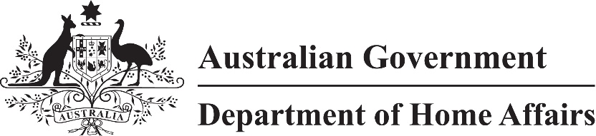
LIN 22/065
Migration (Required medical assessments) Amendment Instrument (LIN 22/065) 2022
I, Dr Gideon Gouws, Chief Medical Officer and delegate of the Minister, make this instrument under paragraphs 4005(1)(aa) and 4007(1)(aa) of Schedule 4 to the Migration Regulations 1994 (the Regulations).
Dated 23 June 2022
Gideon Gouws
Chief Medical Officer
Department of Home Affairs

1 Name
This instrument is the Migration (Required medical assessments) Amendment Instrument (LIN 22/065) 2022.

2 Commencement
This instrument commences on 1 July 2022.

3 Amendment
Schedule 1 amends REQUIRED MEDICAL ASSESSMENT (F2015L01826).

Schedule 1 Amendment
(s.3)
[1] Paragraph 2(d)
omit
C, D and E
insert
C and D
[2] After paragraph 2(e)
insert
f. for paragraph 4006A(1)(aa) of Schedule 4 to the Regulations, the additional medical assessments mentioned in column E of Schedule 2 apply to the class of persons mentioned in paragraph 2(c); and
g. for paragraphs 4005(1)(aa) and 4007(1)(aa) of Schedule 4 to the Regulations, the additional medical assessments mentioned in Schedule 3 apply to the class of persons mentioned in paragraph 2(c); and
[3] Schedule 2
omit each occurrence of
Column E of this Table
insert
column E of this table or Schedule 3
[4] Schedule 2, column E, heading
substitute
Column E
Additional medical assessments for paragraph 4006A(1)(aa)
[5] After Schedule 2
insert
Schedule 3 Additional medical assessments for paragraphs 4005(1)(aa) and 4007(1)(aa)
(paragraph 2(g))

Item | Additional medical assessments for paragraphs 4005(1)(aa) and 4007(1)(aa)
1 | For an applicant who intends to work as, or study or train to be, a doctor, dentist, nurse or paramedic:  (a) if the applicant is not an applicant mentioned in paragraph (b):  (i) medical examination; and  (ii) chest X-ray; and  (iii) HIV test; and  (iv) Hepatitis B test; and  (v) Hepatitis C test; and  (vi) latent tuberculosis screening; or  (b) if the applicant has applied for a Visitor (Subclass 600) visa for temporary stay in Australia of not more than 6 months:  (i) medical examination; and  (ii) chest X-ray; and  (iii) HIV test; and  (iv) Hepatitis B test; and  (v) Hepatitis C test
2 | For an applicant who intends to work as, or study or train to be, a health care worker, or to work within a health care, aged care or disability care facility, in a health care profession not mentioned in item 1:  (a) if the applicant is not an applicant mentioned in paragraph (b):  (i) medical examination; and  (ii) chest X-ray; and  (iii) latent tuberculosis screening; or  (b) if the applicant has applied for a Visitor (Subclass 600) visa for temporary stay in Australia of not more than 6 months:  (i) medical examination; and  (ii) chest X-ray
3 | For an applicant who is likely to work or be a trainee at an Australian childcare centre (including preschool and crèche):  (i) medical examination; and  (ii) chest X-ray
4 | For an applicant who is likely to enter a health care or hospital environment:  (i) medical examination; and  (ii) chest X-ray
5 | For an applicant who is pregnant and intending to have the baby in Australia—Hepatitis B test
6 | For an applicant who is at least 75 years old, and applying for a Visitor (Subclass 600) visa or a Tourist (Subclass 676) visa—medical examination

