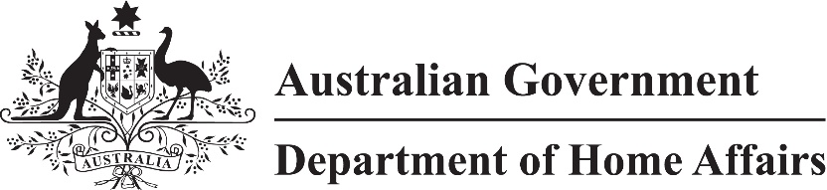

LIN 22/052

Migration (Arrangements for subclass 462 visa applications) Amendment Instrument (LIN 22/052) 2022

I, Paul Denman, delegate of the Minister, make this instrument under subregulation 2.07(5) of the *Migration Regulations 1994* (the Regulations)*.*

Dated 23 June 2022

Paul Denman

Acting Senior Executive Band 1

Immigration Programs Division

Department of Home Affairs

1 Name

This instrument is the *Migration (Arrangements for subclass 462 visa applications) Amendment Instrument (LIN 22/052) 2022.*

2 Commencement

This instrument commences on 1 July 2022.

3 Amendment

Schedule 1 amends *Migration (Arrangements for Work and Holiday (Subclass 462) Visa Applications) Instrument (LIN 21/019) 2021* (F2021L00152).

Schedule 1 Amendment

(section 3)

[1] Section 3, definition of *written notice*

substitute

***written notice*** means an email from the Department authorising an applicant for a Work and Holiday (Subclass 462) visa to submit Form 1208 to WHM.invited.applications@homeaffairs.gov.au.

[2] Subsection 4(2), table, after Austria

insert

| Foreign country |
| --- |
| Brazil |

[3] Subsection 4(2), table, after Malaysia

insert

| Foreign country |
| --- |
| Mongolia |

[4] Subsection 4(3), table, after Austria

insert

| Foreign country |
| --- |
| Brazil |

[5] Schedule 1, table

substitute

| Item | Applicant | Approved form | Place and manner |
| --- | --- | --- | --- |
| 1 | Applicant who:  (a) is, or has previously been, in Australia as the holder of a Work and Holiday (Temporary) (Class US) visa; and  (b) holds a valid passport issued by a foreign country mentioned in paragraph 4(2)(a) | (a) Form 1208 (Internet); or  (b) if the applicant has received a written notice—Form 1208 | (a) internet application; or  (b) for applicants who have received a written notice, by:  (i) attaching a copy of the written notice to Form 1208; and  (ii) submitting the application and written notice to WHM.invited.applications@homeaffairs.gov.au within 7 calendar days after the written notice was sent |
| 2 | Applicant who:  (a) is not, and has not previously been, in Australia as the holder of a Work and Holiday (Temporary) (Class US) visa; and  (b) holds a valid passport issued by a foreign country mentioned in paragraph 4(2)(a) other than a valid passport issued by the People’s Republic of China |
| 3 | Applicant who:  (a) is not, and has not previously been, in Australia as the holder of a Work and Holiday (Temporary) (Class US) visa; and  (b) holds a valid passport issued by the People’s Republic of China; and  (c) has received a written invitation from the Department inviting the applicant to apply for a Work and Holiday (Temporary) (Class US) visa | (a) Form 1208 (Internet); or  (b) if the applicant has received a written notice —Form 1208 | (a) internet application; or  (b) for applicants who have received a written notice, by:  (i) attaching a copy of the written notice to Form 1208; and  (ii) submitting the application and written notice to WHM.invited.applications@homeaffairs.gov.au within 7 calendar days after the written notice was sent |

[6] Schedule 2, after item 2

insert

| Item | Applicant | Educational qualifications |
| --- | --- | --- |
| 2A | Brazil | (a) successful completion of at least 2 years of post-secondary study |

[7] Schedule 2, after item 12

insert

| Item | Applicant | Educational qualifications |
| --- | --- | --- |
| 12A | Mongolia | (a) tertiary qualifications; or  (b) successful completion of at least 2 years of undergraduate university study |