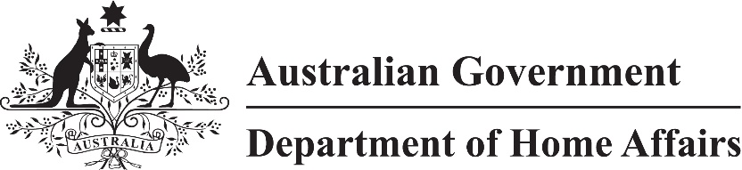

LIN 22/062

Migration (Arrangements for New Zealand Citizen (Family Relationship) visa applications) Amendment Instrument (LIN 22/062) 2022

I, Jodie Bjerregaard, delegate of the Minister, make this instrument under subregulation 2.07(5) of the *Migration Regulations 1994* (the Regulations)*.*

Dated 23 June 2022

Jodie Bjerregaard

Senior Executive Service Band One

Immigration Programs Division

Department of Home Affairs

Name

This instrument is the *Migration (Arrangements for New Zealand Citizen (Family Relationship) visa applications) Amendment Instrument (LIN 22/062) 2022.*

Commencement

This instrument commences on 1 July 2022.

3 Amendment

Schedule 1 amends *Migration (IMMI 18/076: Arrangements for Other Family Visa Applications and New Zealand (Family Relationship) Visa Applications) Instrument 2018* (F2018L00772).

Schedule Amendment

(section 3)

[1] Schedule 3, table

substitute

|  | COLUMN A  Item and Visa | COLUMN B  Approved Form | COLUMN C  Place and Manner |
| --- | --- | --- | --- |
| 1 | Item 1214BA  New Zealand Citizen (Family Relationship) (Temporary) (Class UP) | 147 | An application must be posted to:  New Zealand Family Relationship Processing Centre  Department of Home Affairs  GPO Box 9984  Sydney NSW 2001  Australia |