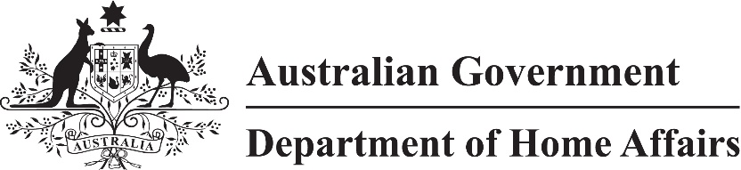

LIN 22/098

Migration (International trade obligations relating to labour market testing – Australia-United Kingdom Free Trade Agreement) Amendment Determination (LIN 22/098) 2022

I, Andrew Giles, Minister for Immigration, Citizenship and Multicultural Affairs, make this instrument under subsection 140GBA(2) of the *Migration Act 1958* (the ***Act***).

Dated 21 November 2022

**Andrew Giles**

Minister for Immigration, Citizenship and Multicultural Affairs

1 Name

This instrument is the Migration (International trade obligations relating to labour market testing – Australia-United Kingdom Free Trade Agreement) Amendment Determination (LIN 22/098) 2022.

2 Commencement

(1) This instrument commences on the later day of:

1. The start of the day after this instrument is registered; and
2. The commencement of Schedule 1 to the *Customs Amendment (Australia-United Kingdom Free Trade Agreement Implementation) Act 2022*.

(2) However, the provisions do not commence at all if the event mentioned in paragraph (b) does not occur.

3 Amendment

Schedule 1 amends Migration (International trade obligations relating to labour market testing) Determination (LIN 21/075) 2021.

Schedule 1 Amendment

(s.3)

[1] Section 5, after paragraph (b)

insert

(ba) Australia-United Kingdom Free Trade Agreement (AUKFTA);