**EXPLANATORY STATEMENT**

**Issued at the authority of the Minister for Aged Care**

[***Aged Care Act 1997***](https://www.legislation.gov.au/Series/C2004A05206)

***Aged Care Legislation Amendment (Governance and Reporting for Approved Providers) Principles 2022***

**Purpose**

The purpose of the *Aged Care Legislation Amendment (Governance and Reporting for Approved Providers) Principles 2022* (Amending Principles) is to introduce new governance and reporting requirements for approved providers of Commonwealth‑funded aged care. The Amending Principles amend the *Accountability Principles 2014* (Accountability Principles) and the *Records Principles 2014* (Records Principles).

The Amending Principles support the implementation of changes made by the *Aged Care and Other Legislation Amendment (Royal Commission Response) Act 2022* (Amending Act). The Amending Principles specify the following requirements for approved providers in relation to:

* record keeping responsibilities relating to the suitability of key personnel of approved providers;
* requirements about membership of quality care advisory bodies;
* the written reports on the quality of aged care that must be given to the governing body of an approved provider by their quality care advisory body;
* responsibilities to give the Secretary of the Department of Health and Aged Care (Department) specified information and statements in relation to a reporting period; and
* other record keeping requirements.

These measures are aimed at improving transparency and accountability among approved providers and ensuring that approved providers are focusing on the best interests of care recipients.

The Amending Principles are a legislative instrument for the purposes of the *Legislation Act 2003*.

**Background**

Schedule 5 of the Amending Act amends the *Aged Care Act 1997* (Aged Care Act) and *Aged Care Quality and Safety Commission Act 2018* (Commission Act) to introduce new governance responsibilities for approved providers. The Amending Principles set out the specific requirements for the implementation of these new governance responsibilities.

The changes broadly align with Recommendations 88 to 90 of the Final Report of the Royal Commission into Aged Care Quality and Safety, which noted the importance of good provider governance arrangements in the provision of high-quality care for aged care recipients.

From 1 December 2022, amendments to the Aged Care Act require approved providers to, at least once every 12 months:

* consider the suitability matters in relation to an individual who is one of the key personnel of the approved provider; and
* be reasonably satisfied that the individual is suitable to be involved in the provision of aged care.

The Amending Principles introduce record keeping requirements for approved providers in relation to the suitability matters. This will ensure that there is evidence that approved providers are complying with their requirements as to suitability of key personnel and that approved providers have exercised due diligence in being reasonably satisfied that their key personnel are suitable to be involved in the provision of aged care.

From 1 December 2022, amendments to the Aged Care Act require certain approved providers to establish, and continue in existence, a quality care advisory body that complies with the requirements about membership specified in the Accountability Principles. The quality care advisory body must, at least once every 6 months, give the governing body of the approved provider a written report about the quality of the aged care that the approved provider provides through an aged care service. The quality care advisory body is also able, at any time, to give feedback to the governing body of the approved provider about the quality of the aged care that the approved provider provides through an aged care service. The governing body of the approved provider must consider such a report, or any such feedback, when making decisions in relation to the quality of the aged care provided through the aged care service; and advise the quality care advisory body in writing, how the governing body considered such a report or any such feedback.

The Amending Principles detail the requirements for the membership of these quality care advisory bodies and the requirements that must be included in the written report that a quality care advisory body must give to the governing body of the approved provider.

A new reporting responsibility is also being introduced which requires approved providers to give the Secretary certain information relating to a reporting period (period of 12 months starting on 1 July 2022 as per subsection 63-1G(3) of the Aged Care Act). The Amending Principles specify the information that must be given to the Secretary as well as including practical details on arrangements where a service has operated for only part of a reporting period. It is intended that this information will be made publicly available by the Department through further legislative amendments. The publication of this information will assist care recipients and their families to understand key details of approved providers’ operations.

**Authority**

Section 96-1 of the Aged Care Act provides that the Minister may, by legislative instrument, make Principles providing for matters required or permitted, or necessary or convenient, to give effect to the relevant Part or section of the Aged Care Act.

Accountability Principles

The Accountability Principles are made under section 96-1 of the Aged Care Act and set out matters for the purpose of Part 4.3 of the Aged Care Act (or matters necessary or convenient to carry out and give effect to the matters set out in that Part).

Records Principles

The Records Principles are made under section 96-1 of the Aged Care Act and set out matters for the purpose of Part 6.3 of the Aged Care Act (or matters necessary or convenient to carry out and give effect to the matters set out in that Part).

**Reliance on subsection 33(3) of the *Acts Interpretation Act 1901***

Under subsection 33(3) of the *Acts Interpretation Act 1901*, where an Act confers a power to make, grant or issue an instrument of a legislative or administrative character (including rules, regulations, or by-laws), the power shall be construed as including a power exercisable in the like manner and subject to the like conditions (if any) to repeal, rescind, revoke, amend, or vary any such instrument.

**Commencement**

The Amending Principles commence on 1 December 2022.

**Consultation**

The Department undertook targeted consultation on provider governance initiatives with aged care sector and consumer reference groups during the period of December 2021 to September 2022.

An Information and Consultation Paper and accompanying questionnaire on the matters to be included in the Amending Principles was available to the sector for comment from 21 December 2021 to 18 January 2022. The Department received 548 questionnaire responses and 12 written submissions from a range of aged care providers, staff, aged care recipients, consumer representatives, and peak organisations.

The consultations indicated that there was a strong level of support from respondents in favour of the aged care governance requirements proposed in the Amending Principles.

A proposal to have a member of the approved provider’s governing body chair their quality care advisory body was the least supported proposed change and subsequently was not included in the Amending Principles. Other key matters raised included:

* a need for a flexible approach to the reforms, in order to support implementation of new governance requirements by the wide variety of approved providers (including care type provided, size location and governance arrangements of approved providers);
* a request for reporting requirements to be simple and avoid duplication of existing requirements;
* a need to consider the privacy implications of reforms; and
* a need for funding and support to implement the reforms.

The Amending Principles have been prepared following careful consideration of the feedback provided, along with further consultation with the Department’s aged care sector and consumer reference groups.

The Department published the draft Amending Principles and the accompanying Explanatory Statement on the Department’s website on 31 October 2022 and provided a 14-day period for comment. Matters raised in relation to the Amending Principles included:

* the operation of quality care advisory bodies and their reporting to governing bodies of approved providers on the quality of care of each service within large organisations;
* the membership of quality care advisory bodies, including whether they should include any consumer representation; an individual consumer as well as a consumer representative (who is not themselves a consumer); and/or other specific representatives; and
* clarification of the specific information that approved providers would be required to give the Secretary of the Department, regarding feedback, complaints and improvements and diversity

Amendments were made to the Amending Principles following feedback.

The Aged Care Quality and Safety Commission (Commission) was also consulted to ensure that the legislation provides appropriate detail and powers to enable the Commission to fulfill its responsibilities in relation to the measures.

**Regulation Impact Statement**

The Office of Best Practice Regulation (OBPR) was consulted during the development of the Amending Principles on the regulatory impact of the governance and record keeping requirements.

The Department certified that a package of independent reviews undertook a process and analysis equivalent to a Regulatory Impact Statement for certain aged care quality measures contained in the Amending Act (including the Strengthening Aged Care Approved Provider Governance reforms).

The OBPR found the scope of the certified review process covered the policy proposals except for implementation and evaluation measures. The certification and list of reviews can be found in the Explanatory Memorandum for the Amending Act at: <https://www.aph.gov.au/Parliamentary_Business/Bills_Legislation/Bills_Search_Results/Result?bId=r6875>

Supplementary analysis of the implementation and evaluation of these measures was accepted by OBPR (reference OBPR22-01446) and a copy is attached.

**Details of the *Aged Care Legislation Amendment (Governance and Reporting for Approved Providers) Principles 2022***

**Section 1** provides that the name of the instrument is the *Aged Care Legislation Amendment (Governance and Reporting for Approved Providers) Principles 2022* (Amending Principles)*.*

**Section 2** provides that the Amending Principles commence on 1 December 2022.

**Section 3** states that the authority to make this instrument is under section 96-1 of the Aged Care Act.

**Section 4** provides that each instrument that is specified in a Schedule to this instrument is amended or repealed as set out in the applicable items in the Schedule, and any other item in a Schedule to this instrument has effect according to its terms.

**Schedule 1 – Amendments**

**Part 1 – Governance of approved providers etc.**

***Accountability Principles 2014***

**Item 1** repeals the existing Part 7A of the Accountability Principles and replaces it with new Part 7, new Part 7A and new Part 7B.

Part 7—Responsibilities relating to the suitability of key personnel of approved providers

New Part 7 sets out approved providers’ record keeping responsibilities regarding the suitability matters considered by the approved provider in relation to an individual who is a key personnel of the approved provider. Section 63-1A of the Aged Care Act requires an approved provider, at least once every 12 months, to consider the suitability matters (as defined in section 8C of the Commission Act) in relation to all of its key personnel and be reasonably satisfied that its key personnel are suitable to be involved in the provision of aged care. New Part 7 consists of new sections 52 and 53.

Section 52 – Purpose of this Part

New section 52 provides that new Part 7 is made for the purposes of section 63-1A(b) of the Aged Care Act and specifies approved providers’ record keeping requirements for the suitability matters considered by the approved provider in relation to an individual who is one of its key personnel.

Section 53 – Record of consideration of suitability matters

New section 53 sets out the requirements for approved providers’ records relating to the suitability of the approved providers’ key personnel. New subsections 53(a) to 53(d) require the record to include all of the following:

* name of the individual in relation to whom the suitability matters were considered;
* date or dates on which the suitability matters were considered in relation to the individual;
* the outcome of the provider’s consideration of each suitability matter in relation to the individual; and
* the reasons for reaching that outcome.

Part 7A—Responsibilities of certain approved providers relating to their governing bodies etc.

New Part 7A sets out the responsibilities of certain approved providers in relation to their governing bodies. New Part 7A consists of new sections 53A, 53B and 53C.

Section 53A – Purpose of this Part

New section 53A provides that the purpose of Part 7A is to set out the requirements for membership and reporting in relation to a quality care advisory body. New subsection 53A(a) provides that Part 7A specifies the requirements about membership of the quality care advisory body required to be established and continued in existence by an approved provider.

New subsection 53A(b) provides that Part 7A specifies the requirements that the report the quality care advisory body is required to give to the governing body of the approved provider must comply with.

Section 53B – Requirements about membership of quality care advisory bodies

New subsection 53B(1) provides that for the purpose of subparagraph 63‑1D(6)(a)(i) of the Aged Care Act, a quality care advisory body established by an approved provider must comply with the membership requirements specified in subsection 53B(2).

New subsection 53B(2) provides that the quality advisory body must include the following members:

* an individual who is one of the key personnel of the approved provider and has appropriate experience in the provision of aged care; and
* an individual who is directly involved in the delivery of aged care or, if an approved provider delivers clinical care, an individual who is directly involved in the provision of clinical care; and
* an individual who represents the interests of care recipients. Examples of this include a care recipient, a member of the consumer advisory body, a member of an organised consumer advisory service, or a consumer advocate.

The note following new subsection 53B(2) clarifies that the quality care advisory body may also include other persons with an interest in the quality of aged care delivered by the approved provider. This indicates that the requirements set out in subsection 53B(2) are minimum requirements. It allows quality care advisory bodies to include persons in addition to those who meet the requirements specified in subsection 53B(2).

Section 53C – Report about quality of aged care provided

Under subsection 63-1D(6) of the Aged Care Act, an approved provider must establish and continue in existence a quality care advisory body. Subsection   
63-1D(6)(a)(ii) of the Aged Care Act requires this body, at least once every 6 months, to give the governing body of the approved provider a written report about the quality of the aged care that the approved provider provides through an aged care service.

Subsection 63-1D(7) of the Aged Care Act provides that the written report about the quality of the aged care, must comply with any requirements specified in the Accountability Principles.

Under new subsection 53C(1), this written report must comply with the requirements specified under subsection (2).

New subsection 53C(2) provides that the report for each aged care service provided by the approved provider must include any concerns that the quality care advisory body has about the quality of the aged care provided through the service in the period covered by the report. The report must take into account:

* feedback provided in the report period by care recipients and the approved provider’s staff members about the quality of aged care provided;
* complaints received in the report period by the approved provider about the quality of aged care provided and actions taken by the approved provider to address the complaints;
* regulatory action taken in the report period by the Aged Care Quality and Safety Commissioner (the Commissioner) in relation to the quality of aged care provided by the approved provider;
* progress made in the report period in relation to the approved provider’s plan for continuous improvement (within the meaning of the *Aged Care Quality and Safety Commission Rules 2018*), particularly improvements made in the provision of aged care by the approved provider through the service;
* performance reports given to the approved provider in the report period by the Commissioner, in accordance with rules made under the Commission Act in relation to the quality of aged care provided;
* staffing arrangements at the service during the report period including details on the following, as applicable:
  + the availability of allied health practitioners or other health support at the service (such as physiotherapists, speech therapists, occupational therapists and hearing or vision services);
  + the availability of registered nurses at the service (registered nurses has the same meaning as in the *Health Insurance Act 1973*);
  + staff turnover at the service (that is, the proportion of staff who have left the service);
* any reportable incident for the approved provider that occurred at the service in the report period and any action taken by the approved provider in response to the reportable incident (reportable incident is defined in the Aged Care Act);
* if the service is a residential care service:
  + feedback received in the report period from care recipients at the service about the quality of food provided by the service to care recipients;
  + changes in the report period in the quality of food provided and the food preparation model used, by the service;
  + any menu assessments conducted during the reporting period by an accredited practicing dietitian in relation to food and nutrition provided by the service; and
  + information compiled or derived from a measurement or other assessment made by the approved provider in the report period in accordance with section 26 of the Accountability Principles(that is, performance against the National Aged Care Mandatory Quality Indicators).

The quality care advisory body must, at least once every 6 months, provide a written report to the governing body of the approved provider about the quality of the aged care that the approved provider provides through an aged care service. The quality care advisory body may provide written reports more frequently than once every   
6 months, however the above matters must be taken into account at least once every   
6 months.

The quality care advisory body’s report only has to include any concerns that the quality care advisory body has about the quality of care and does not need to address each matter listed in new subsection 53C(2). However, the quality care advisory body may consider issues beyond those listed in subsection 53C(2) when preparing the report and may wish to report to the governing body on issues beyond its concerns about the quality of the care being provided to care recipients. For example, the quality care advisory body could also report on areas of commendable performance, as well as areas for improvement. The quality care advisory body’s report could take into account information that the provider has already provided to the Department (such as staffing information reported through the Aged Care Financial Report and Quarterly Financial Report). It also may be useful for the quality care advisory body to take into account how performance during the current reporting period compares to previous reporting periods.

Part 7B—Responsibilities relating to the giving of information relating to reporting periods

New Part 7B deals with responsibilities relating to the giving of information relating to reporting periods. New Part 7B consists of new sections 53D, 53E, 53F, 53G and 53H.

Section 53D – Purpose of this Part

New section 53D provides that the purpose of new Part 7B is to set out the responsibilities of an approved provider under section 63‑1G and paragraph 63‑1(1)(m) of the Aged Care Act to give the Secretary specified information and statements in relation to a reporting period for the approved provider.

This provision, in conjunction with Schedule 3 of the Implementing Care Reform Act, responds to the Royal Commission’s recommendation that aged care legislation be amended to require every approved provider to report annually on their operations to enable proper scrutiny. The note following new subsection 53D provides that a reporting period for an approved provider is defined in clause 1 of Schedule 1 to the Aged Care Act as having the meaning given by subsection 63-1G(3) of the Aged Care Act.

Section 53E – Providers of residential and home care—responsibility relating to the giving of information relating to reporting periods

New section 53E provides that for the purposes of subsection 63-1G(1) of the Aged Care Act, the following kind of information is specified in relation to a reporting period for an approved provider that provides a residential care service or a home care service:

* information about the kind of feedback and complaints received by the approved provider in respect of each residential care service and home care service provided by the approved provider.
* information about improvements made by the approved provider in the reporting period in relation to the quality of each residential care service and home care service provided by the approved provider.
* information about
  + the diversity of the governing body of the approved provider in the reporting period (such as whether the governing body includes representation of people who are Aboriginal and/or Torres Strait Islander; have a disability; are gender diverse; and are culturally and linguistically diverse), and
  + initiatives that the approved provider has implemented in the reporting period to support a diverse and inclusive environment for care recipients and staff members in relation to each residential care service and home care service provided by the approved provider. This may include, for example, information about the service’s policies and procedures for cultural awareness, diversity and inclusion, social activities to support culture, diversity and inclusion, and whether the provider’s governance framework has commitment to cultural awareness, diversity and inclusion.
* whether the approved provider was a person or body mentioned in any of paragraphs 63‑1D(1)(a) to (c) of the Aged Care Act. These provisions relate to whether the approved provider is a State or Territory; a State or Territory authority; or a local government authority.
* if subsection 63‑1D(2) of the Aged Care Act applied to the approved provider during the reporting period, whether the provider complied with the responsibilities set out in paragraphs 63‑1D(2)(a) and (b) of the Act. These provisions require certain approved providers to ensure that a majority of the members of the governing body of the approved provider are independent non‑executive members; and at least one member of the governing body of the approved provider has experience in the provision of clinical care.
* whether any of subsections 63‑1D(3) to (5) of the Aged Care Act applied to the approved provider during the reporting period. These provisions state that the requirements for membership of governing bodies set out in subsection 63‑1D(2) of the Act do not apply to an approved provider at a particular time if:
  + the governing body of the provider has fewer than 5 members and the provider provides aged care through one or more aged care services to fewer than 40 care recipients; or
  + the provider is a kind of body that is known as an Aboriginal Community Controlled Organisation; or
  + if a determination under section 63‑1E that the responsibility set out in paragraphs 63-1D(2)(a) or (b) does not apply in relation to the provider is in force at that time.

Section 53F – Providers of flexible care— responsibilities relating to the giving of information relating to reporting periods

New section 53F provides that for the purposes of subsection 63-1G(1) of the Aged Care Act, the following kind of information is specified in relation to a reporting period for an approved provider that provides flexible care as transition care (within the meaning of the *Subsidy Principles 2014*):

* information about the kind of feedback and complaints received by the approved provider in the reporting period in respect of each flexible care service provided by the approved provider through which transition care is provided;
* information about improvements made by the approved provider in the reporting period in relation to the quality of each flexible care service provided by the approved provider through which transition care is provided.

Section 53G – Responsibilities to prepare and provide statements

New subsection 53G(1) provides that for the purposes of 63-1(1)(m) of the Aged Care Act, the following responsibilities are specified for an approved provider that provides a residential care service or a home care service:

* to prepare a statement for a reporting period for the approved provider that complies with the requirements set out in subsection 53G(2);
* to give a copy of the statement to the Secretary within 4 months after the end of the reporting period for the approved provider.

New subsection 53G(2) provides that the statement must:

* be in the form approved by the Secretary; and
* state if the approved provider’s governing body believes that the approved provider has complied with its responsibilities under the Aged Care Act and the requirements under the Commission Act, and must be signed by a member of the approved provider’s governing body on behalf of all members of the governing body; and
* if the approved provider’s governing body believes that the approved provider has failed to comply with one or more responsibilities under the Aged Care Act or requirements under the Commission Act, state that fact and must be signed by a member of the approved provider’s governing body on behalf of all members of the governing body. Examples of approved provider requirements under the Commission Act are:
  + to give an undertaking about remedying non-compliance (see section 63T of that Act); or
  + to agree to certain matters if revocation of approval is being considered (see section 63U of that Act).
* If the approved provider’s governing body believes that that the approved provider has failed to comply with one or more of its responsibilities or requirements, the statement must set out the details of each responsibility or requirement that the governing body believes that the approved provider has failed to comply with; the reasons why the approved provider failed to comply with the responsibility or requirement; and actions that the approved provider has taken, has started to take, or will take, to rectify the non‑compliance.

Section 53H – Service provided during part only of reporting period

New section 53H provides that if an approved provider was responsible for a service for only part of the reporting period, then in order to meet the requirements in sections 53E, 53F and 53G, the approved provider must provide the required information for that service for only the part of the reporting period in which they were responsible.

This ensures that approved providers are not responsible to report on a service for a period in which they did not have responsibility. For example, if a service is sold from one approved provider to another, then the approved provider that purchased the service would only report information on the service for the period in which they were responsible for the operations of the service.

**Item 2** inserts new section 60 in the appropriate position in Part 8 of the Accountability Principles

Section 60 - Amendments made by the *Aged Care Legislation (Governance and Reporting for Approved Providers) Principles 2022*

New subsection 60(1) specifies that approved providers in existence before 1 December 2022 must comply with the responsibilities relating to governing bodies, as set out in Part 7A, from 1 December 2023. This gives existing approved providers one year to make any changes necessary to meet the responsibilities.

New subsection 60(2) specifies that providers approved on or after 1 December 2022 must comply with responsibilities relating to governing bodies, as set out in Part 7A, from the day they become an approved provider.

New subsection 60(3) specifies that the responsibilities relating to giving information, as set out in Part 7B, applies in relation to a reporting period of 12 months that starts on 1 July 2022 and each subsequent reporting period for the approved provider (with each subsequent reporting period starting on 1 July of each year or another date as determined for the approved provider by the Secretary in accordance with the Accountability Principles). This timing is intended to enable approved providers to report on their operations for the period between 1 July 2022 to 30 June 2023.

**Part 2 – Record keeping requirements**

***Records Principles 2014***

**Item 3** inserts new Part 1 before section 1.

Part 1—Preliminary

**Item 4** inserts new Part 2 after section 5.

Part 2—Records to be kept

**Item 5** inserts new section 6A after section 6.

Section 6A – Records about governing body

New subsection 6A(1) provides that this section applies to approved providers that have responsibilities as set out in paragraphs 63-1D(2)(a) of the Aged Care Act.

New subsection 6A(2) provides that the approved provider must keep a record about the members of their governing body that includes the following information:

* the names of members who are independent non-executive members;
* the names of members who are not independent non-executive members; and
* the names of members who have experience in the provision of clinical care and the details of each member’s experience.

Section 6B – Records about the quality advisory body

New subsection 6B(1) provides that new section 6B applies to approved providers that have responsibilities to establish and maintain a quality care advisory body under subsection 63-1D(6) of the Aged Care Act.

New subsection 6B(2) provides that the approved provider must keep a record about their quality care advisory body that includes the following information and documents:

* the names of each member, the date the member was appointed and the date the member resigned;
* details of how the body satisfies the requirements of section 53B of the Accountability Principles (that is, how the body satisfies the requirements about membership of quality care advisory bodies);
* a copy of the minutes of any meeting held by the body and the date on which the meeting was held (if meetings were held);
* a copy of each written report given to the governing body of the approved provider by the quality care advisory body under subparagraph 63-1D(6)(a)(ii) of the Aged Care Act;
* details of any feedback given to the governing body of the approved provider by the quality care advisory body under subparagraph 63-1D(6)(a)(iii) of the Aged Care Act; and
* a copy of any written advice from the governing body of the approved provider to the quality care advisory body under subparagraph 63‑1D(6)(b)(ii) of the Aged Care Act advising how the governing body has considered the report and the feedback from the quality care advisory body.

Section 6C – Records about the consumer advisory body

New subsection 6C(1) provides that this section applies to approved providers that have responsibilities to offer care recipients and their representatives an opportunity to establish a consumer advisory body under subsection 63-1D(9) of the Aged Care Act.

New subsection 6C(2) provides that the approved provider must keep a record that includes the following information and documents:

* a copy of each written offer made to care recipients and their representatives to establish a consumer advisory body;
* the date on which each offer was given;
* if a consumer advisory body is established:
  + a copy of the minutes of each meeting (if meetings were held); and
  + details of any feedback given to the governing body of the approved provider by the consumer advisory body under paragraph 63-1D(9)(a) of the Aged Care Act; and
  + a copy of any written advice given to the consumer advisory body by the governing body of the approved provider under subparagraph   
    63-1D(9)(b)(ii) of the Aged Care Act advising how the governing body has considered any such feedback. This may include details of how feedback has been addressed or if the feedback was not addressed, why the feedback was not addressed.

Section 6D – Records about the qualifications, skills or experience etc. of staff members

New subsection 6D(1) provides that this section applies to approved providers that have responsibilities under subsection 63-1D(11) of the Aged Care Act (that is, approved providers other than a State or Territory; a State or Territory authority; and a local government authority).

Subsection 63-1D(11) of the Aged Care Act requires the governing body of these approved providers to ensure staff members of the approved provider:

* have appropriate qualifications, skills, or experience to provide the care or other services that the approved provider provides to care recipients through an aged care service; and
* are given opportunities to develop their capability to provide that care or those other services.

New subsection 6D(2) provides that the approved providers that have these responsibilities under subsection 63-1D(11) of the Aged Care Act must keep a record about how the governing body of the approved provider has ensured that the approved provider’s staff members:

* have appropriate qualifications, skills or experience to provide the care or other services that the approved provider provides to care recipients through an aged care service; and
* are given opportunities to develop their capability to provide that care or those other services.

The note following new section 6D(1) provides that approved providers have other record keeping responsibilities in relation to certain staff as set out in sections 9, 10A and 10B of the Records Principles.

**Item 6** inserts new Part 3 after section 11.

Part 3—Application, transitional and saving provisions

**Item 7** adds new section 13 at the end of the Records Principles.

Section 13 Amendments made by the Aged Care Legislation Amendment (Governance and Reporting for Approved Providers) Principles 2022

New section 13 provides for transitional arrangements for the Amending Principles.

New subsection 13(1) specifies that approved providers in existence before 1 December 2022 must comply with the requirements set out in sections 6A to 6D from 1 December 2023. This gives existing approved providers one year to make any changes necessary to meet their responsibilities.

New subsection 13(2) specifies that providers approved on or after 1 December 2022 must comply with requirements set out in sections 6A to 6D from the day they become an approved provider.

**Statement of Compatibility with Human Rights***Prepared in accordance with Part 3 of the Humans Rights (Parliamentary Scrutiny) Act 2011*

***Aged Care Legislation Amendment (Governance and Reporting for Approved Providers) Principles 2022***

The *Aged Care Legislation Amendment (Governance and Reporting for Approved Providers) Principles 2022* (Amending Principles) is compatible with the human rights and freedoms recognised or declared in the international instruments listed in section 3 of the *Human Rights (Parliamentary Scrutiny Act) Act 2011*.

**Overview of Legislative Instrument**

The Amending Principles amend the *Accountability Principles 2014* (Accountability Principles) and *Records Principles 2014* (Records Principles).

The purpose of the Amending Principles is to enable the effective implementation of arrangements relating to governance and reporting requirements for approved providers of Commonwealth-funded aged care. Improved governance arrangements are intended to improve leadership and culture, enhance transparency and accountability, and ensure approved providers’ focus, from the top down, is in the best interests of care recipients.

The Amending Principles set out requirements for approved providers regarding membership of quality care advisory bodies, the report about quality of aged care that quality care advisory bodies must give to the governing body of an approved provider, and specifies the information and statements in relation to a reporting period that an approved provider must give to the Secretary. It also details record keeping responsibilities regarding the suitability matters relating to key personnel of approved providers, as well as approved providers’ governing bodies, quality care advisory bodies, consumer advisory bodies and the qualifications, skills or experience etc of staff members.

**Human Rights Implications**

The Amending Principles engages the following human rights:

* right to an adequate standard of living, as contained in article 11(1) of the International Covenant on Economic, Social and Cultural Rights (ICESCR) and articles 28 of the Convention on the Rights of Persons with Disabilities (CRPD);
* right to health in article 12(1) of the ICESCR and article 25 of the CRPD; and
* right to privacy in Article 17 of the International Covenant on Civil and Political Rights (ICCPR) and Article 22 of the CRPD.

*Right to an adequate standard of living*

The right to an adequate standard of living, including adequate food and housing, and to the continuous improvement of living conditions is contained in article 11(1) of ICESCR. Article 28 of the CRPD also require appropriate measures to be taken to ensure clean water services and public housing programs for people with disability.

The Amending Principles promotes the right to an adequate standard of living by improving the accountability and transparency of governance of approved providers of aged care. This will in turn deliver high quality care and standards of living to aged care recipients.

*Right to Health*

The right to health is contained under article 12 of the ICESCR and article 25 of the CRPD. These articles refer to the right of individuals, including persons with disability, to the highest attainable standard of physical and mental health. The Amending Principles promotes the right to health by ensuring approved providers have good governance arrangements, including having at least one member with experience in the provision of clinical care as part of their governing body, and having a quality care advisory body that reports to their governing body about the quality of the aged care that the provider provides.

The new governance arrangements include establishing mechanisms for care recipients and their families to provide feedback to the approved provider’s governing body on the quality of care that is provided. The approved provider’s governing body must consider this information. These arrangements allow care recipients to engage and participate in matters concerning their health, particularly where they are being provided with residential aged care.

The Amending Principles also promote the right to health by maximising care recipients’ ability to receive the best care appropriate for their needs, by placing more rigorous requirements on aged care providers regarding the suitability of their key personnel.

*Right to privacy*

The Amending Principles engages with the right to privacy in Article 17 of the ICCPR and Article 22 of the CRPD. The right to privacy under Article 17 of the ICCPR, states that no person should be subject to arbitrary or unlawful interference with their privacy. Article 22 of the CRPD contains a similar provision in relation to persons with disability. Although the United Nations Human Rights Committee has not defined ‘privacy’, it should be understood to comprise freedom from unwarranted and unreasonable intrusions into activities that society recognises as falling within the sphere of individual autonomy.

The right to privacy under Article 17 can be permissibly limited to achieve a legitimate objective and where the limitations are lawful and not arbitrary. The term ‘unlawful’ in Article 17 of the ICCPR means that no interference can take place except as authorised under domestic law. Additionally, the term ‘arbitrary’ in Article 17(1) of the ICCPR means that any interference with privacy must be in accordance with the provisions, aims and objectives of the ICCPR and should be reasonable in the circumstances. The Committee has interpreted ‘reasonableness’ to mean that any limitation must be proportionate and necessary in the circumstances.

The Amending Principles limit the right to privacy under Article 17 of the ICCPR by requiring approved providers to keep records of their consideration of the suitability of key personnel to be involved in the provision of aged care. This assessment may require the provider to keep records of personal information about their key personnel, such as police checks, or evidence of work experience or training. The Aged Care Quality and Safety Commission may also view these records as part of its monitoring and investigation functions to ensure compliance with the new responsibility. The objective of this requirement is to ensure that key personnel of providers are suitable to be involved in the provision of aged care and to protect the care recipient’s rights under article 12(1) of ICESCR.

These are legitimate objectives that fall within the permissible purposes of protecting the rights of those receiving care and protecting public health. These provisions are also reasonable, necessary, and proportionate to achieving this objective, since the handling of a key personnel’s personal information is subject to the protected information provisions in Part 6.2 of the *Aged Care Act 1997*, as well as the general protections under the *Privacy Act 1988.* The existing harsh penalties for misuse of personal information will protect and ensure safe handling of the information collected.

**Conclusion**

The Amending Principles are compatible with human rights and freedoms recognised or declared in the international instruments listed in section 3 of the *Human Rights (Parliamentary Scrutiny) Act 2011*. The Amending Principles positively promote the right to an adequate standard of living and to attain the highest standard of physical and mental health. To the extent that aspects of the Amending Principles may limit the right to privacy, those limitations are reasonable, necessary, and proportionate.

**Circulated by the authority of the Minister for Aged Care, the Hon Anika Wells MP**

Supplementary Assessment RIS Question 7 - How Will You Implement and Evaluate Your Chosen Option?

Implementation

The Act includes details of the timeframes for implementation of the approved provider governance reforms. In summary, the implementation timeframes for the new approved provider reforms are:

* On 1 December 2022, proposed new responsibilities regarding the suitability of key personnel will commence for all approved providers.
* Approved providers need to submit information for the 2022-23 financial year to the Secretary by 31 October 2023.
* On 1 December 2022 the following reforms commence for new approved providers; however, providers who are approved before 1 December2022, will have until 1 December 2023 to meet these new responsibilities:
  + new responsibilities for the membership of governing bodies
  + reforms regarding provider’s constitution
  + reforms regarding a quality care advisory body and consumer advisory body
  + governing body responsibilities regarding staff qualifications, skills and experience.

A key challenge for implementation of the approved provider measures includes service providers not being prepared or unable to meet the new regulatory requirements. This may arise from the need for priority to be placed on responding to COVID-19, as well as the breadth of aged care reforms arising from the Royal Commission.

To help mitigate this risk, the timeframes commencing from 1 December 2022, are staggered. As indicated above, existing providers will have grace periods on some new responsibilities to acknowledge the time it may take for governing bodies to approve changes. Implementation will also include information and training for providers to support them to make the proposed changes.

Initial information about the proposed reforms has been provided to the sector through stakeholder and consumer reference groups. Broad consultation on the subordinate legislation changes (undertaken between 21 December 2021 and 18 January 2022) has also been used to inform the sector of the proposed approved provider governance measures being considered by Parliament and seek feedback on the areas to be covered in the proposed amended subordinate legislation. Information about the provider governance reforms is available on both the Department and Commission’s websites. On 7 November 2022, the Commission hosted a webinar for providers to discuss the new provider governance requirements. A recording of the webinar and a copy of the presentation slides are available on the Commission’s website.

Following the proposed legislative amendments being made law, implementation of the new arrangements will be further supported through broadcasts to providers through Department and Commission newsletters and websites, including guidance material.

In addition, a 'Governing for Reform in Aged Care' education program, led by the Commission has been launched to help aged care providers strengthen organisational governance and leadership. The program is designed to strengthen organisational and clinical governance capability across the aged care sector to ensure that all providers are well placed to participate in and progress the urgent calls for change in the aged care sector.

The program will specifically target leaders and members of governing bodies of approved aged care, aiming for approximately 3,700 participants. This program is available to providers irrespective of their corporate status, size or location of their service(s). Enrolment in the program is free and will continue until June 2023.

The program was announced on 20 December 2021 and by a letter from the Commissioner to each approved provider. Information on the program is available on the Commission’s website: <https://www.agedcarequality.gov.au/providers/provider-governance>

While the legislation allows for non-compliance actions to be utilised when a provider breaches its provider governance responsibilities, the initial focus of implementation will be to support providers to understand and implement the new provisions.

Regarding implementation of the annual reporting on providers’ operations, an information and communication technology (ICT) capability is being developed. This capability will enable the extraction of existing information held by the department, additional information to be submitted by providers, and for the information to be made publicly available on the My Aged Care portal. Stakeholders will be consulted during the development of the ICT solution to help enhance the user experience for providers in submitting data and for those accessing the annual statements on My Aged Care.

Aged care stakeholders will be supported to implement the ICT solution by:

* involvement in user testing
* online training for approved providers
* online support tools
* a Department staff member being available to respond to sector enquires regarding the annual reporting to the Secretary and review data quality.

A key challenge to the ICT capability is the development of an elegant solution to extract data that is currently held by the Department in multiple databases to minimise the need for providers to resubmit this data. The ICT solution will be developed in close consultation with owners of each source database to respond to this challenge.

Evaluation

The evaluation of this measure will be undertaken as part of the Department’s overall approach to measuring key outcomes of aged care reforms that address the Royal Commission recommendations and improve aged care service delivery to care recipients.

The evaluative approach will use qualitative and quantitative metrics to measure success against the objectives of the provider governance reforms in support of broader aged care reform for senior Australians. This approach will also enable identification of whether additional reforms are required to deliver sustainable quality and safety in Australia’s home and residential aged care services. The approach will feed into Ministerial reporting and public reporting.

Specific components of the approved provider governance reforms will also be monitored using a mixed methods approach, drawing on quantitative and qualitative data sources. Monitoring activities will help keep track of sector performance against the new responsibilities and help to inform any decision to modify aspects of the approved provider responsibilities.

Where practicable the evaluation will utilise existing data. Where new systems are being developed (e.g. for submission of information about the providers’ operations) technical reporting mechanisms will be incorporated to allow monitoring and notifications.

Examples of data that may be tracked include:

* formal and informal feedback and consultation with the aged care sector on the impact of the reforms
* monitoring provider compliance, including provider performance against Aged Care Quality Standard 8 - Organisational Governance and Standard 7 - Human Resources;
* timely submission of annual statements of operations and updating of key personnel data
* user experience feedback regarding use of IT tools supporting submission of annual statements of operations
* analysis of complaints data for matters relating to organisational governance
* number of applications for determinations regarding provider membership of governing bodies.

Estimate of Regulatory Burden

The regulatory burden to business, community or individuals is quantified using the Australian Government’s Regulatory Burden Measurement Framework and is provided below.

The net effect of this regulatory change is estimated as $ 8.91 million per annum, based on estimated costs across a 10-year timeframe. This is a refinement of costs for the approved provider governance matters addressed by the subordinate legislation. The certification letter (refer Attachment A) included an *in globo* estimate of these costs.

| Regulatory burden estimate table  Average annual regulatory costs (from business as usual) | | | | |
| --- | --- | --- | --- | --- |
| Change in costs ($ million) | Business | Community organisations | Individuals | Total change in costs |
| Total, by sector | $ 2.64 | $ 6.27 | $ - | $ 8.91 |

The arrangements for approved governance reforms addressed by subordinate legislation will increase the regulatory burden on business and community organisations. However, the Royal Commission into Aged Care Quality and Safety made strong links between the criticality of sound organisational governance and the quality and safety of services and many of the changes are regular consumer-centred practice with information and procedure able to be adapted from current business practice.

No offsets were identified to offset this regulatory burden, the Department remains alert to reduce the regulatory burden for affected stakeholders.

Attachment A

Certification of independent reviews: response to the Royal Commission into Aged care Quality and Safety

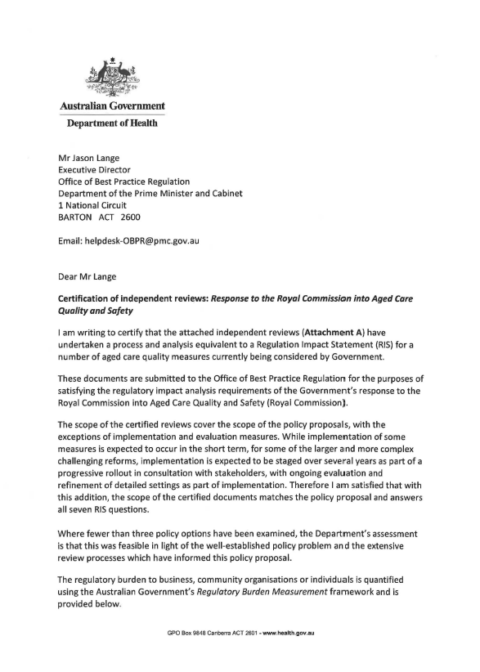

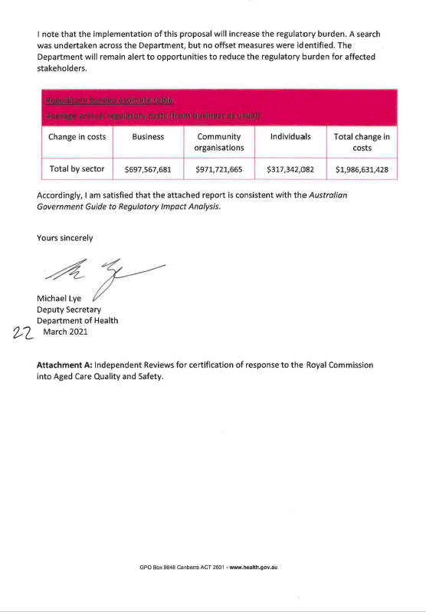

**Attachment A**

**Independent reviews for certification of response to the Royal Commission into Aged Care Quality and Safety**

1. Royal Commission into Aged Care Quality and Safety, *Final Report*, 26 February 2021

Available at: <https://agedcare.royalcommission.gov.au/publications/final-report>

1. Royal Commission into Aged Care Quality and Safety, *Counsel Assisting's Proposed Recommendations at Final Hearing*, 22 October 2020

Available at: <https://agedcare.royalcommission.gov.au/media/29098>

1. Royal Commission Aged Care Quality and Safety Hearing, *Interim Report*, 31 October 2019

Available at: <https://agedcare.royalcommission.gov.au/publications/interim-report>

1. Human Rights Watch, "*Fading Away" How Aged Care Facilities in Australia Chemically Restrain Older People with Dementia*, October 15, 2019

Available at: [https://www.hrw.org/report/2019/10/15/fading-away/how-aged-care­ facilities-australia-chemically-restrain-older-people](https://www.hrw.org/report/2019/10/15/fading-away/how-aged-care­%20facilities-australia-chemically-restrain-older-people)

1. Senate Community Affairs References Committee, *Effectiveness of the Aged Care Quality Assessment and accreditation framework for protecting residents from abuse and poor practices, and ensuring proper clinical and medical care standards are maintained and practised - Final Report* (April 2019)

Available at: [https://www.aph.gov.au/Parliamentary_Business/Committees/Senate/Community_Affa irs/AgedCareQuality](https://www.aph.gov.au/Parliamentary_Business/Committees/Senate/Community_Affa%20irs/AgedCareQuality)

1. *Review of National Aged Care Quality Regulatory Processes Report*, Carnell, K and Paterson, R, October 2017

Available at: [https://www.health.gov.au/resources/publications/review-of-national­ aged-care-quality-regulatory-processes-report](https://www.health.gov.au/resources/publications/review-of-national­%20aged-care-quality-regulatory-processes-report)

1. Australian Law Reform Commission, *Elder Abuse-A National Legal Response* {ALRC Report 131) June 2017

Available at: [https://www.alrc.gov.au/publication/elder-abuse-a-national-legal­ response-a Irc-report-131/](https://www.alrc.gov.au/publication/elder-abuse-a-national-legal­%20response-a%20Irc-report-131/)

1. *Legislated Review of Aged Care*, Final Report 2017

Available at: [https://www.health.gov.au/resources/publications/legislated-review-of­ aged-care-2017-report](https://www.health.gov.au/resources/publications/legislated-review-of­%20aged-care-2017-report)

1. Senate Community Affairs Reference Committee, *Care and management of younger and older Australians living with dementia and behavioural and psychiatric symptom of dementia - Final Report*, 2014

Available at: <https://www.aph.gov.au/Parliamentary_Business/Committees/Senate/Community_Affairs/Dementia/Report/index>

1. House of Representatives Standing Committee on Health and Ageing, *Thinking Ahead, Report on the inquiry into dementia: early diagnosis and intervention*, 2013

Available at: <https://www.health.gov.au/resources/publications/thinking-ahead-report­on-the-inquiry-into-dementia-early-diagnosis-and-intervention>

1. Department of Health, *Inquiry into Events at Earle Haven*, 2019

Available at: <https://www.health.gov.au/resources/publications/inquiry-into-events-at­earle-haven>

1. Productivity Commission, *Caring for Older Australians*, 2011

Available at:

[https://www.pc.gov.au/inquiries/completed/aged-care/report](https://www.pc.gov.au/inquiries/completed/aged-care/report )

1. Australian Skills Quality Authority, *Training for Aged and Community Care in Australia, A national strategic review of registered training organisations offering aged and community care sector training*, 2013

Available at:

<https://www.asqa.gov.au/sites/default/files/Strategic_Reviews_2013_Aged_Care_Report.pdf?v=1508135481>

1. Aged Care Strategy Taskforce, *A matter of care, Australia's aged care Workforce Strategy*, 2018

Available at:

<https://www.health.gov.au/resources/publications/a-matter-of-care-australias-aged-care-workforce-strategy>

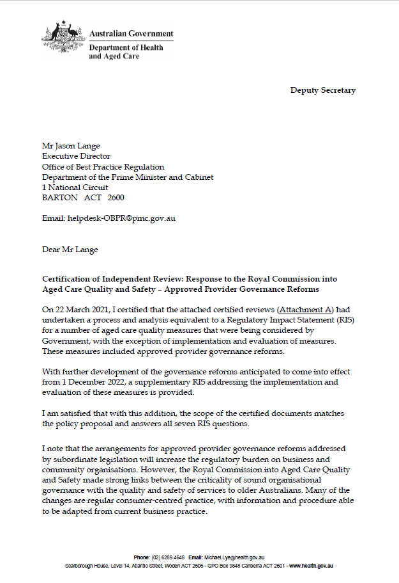

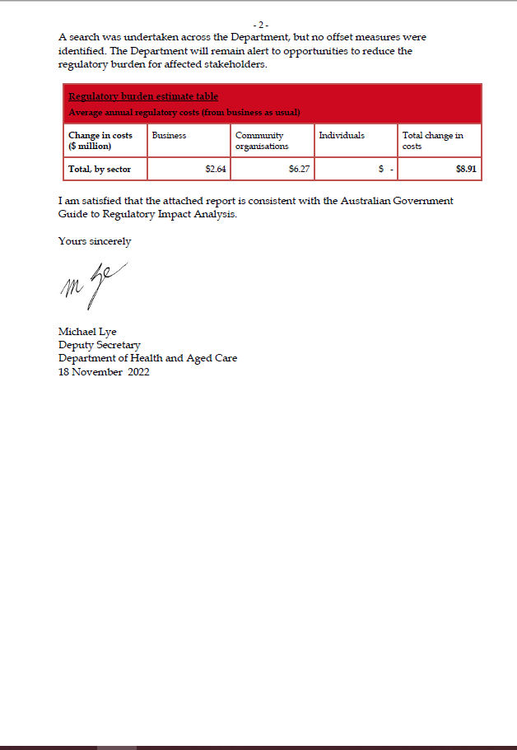

**Reforms** **to Strengthening Aged Care Approved Provider Governance**

**Supplementary Regulatory Impact Analysis**

**November 2022**

# Purpose of this document

This Supplementary Regulatory Impact Analysis has been prepared by the Department of Health and Aged Care (the Department) to inform Australian Government decision-making on subordinate legislative reforms to strengthen aged care approved provider governance.

This supplementary analysis complements the certification by the Department that independent reviews undertook a process and analysis equivalent to a Regulatory Impact Statement (RIS) for certain aged care quality measures (included the Strengthening Aged Care Approved Provider Governance reforms) contained in the [*Aged Care and Other Legislation Amendment (Royal Commission Response) Act 2022* (the Act).](https://www.legislation.gov.au/Details/C2022A00034) The Office of Best Practice Regulation (OPBR) found the scope of the certified review covered the policy proposals except for implementation and evaluation of measures **(refer Attachment A**).

As subordinate legislation is now being prepared to support the Act’s provider governance reforms, a supplementary RIS analysis is required for the implementation and evaluation of this measure. The implementation and evaluation measures address RIS *Question 7 - How Will You Implement and Evaluate Your Chosen Option?*

# Background

On 2 August 2022, the Government passed the Act which contains nine measures in response to recommendations of the Aged Care Quality and Safety (Royal Commission).

Schedule 5 of the Act amends the *Aged Care Act 1997* and the *Aged Car*e *Quality and Safety Commission Act 2018* to improve the governance of approved providers of Commonwealth-funded aged care. From 1 December 2022, new governance responsibilities will commence for approved providers in relation to the membership of their governing bodies and the establishment of new advisory bodies, as well as measures to improve leadership and culture. Schedule 5 also introduces new reporting responsibilities for approved providers, which will help care recipients and their families to understand the operations of providers.

These measures are aimed at improving transparency and accountability and ensuring the focus of approved providers, from the top down, is on the best interests of care recipients.

Schedule 5 of the Act aligns with Recommendations 88 to 90 of the Royal Commission, which noted the importance of good provider governance arrangements to the provision of high-quality care for care recipients.

The Act allows for extra details about how these governance arrangements are to be implemented. These legislative rules will be set out in subordinate legislation.

## The importance of provider governance

The governing body (for example, a Board) of a provider is responsible for the safe and quality care and services delivered to care recipients.

The governing body sets the strategic priorities for the provider’s organisation. It plays a critical role in setting the provider’s culture and whether this is focused on safety, quality and the best interests of care recipients.

The Royal Commission noted the need for aged care providers to have strong governance arrangements. Provider governance and management impacts all aspects of aged care.

The Royal Commission recommended introducing new legislation by 1 January 2022 to strengthen provider governance. The Act will place new requirements on providers from 1 December 2022 in relation to:

* the membership of governing bodies
* the provider’s constitution
* advisory bodies
* staff qualifications, skills and experience
* the suitability of key personnel in the provider’s organisation
* giving annual information to the Secretary of the Department.

### Membership of governing bodies

The reforms in the Act will introduce new responsibilities for the membership of governing bodies that will mean certain approved providers must have:

* a majority of the members on their governing body be independent non-executive members
* at least one member on their governing body who has clinical care experience.

These responsibilities will not apply to approved providers, if:

* the governing body has fewer than five members; and
* the approved provider provides care to fewer than 40 care recipients across their services; and
* the approved provider is a kind of body that is known as an Aboriginal Community Controlled Organisation.

This responsibility also does not apply to approved providers that are a State or Territory, a State or Territory authority, or a local government authority.

Under the arrangements in the Act, an approved provider may apply to the Aged Care Quality and Safety Commissioner (Commissioner) for a determination that either or both of the above responsibilities do not apply for a period of time.

When deciding that these responsibilities do not apply, the Commissioner may consider several matters such as:

* the number of care recipients,
* the location of the provider’s services, and
* any arrangements the provider has made to support members of the governing body in their decision making (such as seeking advice from a person with clinical care experience).

**Start date:** 1 December 2022. However, providers who are approved before 1 December2022, will have until 1 December 2023 to meet these new responsibilities.

### Provider’s constitution

The reforms in the Act will mean certain organisations need to ensure their constitution does not allow a director to act other than in the best interests of the approved provider. This responsibility will apply to certain approved providers who are:

* incorporated or taken to be incorporated under the *Corporations Act 2001*; or
* an Aboriginal and Torres Strait Islander corporation within the meaning of the *Corporations (Aboriginal and Torres Strait Islander) Act 2006*.

**Start date:** 1 December 2022. However, providers who are approved before 1 December2022, will have until 1 December 2023 to meet these new responsibilities.

### Advisory bodies

#### Quality care advisory body

The reforms in the Act will mean approved providers have to create, and maintain, a quality care advisory body. This body is to help keep the governing body informed about the quality of care delivered by the provider’s service/s.

The reforms will mean the quality care advisory body has to give the provider’s governing body a written report on the quality of the aged care provided for each aged care service at least once every six months. The quality care advisory body can also give feedback to the provider’s governing body about the quality of care of a service.

Under the reforms, the governing body will have to consider the report and any other feedback from the quality care advisory body when making decisions about the quality of care and tell the quality care advisory body in writing of how the feedback was considered.

#### Consumer advisory body

The reforms in the Act will mean that, at least once every 12 months, approved providers have to offer care recipients and their representatives the opportunity to create a consumer advisory body. Its purpose is to give the provider’s governing body feedback about the quality of care delivered at a provider’s service/s.

If the consumer advisory body is created, the governing body must consider its feedback when making decisions about the quality of care and tell the consumer advisory body in writing of how the feedback was considered.

**Start date:** 1 December 2022. However, providers who are approved before 1 December 2022, will have until 1 December 2023 to meet these new responsibilities.

### Staff qualifications, skills and experience

The new legislation will mean the governing body must ensure the approved provider’s staff members:

* have appropriate qualifications, skills or experience to provide the care or other services to care recipients through an aged care service; and
* have opportunities to develop their capability to provide that care or those other services.

**Start date:**1 December 2022. However, providers who are approved prior to 1 December2022, will have until 1 December 2023 to meet these new responsibilities.

### Suitability of key personnel

Under current aged care legislation, the key personnel of an approved provider include:

* people responsible for the nursing services who hold a recognised qualification in nursing, and
* any person who is responsible for the day-to-day operations of an aged care service.

For providers who are not a State or Territory it also includes:

* a member of the group responsible for executive decisions, and
* a person who has authority/responsibility for, or significant influence over, the planning, direction or control of the provider’s activities.

The reforms in the Act will mean that, at least once every 12 months, approved providers must consider the suitability of their key personnel and be satisfied that their key personnel are suitable to be involved in providing aged care. Providers must keep a record of this.

Key personnel must tell the provider of changes in their circumstances that may affect their suitability to provide aged care.

In addition, approved providers must tell the Aged Care Quality and Safety Commission (Commission) of any changes to key personnel within 14 days of the change. This includes a change of circumstances that is about the suitability of their key personnel involved in providing aged care.

The Commission will have the power to ask the approved provider for information relevant to the suitability of key personnel at any time.

The Commissioner may decide that an individual who is a key personnel of an approved provider is not suitable to provide aged care and that a provider must take action to stop the individual being one of their key personnel.

**Start date**: 1 December 2022 for all approved providers.

### Responsibility to give information and statements to the Secretary

The reforms in the Act mean approved providers will need to give the Secretary of the Department specified information and statements in relation to an annual reporting period. This information is intended to be published on My Aged Care to help care recipients and their families to better understand the provider’s operations.

**Proposed start date:** Approved providers will need to submit information for the 2022-23 financial year to the Department by 31 October 2023.

## Further issues to be addressed by subordinate legislation

Rules are also being prepared to support the application of the above requirements. These rules, to be contained in subordinate legislation, are to address the following issues:

* Membership of the quality care advisory body
* Quality care advisory body reports to the governing body
* Responsibilities relating to the giving of information relating to reporting periods
* Records to be kept by approved providers, including records about the suitability matters considered by an approved provider.

#### Membership of the quality care advisory body

The subordinate legislation will set out the membership requirements of the quality care advisory body. It is proposed that the legislation set out minimum requirements that apply to all approved providers and would allow providers to include extra members on their quality care advisory body if they wished.

#### Quality care advisory body’s report to the governing body

The subordinate legislation will set out the matters that the quality care advisory body report must consider as part of its written report given to the governing body of an approved provider about the quality of aged care that the approved provider provides through an aged care service The report is to include any concerns that the quality care advisory body has about the quality of aged care provided by the approved provider. concerns about care .

***Responsibility to give information and statements to the Secretary***

The subordinate legislation will set out the information the provider must give to the Secretary in relation to reporting periods . An information and communication technology (ICT) capability is to be developed to reduce duplication of reporting for providers where information has already been collected by the Department.

#### Proposed records to be kept by approved providers:

The subordinate legislation will set out the records a provider will need to keep as evidence they comply with the above proposed governance obligations. It is proposed that approved aged care providers be required to keep records regarding:

* Membership of the governing body
* Quality care advisory body
* Consumer advisory body
* Governing body responsibility for staff members
* Suitability of key personnel

Public consultation on subordinate legislation

Public consultation on the proposed subordinate legislation changes occurred during the period 21 December 2021 and 18 January 2022. Information on the public consultation is available at: <https://consultations.health.gov.au/aged-care-reform-compliance-division/strengthening-aged-care-provider-governance-consul/>

The Department undertook targeted consultation on provider governance initiatives with aged care stakeholder and consumer reference groups during the period of December 2021 to September 2022.

The Department published the draft subordinate legislation and the accompanying Explanatory Statement on the Department’s website on 31 October 2022 and provided a 14-day period for comment.