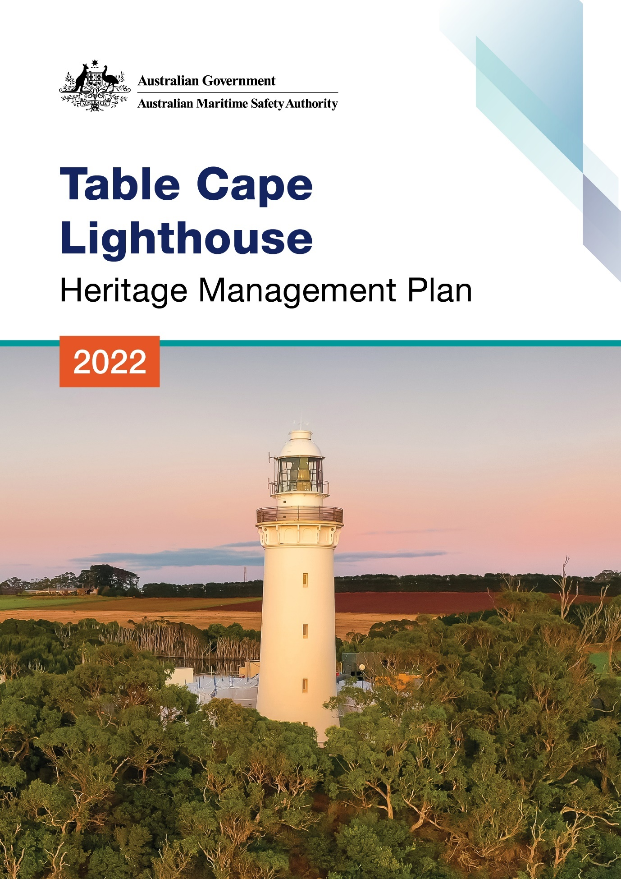

The Australian Maritime Safety Authority makes this heritage management plan under section 341S of the Environment Protection and Biodiversity Conservation Act 1999 (Cth) for Table Cape Lighthouse.
6 December 2022
Mick Kinley
Chief Executive Officer

Copyright
© Australian Maritime Safety Authority

The Australian Maritime Safety Authority encourages the dissemination and exchange of information provided in this publication.

Except as otherwise specified, all material presented in this publication is provided under Creative Commons Attribution 4.0 International licence. This excludes:
- the Commonwealth Coat of Arms
- this department's logo
- content supplied by third parties.

The Creative Commons Attribution 4.0 International Licence is a standard form licence agreement that allows you to copy, distribute, transmit and adapt this publication provided that you attribute the work. The details of the version 4.0 of the licence are available on the Creative Commons website, as is the full legal code for that licence.

Third Party Copyright
Some material in this document, made available under the Creative Commons Licence framework, may be derived from material supplied by third parties. The Australian Maritime Safety Authority has made all reasonable efforts to identify content supplied by third parties using the following format ‘© [name of third party]’ or ‘Source: [name of third party]’. Permission may need to be obtained from third parties to re-use their material.

Acknowledgements
The Australian Maritime Safety Authority acknowledges the Traditional Custodians of country throughout Australia and their connections to land, sea and community.
Contact
Comments or questions regarding this document should be addressed to:
The Australian Maritime Safety Authority,
Manager Asset Management and Preparedness,
PO Box 10790,
Adelaide Street, Brisbane QLD 4000

Phone: (02) 6279 5000 (switchboard)
Email: Heritage@amsa.gov.au
Website: www.amsa.gov.au

Attribution
AMSA’s preference is that you attribute this publication (and any material sourced from it) using the following wording:
Source: Australian Maritime Safety Authority Table Cape Lighthouse Heritage Management Plan – 2022
Front cover image
Figure 1. Table Cape Lighthouse (Source: iStock.com/UWPhotog
More information
For enquiries regarding copyright including requests to use material in a way that is beyond the scope of the terms of use that apply to it, please contact us through our website: www.amsa.gov.au

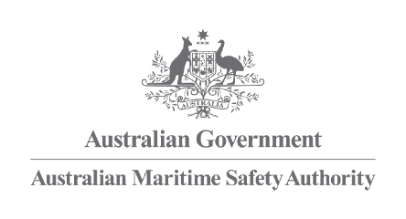

Table Cape
Lighthouse

Heritage Management Plan
2022

Table of Contents
Executive summary
- Introduction
  - Background and purpose
  - Heritage management plan objectives
  - Methodology
  - Status
  - Authorship
  - Acknowledgements
  - Language
  - Previous reports
  - Sources of information and images

- Table Cape lighthouse site
  - Location
  - Setting and landscape
  - Lease and ownership
  - Access
  - Listings

- History
  - General history of lighthouses in Australia
  - The Commonwealth Lighthouse Service
  - Tasmanian lighthouse management administration
  - Table Cape: a history
  - Planning a lighthouse
  - Lighthouse keeping
  - Chronology of major events
  - Changes and conservation over time
  - Summary of current and former uses
  - Summary of past and present community associations
  - Unresolved questions or historical conflicts
  - Recommendations for further research

- Fabric
  - Register
  - Related objects and associated AMSA artefacts
  - Comparative analysis

- Heritage significance
  - Commonwealth heritage listing – Table Cape Lighthouse
  - TAS State Heritage Register – Table Cape Lighthouse
  - Condition and integrity of the Commonwealth heritage values
  - Gain and loss of heritage values

- Opportunities and constraints
  - Implications arising from significance
  - Framework – sensitivity to change
  - Statutory and legislative requirements
  - Operational requirements and occupier needs
  - Proposals for change
  - Potential pressures
  - Processes for decision-making

- Conservation management principles and policies

- Policy implementation schedule
  - Plan
  - Monitoring and reporting

- Appendices
Appendix 1. Glossary of heritage conservation terms
Appendix 2. Glossary of historic lighthouse terms relevant to Table Cape
Appendix 3. Table demonstrating compliance with the EPBC Regulations
Appendix 4. Table Cape current light details.
Endnotes
Reference list

List of Figures
Figure 1. Table Cape Lighthouse (Source: iStock.com/UWPhotog)
Figure 2. Planning processes applied for heritage management (Source: Australia ICOMOS, 1999)
Figure 3. Location of Table Cape Lighthouse within Tasmania (Imagery ©2021 TerraMetrics, Map Data ©2021 Google)
Figure 4. Table Cape and lighthouse, Tasmania (Imagery ©2021 CNES/Airbus, Maxar Technologies, Map data: ©2021 Google)
Figure 5. View of Table Cape Tulip Farm from Lighthouse tower (© AMSA, 2018)
Figure 6. View from lighthouse tower of Conservation Area vegetation along cliff-side (© AMSA, 2017)
Figure 7. Table Cape Lighthouse, AMSA Map of Lease 2018 (Map data: © Esri, DigitalGlobe, GeoEye, Earthstar Geographics, CNES/Airbus DS, USDA, USGS, AeroGRID, IGN, and the GIS User Community)
Figure 8. Roundabout and carpark at base of lighthouse tower (© AMSA, 2018)
Figure 9. Barrier across Lighthouse Rd leading to Table Cape tower (© AMSA, 2018)
Figure 10. Incandescent oil vapour lamp by Chance Brothers (Source: AMSA)
Figure 11. Diotpric lens on display at Narooma (Source: AMSA, 2011)
Figure 12. Dalén’s system - sunvalve, mixer, flasher and cylinder (Source: AMSA)
Figure 13. Design blueprint for Table Cape Lighthouse, 1887. Courtesy of the National Archives of Australia: A9568, 5/14/1 (© Commonwealth of Australia, National Archives of Australia)
Figure 14. Table Cape Lighthouse. Courtesy of the National Archives of Australia: A1200, L10744 (© Commonwealth of Australia, National Archives of Australia)
Figure 15. Farmer tending fields by Table Cape Lighthouse, 1948. Courtesy of the National Archives of Australia: A1200, L10749 (© Commonwealth of Australia, National Archives of Australia)
Figure 16. Mersey Bluff Lighthouse, Tasmania, first lit 1889 (Source: AMSA, 2010)
Figure 17. Table Cape Lighthouse, Tasmania, first lit 1888 (Source: AMSA)

Acronym List
List of acronyms utilised throughout this heritage management plan:
Acronym | Definition
AGA | Gas Accumulator Company
AMSA | Australian Maritime Safety Authority
AMSG | Australian Maritime Systems Group
AtoN | Aid to Navigation
BBT | Barbier, Benard, et Turenne
CHL | Commonwealth Heritage List
EPBC Act | Environment Protection and Biodiversity Conservation Act 1999 (Cth)
EPBC Regulations | Environment Protection and Biodiversity Conservation Regulations 2000 (Cth)
HMP | Heritage Management Plan
IALA | International Association of Marine Aids to Navigation and Lighthouse Authorities
LED | Light emitting diode
NAA | National Archives of Australia
NES | National Environmental Significance
NLA | National Library of Australia
RMS | Record Management System
RNE | Register for the National Estate (non-statutory archive)
THR | Tasmanian Heritage Register

Executive Summary
Table Cape Lighthouse is a historic site recognised by both Commonwealth Government and Tasmanian State Government. The lighthouse was placed on the Commonwealth Heritage List in 2004 for its contribution to the development of marine navigation in Bass Strait, its distinctive design, and aesthetic values as a prominent landmark.
Table Cape Lighthouse is listed on the Tasmanian State Heritage Register for its contribution to the development of the Table Cape region, its representation of a characteristic Victorian brick lighthouse, and immense community values as a prominent landmark.
Built in 1888, the lighthouse is situated on Table Cape, a flat-topped promontory located on Tasmania’s north coast. Originally accompanied by keepers’ cottages and a flagstaff, the lighthouse tower is now the only structure found at the site and is leased by the Australian Maritime Safety Authority (AMSA) from the Tasmanian State Government.
Fitted with its original 2nd Order Chance Brothers Co. 700mm focal radius fixed lens, the lighthouse now operates on an automated mechanism with a Light Emitting Diode (LED) lightsource as part of AMSA’s network of marine aids to navigation (AtoN). The equipment is serviced by AMSA’s maintenance contractor who visits at least once each year. AMSA officers visit on an ad hoc basis for auditing, project and community liaison purposes.
This heritage management plan concerns the lighthouse, however it also addresses the management of the surrounding precinct and land which is managed by the Minister administering the National Parks and Wildlife Act 1970 (TAS). The plan is intended to guide our decisions and actions. AMSA has prepared this plan to integrate the heritage values of the lighthouse in accordance with the Environment Protection and Biodiversity Conservation Act 1999 (Cth) (EPBC Act), and the Environment Protection and Biodiversity Conservation Regulations 2000 (Cth) (EPBC Regulations).
Well-built and generally well-maintained, the lighthouse precinct is in relatively good, stable condition. The policies and management guidelines set out in this heritage management plan strive to ensure the Commonwealth heritage values of Table Cape Lighthouse are recognised, maintained and preserved for future generations.

- Introduction
  - Background and purpose
The Australian Maritime Safety Authority (AMSA) is the Commonwealth agency responsible for marine aids to navigation. AMSA’s network includes the Table Cape lighthouse built in 1888.
Section 341S of the Environment Protection and Biodiversity Conservation Act 1999 (Cth) (EPBC Act) requires AMSA to prepare a management plan for Table Cape Lighthouse that addresses the matters prescribed in Schedules 7A and 7B of the Environment Protection and Biodiversity Conservation Regulations 2000 (Cth) (EPBC Regulations). The principal features of this management plan are:
- a description of the place, its heritage values, their condition and the method used to assess its significance
- an administrative management framework
- a description of any proposals for change
- an array of conservation policies that protect and manage the place
- an implementation plan
- ways the policies will be monitored and how the management plan will be reviewed.

AMSA has prepared this heritage management plan to guide the future conservation of the place. This plan provides the framework and basis for the conservation and best practice management of the Table Cape Lighthouse in recognition of its heritage values. The policies in this plan indicate the objectives for identification, protection, conservation and presentation of the commonwealth heritage values of the place. Figure 2 shows the basic planning process applied.
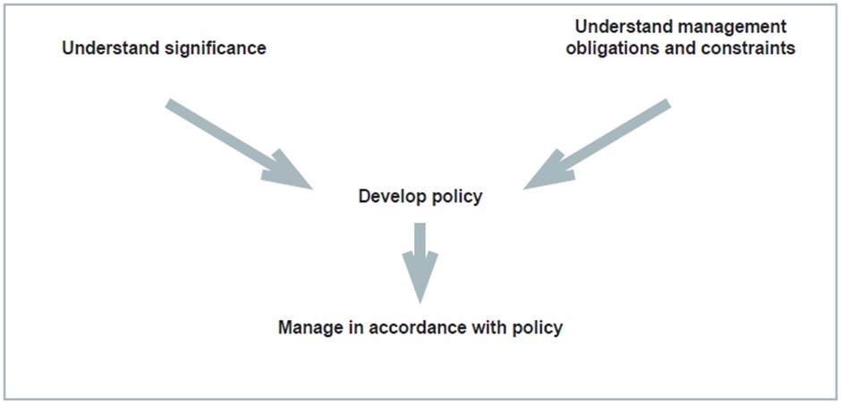 Figure 2. Planning process applied for heritage management (Source: Australia ICOMOS, 1999)

1.2 Heritage management plan objectives
The objectives of this heritage management plan are to:
- protect, conserve and manage the Commonwealth heritage values of the Table Cape Lighthouse.
- interpret and promote the Commonwealth heritage values of the Table Cape Lighthouse.
- manage use of the lighthouse.
- use best practice standards, including ongoing technical and community input, and apply best available knowledge and expertise when considering actions likely to have a substantial impact on Commonwealth heritage values.

In undertaking these objectives, this plan aims to:
- Provide for the protection and conservation of the heritage values of the place while minimising any impacts on the environment by applying the relevant environmental management requirements in a manner consistent with Commonwealth heritage management principles.
- Take into account the significance of the region as a cultural landscape occupied by Aboriginal people over many thousands of years.
- Recognise that the site has been occupied by lease holders since the early 20th century.
- Encourage site use that is compatible with the historical fabric, infrastructure and general environment.
- Record and document maintenance works, and changes to the fabric in the Table Cape Lighthouse fabric register (see 4.1 Fabric).

The organisational planning cycle and associated budgeting process is used to confirm requirements, allocate funding and manage delivery of maintenance activities. Detailed planning for the AtoN network is managed through AMSA’s internal planning processes.
An interactive map showing many of AMSA’s heritage sites, including Table Cape, can be found at AMSA Heritage Lighthouses Interactive MapP0FP0FPP.

  - Methodology
The methodology used in the preparation of this plan is consistent with the recommendations of The Burra Charter and with the requirements of Chapter 5, Part 15 Division 1A of the EPBC Act. In particular, the plan:
- details the history of the site based on information sourced from archival research, expert knowledge, and documentary resources.
- provides a description of the site based on information sourced from site inspection reports and fabric registers.
- details the Commonwealth heritage criteria satisfied by Table Cape as set out by Schedule 7A of the EPBC Regulations.

The criterion set out at Schedule 7A (h) (i-xiii) informed the development of the required policies for the management of the Table Cape Lighthouse, in conjunction with input from the Department of Agriculture, Water and the Environment on best practice management.
Consultation
Consultation with the Waratah-Wynyard Council was undertaken in September 2020, and AMSA was provided feedback concerning minor historical information. This was included within the plan. AMSA consulted with the Tasmanian Parks and Wildlife Service (TPWS) in February 2022 and were provided with historical photographs of the lighthouse.
In preparation of the plan, AMSA initiated contact in September 2021 with the Tasmanian Aboriginal Corporation (Burnie office), Tasmania Aboriginal Corporation (Launceston) and Circular Head Aboriginal Corporation in under direction from the Department of Primary Industries, Parks, Water and Environment TAS (Aboriginal Heritage Tasmania). Future versions of the plan will include an update on this consultation progress.
In accordance with the EPBC Regulations, the draft heritage management plan was made available on AMSA’s website from 7 March 2022 – 1 April 2022. A notice was placed in The Australian newspaper on 7 March 2022 informing the general public that a plan had been drafted and was available for review and feedback on AMSA’s website. No comments were received.
  - Status
This plan has been adopted by AMSA in accordance with Schedule 7A (Management plans for Commonwealth Heritage places) and Schedule 7B (Commonwealth Heritage management principles) of the EPBC Regulations to guide the management of the place and for inclusion in the Federal Register of Legislative Instruments.
  - Authorship
This plan has been prepared by AMSA. At the initial time of publication, the Australian Maritime Systems Group (AMSG) was the contract maintenance provider for the Commonwealth Government’s AtoN network including Table Cape Lighthouse.
  - Acknowledgements
AMSA acknowledges the professional assistance of the Waratah-Wynyard Council, the Tasmanian Parks and Wildlife Service, and the Department of Primary Industries, Parks, Water and Environment (TAS).
  - Language
For clarity and consistency, some words in this plan such as restoration, reconstruction and preservation, are used with the meanings defined in the Burra Charter. (See Appendix 1 Glossary of heritage conservation terms). Also see Appendix 2 Glossary of lighthouse terminology relevant to Table Cape which sets out the technical terminology used in this plan.
  - Previous reports
A ‘Table Cape Lighthouse Conservation Management Plan’ was prepared in 2010 for the Waratah Wynyard Council and Heritage Tasmania.
A ‘Heritage Lighthouse Report: Table Cape’ was prepared in 2007 by Peter Marquis-Kyle for AMSA.
A 'Heritage Asset Condition Report' (3rd Revision) was prepared in 2019 by AMSG for AMSA.
  - Sources of information and images
This plan has used a number of sources of information. This includes the National Archives of Australia (NAA), the National Library of Australia (NLA) and AMSA’s heritage collection.


- Table Cape Lighthouse site
  - Location
Table Cape Lighthouse is located on the northern coast of Tasmania, Australia. Situated approximately 5 kilometres north of the township of Wynyard, the lighthouse was built on Table Cape overlooking Bass Strait – a passage of water separating Tasmania from the Australian mainland. The lighthouse stands on the high, flat-topped cliffs approximately 170 metres above sea level.
Coordinates: 40º 56.7957’ S, 145º 43.7439’ E
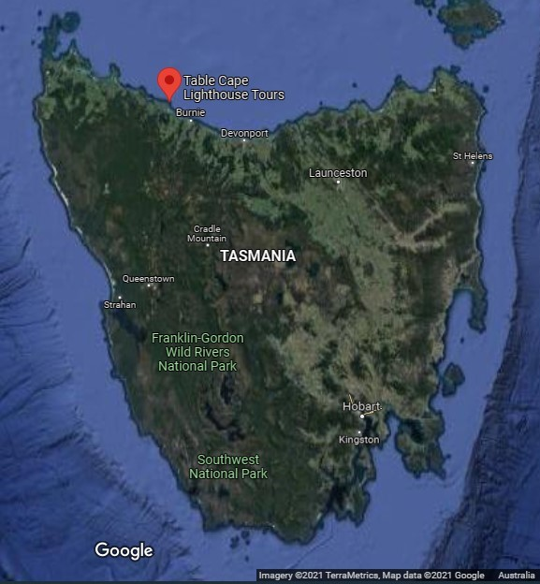
Figure 3. Location of Table Cape Lighthouse within Tasmania (Imagery ©2021 TerraMetrics, Map Data: ©2021 Google)

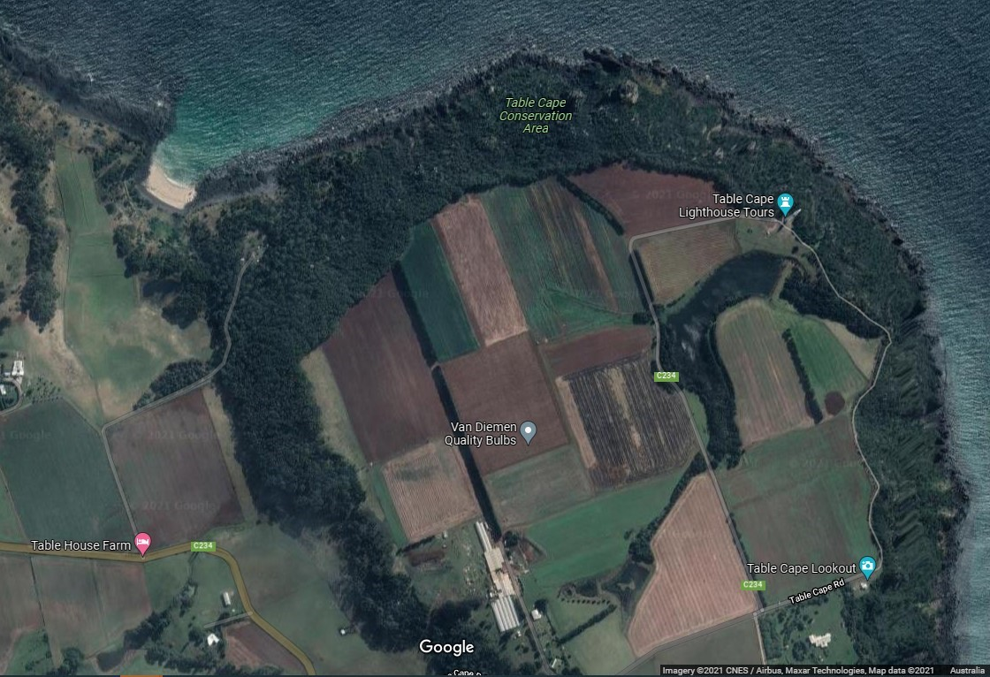
Figure 4. Table Cape and lighthouse, Tasmania (Imagery ©2021 CNES/Airbus, Maxar Technologies, Map data: ©2021 Google)
  - Setting and landscape
Table Cape and its flat-topped cliffs are the remnants of a 12 million-year-old volcano. Its nutritious soil encouraged the establishment of various farms along the Cape which has resulted in the land’s division into large, open fields. Table Cape Lighthouse is nestled between the Table Cape Conservation Area’s cliff edge and the Table Cape Tulip Farms.
A lookout was established on the Cape’s cliff-edge approximately 500 metres south of the lighthouse.
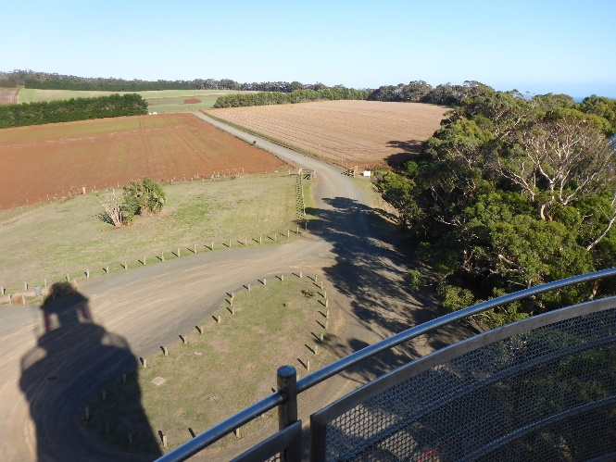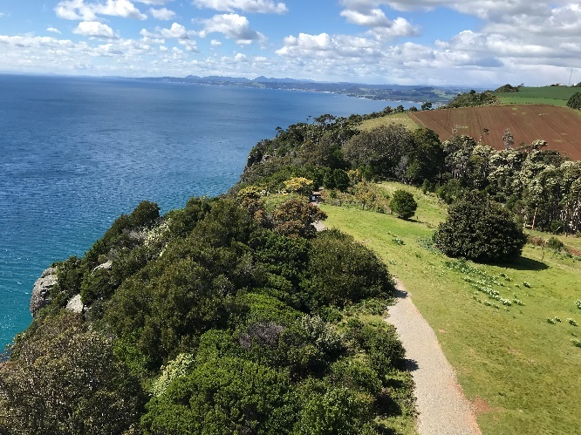
Figure 5. View of Table Cape Tulip Farm from lighthouse tower (© AMSA, 2018)
Figure 6. View from lighthouse tower of Conservation Area vegetation along cliff-side (© AMSA, 2017)

Fauna and flora
Table Cape is widely renowned for its tulip harvests each spring. Covering the Cape in wild patchwork colours, the harvest produces a variety of tulip, daffodil and lilium species. The lighthouse also borders the Cape’s 1.26 kilometre-squared conservation area which is primarily comprised of dense scrubland.
In regards to local fauna, dolphins have been recorded in the waters below the lighthouse, and the endangered Beddomeia capensis, a freshwater snail, is found only in the Table Cape area.

  - Lease and ownership
AMSA leases the lighthouse from the Minister administering the National Parks and Wildlife Act 1970 (TAS). The leased area is comprised of two lots:
- Lot 1: Lighthouse Tower (819 metre-squared)
- Lot 2: (150 metre-squared)
Owing to the popularity of the site, the lease stipulates that guided tours are permitted on-site. AMSA upholds a tourism licence with the Minister administering the National Parks and Reserves Management Act 2002 (TAS) which allows guided tour groups access inside the tower from sunrise to sunset. Access to the lantern room and basement is restricted to authorised personnel only. A tourist sub-licence was granted to the Waratah Wynyard Council, and tours are currently carried out inside the lighthouse tower.
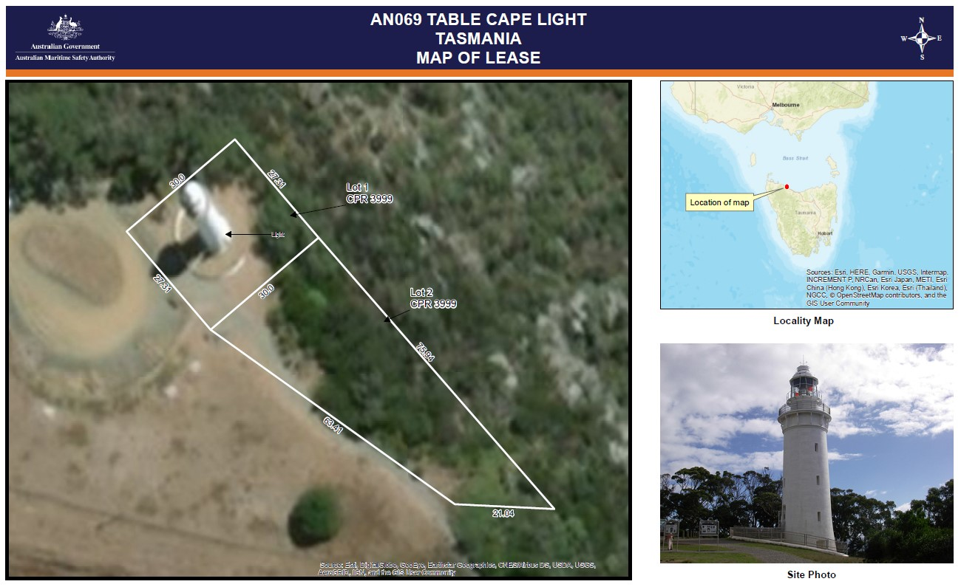
Figure 7. Table Cape Lighthouse, AMSA Map of Lease 2018 (Map data: © Esri, DigitalGlobe, GeoEye, Earthstar Geographics, CNES/Airbus DS, USDA, USGS, AeroGRID, IGN, and the GIS User Community)
Table Cape Lighthouse is the only remaining structure from the lightstation. The land surrounding AMSA’s lease is managed by the Minister administering the National Parks and Wildlife Act 1970 (TAS).
  - Access
Table Cape Lighthouse can be accessed via Lighthouse Road (Table Cape, TAS) – however, this road is closed during nightfall (See Figure 8). The general public are permitted in the vicinity of the lighthouse, however internal access is reserved for authorised personnel and tour groups only.
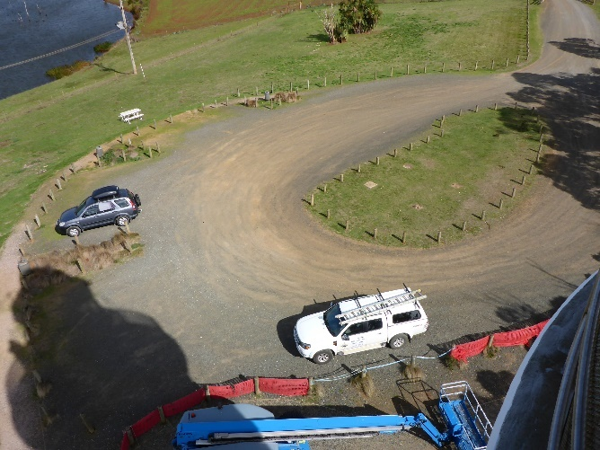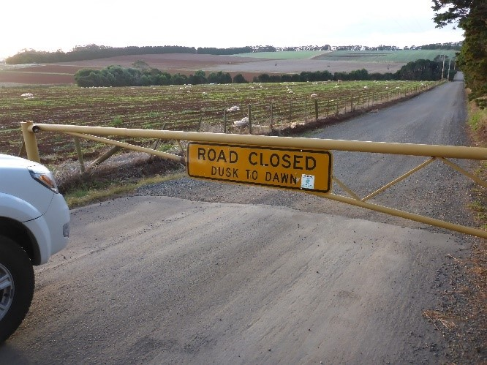
Figure 8. Roundabout and carpark at base of lighthouse tower (© AMSA, 2018).
Figure 9. Barrier across Lighthouse Rd leading to Table Cape tower (© AMSA, 2018)
  - Listings
Table Cape Lighthouse is listed on the following heritage registers:
Register | ID
Register for the National Estate (non-statutory archive) | 103605
Tasmanian Heritage Register | 5626
Commonwealth Heritage List | 105603


- History
  - General history of lighthouses in Australia
The first lighthouse to be constructed on Australian soil was Macquarie Lighthouse, located at the entrance to Port Jackson, NSW. First lit in 1818, the cost of the lighthouse was recovered through the introduction of a levy on shipping. This was instigated by Governor Lachlan Macquarie, who ordered and named the light.
The following century oversaw the construction of hundreds of lighthouses around the country. Constructing and maintaining a lighthouse were costly ventures that often required the financial support of multiple colonies. However, they were deemed necessary aids in assisting the safety of mariners at sea. Lighthouses were firstly managed by the colony they lay within, with each colony developing their own style of lighthouse and operational system. Following Federation in 1901, which saw the various colonies unite under one Commonwealth government, lighthouse management was transferred from state hands to the Commonwealth Lighthouse Service.

Lamps and optics: an overview
Lighthouse technology has altered drastically over the centuries. Eighteenth century lighthouses were lit using parabolic mirrors and oil lamps. Documentation of early examples of parabolic mirrors in the United Kingdom, circa 1760, were documented as consisting of wood and lined with pieces of looking glass or plates of tin. As described by Searle, ’When light hits a shiny surface, it is reflected at an angle equal to that at which it hit. With a light source is placed in the focal point of a parabolic reflector, the light rays are reflected parallel to one another, producing a concentrated beam’.
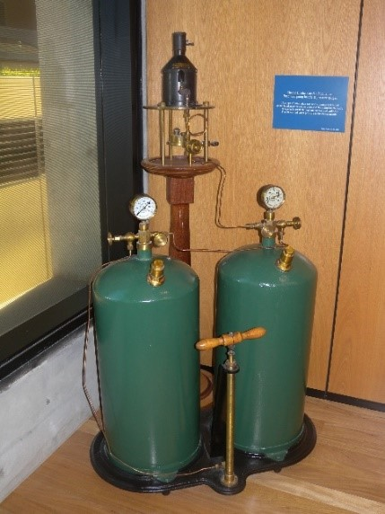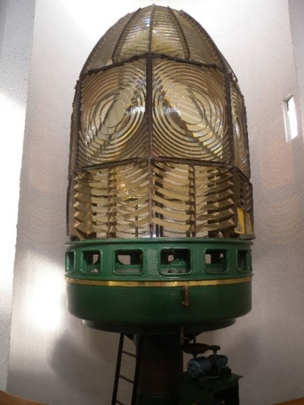
Figure 10. Incandescent oil vapour lamp by Chance Brothers (Source: AMSA)
Figure 11. Dioptric lens on display at Narooma (Source: AMSA)
In 1822, Augustin Fresnel invented the dioptric glass lens. By crafting concentric annular rings with a convex lens, Fresnel had discovered a method of reducing the amount of light absorbed by a lens. The Dioptric System was adopted quickly with Cordouran Lighthouse (France), which was fitted with the first dioptric lens in 1823. The majority of heritage-listed lighthouses in Australia house dioptric lenses made by others such as Chance Brothers (United Kingdom), Henry-LePaute (France), Barbier,
Bernard & Turenne (BBT, France) and Svenska Aktiebolaget Gasaccumulator (AGA of Sweden). These lenses were made in a range of standard sizes, called orders—see ‘Appendix 2. Glossary of lighthouse Terms relevant to Table Cape Lighthouse’.
Early Australian lighthouses were originally fuelled by whale oil and burned in Argand lamps, and multiple wicks were required in order to create a large flame that could be observed from sea. By the 1850s, whale oil had been replaced by colza oil, which was in turn replaced by kerosene, a mineral oil.
In 1900, incandescent burners were introduced. This saw the burning of fuel inside an incandescent mantle, which produced a brighter light with less fuel within a smaller volume. Lightkeepers were required to maintain pressure to the burner by manually pumping a handle as can be seen in Figure 8.
In 1912, Swedish engineer Gustaf Dalén was awarded the Nobel Prize in physics for a series of inventions relating to acetylene-powered navigation lights. Dalén’s system included the sun valve, the mixer, the flasher, and the cylinder containing compressed acetylene. Due to their efficiency and reliability, Dalén’s inventions led to the gradual de-staffing of lighthouses. Acetylene was quickly adopted by the Commonwealth Lighthouse Service from 1915 onwards.
Large dioptric lenses, such as that shown in Figure 9, gradually decreased in popularity due to cost and the move towards unmanned automatic lighthouses. By the early 1900s, Australia had stopped ordering these lenses with the last installed at Eclipse Island in Western Australia in 1927. Smaller Fresnel lenses continued to be produced and installed until the 1970s when plastic lanterns, still utilising Fresnel’s technology, were favoured instead. Acetylene remained in use until it was finally phased out in the 1990s.
In the current day, Australian lighthouses are lit and extinguished automatically using mains power, diesel generators, and solar-voltaic systems.
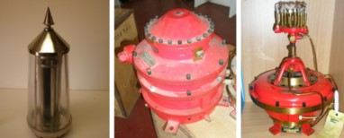
Figure 12. Dalén's system - sunvalve, mixer, flasher and cylinder (Source: AMSA)
  - The Commonwealth Lighthouse Service
When the Australian colonies federated in 1901, it was decided that the new Commonwealth government would be responsible for coastal lighthouses—that is, major lights used by vessels travelling from port to port—but not the minor lights used for navigation within harbours and rivers. There was a delay before this new arrangement came into effect. Existing lights continued to be operated by the states.
Since 1915, various Commonwealth departments have managed lighthouses. AMSA, established under the Australian Maritime Safety Authority Act 1990 (Cth), is now responsible for operating Commonwealth lighthouses and other aids to navigation, along with its other functions.
  - Tasmanian lighthouse management administration
The table below details the authorities of Tasmanian lighthouse management from 1915 to present.
Time Period | Administration
1915-1927:  1927-1963:  1963-1972:  1972-1982:  1982-1983:  1983-1985  1985-1987:  1987-1990:  1991- | Lighthouse District No. 3 (Victoria, New South Wales, Tasmania), Hobart Headquarters.  Deputy Director of Lighthouses and Navigation, Tasmania.  Department of Shipping and Transport, Regional Controller, Tasmania.  Department of Transport [III], Regional Controller, Tasmania.  Department of Transport and Construction. Victoria-Tasmania Region, Transport Division (Tasmania)  Department of Transport [IV] Victoria-Tasmania Region, Hobart Office.  Department of Transport [IV] Tasmanian Region.  Department of Transport and Communications, Tasmanian Region.  Australian Marine Safety Authority.

  - Table Cape: a history
Aboriginal history
There are two Aboriginal heritage sites (middens) that are recorded along the existing walking track, between the Lookout and Table Cape Lighthouse. The middens are recorded under the Tasmanian Aboriginal Site Index as AHR9172 and AHR9257.
It is understood that the nearby Freestone Cove was used as a site for stone tidal fish traps built by members of the clan.

Further consultation with local Traditional stakeholders will be reflected within this section of future versions of the plan.

Early European history
In 1798, British navigator and cartographer Matthew Flinders, and British explorer George Bass, traversed Bass Strait aboard the sloop Norfolk. After sighting a noticeable, flat-topped promontory along the northern coastline of Van Diemen’s Land, they named it Table Cape.
The area remained strictly inhabited by local Aboriginal communities until the mid-1850s.

In 1852, The Courier reported:

We perceive that about 1600 acres of land at Table Cape, Emu Bay, is offered to be let for the term of seven years at 5s. per acre; or to meet the convenience of all parties, the proprietor will let it in allotments from 10 acres and upwards for the term of five years, the first two years rent free. The proprietor to buy the grain at the Launceston market prices, allowing a deduction of 4d. per bushel for tonnage.

By 1856, a thriving colony had established itself along the Cape and surrounding region.
The Courier documented statements made by Sir H. Fox Young, Governor-in-chief of the Island of Tasmania and dependencies, in response to the Reverend George Wilkinson, a key settler at Table Cape:

I am rejoiced to find that the land upon which you have settled is of so productive a character, and it will afford me much pleasure to do all I can for the benefit of your neighbourhood….
This very spot, Table Cape, is a striking instance of what may be done by individual enterprise when facilities are accorded for the cultivation of soil.

A schoolroom, church, residential dwellings and farms were established on Table Cape as a steady population thrived over the 19th and 20th centuries.

  - Planning a lighthouse
Why Table Cape?
By the late 1870s and early 1880s, the adjacent port of Wynyard had grown into the biggest port along the north-west coast. Between 1869-1870, signal lamps, also known as iron beacons, were installed near the mouth of the Inglis River. However, by the mid-to-late 19th century, calls for a lighthouse had increased following the wrecking of the Emma Prescott (1867) and the Orson (1884).

The Tasmanian newspaper detailed these calls, reporting:

In March, 1875, Captain Barnard, R.N., Master Warden of the Hobart Board (presumably having received some urgent representations on the subject), wrote to the Launceston Board asking that circulars should be sent to masters of coasting and intercolonial vessels requesting information as to the need and most advantageous site of a lighthouse for the coastline in question. The result was that 31 replies were received, urging the erection of a light – twenty-four advocating the site of Table Cape, six Rocky Cape, and one Circular Head.”

Rocky Head/Cape, which had garnered some support amongst shipmasters, lay approximately 20 km north-west of Table Cape along the Tasmanian coastline. However the site was considered unwise for a light due to the lack of anchorage nearby, and the presence of a ‘dangerous rock’ with which a vessel could strike itself on whilst travelling by the light.
Table Cape was recognised as a prime position to alert incoming vessels to the west of Wynyard’s port. Rising approximately 500 ft. above sea level, the Cape offered a good vantage over the southern region of the Bass Strait, as well as suitable anchorage for vessels.

Mr Climie reportedly stated at a meeting of the Launceston Marine Board:

…there is a point on the face of the cliff well suited for a light. If a point could be got at about 250ft. above sea level it would be free from the fogs generally and no doubt a light placed on Table Cape at that elevation would be of great benefit to the coast.

Despite the ever-insistent requests for a lighthouse, the various marine boards of Tasmania were reluctant to action the works claiming “there was no necessity at present for a light at Table Cape”.

Eventually in 1880, the erection of a light on Table Cape was put towards the Consolidated Marine Board, a board comprised of members from both the Launceston and Hobart Marine Boards. Finally, the motion was accepted and by early 1883, a site on Table Cape had been inspected, selected and cleared.

Design and construction
The design for Table Cape Lighthouse was originally tasked to a Mr H. Conway, who visited the chosen site in 1883. Conway’s design was never completed and eventually in 1886, the Marine Board Architect, Mr. R. Huckson of Huckson & Hutchinson, was given the responsibility of designing the lighthouse. His designs displayed a brick structure approximately 50 ft. in height with two accompanying cottages.
Huckson & Hutchinson
Huckson & Hutchinson was founded in 1887 by Robert Huckson and R. Hutchinson. The firm was responsible for the design of many Tasmanian lighthouses including Table Cape, Mersey Bluff, Eddystone Point, Maatsuyker, Cape Sorrell, and Low Head. The firm also designed various alterations and necessary repairs to lightstations across the state.

On 9 February 1887, tenders were called for the construction of the lighthouse. The original estimate for the works was placed at £7,000, and Mr. John Luck’s tender of £4240 5s. 11d. was accepted for construction of the tower and keepers quarters. Construction began that same year. Approximately 110,000 red vitrified bricks were imported from Victoria for the construction of the lighthouse, and a hydraulic ram pumped water from the nearby creek to the site.
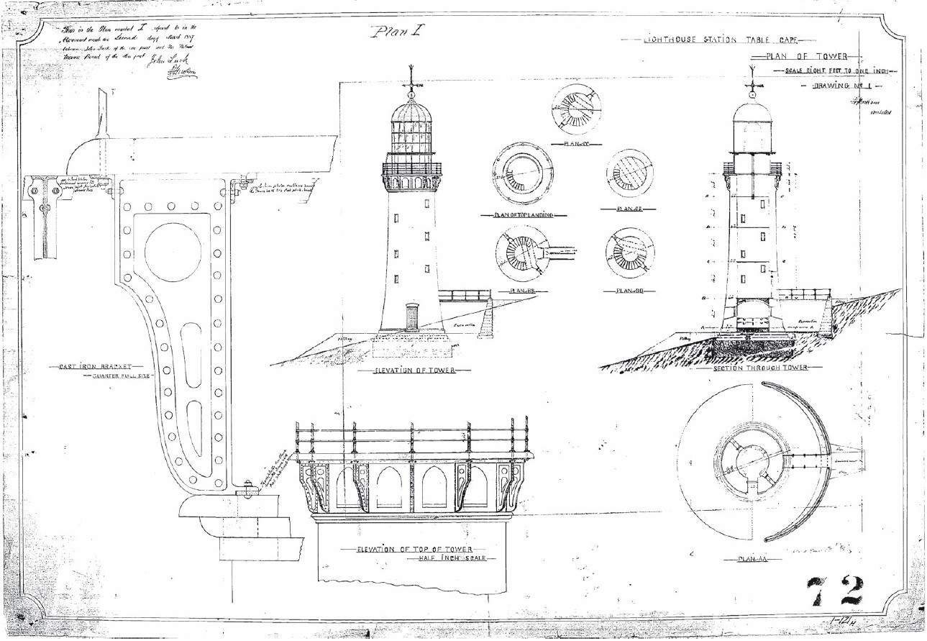Figure 13. Design blueprint for Table Cape Lighthouse, 1887. Image courtesy of the National Archives of Australia: A9568, 5/14/1 (© Commonwealth of Australia, National Archives of Australia)

Equipment when built
Upon completion, the lightstation consisted of the tower, a flagstaff, and two cottages to house the Head Lightkeeper, Assistant Lightkeepers, and their families.
The tower stood at 45 ft. in height, and the lantern at 25 ft. A vaulted chamber was constructed at the base of the tower to be used as a storeroom with an iron spiral staircase made up of 65 steps leading to the lantern room.

The following was the ‘Notice to Mariners’ published in The Mercury newspaper on 30 April 1888:

It is situated in lat. 41deg. 3 min. south; long. 145deg. 43min. 30sec. east (approximate). The tower is 50 ft. in height from the base of the lantern and is built of red bricks, and left in the natural colour. It will be a ‘fixed white light,’ dioptric, of the second order, visible all round seaward between the bearings of S. 61deg. E. round by N. to N. 66deg. W.; and will be elevated about 390ft. above the sea. It will be seen for a distance of 27 miles (nautical) in clear weather, and at lesser distances, according to the state of the atmosphere. The bearings are magnetic and seaward.

The light was a 2nd Order Chance Bros. Catadioptric 700 mm focal radius lens, and was first exhibited on 1 August 1888.

  - Lighthouse keeping
Lighthouse keeping was observed to be a valuable profession within local communities. Keepers would operate on shifts, taking it in turns to tend to the light through the night and watch for distressed vessels. It was often an isolating ordeal with very little contact with the surrounding communities. Stationed on-site within the keepers’ cottages, those employed at Table Cape were at least spared from total isolation as the region’s population had grown spectacularly over the course of the 19th century. However, life at the lighthouse was not without tragedy.
On 17 August 1888, just over two weeks following the lighthouse’s opening, the Head Lightkeeper’s infant son passed away. The lighthouse’s log book for that devastating day read:
Wind south. A strong breeze and misty weather. Employed in the lighthouse and cleaning up about station. At 5.10 p.m. Bertie Jackson, son of the head lightkeeper, departed this life aged one year and two months.
Following advice from the undertaker, the family chose to have Bertie buried on-site. The grave was maintained and remains viewable to passers-by with a headstone reading:
Bertram Jackson
Died – 17th Aug 1888
Infant son of Mary and Robert Jackson
Past Lighthouse Keepers
Aged 1 yr 2 mths 1888

14 years later in March of 1902, the young son of Assistant Lightkeeper Arthur King died after falling from the cliff edge by the lighthouse.
In 1920, the light was converted to automated operation and the keepers were withdrawn sometime after. The keepers’ cottages were left to deteriorate until their demolition in 1926.
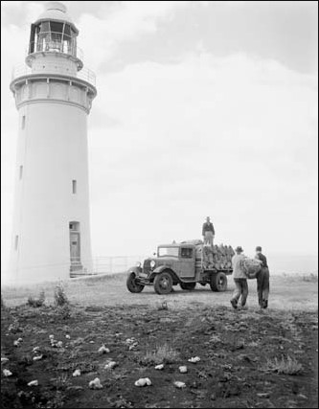
Figure 14. Table Cape Lighthouse Courtesy of the National Archives of Australia: A1200, L10744 (© Commonwealth of Australia, National Archives of Australia)
  - Chronology of major events
The following table details the timeline of major events to have occurred at Table Cape Lighthouse.
Date | Event
1 Aug 1888 | Light first exhibited from Table Cape Lighthouse.
17 Aug 1888 | Head Lightkeeper’s baby passes away shortly after being posted to the newly constructed lighthouse. Buried on-site at the Lighthouse.
26 Jan 1889 | Flagstaff reported missing from Table Cape.
2 Oct 1889 | School at Table Cape Lighthouse completed.
1899 | A third keepers’ cottage constructed onsite at lighthouse.
19 Mar 1902 | Son of Assistant Lightkeeper, Mr Arthur King, passes away after falling off the Cape’s cliff edge.
1917 | New flagstaff erected at Table Cape Lighthouse.
1920-23 | Lighthouse de-staffed following conversion to automated operation.
1926 | Keepers’ cottages demolished.
21 Oct 1980 | Table Cape Lighthouse listed on the Register of the National Estate.
1988 | 100th Anniversary celebrations held for the Table Cape Lighthouse.
Prior to 2007 | Table Cape Lighthouse listed on the Tasmanian State Heritage Register.
2004 | Table Cape Lighthouse included on the Commonwealth Heritage List.
2010 | Table Cape Lighthouse opened for tours.

  - Changes and conservation over time
Table Cape Lighthouse has undergone both physical and technological changes since its construction in 1888. The following section addresses these changes and the tower’s standing in present day.
The Brewis Report
Commander CRW Brewis, RN retired naval surveyor was commissioned in 1911 by the Commonwealth Government to report on the condition of existing lights and to recommend any additional ones. Brewis visited every lighthouse in Australia between June and December 1912 and produced a series of reports published in their final form in March 1913. These reports were the basis for future decisions made about individual lighthouses.
Brewis’ report on his visit to Table Cape Lighthouse captured the lighthouse as it stood in 1912. The recommendations made included altering the light’s character and intensity, and withdrawing one of the three keepers from service.
TABLE CAPE LIGHT (WYNYARD).
(11 miles from Emu Bay.)
Lat. 40º 57’ S., Long. 145º 45’ E., Charts Nos. 1695b and 1079.- Established in the year 1888.
Lloyd’s Signal Station, not connected by telephone.
Character.- One white, with red sectors, fixed dioptric. About 2,750 c.p. Visible from S. 56º E.,
through south, to N. 72º W.; red inshore of these bearings.
Brick tower, 50 feet. Height of focal plane, 390 feet above high water. Visible – white, in clear
weather, 27 nautical miles; red, 10 miles.
Condition and State of Efficacy.- The light-house tower and apparatus are in good condition
New flagstaff required. The light is of low brilliancy, considering that optic if of the 2nd Order. The
dwellings are in good repair and servicable.
Three men are stationed here. Only two light-keepers are necessary, and the staff should be regu-
lated accordingly. If required, assistance can always be obtained locally for relieving duties, &c.
Communication.- By road, 7 miles to Wynyard. Stores are landed at Wynyard by steamer every
quarter, and carted to light station.
RECOMMENDED.-
- The light be given a distinctive character, by inserting a revolving cylinder, actuated by
clockwork mechanism (to be wound every sixteen hours), thus converting the light from
fixed to flashing. Light characteristic – four flashes, each of one-third second duration,
in quick succession, every twelve seconds.
- The power of the light be increased from 2,750 c.p. to 20,000 c.p., and economy effected
in the consumption of oil by installing a 55 mm. incandescent mantle; illuminant,
vaporised kerosene.
- One light-keeper be withdrawn.

Alterations to the light
The following table outlines the technological alterations made to the Table Cape light.
Date | Alteration
1913 | Converted to vaporised kerosene operation.
1920 | Converted to automated operation.
1979 | Lighthouse connected to mains electrcity – electric lamp installed.
2008 | Light converted to12V 100W C8 Halogen LP PR30s.
2020 | Light converted to Sealite SL-LED-216-W

Recent conservation works
The following table outlines recent conservation works to have occurred at the lighthouse.
Date | Works Completed
2003 | 10 glazing panes replaced in lantern room.
2006 | Entry door repaired and security door fitted after being vandalised by an axe.
2010 | Road to lighthouse realigned and resurfaced.  Pedestrian pathways added around base of Lighthouse.  12.7mm steel mesh clamped to balcony handrail.  Non-slip paint applied to internal stairs.  10 polycarbonate windows removed and replaced with laminated safety glass.  12.7mm steel mesh clamped to internal balusters on four landings.
2020 | Lead paint removal and repainting of tower basement floor, bridge walkway, entrance level, and lantern room floor.  Corrosion reparation to metallic substrates and walkway bridge support beams.  Repairs to pre-cast concrete slabs (walkway bridge).

  - Summary of current and former uses
The Table Cape Lightstation originally comprised of separate keepers’ cottages and the tower itself. The keepers and their families resided onsite within the cottages and the tower was observed to be purely a vital worksite for marine safety.
Following the de-staffing of the lighthouse and the demolition of the cottages, the site remained closed to the general public until 2010. Table Cape Lighthouse was then opened for tourism under a license with AMSA.
At present day, the lighthouse’s AtoN capability remains its primary use.

  - Summary of past and present community associations
The lighthouse and its immediate surrounds maintain strong associations with a variety of groups locally, nationally and internationally.
Aboriginal heritage significance
The cape is a site of important Aboriginal heritage significance, and appreciation of this significance is paramount. Further consultation with local Traditional stakeholders will be included within this section.
Local, national and international associations
The site’s contribution to the development of the Table Cape district has cemented the lighthouse as a popular and significant local landmark.
As a manned site from its construction in 1888 until 1920, Table Cape Lighthouse maintains familial ties from past lightkeepers – ties that transcend local, national and international borders.

  - Unresolved questions of historical conflicts
The overall cost of the construction project is disputed amongst documents. The Tasmanian Heritage Register lists £3 970 was charged for the staircase and retaining wall, and an extra £2 265 for the light making a combined cost of £6 235. The 2010 Table Cape Conservation Management Plan details that the light apparatus cost a total of £1,869 16s. 9d. and cited sources that declared the total cost of the lighthouse to have cost upwards of £7 000.
Dates for when the Lighthouse school was discontinued are unclear, however sources appear to suggest it was still operating in 1904.
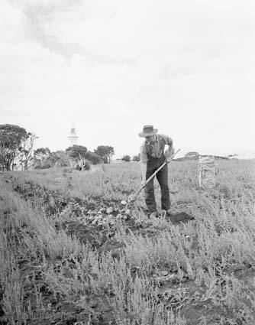
Figure 15. Farmer tending fields by Table Cape Lighthouse, 1948. Courtesy of the National Archives of Australia: A1200, L10749 (© Commonwealth of Australia, National Archives of Australia)
The lighthouse was originally left unpainted in its natural brick colour. The date for when it was painted white is unclear.
The third keeper’s cottage added to the station in 1899 was said to have replaced an unsuitable structure onsite. It is unclear of what this structure was and whether it was built alongside the other cottages in 1888.
There is conflict over when the lighthouse keepers were withdrawn from service at Table Cape. The 2010 Table Cape Conservation Management Plan details that the keepers were withdrawn in 1920 following the conversion to automatic operation, while other sources detail keepers remained onsite until 1923.
Any historical conflicts or unresolved questions brought to light concerning the lighthouse’s history will be included in this section within future plans.

  - Recommendations for further research
Further research into the lightkeepers stationed at Table Cape and their daily lives would provide valuable insight into the ordeals faced by keepers and their families who dedicated their time and effort to keep the fires burning.
Additionally, research into changes made to the tower and station as a whole, particularly regarding its major refurbishment in the 1970s, would provide greater insight into the transformation of the lightstation from its construction in 1888 to the present day.


- Fabric
4.1 Fabric register
The cultural significance of the lighthouse resides in its fabric, and also in its intangible aspects – such as the meanings people ascribe to it, and the connections to other places and things. The survival of its cultural value depends on a well-informed understanding of what is significant, and on clear thinking about the consequences of change. The Burra Charter sets out good practice for conserving cultural significance.
Criterion under 'Heritage Significance' refer to the criterion satisfied within the specific Commonwealth heritage listing (see section 5.1).

Images included in Sections 4.1 and 4.2 – © AMSA

Lighthouse feature: Lantern roof
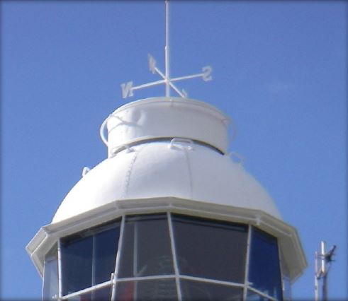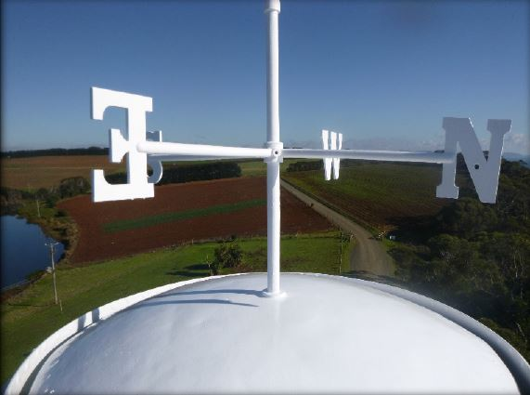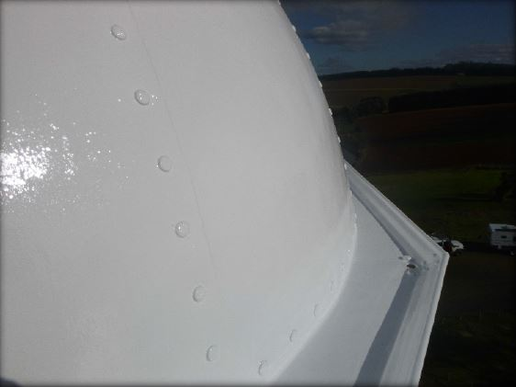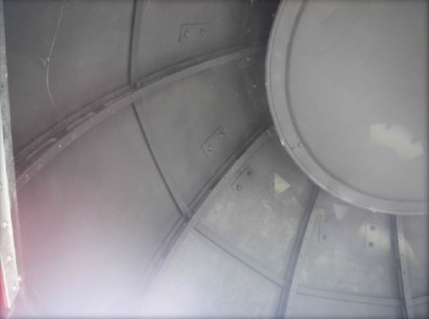
© AMSA 2019
Description and condition
1888 Chance Bros part spherical dome of copper sheets lapped and screwed to ribs.
- Ribs – Chance Bros cast iron radial ribs.
- Inner skin – none.
- Ventilator – drum type with direction pointers attached but no wind vane.
- Lightning conductor – vertical pole on centre of ventilator, extending the direction pointer support.
- Gutter – polygonal fabricated gutter attached to ring of cast iron pieces bolted together.
- External ladder – three handholds fixed to outside of roof; other handholds fixed around roof below the ventilator; one circular handrail attached to top of ventilator drum.
- Drip tray – copper dish suspended under ventilator.

Finish: | painted
Condition | intact and sound
Integrity | high
Significance | high
Maintenance | keep in service, prepare and repaint at normal intervals
Rectification works | none

Heritage significance: High
The lantern roof is an original and essential part of a lighthouse associated with the development of navigational aids along the Tasmanian coast (criteron a).
The lantern roof contributes to the aesthetic value of the lighthouse (criterion e).

Lighthouse feature: Lantern glazing
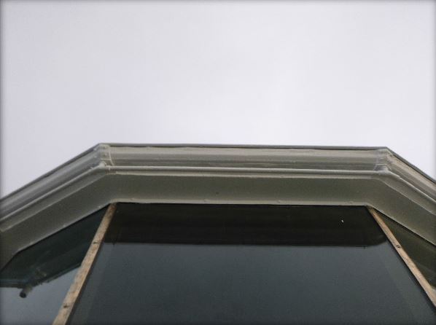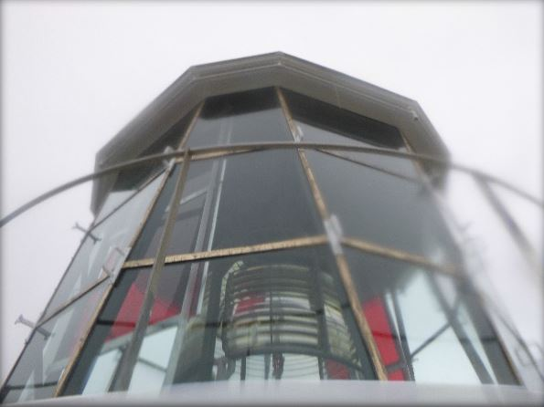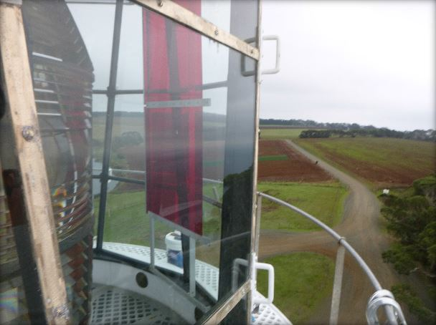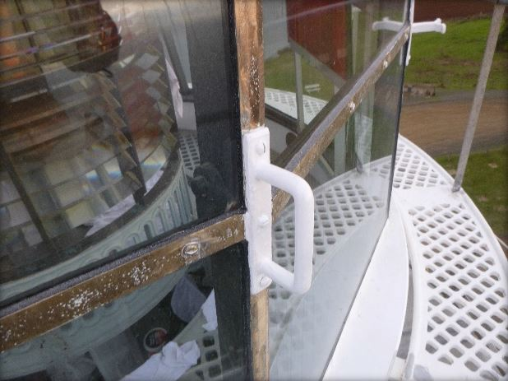
© AMSA 2019
Description and condition
1888 Chance Bros, polygonal in form.
- Panes – flat trapezoidal glass, three tier.
- Astragals – Chance Bros vertical astragals of rectangular section iron, bolted to gutter ring at top, and to lantern base below. Horizontal astragals of triangular section.
- Downpipes – none.
- Handholds – two cast metal handholds bolted to each vertical astragals, except where downpipes are/were fitted.

Finish | astragals and glazing strips painted
Condition | intact and sound
Integrity | high
Significance | high
Maintenance | keep in service, reglaze as necessary  prepare and repaint at normal intervals
Rectification works | none

Heritage significance: High
The lantern glazing is an original and essential part of a lighthouse associated with the development of navigational aids along the Tasmanian coast (criterion a)
The lantern glazing contributes to the aesthetic value of the lighthouse (criterion e).

Lighthouse feature: Internal catwalk
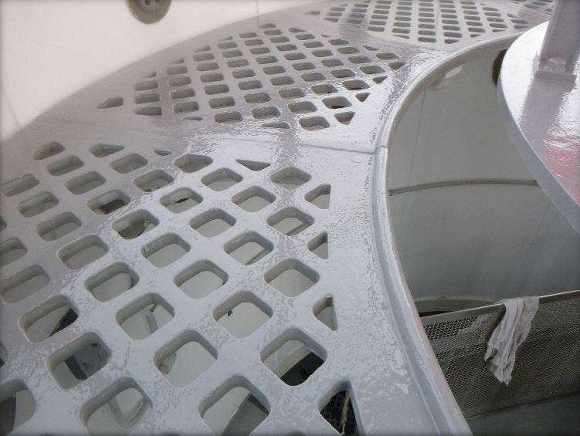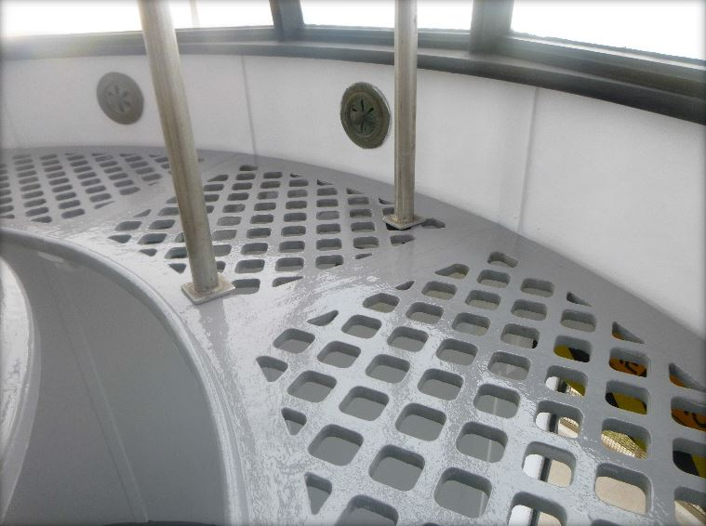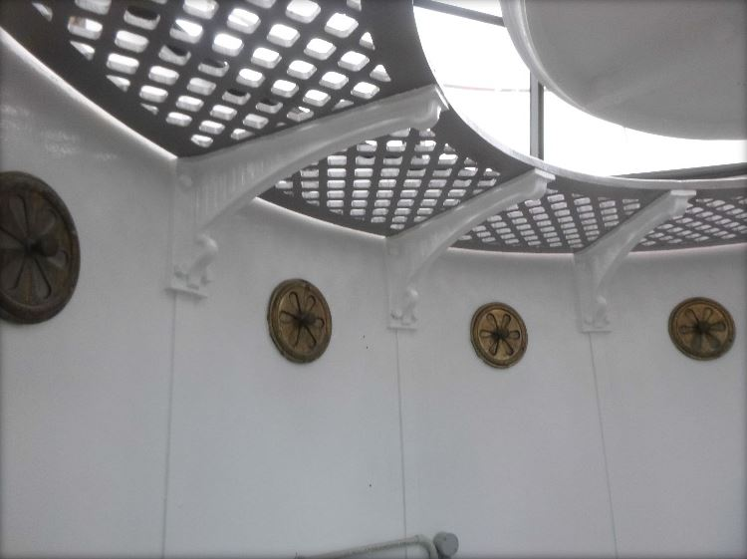© AMSA 2019
Description and condition
Chance Bros, cast iron lattice floor panels supported on solid cast iron brackets bolted to the top of the lantern base.
- Ladder – fixed ladder with cast iron treads on wrought iron strings.

Finish | painted
Condition | intact and sound
Integrity | high
Significance | high
Maintenance | keep in service, prepare and repaint at normal intervals
Rectification works | none

Heritage significance: High
The internal catwalk is an original and essential part of a lighthouse associated with the development of navigational aids along the Tasmanian coast (criterion a).

Lighthouse feature: External catwalk
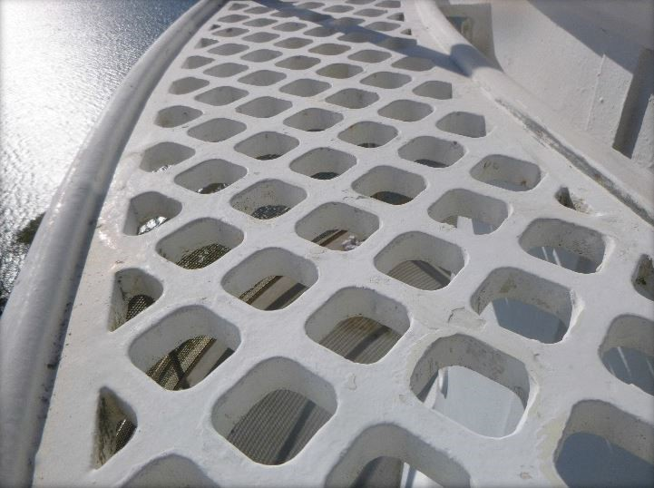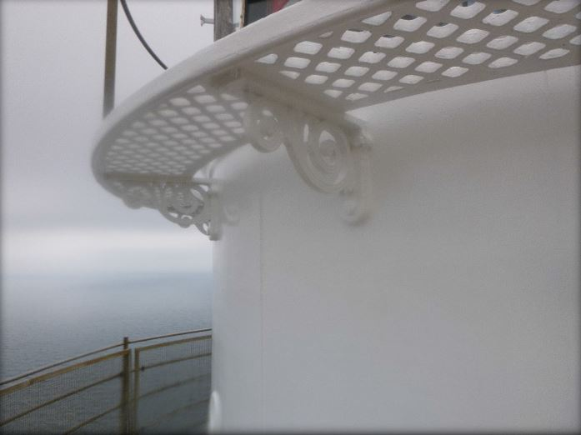
© AMSA 2019
Description and condition
1888 Chance Bros, cast iron lattice floor panels supported on openwork cast iron brackets bolted to lantern base.
- Handrail – recent stainless steel tubular handrail on rectangular section stanchions, bolted to floor panels.

Finish | handrail and stanchions bare: stainless steel  other parts: painted
Condition | intact and sound
Integrity | high
Significance | high
Maintenance | keep in service, prepare and repaint at normal intervals
Rectification works | none

Heritage significance: High
The external catwalk is an original and essential part of a lighthouse associated with the development of navigational aids along the Tasmanian coast (criterion a).

Lighthouse feature: Lantern base
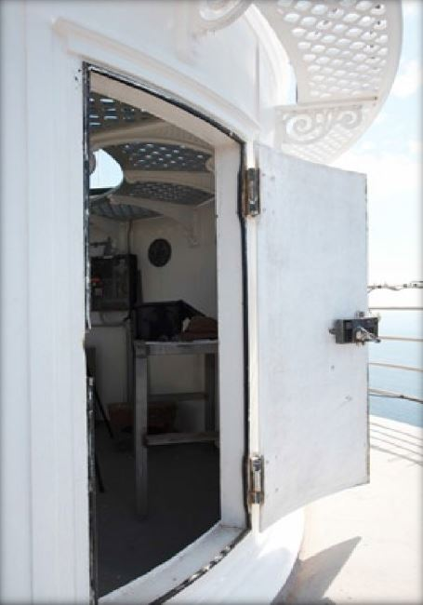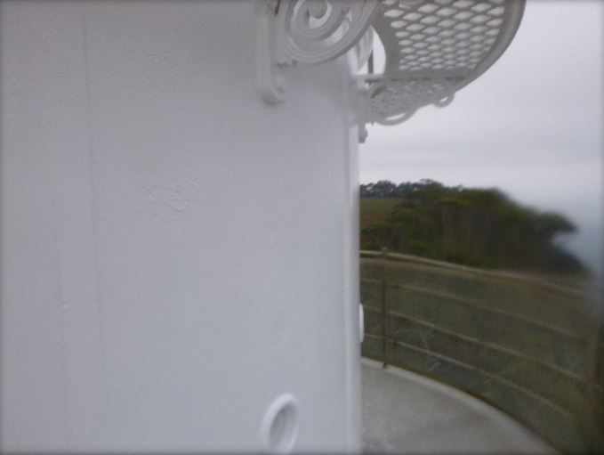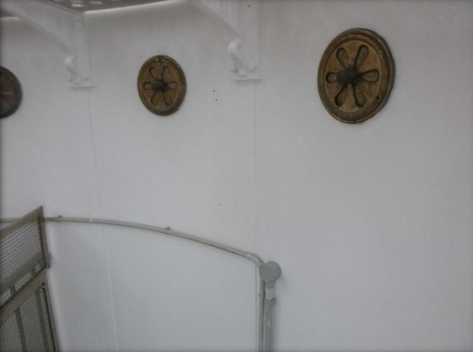© AMSA 2019
Description and condition
1888 Chance Bros, cylindrical in form. Curved panels of cast iron bolted together with flanged joints.
- Internal lining – curved iron plates screwed to the outer cast iron panels.
- Vents – round air inlets in the middle of exterior of each panel. Large copper alloy circular regulators below internal catwalk and small ones above.
- Door – Chance Bros iron door. No internal frame or lining. Copper alloy hinges. Original copper alloy rim lock still in use, with bar handles inside and out. Recent rubber door seals.

Finish | painted
Condition | intact and sound
Integrity | high
Significance | high
Maintenance | keep in service, prepare and repaint at normal intervals
Rectification works | none

Heritage significance: High

The lantern base is an original and essential part of a lighthouse associated with the development of navigational aids along the Tasmanian coast (criterion a).

Lighthouse feature: Lantern floor
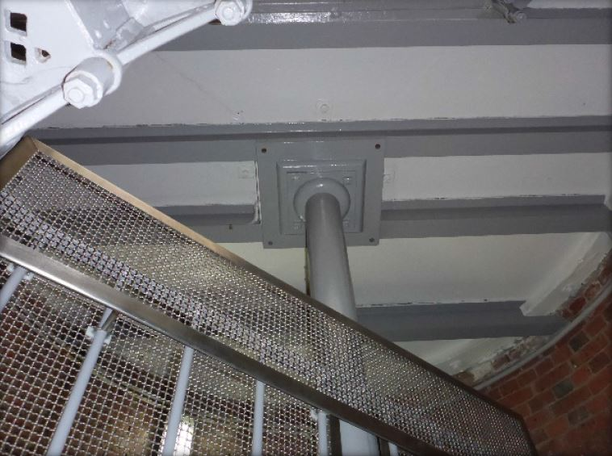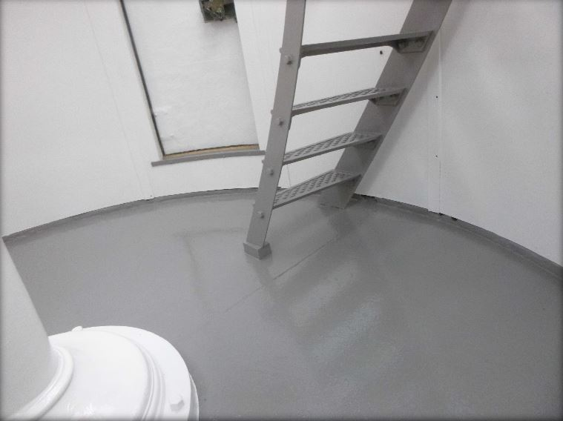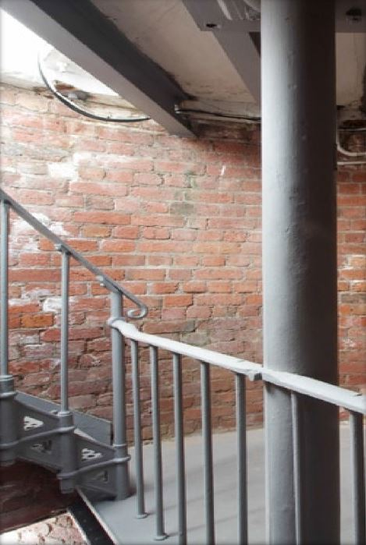© AMSA 2019
Description and condition
Slate slab floor, continues with balcony floor, supported on the top of the tower walls and on rolled iron beams.
Finish | painted
Condition | intact and sound
Integrity | high
Significance | high
Maintenance | keep in service, prepare and repaint at normal intervals
Rectification works | none

Heritage significance: High
The lantern floor is an historic and essential part of a lighthouse associated with the development of navigational aids along the Tasmanian coast (criterion a).

Lighthouse feature: Lens assembly
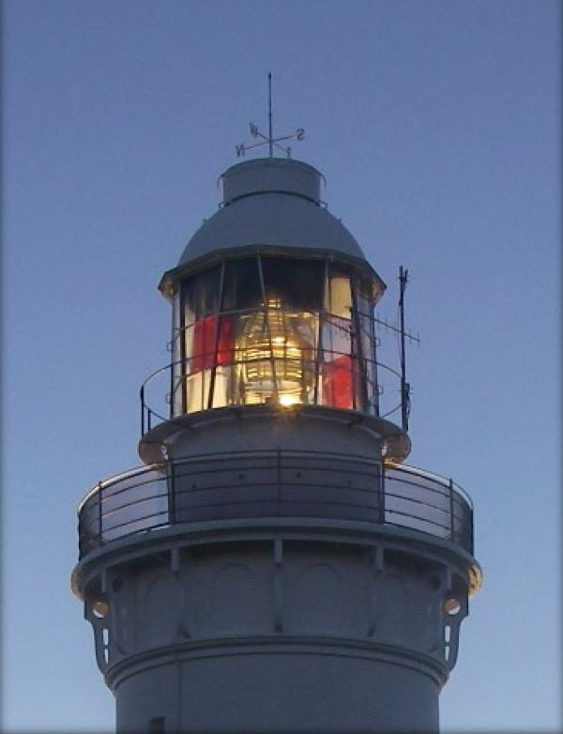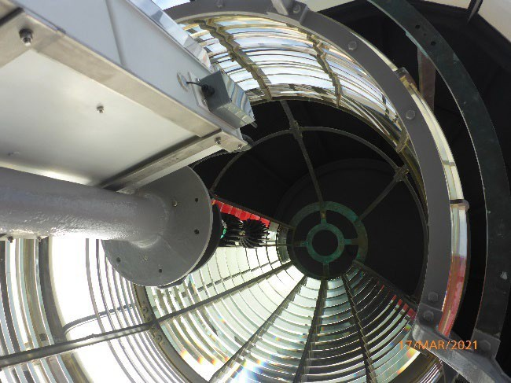
© AMSA 2021
Description and condition
1888 Chance Bros 700mm focal radius (2nd order) fixed (non-rotating) lens assembly of glass and gunmetal, with array of reflecting prisms on the landward side.
Condition | intact and sound
Integrity | high
Significance | high
Maintenance | keep in service, clean at normal intervals
Rectification works | none

Heritage significance: High
The lens assembly is both an original and essential part of a lighthouse associated with the development of navigational aids along the Tasmanian coast (criterion a).
The lens asembly contributes to the aesthetic value of the lighthouse (criterion e).

Lighthouse feature: Light source
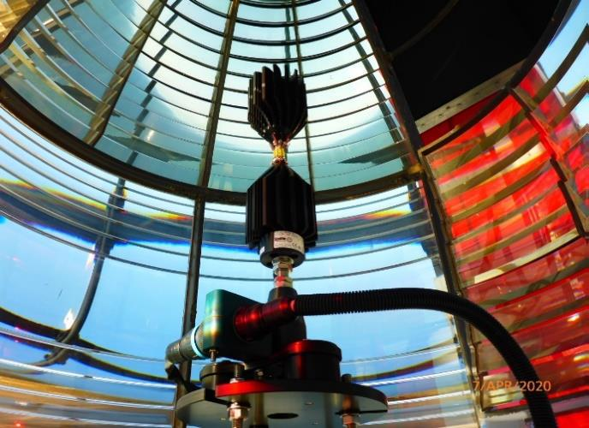© AMSA 2020
Description and condition
Sealite SL-LED-216-W
Condition | intact and sound
Significance | low
Maintenance | keep in service
Rectification works | none

Heritage significance: Low

Lighthouse feature: Pedestal
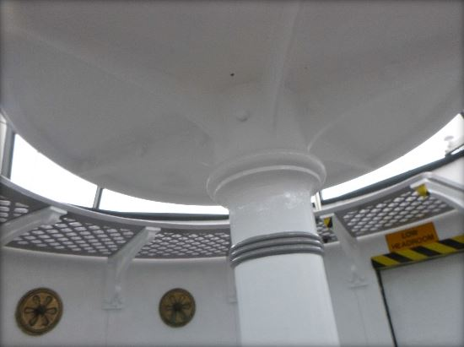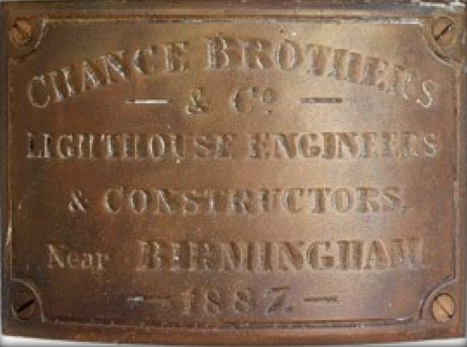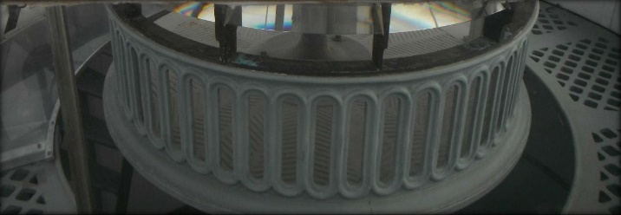© AMSA 2019
Description and condition
Chance Bros cast iron pedestal (with 1887 maker’s plate) and circular platform.
Finish | painted
Condition | intact and sound
Integrity | high
Significance | high
Maintenance | keep in service, prepare and repaint pedestal at normal intervals
Rectification works | none

Heritage significance: High
The pedestal is both an original and essential part of a lighthouse associated with the development of navigational aids along the Tasmanian coast (criterion a).

Lighthouse feature: Balcony floor
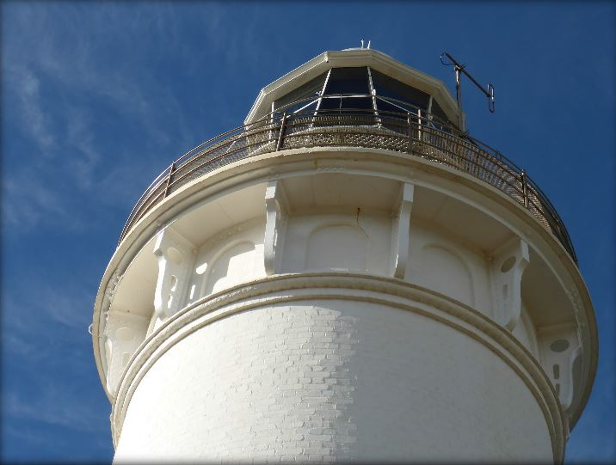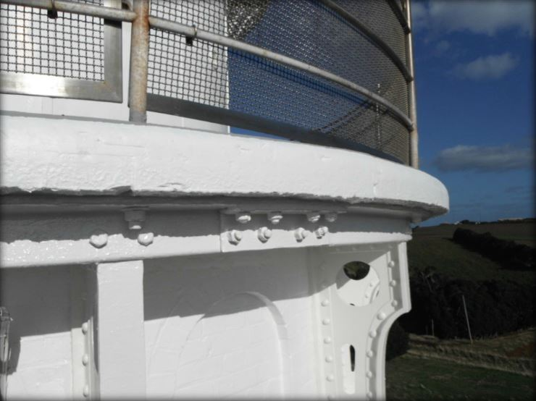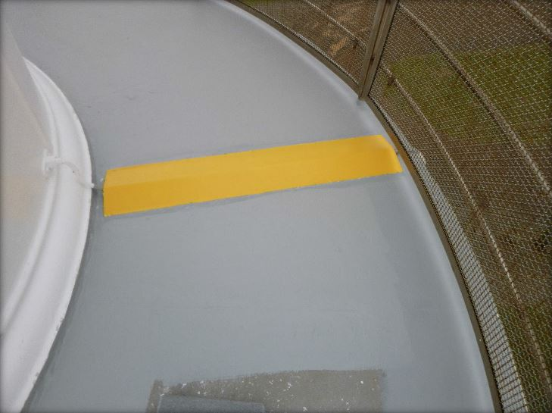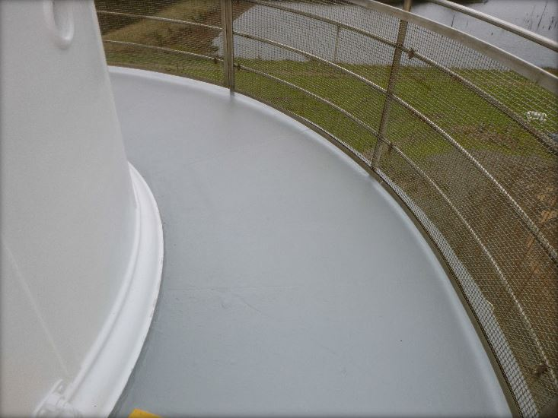
© AMSA 2019
Description and condition
1888 slate slab floor, continuous with lantern floor, supported by the top of the tower wall and by cast iron brackets and wrought iron fascia.
Finish | painted
Condition | intact and sound
Integrity | high
Significance | high
Maintenance | keep in service, maintain joint seals  prepare and repaint at normal intervals
Rectification works | none

Heritage significance: high
The balcony floor is both an original and essential part of a lighthouse associated with the development of navigational aids along the Tasmanian coast (criterion a).

Lighthouse feature: Balcony balustrade
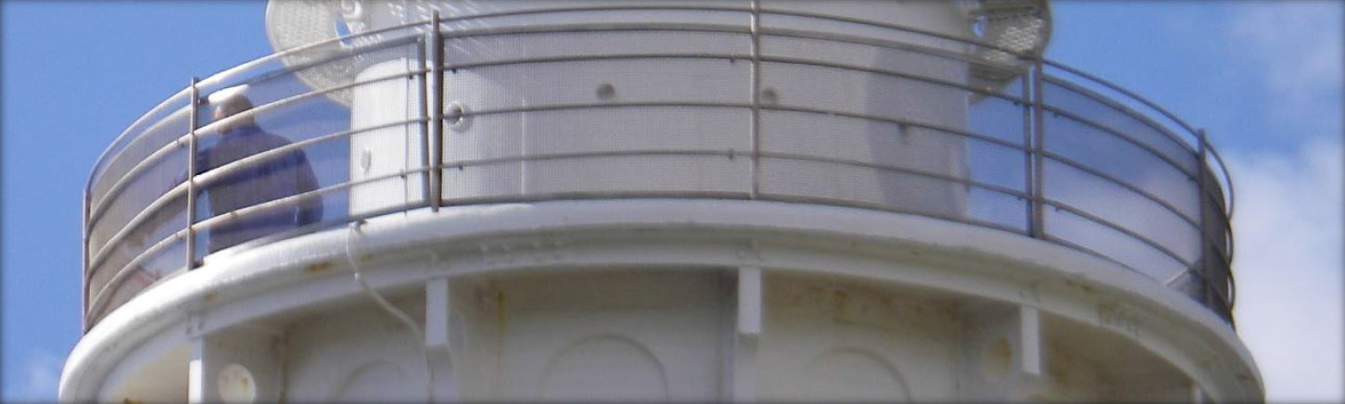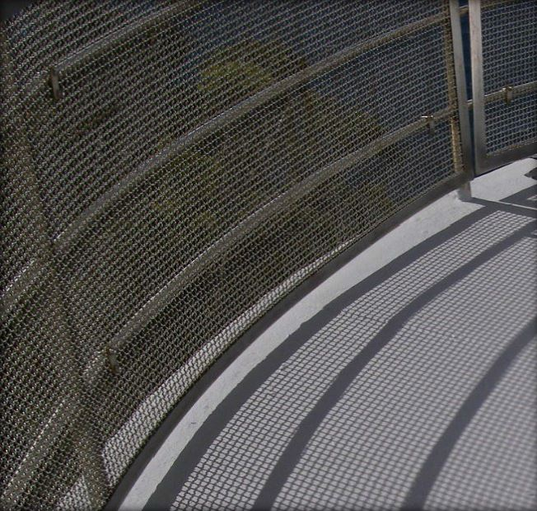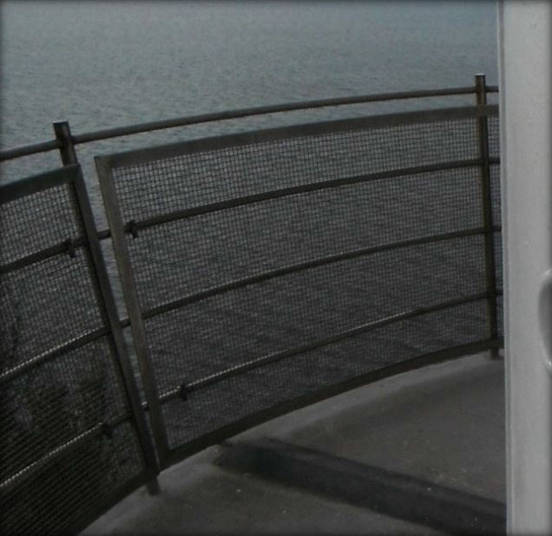
© AMSA 2019
Description and condition
Recent stainless steel balustrade with four tubular rails welded to tubular stanchions. Recent stainless steel mesh and frame attached to balustrade for public safety.
Finish | bare stainless steel
Condition | intact and sound
Integrity | high
Significance | high
Maintenance | keep in service, monitor condition
Rectification works | none

Heritage significance: High
The balcony balustrade is an essential part of the lighthouse (criterion a).

Lighthouse feature: Walls
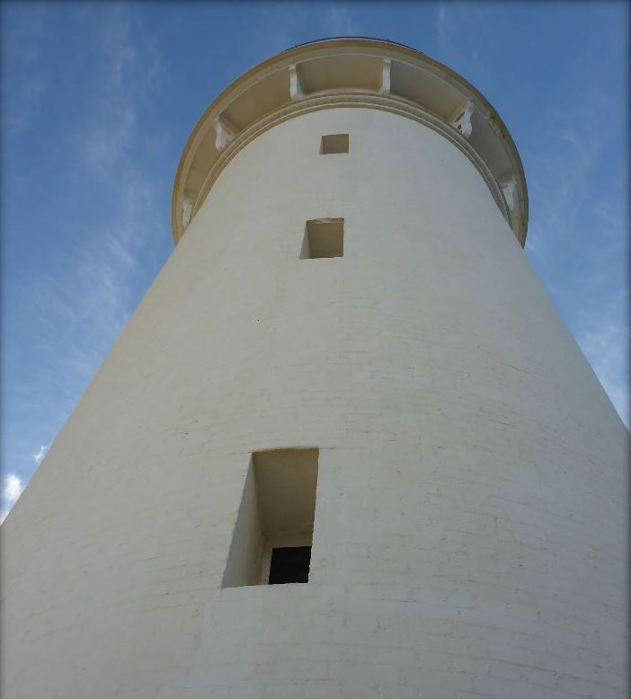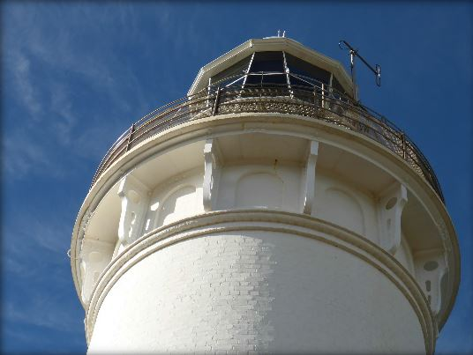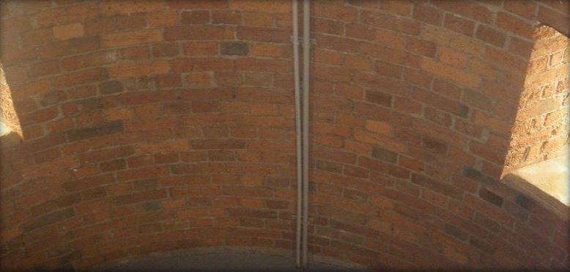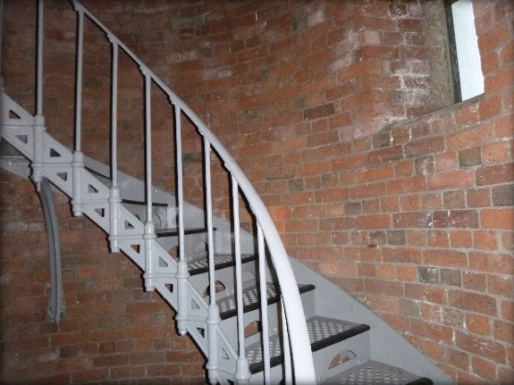
© AMSA 2019
Description and condition
1888 brick walls, built with the internal face plumb so that the internal volume is of constant diameter.
Finish | external: painted  internal: most paintwork removed by abrasive blasting
Condition | minor erosion of internal surface by abrasive blasting  otherwise intact and sound
Integrity | high
Significance | high
Maintenance | keep in service, prepare and paint at normal intervals  monitor condition of pointing and brickwork
Rectification works | none

Heritage significance: High
The tower walls are an original and essential part of a lighthouse associated with the development of navigational aids along the Tasmanian coast (criterion a).
The height of the tower walls contribute to the aesthetic value of the lighthouse (criterion e).

Lighthouse feature: Windows
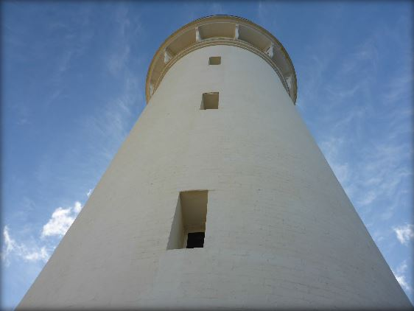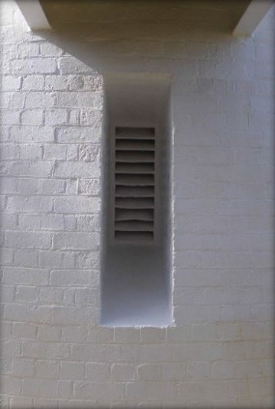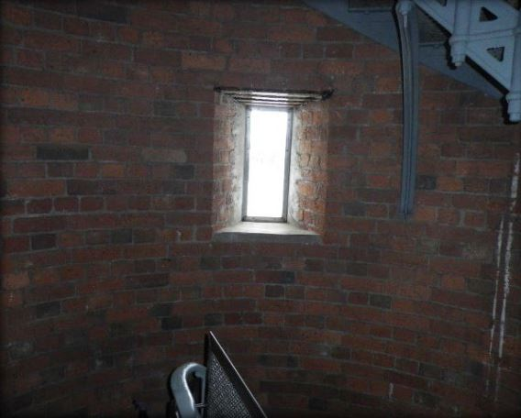
© AMSA 2019
Description and condition
Original window openings with recent stainless steel frames built into brickwork, with fixed glazing.

Finish | frames: painted outside, bare metal inside  glass: clear
Condition | intact and sound
Integrity | high
Significance | moderate
Maintenance | keep in service, prepare and repaint at normal intervals
Rectification works | none

Heritage significance: Moderate
The window openings are an original part of a lighthouse associated with the development of navigational aids along the Tasmanian coast (criterion a).

Lighthouse feature: Door
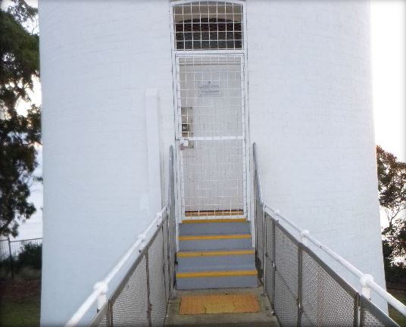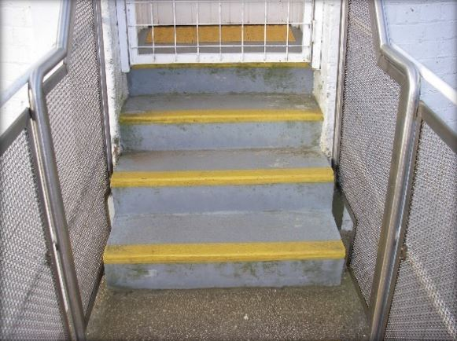
© AMSA 2021
Description and condition
1888 door opening.
- Inner door – recent timber framed, braced and sheeted door, hung in timber door frame with fixed glass fanlight. Recent cylinder dead locking rimlock. Three recent heavy strap hinges. Stainless steel plate around keyhole.
- Outer door – welded steel grille door, with welded mesh infill, hung in welded steel frame with fixed grille above transom. Secured with pad bolt.
- Entry steps – three concrete entry steps. Steps and landing were demolished and reconstructed in 2011 as previous steps had varying height risers and were not suitable for tourist access.

Finish | painted
Condition | sound
Integrity | high
Significance | high
Maintenance | keep in service, prepare and repaint at normal intervals
Rectification works | none

Heritage significance: High
The tower door is an original and essential part of a lighthouse associated with the development of navigational aids along the Tasmanian coast (criterion a).

Lighthouse feature: Intermediate floors
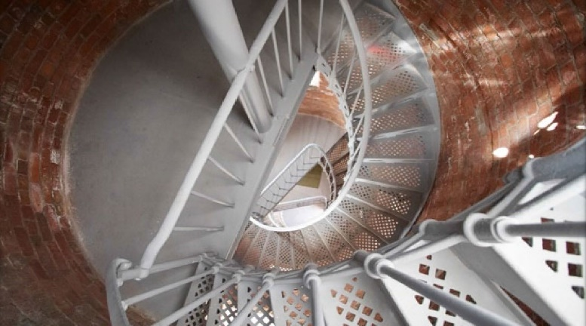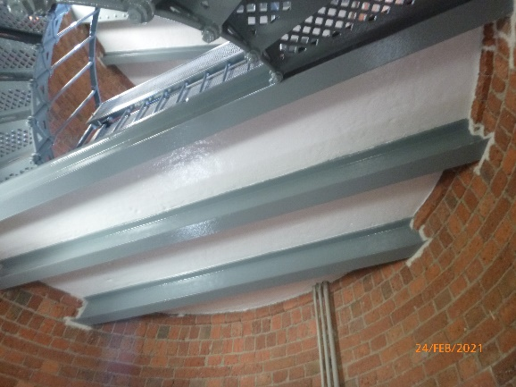
© AMSA 2021
Description and condition
Finish | painted
Condition | intact and sound
Integrity | high
Significance | high
Maintenance | keep in service, prepare and repaint at normal intervals
Rectification works | none
Three 1888 part floors forming stair landings. Slate floor slabs supported on rolled steel beams built into the tower walls.

Heritage significance: High
The intermediate floors are an original and essential part of a lighthouse associated with the development of navigational aids along the Tasmanian coast (criterion a).

Lighthouse feature: Stairs
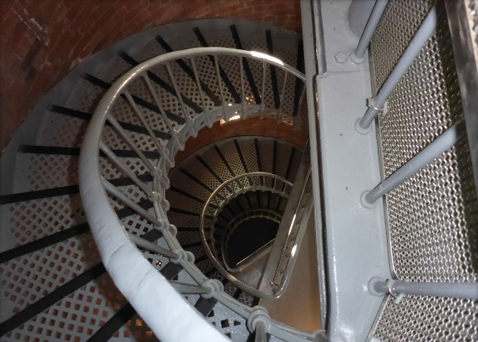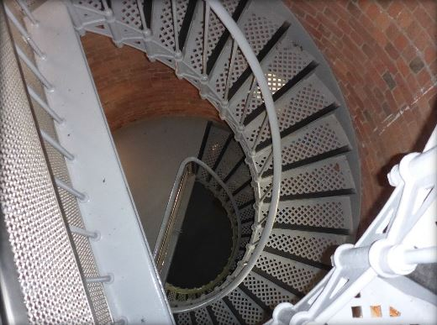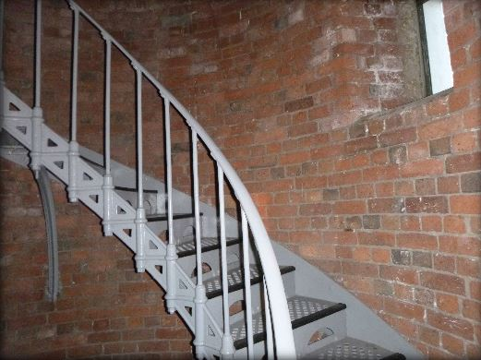© AMSA 2019

Description and condition
1888 geometric stair with cast iron treads/risers attached to curved iron plate fixed to the tower wall, and wrought iron handrail and stanchions. Curved iron supported set into the tower walls support each flight at mid span.
Finish | painted
Condition | intact and sound
Integrity | high
Significance | high
Maintenance | keep in service, prepare and repaint at normal intervals
Rectification works | none

Heritage significance: High
The stairs are an original and essential part of a lighthouse associated with the development of navigational aids along the Tasmanian coast (criterion a).

Lighthouse feature: Ground floor
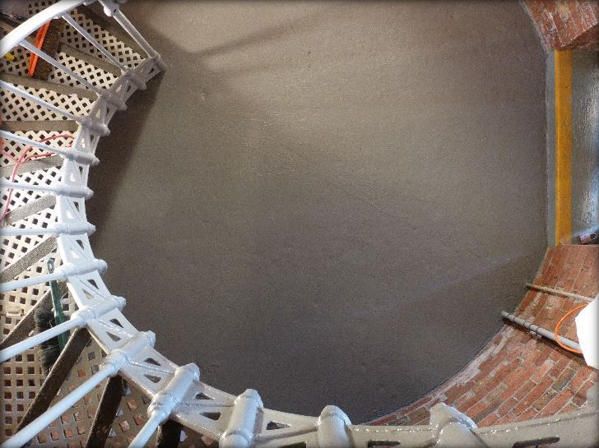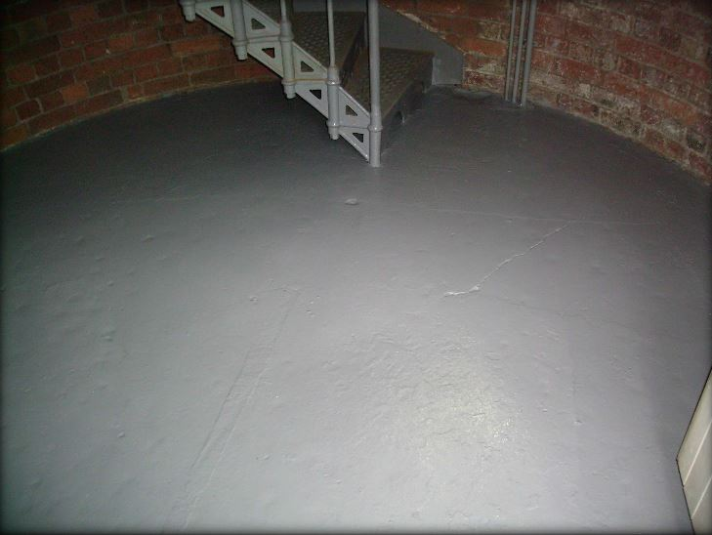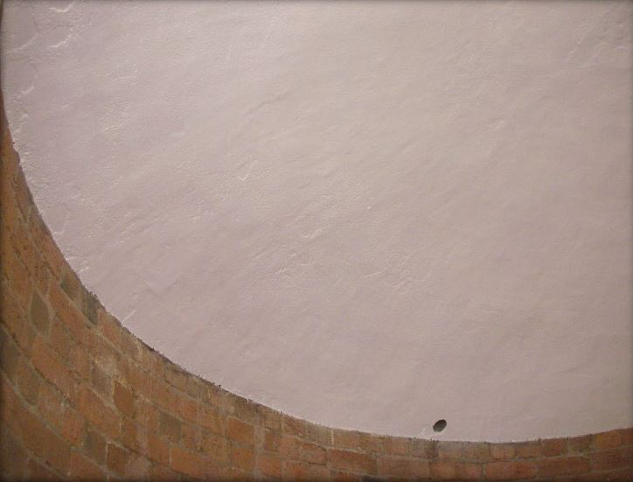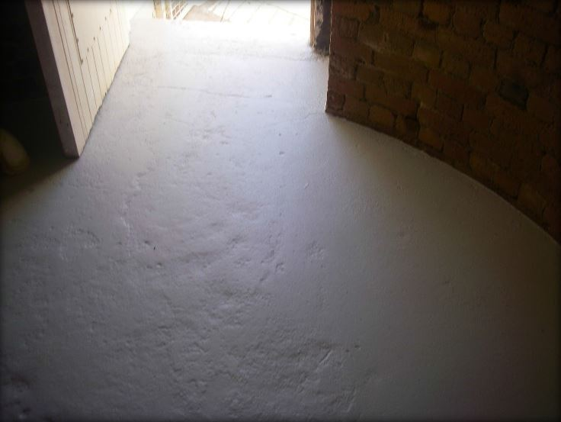
© AMSA 2019
Description and condition
1888 suspended concrete floor slab with domed soffit.
Finish | bare concrete
Condition | intact and sound
Integrity | high
Significance | high
Maintenance | keep in service, clean at normal intervals
Rectification works | none

Heritage significance: High
The ground floor is an original and essential part of a lighthouse associated with the development of navigational aids along the Tasmanian coast (criterion a).

Lighthouse feature: Basement
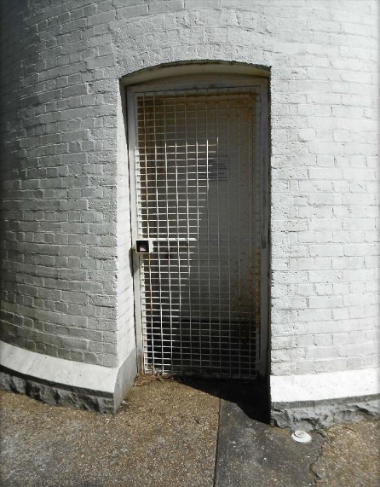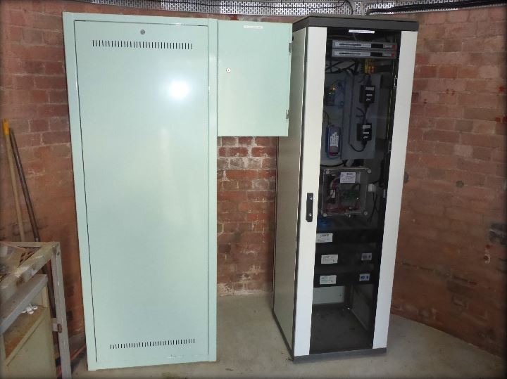
© AMSA 2021
Description and condition
1888 lower level space, not connected with the main tower interior. Back-up power supply and electrical control equipment is stored on this level.
- Inner door – timber framed and sheeted door, hung in timber door frame.
- Outer door – welded steel grille door with mesh infill, hung in welded steel frame.
- Windows – 1888 window openings, fitted with recent fixed metal louvres.

Finish | tower walls: base brick (abrasive blasting)  concrete floor: bare  ceiling: painted (soffit of ground floor above)
Condition | sound
Integrity | high
Significance | high
Maintenance | keep in service, maintain painted parts
Rectification works | none

Heritage significance: High
The basement is an original and essential part of a lighthouse associated with the development of navigational aids along the Tasmanian coast (criterion a).
The basement’s below-ground-level position is unique to the lighthouse (criterion d).

Lighthouse feature: Apron paving
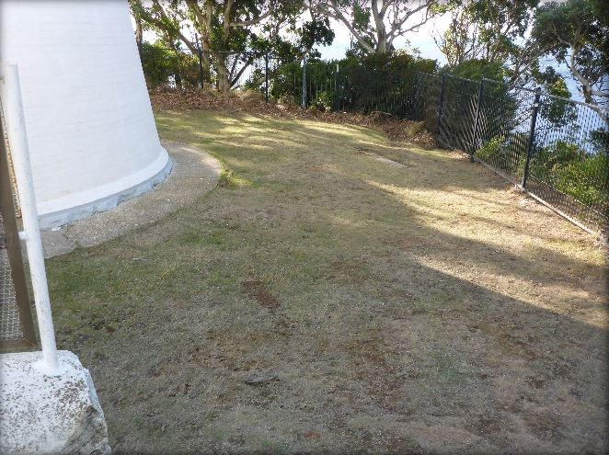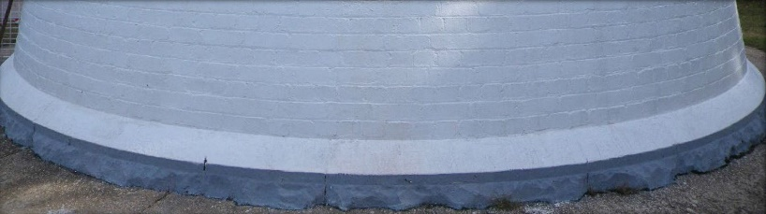
© AMSA 2019
Description and condition
1888 cast concrete paving border around lighthouse perimeter.
Finish | trowelled bare concrete
Condition | intact and sound with minor crack visible
Integrity | high
Significance | high
Maintenance | keep in service, maintain and monitor for further cracks
Rectification works | none

Heritage significance: High
The apron paving is an original and essential part of a lighthouse associated with the development of navigational aids along the Tasmanian coast (criteiron a).

Lighthouse feature: Retaining wall
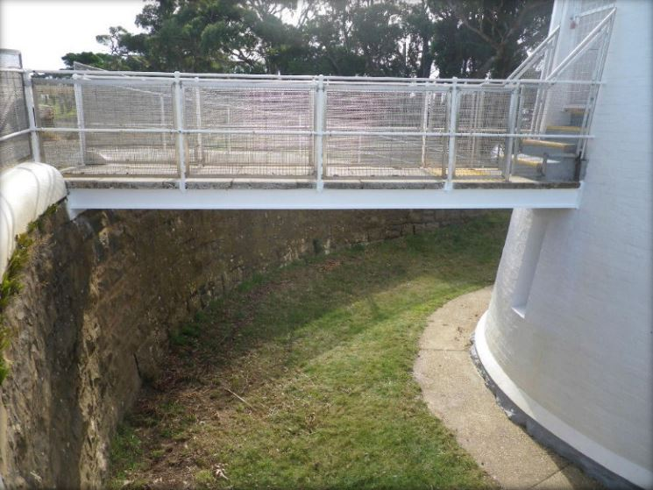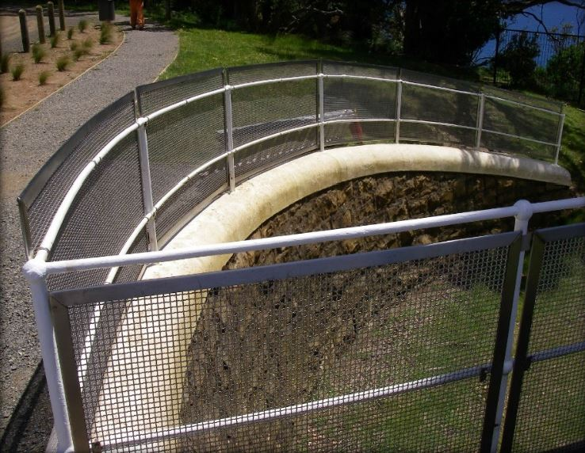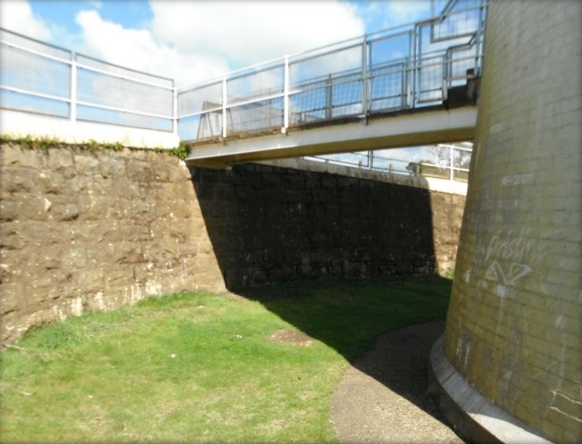© AMSA 2019
Description and condition
Condition | sound
Integrity | high
Significance | stainless steel parts: low  other parts: high
Maintenance | keep in service, maintain painted parts
Rectification works | none
1888 semi-circular wall of rock-faced stone. Rendered and painted coping course. Balustrade of iron pipe rails and stanchions, painted. Recent stainless steel mesh and frame attached to balustrade for public safety.

Heritage significance: high
The retaining wall is an original and essential part of a lighthouse associated with the development of navigational aids along the Tasmanian coast (criterion a).
The layout of the retaining wall is a feature unique to the lighthouse (criterion d).
The retaining wall contributes to the aesthetic value of the lighthouse (criterion e).

Lighthouse feature: Bridge

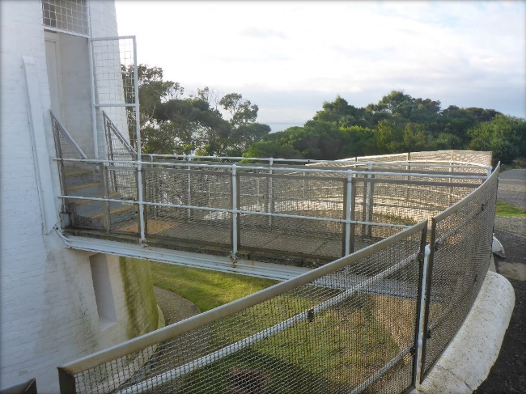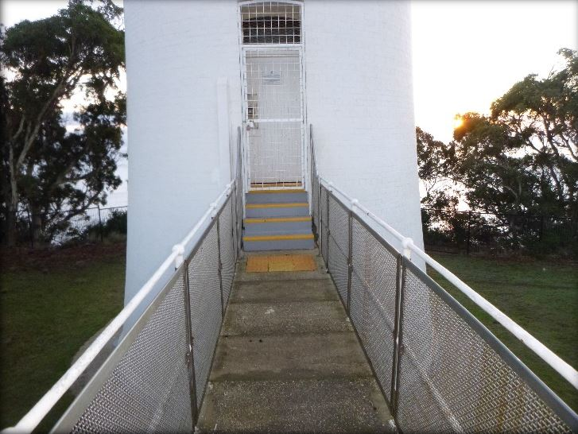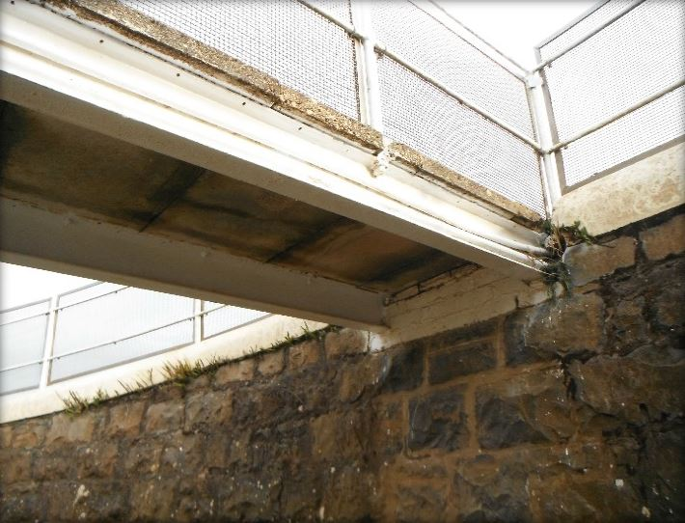
© AMSA 2019

Description and condition
Rolled steel beams supporting precast concrete floor slabs, with balustrade of iron pipe rails and stanchions.
Recent stainless steel mesh and frame attached to balustrade for public safety.
Condition | sound
Integrity | high
Significance | form and balustrade: high  other parts: moderate
Maintenance | keep in service, maintain painted parts  monitor condition of concrete panels
Rectification works | none
Heritage significance: High
Parts of the bridge are original and essential features of a lighthouse associated with the development of navigational aids along the Tasmanian coast (criterion a).
The form and layout of the bridge is a feature unique to the lighthouse (criterion d).
The bridge contributes to the aesthetic value of the lighthouse (criterion e).

  - Related object and associated artefacts
There are currently no AMSA registered artefacts stored on this site.
4.3 Comparative analysis
The closest lighthouse resembling that of Table Cape lighthouse is Mersey Bluff Lighthouse (first lit 1889). Located approximately 74 km east of Table Cape along the norther coastline of Tasmania, Mersey Bluff Lighthouse was similarly designed by Huckson & Hutchinson. Its tower was also constructed by Duff Bros. Co., the same company to construct Table Cape’s lantern house. Similarly, both towers were constructed of brick despite Table Cape’s upper section being of steel sourced from England. Both sites were automated in 1920.
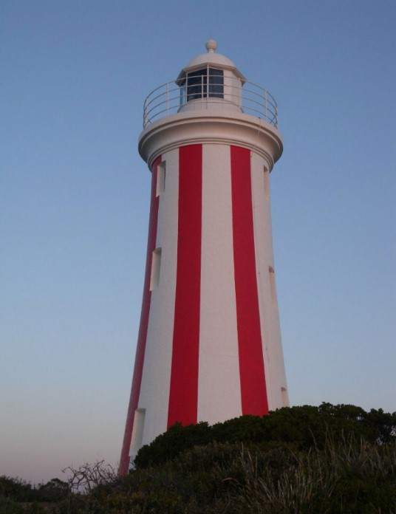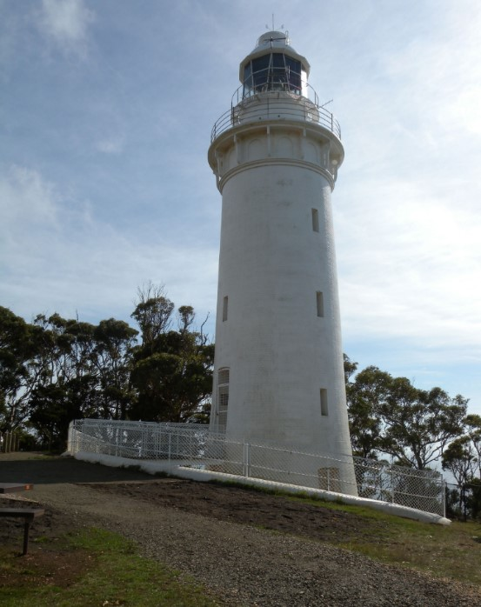

Figure 16. Mersey Bluff Lighthouse, first lit 1889 (Source: AMSA, 2010)
Figure 17. Table Cape Lighthouse, first lit 1888 (Source: AMSA)


- Heritage Significance
5.1 Commonwealth Heritage listing – Table Cape Lighthouse
The following statement of significance and heritage value criterion below is taken from the Table Cape Lighthouse listing on the Commonwealth Heritage List (Place ID: 105603).
Commonwealth statement of significance
Table Cape Light, built in 1888, is significant for its association with the development of maritime navigation aids along the Tasmanian coast, and with the development of the surrounding region and the expansion of the shipping trade along the north coast (Criterion A) (Themes 3.8.1 Shipping to and from Australian ports, 3.16.1 Dealing with hazards and disasters)
The tower is distinctive for its unusual below-ground-level base and access bridge (Criterion B).
Standing on a flat-topped headland atop cliffs towering high above the sea, the light tower is a well-known landmark feature of considerable aesthetic value (Criterion E).
Commonwealth heritage criteria
There are nine criteria for inclusion in the Commonwealth Heritage List – meeting any one of these is sufficient for listing a place. These criteria are similar to those used in other Commonwealth, state and local heritage legislation, although thresholds differ. In the following sections, the Table Cape Lighthouse is discussed in relation to each of the criteria as based on the site’s current Commonwealth Heritage Listing (Place ID: 105603).
Criterion | Relevant Attributes Identified | Explanation
Criterion A – Processes  This criterion is satisfied by places that have significant heritage value because of [their] importance in the course, or pattern, of Australia’s natural or cultural history. | - The whole of the lighthouse form, brick fabric, steel features and landscaped setting. | Table Cape Light, built in 1888, is significant for its association with the development of maritime navigational aids along the Tasmanian coast, and with the development of the surrounding region and the expansion of the shipping trade along the north coast.
Criterion B – Rarity  This criterion is satisfied by places that have significant heritage value because of [their] possession of uncommon, rare or endangered aspects of Australia’s natural or cultural history. | - The below-ground-level base and access bridge. | The tower is distinctive for its unusual below-ground-level base and access bridge.
Criterion E – Aesthetic characteristics  This criterion is satisfied by places that have significant heritage value because of [their] importance in exhibiting particular aesthetic characteristic value by a community or cultural group. | - The tower’s prominence and setting. | Standing on a flat-topped headland atop cliffs towering high above the sea, the light tower is a well-known landmark feature of considerable aesthetic value.

  - TAS Heritage Register – Table Cape Lighthouse
Table Cape Lighthouse is listed on the Tasmanian Heritage Register (THR ID: 5626). The information below is taken from this listing.
TAS statement of significance
No statement of significance is provided for places listed prior to 2007.
TAS State heritage criteria
The heritage council may enter a place in the Heritage Register if it meets one or more of eight criterions – Table Cape Lighthouse meets the following three criterions.
Criteria | Explanation and evidence
Criterion a) The place is important to the course or pattern of Tasmania’s history. | Table Cape Lighthouse, built in 1888, is significant for its association with the early settlement and development of the surrounding region and the expansion of the shipping trade along the coast of Tasmania.
Criterion d) The place is important in demonstrating the principal characteristics of a class of place in Tasmania’s history. | Table Cape Lighthouse is of historic heritage significance because it represents the principal characteristics of a Victorian brick lighthouse.
Criterion f) The place has a strong or special association with a particular community or cultural group for social or spiritual reasons. | Table Cape Lighthouse is of historic heritage significance as a dramatic landmark feature values by the community.

These heritage values, identified and explained in the Commonwealth Heritage List and the Tasmanian Heritage Register, will form the basis of the management of the Table Cape Lighthouse. In the event of necessary works, all criteria will be consulted to inform best practice management of the values associated with the lighthouse. (See Section 7. Conservation management policies for further information on strategies to conserve heritage values of the Table Cape Lighthouse)

  - Condition and integrity of the Commonwealth heritage values
A heritage monitoring program was implemented in 2016. Each site is visited and reviewed every two years where the heritage fabric and values of the site are evaluated. Assessment of the condition and integrity of lighthouse's values are derived from the latest available Heritage Asset Condition Report produced by AMSA’s maintenance contractor.
‘Condition’ is measured on a Good – Fair – Poor scale and incorporates the current condition of the specific value. Integrity is measured on a High – Medium – Low scale which incorporates the value’s intactness.
As a whole, Table Cape Lighthouse’s Commonwealth values demonstrate Good condition and High integrity. Much of the site’s original fabric and form remains intact and in good condition, and the tower remains a prominent landmark within its setting.
Criteria | Values (including attributes) | Condition | Integrity
Criterion A – Processes | Table Cape Light, built in 1888, is significant for its association with the development of maritime navigational aids along the Tasmanian coast, and with the development of the surrounding region and the expansion of the shipping trade along the north coast. | Good | High
Criterion B –  Rarity | The tower is distinctive for its unusual below-ground-level base and access bridge. | Good | High
Criterion E – Aesthetic characteristics | Standing on a flat-topped headland atop cliffs towering high above the sea, the light tower is a well-known landmark feature of considerable aesthetic value. | Good | High

  - Gain or loss of heritage values
Evidence for the potential gain or loss of heritage values will be documented within this section of future versions of this heritage management plan.

- Opportunities and constraints
6.1 Implications arising from significance
The Commonwealth statement of significance (section 5.1 above) demonstrates that Table Cape Lighthouse is a place of considerable heritage value due to its contribution to the development of maritime navigation aids along the Tasmanian coast, and due to its distinctive design and aesthetic qualities.
The implication arising from this assessment is that key aspects of the place should be conserved to retain this significance. The key features requiring conservation include:
- Architectural quality of the building
- Interior spaces and features, which are notable for their design, details and/or their original lighthouse function. These include:
- Lantern room
- Intermediate floors
- Ground floor
- Spiral staircase
- Basement
- External spaces and features, which are notable for their design, details, and/or their original lighthouse function. These include:
- Lantern roof
- Balcony
- Lighthouse walls and windows
- Walkway bridge
- Retaining wall
Referral and approvals of action
The EPBC Act requires approval from the Minister for the Environment for all actions likely to have a significant impact on matters of National Environmental Significance (NES).
The Act provides that actions:
- taken on Commonwealth land which are likely to have a significant impact on the environment will require the approval of the Minister.

- taken outside Commonwealth land which are likely to have a significant impact on the environment on Commonwealth land, will require the approval by the Minister.

- taken by the Australian Government or its agencies which are likely to have a significant impact on the environment anywhere will require approval by the Minister.
The definition of ‘environment’ in the EPBC Act and EPBC Regulations includes the cultural heritage values of places.
Heritage strategy
If an Australian Government agency owns or controls one or more places with Commonwealth heritage values, it must prepare a heritage strategy within two years from the first time they own or control a heritage place (section 341ZA).
A heritage strategy is a written document that integrates heritage conservation and management within an agency’s overall property planning and management framework. Its purpose is to help an agency manage and report on the steps it has taken to protect and conserve the commonwealth heritage values of the properties under its ownership or control.
The heritage strategy for AMSA’s AtoN assets was completed and approved by the Commonwealth Minister for the Environment in and the latest version is available online.P37FP37F
Heritage Asset Condition Report
A heritage asset condition report is a written document that details the heritage fabric of a site with an in-depth description of each architectural and structural element. The document includes: a brief history of the site, the Commonwealth Heritage statement of significance and value criteria, a heritage significance rating for each individual element, and a catalogue of artefacts on-site. The document is also accompanied by up-to-date photos of each structural element. This document operates as a tool for heritage monitoring, and is reviewed and updated biennially.
Natural and Aboriginal heritage values
AMSA understands that Table Cape as a whole has noted Aboriginal cultural heritage, and natural values. Although these values lie outside of the Commonwealth heritage listing curtilage and AMSA’s lease, the potential remains for future works at the lighthouse to impact these values. At the time this plan was written, no plans have been made for future works at Table Cape Lighthouse. In the event major works at the lighthouse are to be carried out, AMSA will seek to minimise impacts to the surrounding area by:
- Utilising specific access tracks to ensure no damage to surrounding vegetation,
- Ensuring project footprint is limited to the AMSA lease. In any instance that work is required outside of this footprint, approvals will be sought from the appropriate stakeholders, and
- Consulting with the Department of Primary Industries, Parks, Water and Environment (Aboriginal Heritage Tasmania) in the event heritage artefacts/sites are uncovered or suspected during works.
- Implementing an appropriate discovery plan in the instance Aboriginal cultural heritage is suspected and/or found.

  - Framework: sensitivity to change
Owing to the site’s association with the development of the region, its rare design, and its prominence in the landscape, Table Cape Lighthouse is of high significance. Therefore, work actioned by AMSA on the lighthouse’s fabric harnesses the potential to reduce or eradicate the significance of the site’s heritage values.
Conservation works, including restoration and reconstruction, or adaption works of the absolute minimum so as to continue the lighthouse’s usefulness as an AtoN are the only works that should be actioned by AMSA on Table Cape Lighthouse. Some exceptions are made for health and safety requirements, however any and all work carried out must be conducted in line with heritage considerations and requirements of the EPBC Act.
The table below demonstrates the level of sensitivity attributed to the various elements of the fabric register in the face of change. These are measured on a High-Moderate-Low spectrum depending on the action’s possible threat to the site’s heritage values.
High sensitivity
High sensitivity to change includes instances wherein a change would pose a major threat to the heritage value of a specific fabric, or the lighthouse as a whole. A major threat is one that would lead to substantial or total loss of the heritage value.

Moderate sensitivity
Moderate sensitivity to change includes instances wherein a change would pose a moderate threat to the heritage value of a specific fabric, or would pose a threat to the heritage significance of a specific fabric in another part of the building. A moderate threat is one that would diminish the heritage value, or diminish the ability of an observer to appreciate the value.
Low sensitivity
Low sensitivity to change includes instances wherein a change would pose little to no threat to the heritage value of a specific fabric, and would pose little to no threat to heritage significance in another part of the building.

Component | Level of sensitivity | Nature of change impacting heritage values
Table Cape Lighthouse structure | High | - Changes to façade materials and design.  - Reduction of the structure’s prominence in its landscape setting.  - Removal of walk way bridge and retaining wall.
 | Low | - Repainting of structure in like colours.  - Removal of asbestos and lead paint or other toxic materials.
Ground floor | High | - Major, irreversible changes to façade materials and design.
 | Low | - Repainting of ground floor in like colours.
Stairs and weight tube | High | - Removal of the original stairs.
 | Low | - Repainting of the stairs and weight tube in like colours.  - Necessary maintenance to corrosion.  - Fixing of tiger tape to stair nosing.
Intermediate floors | High | - Major, irreversible changes to façade materials and design.
 | Low | - Removal/replacement of steel mesh from intermediate floor railings.  - Repainting of intermediate floors.
Lantern room | High | - Removal of Chance Bros lantern room door.  - Major, irreversible changes to lantern room façade materials and design.
 | Low | - Replacement of glazing panes.  - Resealing of glazing.  - Corrosion repair to internal catwalk.  - Adding of safety fixtures (i.e. tiger tape and foam stoppers) to fabric.
Lens assembly and pedestal | High | - Permanent removal of 1888 2nd Order Chance Bros 700mm focal radius fixed lens.  - Removal of original pedestal and makers’ plaque.
 | Low | - Removal or replacement of Sealite SL-LED-216-W.  - Repainting of the pedestal in like colours.  - Changing of the light’s character.
Balcony | High | - Major, irreversible changes to original 1888 slate balcony floor.
 | Low | - Repainting of the balcony in like colours.  - Removal/replacement of steel mesh from balustrades.  - Adding of safety fixtures i.e. tiger tape.
Basement | High | - Removal of suspended ceiling.
 | Low | - Removal/movement of electrical equipment cabinets.  - Repainting of suspended ceiling in like colours.
Windows and doors | High | - Major, irreversible changes to original window and door openings.
 | Low | - Replacement of steel window frames.  - Replacement of laminated safety glass panes.  - Replacement of welded mesh outer entry door.  - Replacement of recent timber inner entry door.  - Alterations to recent concrete entry steps.  - Removal/replacement of metal louvres (basement windows).  - Replacement of welded mesh outer basement door.
Retaining wall | High | - Removal of retaining wall.  - Major, irreversible changes to the façade materials and design.
 | Low | - Removal/replacement of steel mesh along balustrades.  - Repainting of coping course, iron pipe rails, and stanchions in like colours.  - Necessary corrosion repairs to balustrades.
Bridge | High | - Removal of bridge.  - Major, irreversible changes to the façade materials and design.  - Removal or major alterations to flagstones at bridge entrance.
 | Low | - Repairs to concrete slabs.  - Removal/replacement of steel mesh on gangway.  - Repainting of balustrades in like colours.  - Corrosion repairs to beams.
Apron paving | High | - Removal or major alteration to original 1888 apron.
 | Low | - Repairs to cracking.

  - Statutory and legislative requirements
The following table outlines the statutory and legislative requirements relevant to the conservation and management of Table Cape Lighthouse.
Act or code | Description
Environment Protection and Biodiversity Conservation Act 1999 (Cth) | The Environment Protection & Biodiversity Conservation Act 1999 (Cth) requires agencies to prepare management plans that satisfy the obligations included in Schedule 7A and 7B of the EPBC Regulations.
Environment Protection and Biodiversity Conservation Regulations 2000 (Cth) | The Commonwealth Department of Agriculture, Water and the Environment has determined these principles as essential for guidance in managing heritage properties.  - The objective in managing Commonwealth Heritage places is to identify, protect, conserve, present and transmit, to all generations, their Commonwealth Heritage values.  - The management of Commonwealth Heritage places should use the best available knowledge, skills and standards for those places, and include ongoing technical and community input to decisions and actions that may have a significant impact on their Commonwealth Heritage values.  - The management of Commonwealth Heritage places should respect all heritage values of the place and seek to integrate, where appropriate, any Commonwealth, state, territory and local government responsibilities for those places.  - The management of Commonwealth Heritage places should ensure that their use and presentation is consistent with the conservation of their Commonwealth Heritage values.  - The management of Commonwealth Heritage places should make timely and appropriate provision for community involvement, especially by people who:  - have a particular interest in, or associations with, the place; and  - may be affected by the management of the place;  - Indigenous people are the primary source of information on the value of their heritage and that the active participation of indigenous people in identification, assessment and management is integral to the effective protection of indigenous heritage values.  - The management of Commonwealth Heritage places should provide for regular monitoring, review and reporting on the conservation of Commonwealth Heritage values.
AMSA Heritage Strategy 2022-2025 | As the custodian of many iconic sites, AMSA has long recognised the importance of preserving their cultural heritage.  This Heritage Strategy is in response to section 341ZA of the EPBC Regulations which obliges AMSA to prepare and maintain a heritage strategy, along with obliging AMSA to:  - Assist in identification, assessment and monitoring of places of heritage value in its care;  - Prepare and maintain a register of its places of heritage value;  - Protect the heritage value of places when they are sold or leased;  - Provide this heritage strategy, and any subsequent major updates, to the relevant minister.  The strategy derives from the AMSA Corporate Plan and achievements are reported through the AMSA Annual Report. The 2020-21 AMSA Annual report can be found online.P38FP38F
Navigation Act 2012 (Cth) | Part 5 of the Act outlines AMSA’s power to establish, maintain and inspect marine aids to navigation (such as Table Cape Lighthouse).  - AMSA may:  - establish and maintain aids to navigation; and  - add to, alter or remove any aid to navigation that is owned or controlled by AMSA; and  - vary the character of any aid to navigation that is owned or controlled by AMSA.  - AMSA, or person authorised in writing by AMSA may, at any reasonable time of the day or night:  - inspect any aid to navigation or any lamp or light which, in the opinion of AMSA or the authorised person, may affect the safety or convenience of navigation, whether the aid to navigation of the lamp or light is the property of:  - a state or territory; or  - an agency of a state or territory; or  - any other person; and  - enter any property, whether public or private, for the purposes of an inspection under paragraph (a); and  - transport, or cause to be transported, any good through any property, whether public or private, for any purpose in connection with:  - the maintenance of an aid to navigation that is owned or controlled by AMSA; or  - the establishment of any aid to navigation by AMSA.
Australian Heritage Council Act 2003 (Cth) | This Act establishes the Australian Heritage Council, whose functions are:  - to make assessments under Division 1A and 3A of Part 15 of the EPBC Act 1999;  - to advise the Minister on conserving and protecting places included, or being considered for inclusion, in the National Heritage List or Commonwealth Heritage List;  - to nominate places for inclusion in the National Heritage List or Commonwealth Heritage List;  - to promote the identification, assessment, conservation and monitoring of heritage;  - to keep the Register of the National Estate;  - to organise and engage in research and investigations necessary for the performance of its functions;  - to provide advice directly to any person or body or agency either if its own initiative of at the request of the Minister; and  - to make reports as outlined in the Act.
TAS Historic Cultural Heritage Act 1995 (TAS) | This Act establishes the Tasmanian Heritage Council.  7 General functions and powers of Heritage Council  - The functions of the Heritage council are –  - to advise the Minister on matters relating to Tasmania's historic cultural heritage and the measures necessary to conserve that heritage for the benefit of the present community and future generations; and  - to work within the planning system to achieve the proper protection of Tasmania's historic cultural heritage; and  - to co-operate and collaborate with Federal, State and local authorities in the conservation of places of historic cultural heritage significance; and  - to encourage and assist in the proper management of places of historic cultural heritage significance; and  - to encourage public interest in, and understanding of, issues relevant to the conservation of Tasmania's historic cultural heritage; and  - to encourage and provide public education in respect of Tasmania's historic cultural heritage; and  - to assist in the promotion of tourism in respect of places of historic cultural heritage significance; and  - to keep proper records, and encourage others to keep proper records, of places of historic cultural heritage significance; and  - to perform any other function the Minister determines.  - The Heritage Council may do anything necessary or convenient to perform its functions.
Building Code of Australia/National Construction Code | The Code is the definitive regulatory resource for building construction, providing a nationally accepted and uniform approach to technical requirements for the building industry. It specifies matters relating to building work in order to achieve a range of health and safety objectives, including fire safety.  As far as possible, Commonwealth agencies aim to achieve compliance with the Code, although this may not be entirely possible because of the nature of and constraints provided by existing circumstances, such as an existing building.
Work Health and Safety Act 2011 (Cth) | The objectives of this Act include:  - The main object of this Act is to provide for a balanced and nationally consistent framework to secure the health and safety of workers and workplaces by:  - protecting workers and other persons against harm to their health, safety and welfare through the elimination or minimisation of risks arising from work; and  - providing for fair and effective workplace representation, consultation, co‑operation and issue resolution in relation to work health and safety; and  - encouraging unions and employer organisations to take a constructive role in promoting improvements in work health and safety practices, and assisting persons conducting businesses or undertakings and workers to achieve a healthier and safer working environment; and  - promoting the provision of advice, information, education and training in relation to work health and safety; and  - securing compliance with this Act through effective and appropriate compliance and enforcement measures; and  - ensuring appropriate scrutiny and review of actions taken by persons exercising powers and performing functions under this Act; and  - providing a framework for continuous improvement and progressively higher standards of work health and safety; and  - maintaining and strengthening the national harmonisation of laws relating to work health and safety and to facilitate a consistent national approach to work health and safety in this jurisdiction.  - In furthering subsection (1)(a), regard must be had to the principle that workers and other persons should be given the highest level of protection against harm to their health, safety and welfare from hazards and risks arising from work as is reasonably practicable.  [Quoted from Division 2 of Act]  This has implications for Table Cape Lighthouse of Australia as it is related to AMSA staff, contractors and visitors.

  - Operational requirements and occupier needs
As a working AtoN, the operational needs of Table Cape Lighthouse are primarily concerned with navigational requirements. Below are the operational details and requirements of the Table Cape light as outlined by AMSA.
Navigational requirement for AMSA’s AtoN site
1 | Objective/rationale | An AtoN is required at Table Cape to mark the cape itself, to provide a navigation mark for vessels on the North West coast of Tasmania, and to provide a landfall mark for the port of Burnie 11 miles to the South East.  A red sector light arrangement is required to the North West and to the South East provide warning position lines for vessels when approaching the coast.  The sector to the South East leads to the pilot station and the leading marks for entering Burnie.
2 | Required type(s) of AtoN | A fixed structure is required to act as a day mark.  A distinctive light is required for use at night.
3 | Priority/significance | An AtoN at this site is important for the navigation of commercial ships.
4 | Required measure of performance | The service performance of the AtoN must comply with the IALA Availability Target Category 2 (99.0 per cent).
5 | Primary and secondary means (if any) of identification | The day mark must be conspicuous. The existing 25 m white round tower and lantern at an elevation of 180 m meets this requirement.  The light must comply with the requirements of rhythmic characters of light as per the IALA NAVGUIDE. The light must have distinct characteristics that are easy to recognise and identify. The present flashing (2) white and red sector light every 10 seconds meets this requirement.
6 | Visual range | During daytime, the AtoN structure should be visible from at least 5 nautical miles.  At night, the white light must have a nominal range of at least 16 nautical miles and the red light at least 13 nautical miles.
7 | Radar conspicuousness | As the cape itself will give a good radar echo, no additional radar enhancement is required for this site.

Tourist access
The existing licence between AMSA and the tour operator includes additional requirements. Access is required by the licensee to conduct tours inside the lighthouse tower (in-keeping with AMSA work safety requirements). The tourism licensee must comply with any requirements, notices or orders any government agency having jurisdiction or authority in respect of the land or the use of the land. Tourism licensees must have an adequate understanding of the site's heritage values, and new staff must be educated in the site's history and significance.
AMSA’s goals
AMSA is responsible, under the Navigation Act, for maintaining a network of marine AtoN around Australia’s coastline that assist mariners to make safe and efficient passages. AMSA’s present network of approximately 500 marine AtoN includes traditional lighthouses such as Table Cape Lighthouse, beacons, buoys, racons, automatic identification system stations, metocean sensors including broadcasting tide gauges, current meter, directional wave rider buoys and a weather station.

Technological developments in the area of vessel traffic management have also contributed to increasing navigation safety and helped promote marine environment protection. AMSA aims to meet international standards for the reliability of lighthouses set by the International Association of Marine Aids to Navigation and Lighthouse Authorities (IALA).

At the time of preparing this management plan, the major goal for Table Cape Lighthouse primarily to continue its utilisation as an AtoN (for as long as necessary), while upkeeping the appropriate maintenance to conserve and preserve the heritage values of the lighthouse.
Lighthouse performance standards
AMSA aims to meet international standards for the reliability of lighthouses set by IALA. Table Cape’s light is designated as an IALA Availability Category 2 AtoN (within a scale of Category 1 to Category 3, Category 1 aids are most critical). Category 2 aids have an availability target of 99.0 per cent.

Access to the lighthouse
One practical effect of this performance standard is that the operational equipment and structure of the light need to be kept in good repair by regular preventative maintenance and equipment that fails in service is repaired quickly. Routine maintenance and emergency repairs are carried out by AMSA’s maintenance contractor. The contractor needs reliable access to the site for this work, and AMSA officers need access for occasional inspections of the site including auditing the contractor’s performance.

  - Proposals for change
Preventative maintenance works are carried out on the lighthouse to maintain its status as a working marine AtoN, and to assist in the site’s conservation.
A list of scheduled preventative maintenance work is identified within the latest available site inspection report. The information provided below was taken from this report.
Maintenance | Estimated date
Lantern room paint | 2025
Reseal glazing | 2025
Structure paint | 2032

  - Potential pressures
A significant pressure that harnesses the potential to effect the Commonwealth heritage values of the place would be the obligation to remove or replace original fabric materials from the lighthouse owing to unavoidable and irreversible deterioration.
At the time of preparing this management plan, no plans have been made to modify/remove heritage fabric. In the event plans are made to modify or remove heritage fabric, work will be conducted in line with the heritage considerations and requirements of the EPBC Act.

The increasing amount of tourism identified at Table Cape Lighthouse harnesses the potential to cause additional wear and tear to the lighthouse.

  - Processes for decision-making
Processes for decision-making are required in the event of an incident that impacts the heritage values of the site. The following incidents are included due to their likelihood of occurrence at the Table Cape Lighthouse.
Incident | Procedure
Major project/maintenance works proposed | - Prepare Heritage Impact Statement on proposed modifications.  - Submit scope of works and Heritage Impact Statement to the Department of Agriculture, Water and the Environment and the Tasmanian Heritage Council for review.
Damage to lighthouse’s fabric (heritage significance) | - AMSA or selected contractors assess extent of damage.  - Seek heritage advice on restoration of heritage fabric impacted.  - Identify possible loss of heritage value (at both state and Commonwealth level).  - Seek the appropriate approvals for restoration of heritage fabric impacted.  - Implement best practice management of restoration work in keeping with the original character of the place.  - In the case of a loss of heritage value, prepare report for submission.  - Update record-keeping of incident and make available to relevant personnel.
Damage to lighthouse’s fabric (no heritage significance) | - AMSA or selected contractors to assess extent of damage.  - Identify possible impact on heritage fabric in any work carried out to restore fabric.  - Implement best practice management of restoration work.  - Update record-keeping of incident and make available to relevant personnel.
Light upgrade | - Assess possible loss of heritage value in the event of an upgrade.  - If necessary, seek expert heritage advice on process of upgrade.  - If necessary, seek heritage approvals for the upgrade of light.  - Implement best practice management of light upgrade work.  - Update record-keeping and make available to relevant personnel.
Minor modification to lighthouse such as adding of attachment | - Assess possible obstruction to light.  - Seek heritage approvals for attachment to tower.  - Monitor attachment and update record-keeping.
Unforeseen discovery of Aboriginal artefacts on-site. | - Immediate stop-work. Create temporary 'buffer' zone and allow no entry in zone until artefacts have been assessed by appropriate personnel.  - Notify Aboriginal Heritage Tasmania and the Waratah-Wynyard Local Council as soon as possible.  - Delay work on site until artefacts have been appropriately assessed, and/or extracted and further investigations carried out in surrounding area.  - Update record-keeping of unforeseen discovery and make available to relevant personnel.
Divestment of lighthouse from AMSA | - Transfer ownership or control of heritage assets to the TAS State Government.  - Terminate lease of Table Cape site with the TAS State Government.  - Transfer relevant records and historical information held by AMSA to the TAS State Government.

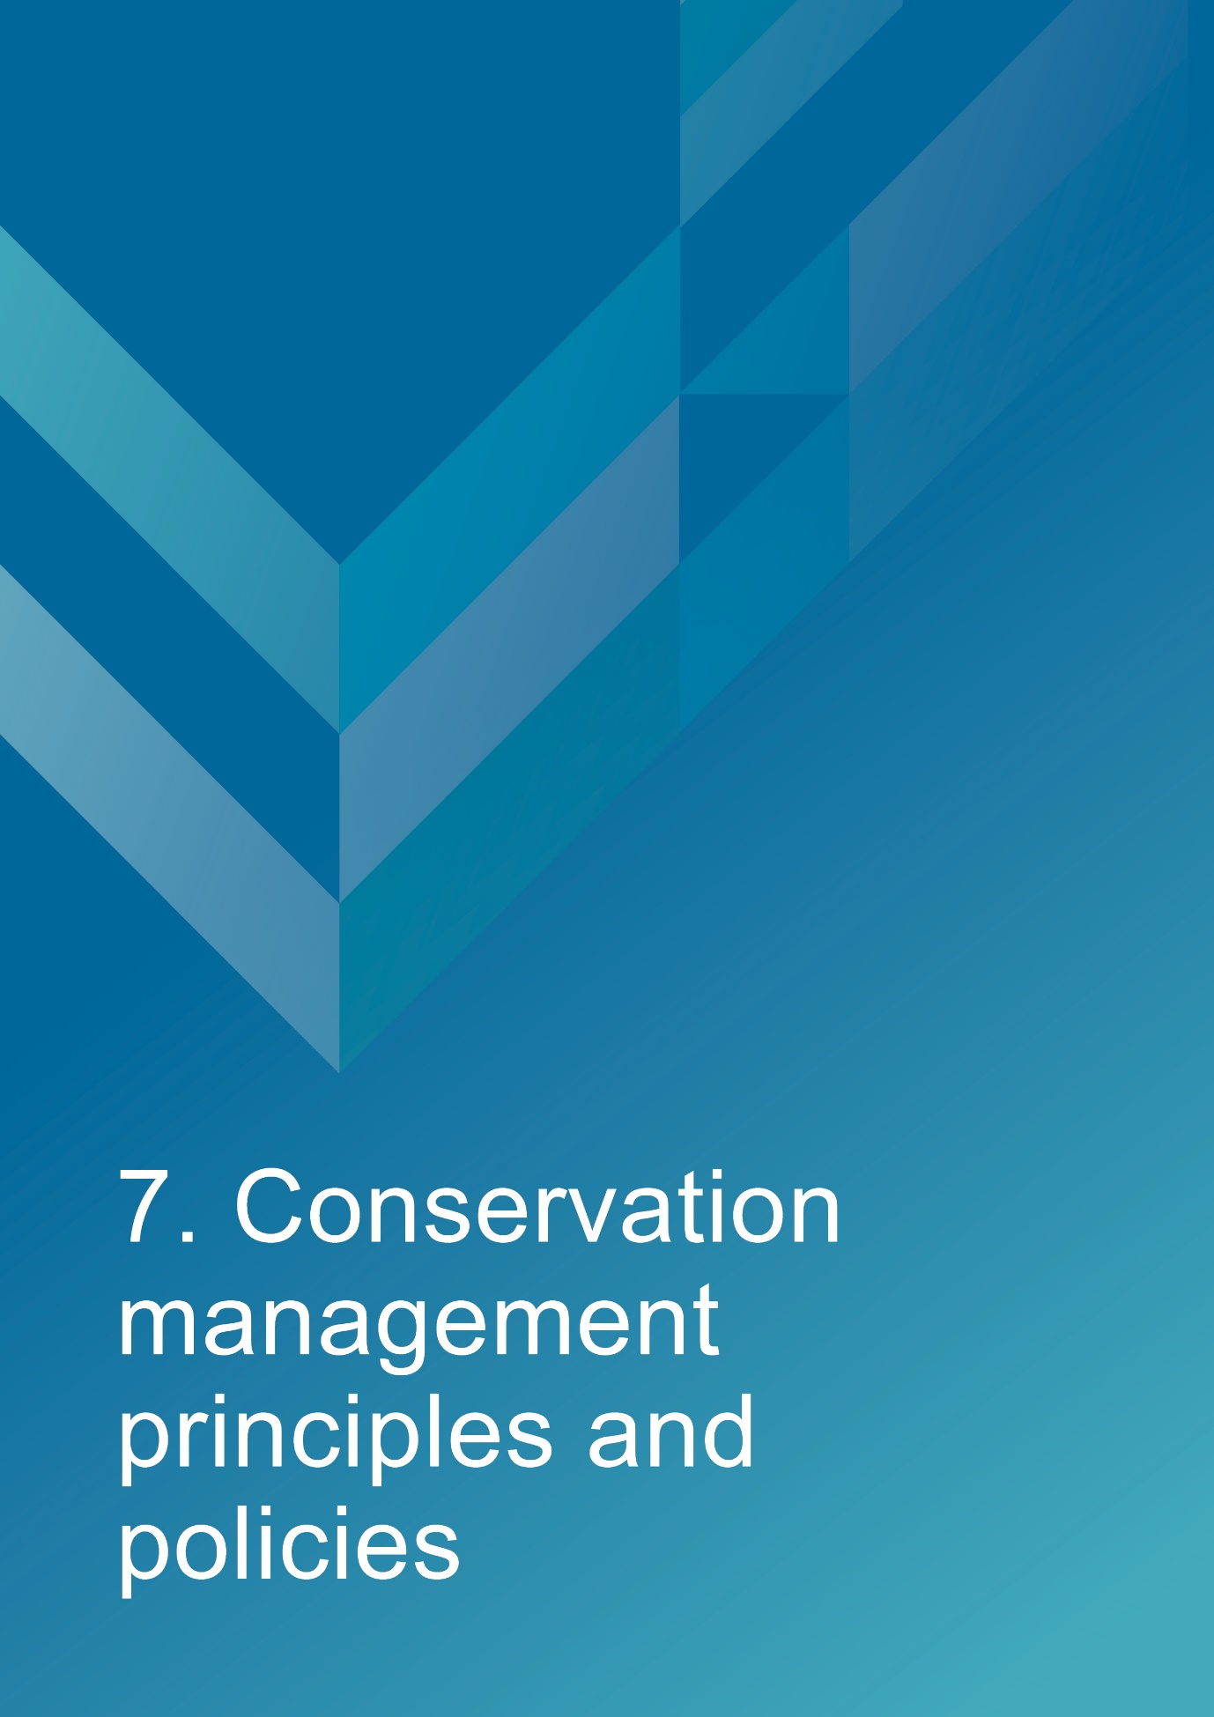
- Conservation management principles and policies
Policies
Note: The management of sensitive information is not relevant to AMSA’s heritage strategy and therefore bears no relevance in this management plan.
Fabric and setting
Policy 1 – Protect and conserve the significant external and internal fabric of the lightstation, including existing buildings, layout and setting.
AMSA’s main purpose is to facilitate the ongoing operation of the site as a marine AtoN while preserving the site’s heritage values. As part of a heritage monitoring program, Heritage Asset Condition Reports are produced for each site every two years to evaluate the condition of the heritage fabric and values. Routine servicing is also carried out by maintenance contractors. Regular written reports from these visits will be sent to AMSA Asset Management and Preparedness for review and any work requirements identified will be scheduled accordingly. Should for some unforeseen reason the site no longer be viable as a marine AtoN, management responsibilities will be passed to an appropriate state or federal authority to ensure preservation of the heritage assets.
Implementation strategy:
- AtoN Maintenance contractor will continue scheduled periodic maintenance of the lighthouse and marine aids to navigation every 12 months to ensure condition is monitored for early warning of deterioration. Schedule must be approved by AMSA Asset Management and Preparedness.
- AMSA Asset Management and Preparedness to arrange for maintenance to be carried out on the lighthouse as required while continuing to operate as an AMSA marine aids to navigation.
- AMSA Asset Management and Preparedness to arrange for the replacement and upgrading of marine aids to navigation equipment in the lighthouse as required to meet AMSA’s service commitment, in a manner that preserves the original fabric of the lighthouse.
- AMSA Asset Management and Preparedness to maintain information on the heritage fabric of the lighthouse including any and all actions, treatments and inspection outcomes within the heritage fabric register. See section 4.1 for fabric register.
- AMSA Asset Management and Preparedness to conserve all the fabric elements identified as significant in the heritage asset condition report.
- AMSA Asset Management and Preparedness to seek expert materials conservation advice when considering repair, restoration and reconstruction of historic fabric. The relevant local, state and federal heritage approvals must be sought prior to repair, restoration and reconstruction.
- AMSA Asset Management and Preparedness to assess any development proposals to surrounding area for possible impacts on the heritage values of Table Cape Lighthouse, and liaise with the appropriate state or federal heritage authorities.
- AMSA AtoN Heritage Coordinator to conserve the distinctive character of the lightstation by collecting photographic evidence and historical documentation of the original fabric.
- AtoN Maintenance Contractor to continue scheduled heritage monitoring visits to Table Cape and review Heritage Asset Condition Reports.
Uses
Policy 2 – Install and operate equipment in the lighthouse, so that it continues to function as an effective marine aid to navigation, in such a way as to impose the least possible harm to the significant fabric.
Table Cape Lighthouse’s use as a working marine AtoN is of high priority. Carrying out maintenance, including upgrades to AtoN equipment, is necessary to its function and continued marine safety along the TAS coast. In the event of the installation and/or upgrade to AtoN equipment, proper precaution will be taken to ensure the least possible harm is done to significant fabric.
Implementation strategy:
- AtoN Maintenance Contractor to monitor Table Cape’s AtoN equipment every 12 months and propose maintenance in the instance of necessary installation or removal. Proposed maintenance is to be approved by AMSA Asset Management and Preparedness.
- AMSA Asset Management and Preparedness to outline all possible risks to significant fabric, external and internal, associated with the installation, removal and operation of equipment.
- AMSA Asset Management and Preparedness to ensure works carried out are those that ensure the least possible harm to significant fabric.
- AMSA Asset Management and Preparedness to seek expert heritage conservation advice on best practice management of the site during installation, removal and operation of equipment.

Policy 3 – Monitor possible impacts to the site resulting from tourism and control appropriate access to the lighthouse for contractors and visitors.
Table Cape Lighthouse attracts a high number of visitors each year, and its location and layout allows relatively easy public access. Although access inside the lighthouse is restricted to authorised personnel, such as contractors and AMSA employees, official tour groups also oversee admittance of tourists from sunrise to sunset. AMSA personnel and contractors require easy access inside the lighthouse precinct and tower for periodical site visits to carry out inspections and routine maintenance.
Implementation strategy:
- AtoN Maintenance contractor to ensure control on access to all buildings within AMSA’s lease area is maintained by periodically inspecting restricted access areas on the precinct during maintenance visits every 12 months.
- AtoN Maintenance contractor to inspect lighthouse for signs of wear and tear attributed to visitor intake during yearly maintenance visit, and note changes in Heritage Asset Condition Report.
- AMSA Asset Management and Preparedness to ensure access to the lighthouse complies with workplace health and safety measures.
- AMSA Asset Management and Preparedness to ensure contractors are made aware of the heritage values of the lighthouse.
- AMSA Asset Management and Preparedness to ensure general admittance inside the lighthouse is monitored by the Minister administering the National Parks and Reserves Management Act 2002 (TAS).
- AMSA Asset Management and Preparedness to ensure access to site is available for Traditional stakeholders to maintain cultural traditions.

Interpretation
Policy 4 – Accurate and relevant interpretation of the history and significance of the place should be made available to site users/visitors and for offsite external research.
AMSA will continue to make information available through the maintenance of site interpretive signage and its website where appropriate.
Implementation strategy:
- All relevant information concerning the history and significance of the place will be checked for accuracy and updated appropriately.
- Information will be primarily presented in online resource files accessible to both relevant personnel and the general public. On-site interpretative signage will be utilised where possible.
- This information will be maintained and updated in accordance with changes to the history and significance of the place.

Management
Policy 5 – AMSA will continue to conserve the lighthouse in accordance with Commonwealth and Tasmanian State heritage listing requirements.
For works requiring heritage approval, AMSA will obtain permission from all relevant state and/or federal authorities. Continuous and as needed conservation works will be undertaken as required.
Implementation strategy:
- AMSA Asset Management and Preparedness to liaise with the relevant federal and state authorities when proposing work on the site.
- Approval in writing must be granted for any proposals for development.

Policy 6 – The cultural significance of the lighthouse will be the basis for deciding how to manage it.

The heritage values or cultural significance of the place must be conserved. This heritage management plan includes relevant background information to support this policy (see Section 3 History).
Implementation strategy:
- AMSA to conserve the lighthouse to protect its heritage values (cultural significance).
- When possible, AMSA will strive to maintain the original fabric of the lighthouse.
- AMSA to use the Burra Charter as the primary guide for treatment of fabric.
- AMSA Asset Management and Preparedness to engage appropriately qualified heritage consultants when making decisions regarding impact on heritage values.
- AMSA Asset Management and Preparedness to assess impacts on the heritage values of the place when considering proposed alterations or adaptations.

Policy 7 – Monitor, review and report the Commonwealth heritage values of the lighthouse every five years or sooner if major changes to the lighthouse occur.

The Commonwealth heritage values of the lighthouse are to be monitored and reported on a regular basis. A Heritage Asset Condition Report is updated for Table Cape Lighthouse every two years which records historical information, condition, and maintenance requirements for fabric within the lighthouse to ensure a gain and/or loss of heritage value is identified.

Implementation strategy:

- AMSA Asset Management and Preparedness to regularly monitor the lighthouse for possible impacts on the identified Commonwealth heritage values.
- AMSA Asset Management and Preparedness to review the current Commonwealth heritage values at least once every five years and assess any gain or loss of values. This review must be undertaken in the event of any major alterations to the lighthouse.
- AMSA Asset Management and Preparedness to report any changes to the Commonwealth heritage values of the lighthouse to the Department of Agriculture, Water and the Environment (Heritage Branch).
- AMSA Asset Management and Preparedness to update AMSA’s heritage strategy and this plan to reflect any changes identified.
- AMSA Maintenance Contractor to review and update Heritage Asset Condition Report biennially.

Policy 8 – Maintain historical, management and maintenance records within AMSA and make available these records.
As part of the proper process for managing change in significant places, the Burra Charter points out the importance of making records before any change, and advocates placing records in a permanent archive, and making them available where this is appropriate. AMSA’s collection of records, which include documents pertaining to heritage intervention, management and maintenance, are subject to this process. Heritage Asset Condition Reports are routinely generated for each lighthouse and stored in AMSA’s recordkeeping system. AMSA will continue to practice such processes via their Records Management Systems (RMS).
Implementation strategy:
- AMSA to maintain, review and update records through existing AMSA RMS as required.
- AMSA to ensure records are made available to the relevant personnel and parties as required.

Policy 9 – Develop and provide appropriate training and resources to all relevant AMSA staff, contractors and licensees.
In order to ensure best practice management of AMSA-operated lighthouses, all staff, contractors and licensees should have access to the appropriate training and resources in order to provide best practice conservation of the site.
Implementation strategy:
- Provide staff personnel involved with the management and maintenance of Table Cape Lighthouse access to up-to-date versions of the AMSA heritage strategy, heritage management plans and fabric registers.
- When funds are made available, AMSA Asset Management and Preparedness staff will undertake a relevant training to ensure comprehension of the Commonwealth heritage and EPBC Act statutory requirements.
- Develop and provide appropriate training for contractors engaged with heritage sites to ensure comprehension of the Commonwealth heritage and EPBC Act statutory requirements.
- AMSA representatives will attend Commonwealth-run heritage workshops, programs and conferences for up-to-date information on statutory requirements and best-practice management of sites of national and state heritage significance.
- All current and incoming tour guides operating within AMSA lighthouses will be required to take the lighthouse tour guide safety induction e-learning module once every two years to stay informed on heritage values, visitor safety and duty-of-care for the site’s heritage values.

Policy 10 – Use contractors and service providers with appropriate experience.
AMSA is to ensure parties carrying out work have appropriate knowledge and use effective methods to ensure conservation of the lighthouse.
Implementation strategy:
- AMSA Asset Management and Preparedness to engage staff and contractors with the relevant experience and expertise concerning conservation of the lighthouse.
- Develop and provide the appropriate training on heritage conservation matters for AMSA Asset Management and Preparedness staff and other relevant parties who hold responsibility for heritage management.

Policy 11 – Seek heritage advice and apply best heritage practice.
AMSA will continue to use in-house heritage expertise, external consultancy, or a combination of both as required in order to successfully apply best heritage practice. Should in-house heritage expertise be limited in responding to a requirement, external heritage expertise will be engaged to address the issue.
Implementation strategy:
- AMSA Asset Management and Preparedness to apply in-house heritage expertise when required.

- AMSA Asset Management and Preparedness to use tools such as the Burra Charter and Working Together: Managing Commonwealth Heritage Places to measure the likely impact of proposals.
- AMSA Asset Management and Preparedness to seek external heritage expertise in the event of limited in-house capability.

Policy 12 – Appropriate protocol in the event of unforeseen discoveries or disturbances of heritage within the AMSA site.
AMSA’s scope of work rarely involves excavation. Should such work need be undertaken, AMSA will implement a suitable discovery plan and seek advice from suitably qualified personnel as required. In the event of any unforeseen discovery or disturbance of heritage-related items on the AMSA site, notification to the appropriate organisation will occur in accordance with the conditions of the discovery plan. This plan will also be updated accordingly.
Note: In most cases, AMSA’s leases are limited to the immediate vicinity of the lighthouse and therefore this scenario is not anticipated as a likely occurrence.
Implementation strategy:
- AMSA Asset Management and Preparedness to consult Aboriginal Heritage Tasmania in the event Aboriginal heritage is discovered/suspected.
- AMSA Asset Management and Preparedness to seek appropriate heritage advice and apply best practice in the event of unforeseen discoveries/disturbances.

Policy 13 – Make this Heritage Management Plan available to all persons involved in decision-making on the management of the lighthouse and its setting.
The plan will be made available to all personnel intrinsic to management of the lighthouse and its setting, for example AMSA maintenance contractors, staff and other relevant parties.
Implementation strategy:
- AMSA to provide links to this plan via the AMSA website.
- AMSA to provide copies to all relevant personnel and parties.

Future Developments
Policy 14 – Adaptation of the place using methods or processes that minimise impact on heritage values and significance in accordance with The Burra Charter principles.
It is likely that over time the lighthouse will house new equipment as technology changes and improves. The Burra Charter principles will be used as the basis for decision-making.
Implementation strategy:
- AMSA Asset Management and Preparedness to assess the likely impacts of changes on the heritage values and significance of the place.
- AMSA Asset Management and Preparedness to preserve the original fabric of the place and do only what is necessary for the continued use and care of the place.
- AMSA Asset Management and Preparedness to engage expert heritage advice and use The Burra Charter in adapting the place.

Policy 15 – When required, engage with adjacent landowners to maintain an appropriate setting for the lighthouse in its visual and natural context.
Any changes to the surrounding land or AMSA leased area, requires careful consideration. AMSA will liaise with all adjacent landowners in the event of any proposed changes that may affect the setting and attempt to influence a positive outcome.
Implementation strategy:
- AMSA Asset Management and Preparedness to engage with adjacent landowners through consultation when changes are proposed regarding the wider visual and natural context.
- Consultations will take the form of online correspondence where in-person engagement is not possible.

Policy 16 – In the event of adaptive re-use or divestment, which would no longer place the lighthouse under AMSA control, AMSA will strive to ensure the Commonwealth and TAS State heritage values of the site are recognised and preserved.

In the event Table Cape Lighthouse is no longer identified as a working AtoN, AMSA will withdraw its standing as lessee and hand over all authority to the lessor. This process must be conducted in line with section 341ZE of the EPBC Act.

Implementation strategy:
            - AMSA will negotiate with lessor to have site lease terminated.
            - All available heritage information within AMSA’s collection, including this Heritage Management Plan, will be shared with the relevant parties to ensure the Commonwealth and State heritage values of the site are recognised and preserved.

Community Involvement
Policy 17 – Consult with Traditional stakeholders and wider community in the preparation of the management plan.
AMSA will give the community and Traditional stakeholders, as well as the general public, an opportunity to review and comment on this management plan through a public consultation process.
Implementation strategy:
- AMSA to undertake community consultation when preparing the heritage management plan in accordance with EPBC Regulations.
- AMSA to seek advice from Traditional stakeholders and refer to Engage Early – Guidance for proponents on best practice Indigenous engagement for environmental assessments under the Environment Protection and Biodiversity Conservation Act 1999 (EPBC Act) to guide consultations.

Review
Policy 18 – Review this plan within five years of its adoption or sooner if major changes are needed.
This plan will be reviewed every five years. This review should:
- assess the content of the plan.
- determine its effectiveness in protecting the identified heritage values.
- provide any necessary recommendations for updating or re-writing of the plan. If major changes occur at the site in the interim, this plan will be reviewed and updated earlier than the specified five years.

Implementation strategy:
- AMSA Asset Management and Preparedness to review this heritage management plan at least five years after its adoption.
- AMSA Asset Management and Preparedness to review and update this heritage management plan in the event of a major change to the lighthouse.
- AMSA Asset Management and Preparedness to summarise changes implemented within updated plan.
- AMSA Asset Management and Preparedness to submit revised plan for approval.


- Policy Implementation Plan
8.1 Plan
Key Issue | Management action/task | Policies | Responsibility | Priority | Timeframe
Conservation and preservation | Conserve the lighthouse. | 1, 2, 3, 5, 6, 10, 11, 14 | AMSA, Asset Management and Preparedness | High | On-going
 | Review the heritage management plan every five years. | 18 | AMSA, AtoN Heritage Coordinator | Medium | 2027 (5 years from registration)
 | Make this plan available to all relevant personnel. | 7, 13 | AMSA, AtoN Heritage Coordinator | High | Ongoing
Liaison dealings | If applicable, ensure communication is maintained with adjacent landowners. | 15 | AMSA, Asset Management and Preparedness | Medium | As required
 | Consult with Traditional Custodians and community stakeholders in preparing the management plan. | 17 | AMSA, AtoN Heritage Coordinator | Medium | As required
Heritage values | Review the Commonwealth heritage values every five years. | 7 | AMSA, AtoN Heritage Coordinator | High | 2027
 | Consider heritage values when proposing new planning and/or developments. | 5, 6, 7, 14 | AMSA, AtoN Heritage Coordinator and Project Managers | High | Ongoing
 | Ensure process of re-use or divestment of the site recognises and preserves heritage values. | 16 | AMSA, AtoN Heritage Coordinator | High | As required
 | Conduct heritage monitoring site visit and review Heritage Asset Condition Report every two years. | 1, 7 | AMSA, AtoN Heritage Coordinator | High | Once every two years (ongoing)
Staff and community awareness | Provide relevant training and awareness for management personnel (contractors and site-users). | 9 | AMSA, Asset Management and Preparedness | High | As required
 | Ensure the availability of accurate and relevant information on the history and significance of the lightstation for site-users and visitors. | 4 | AMSA, AtoN Heritage Coordinator | Medium | Ongoing
Record-keeping/access | Maintain adequate record-keeping of historical, management and maintenance documents. Make these records available. | 8 | AMSA, Asset Management and Preparedness | High | Ongoing
Expert heritage advice | Ensure knowledge and advice of heritage experts is used. | 10, 11 | AMSA, Asset Management and Preparedness | Medium | As required
Lighthouse maintenance | Schedule periodic maintenance. | 1 | AMSA, Asset Management and Preparedness | High | Ongoing (reoccurring once every 12 months)
 | The implementation of unforeseen discovery or disturbance processes in the event of an accidental discovery. | 12 | AMSA, Asset Management and Preparedness | Medium | As required
Lighthouse access | Secure appropriate access to lightstation for contractor and visitors. | 3 | AMSA, Asset Management and Preparedness | Medium | As required

  - Monitoring and reporting
As stipulated by Schedule 7A of the EPBC Regulations, the outlined implementation plan and associated policies listed above are required to be monitored and updated accordingly. The below review process timetable will be adhered to over the next five years:
Timeframe | Review step | Responsibility
2025 | Plan’s half-life internal review:  - Assess strengths and weaknesses of existing plan  - Address any known impact to the lighthouse’s heritage values | AMSA, Asset Management and Preparedness
2027 | Plan’s full-life review:  - Consult with internal and external stakeholders on existing plan  - Prepare updated draft plan and consult with the Heritage Branch  - Submit reviewed plan to the Minister | AMSA, Asset Management and Preparedness

Other key actions in monitoring and reporting include:
- ensuring the implementation plan and policies are readily available for all relevant personnel
- delegating AMSA staff to periodically check the implementation plan is up-to-date and being utilised appropriately by the relevant personnel
- ensuring the timeframes outlined within the plan are followed
- delegating AMSA Response staff to review this plan and the associated policies at least every five years and determine whether its contents are relevant and effective in terms of continuing to conserve the place.


Appendix 1. Glossary of heritage conservation terms
The Burra Charter, from its first version (1979) and its current version (2013), defined a set of terms that have since been widely adopted in Australian heritage conservation practice.
Where the following terms are used in their heritage management plan, the particular meanings defined in the charter are intended. The definitions are quoted from Article 1 of The Burra Charter.
Adaptation means modifying a place to suit the existing use or a proposed use.
Associations mean the special connections that exist between people and a place.
Compatible use means a use which respects the cultural significance of a place. Such a use involves no, or minimal, impact on cultural significance.
Conservation means all the processes of looking after a place to retain its cultural significance.
Cultural significance means aesthetic, historic, scientific, social or spiritual value for past, present or future generations. Cultural significance is embodied in the place itself, its fabric, setting, use, associations, meanings, records, related places and related objects. Places may have a range of values for different individuals or groups.
Fabric means all the physical material of the place including components, fixtures, contents, and objects.
Interpretation means all the ways of presenting the cultural significance of a place.
Maintenance means the continuous protective care of a place and its setting. Maintenance is to be distinguished from repair which involves restoration or reconstruction.
Meanings denote what a place signifies, indicates, evokes or expresses to.
Place means a geographically defined area. It may include elements, objects, spaces and view. Place may have tangible and intangible dimensions.
Preservation means maintaining a place in its existing state and retarding deterioration.
Reconstruction means returning a place to a known earlier state and is distinguished from restoration by the introduction of new material.
Related object means an object that contributes to the cultural significance of a place but is not at the place.
Related place means a place that contributes to the cultural significance of another place.
Restoration means returning a place to a known earlier state by removing accretions or by reassembling existing elements without the introduction of new material.
Setting means the immediate and extended environment of a place that is part of or contributes to its cultural significance and distinctive character.
Use means the functions of a place, including the activities and traditional and customary practices that may occur at the place or are dependant on the place.

Appendix 2. Glossary of historic lighthouse terms relevant to the Table Cape Lighthouse
A
Apron Paving – The concrete paving surround the base of the lighthouse tower.
Astragal – the bars which support the glazing of a lantern. They may also support the roof. Simply a framing member between the glazing bars in the lantern glazing. In its true meaning an astragal is a moulding that has a rounded profile. In lanterns this is almost never the case.

B
Balcony – a walk way around the outside of the lantern, used for maintenance and (formerly, when lighthouses were manned) for observing ships. Principal parts are the balcony floor and the balcony balustrade. (Synonym: gallery deck).
Balcony floor – floor of the balcony. Table Cape Lighthouse’s balcony floor is 1888 slate slab floor.
Balcony balustrade – a handrail together with its supports. The supports are called balusters. Simply a railing or wall on the outer perimeter of the balcony, to prevent people from falling off the balcony. Generally made of metal stanchions and rails – Table Cape’s balcony balustrades are of recent stainless steel.
Balcony door – door in the lantern base to give access to the balcony. In AMSA lanterns two doors are sometimes fitted but only one is operational. (Synonym: parapet hatch, service room door).

C
Cast iron – a mixture of iron and carbon with a relatively high carbon content and a low melting point, produced directly from a blast furnace.
Chance Bros – English manufacturer of optical apparatus, lanterns, cast iron stairs, cast iron towers, and other lighthouse components. The Chance family established a glass-making business in Smethwick, England in 1824 and is often described as ‘near Birmingham’. The business was absorbed into the Pilkington group of companies in 1951 and now ceases to exist.
Character – pattern of flashes of light emitted by a lighthouse, designed to identify that particular lighthouse.
Copper – a red malleable metal of low resistivity.

E
External catwalk – a landing around the external face of the tower complete with hand rail. Table Cape’s external catwalk is comprised of 1888 Chance Bros. cast iron lattice floor panels.

F
Flagstaff – a structure whereby signalling flags could be attached for communication with passing vessels.

G
Gangway – a raised platform or walkway providing a passage.

I
Intermediate floors – levels found mid-way up a building. Table Cape Lighthouse has three intermediate floors of slate slab.
Internal catwalk – an open landing inside the tower complete with handrail. Table Cape’s internal catwalk is comprised of 1888 Chance Bros. cast iron lattice floor panels.
Iron – there were two common types of iron used in lighthouse construction; wrought and cast. Older lights will almost certainly contain these iron types. Wrought iron has been worked by hand and is an iron alloy with a very low carbon content in contrast to steel, it also has fibrous inclusions. Cast iron is iron which has been heated until it liquefies, and is then poured into a mould to solidify.

L
Lantern – the glazed enclosure, usually of cylindrical or polygonal shape, at the top of a lighthouse, which surrounds and protects the optical apparatus. It contains the optical apparatus, made up of the lantern roof, lantern glazing and lantern base sections.
Lantern floor – the level in a lighthouse at which the lantern is installed, and by which access may be gained to the optical system and to the inside and outside of the lantern glazing. The lantern floor is generally at or near the same level as the catwalk and cane be made from steel, concrete, or timber.
Lantern glazing – the middle section of the lantern, circular or polygonal in plan, between the lantern roof above and the lantern base below, made up of glass panes held in a framework of glazing bars. On the landward side there may be blank panels in place of glass, or other opaque construction. Types of lantern glazing include: flat & curved trapezoidal panes and curved diamond/triangular panes. Table Cape’s lantern glazings are flat trapezoidal in form.
Lantern roof – the roof of the lantern. Usually made of copper sheeting over a framework of rafters.
Lens assembly – a transparent optically refracting element of glass. The surface is usually spherical in form.
Light source – electric bulbs now illuminate most lighthouses.
Lighthouse – the principal structure of a lightstation, generally made up of a lantern, balcony and tower.
Lightstation – a precinct containing a lighthouse structure and other related buildings, for example. Keepers’ cottages, store room, signal house.

O
Order – a shorthand expression of the size of an optical apparatus or lantern. At the time the system of orders was established, when kerosene burners were used, longer range lights needed larger burners, and larger burners needed lens assemblies of longer focal length to ensure a sharply defined beam. Thus in turn the lantern rooms were required to be larger to house these lens assemblies. AMSA historic lantern rooms range from 1st to 4th order.

P
Pedestal – part of the optical apparatus, consisting of a metal column or base standing on the balcony floor inside the lantern and supporting the lens assembly and light source. Some later Chance documentation (such as their tariffs 1908) also refer to the lantern base as a pedestal.

R
Retaining wall – a wall that holds back earth or water.

S
Suspended floor – a floor slab where its perimeter is, or at least two of its opposite edges are, supported one walls, beams or columns that carry its self-weight and imposed loading.

T
Tower – structure to support the lantern at a sufficient height above the ground. The most common types are the masonry tower, timber-framed tower, cast iron tower, and lattice tower.

Appendix 3. Table demonstrating compliance with the EPBC Regulations
Environment Protection and Biodiversity Conservation Regulations 2000 (Cth) Schedule 7A – Management Plans for Commonwealth Heritage Places
Legislation | Satisfied within
A management plan must:
(a) Establish objectives for the identification, protection, conservation, presentation and transmission of the Commonwealth Heritage values of the place; and | Section 1 – Introduction
(b) Provide a management framework that  includes reference to any statutory  requirements and agency mechanisms for  the protection of the Commonwealth  heritage values of the place; and | Section 1 – Introduction
(c) Provide a comprehensive description of the  place, including information about its  location, physical features, condition,  historical context and current uses; and | Section 2 – Table Cape Lighthouse site  Section 3 - History  Section 4 - Fabric
(d) Provide a description of the  Commonwealth heritage values and any  other heritage values of the place; and | Section 5 – Heritage significance
(e) Describe the condition of the  Commonwealth heritage values of the  place; and | Section 5 – Heritage significance
(f) Describe the method used to assess the  Commonwealth heritage values of the  place; and | Section 5 – Heritage significance
(g) Describe the current management  requirements and goals including  proposals for change and any potential  pressures on the Commonwealth heritage  values of the place; and | Section 6 – Opportunities and constraints
(h) Have policies to manage the
Commonwealth heritage values of a place,
and include in those policies, guidance in
relation to the following:
i. The management and conservation processes to be used; | Section 7 – Conservation management principles and policies (Policy 1, 2, 3, 5, 6, 10, 11, 14)
ii. The access and security  arrangements, including access to  the area for indigenous people to  maintain cultural traditions; | Section 7 – Conservation management principles and policies (Policy 3)
iii. The stakeholder and community  consultation and liaison  arrangements; | Section 7 – Conservation management principles and policies (Policy 15, 17)
iv. The policies and protocols to  ensure that indigenous people  participate in the management  process; | Section 7- Conservation management principles and policies (Policy 17)
v. The protocols for the management  of sensitive information; | Not Applicable
vi. The planning and management of  works, development, adaptive reuse  and property divestment  proposals; | Section 7 – Conservation management principles and policies (Policy 16)
vii. How unforeseen discoveries or  disturbances of heritage are to be  managed; | Section 7 – Conservation management principles and policies (Policy 12)
viii. How, and under what  circumstances, heritage advice is  to be obtained; | Section 7 – Conservation management principles and policies (Policy 10, 11)
ix. How the condition of  Commonwealth heritage values is  to be monitored and reported; | Section 7- Conservation management principles and policies (Policy 5, 6, 7, 14)
x. How records of intervention and  maintenance of a heritage places  register are kept; | Section 7 – Conservation management principles and policies (Policy 7, 13)
xi. The research, training and  resources needed to improve  management; | Section 7 – Conservation management principles and policies (Policy 9)
xii. How heritage values are to be  interpreted and promoted; and | Section 7 – Conservation management principles and policies (Policy 4)
(i) Include an implementation plan; and | Section 8 – Heritage implementation schedule
(j) Show how the implementation of policies  will be monitored; and | Section 8 – Heritage implementation schedule
(k) Show how the management plan will be  reviewed. | Section 7 – Conservation management principles and policies (Policy 18)  Section 8 – Policy implementation plan

Appendix 4. Table Cape current light details
IALA AVAILABILITY CATEGORY: | 2
PERFORMANCE CRITERIA (AVAILABILITY): | 99.0 per cent
POSITION: | Latitude: 40º 56.7957’ S  Longitude: 145º 43.7439’ E  Datum: WGS 84
CHART: | AUS 798
BA LIST OF LIGHTS: | K 3532
DAYMARK: | White round tower and lantern-house
HIEGHT OF DAYMARK: | 25 metres
CHARACTER: | Flashing (2) in 10.0 secs  Flash: 1.0 sec  Short Eclipse: 2.0 sec  Long Eclipse: 6.0 sec
COLOUR OF LIGHT: | White, Red
SECTORS: | Red: 100° - 138º (038°)  White: 138º - 296º (158º)  Red: 296º - 328° (032°)  True bearings from seaward
LANTERN: | Chance Bros. 2nd Order.
LENS: | Chance Bros. 700mm focal radius Catadioptric drum with catadioptric centred reinforcing mirrors.
LIGHT SOURCE: | Sealite SL-LED-216-W
STRUCTURE: | White masonry tower, 16.5 meters to base of lantern.
INTENSITY: | White: 26,500 cd  Red: 5,557 cd
ELEVATION: | 180 metres.
RANGE: | Nominal: White: 17 nautical miles  Red: 11 nautical miles  Geographical: 31.8 nautical miles

Endnotes

AMSA Interactive heritage lighthouse map, Google, (2019), https://www.operations.amsa.gov.au/lighthouses/?_ga=2.236400321.1108408984.1535497123-1996646104.1535497123
The Burra Charter, Australia ICOMOS, (2013).
Lee, E., Table Cape Lighthouse: Conservation Management Plan, Waratah Wynyard Council and Heritage Tasmania, (2009).
Marquis-Kyle, Peter., Heritage Lighthouse report: Table Cape, AMSG, (2006).
Register of the National Estate, Table Cape Lighthouse (Commonwealth), Lighthouse Rd, Wynyard, TAS, Australia, Australian Heritage Database, Department of the Environment and Energy, https://www.environment.gov.au/cgi-bin/ahdb/search.pl?mode=place_detail;search=place_name%3Dtable%2520cape%2520lighthouse%3Bstate%3DTAS%3Blist_code%3DRNE%3Blatitude_1dir%3DS%3Blongitude_1dir%3DE%3Blongitude_2dir%3DE%3Blatitude_2dir%3DS%3Bin_region%3Dpart%3Bkeyword_PD%3D0%3Bkeyword_SS%3D0%3Bkeyword_PH%3D0;place_id=103605
Tasmanian Heritage Register, Table Cape Light Station, Heritage Tasmania, https://heritage.tas.gov.au/heritage-listed-places/search-the-register#SearchSpatiallyUsingLISTmap%C2%A0
Commonwealth Heritage List, Table Cape Lighthouse, Lighthouse Rd, Wynyard, TAS, Australia, Australian Heritage Database, Department of the Environment and Energy, https://www.environment.gov.au/cgi-bin/ahdb/search.pl?mode=place_detail;search=state%3DTAS%3Blist_code%3DCHL%3Blegal_status%3D35%3Bkeyword_PD%3D0%3Bkeyword_SS%3D0%3Bkeyword_PH%3D0;place_id=105603
Garry Searle, First Order: Australia’s Highway of Lighthouses, (SA: Seaside Lights, 2013), 34.
Johnson, M., and Ian McFarlane, Van Diemen’s Land: An Aboriginal History, UNSW Press: NSW, (2015).
‘Table Cape’s History: Few settlers before year 1850,’ Examiner, Jan 30, 1937, https://trove.nla.gov.au/newspaper/article/52121922
‘Local,’ The Courier, July 24, 1852, https://trove.nla.gov.au/newspaper/article/2958714
‘The Governor’s visit to the coast,’ The Courier, Feb 5, 1856, https://trove.nla.gov.au/newspaper/article/2498325
Lee, Emma., Table Cape Lighthouse, (2009), pg. 12; ‘Table Cape’s History: Few settlers before year 1850,’ Examiner, Jan 30, 1837, https://trove.nla.gov.au/newspaper/article/52121922
‘Wreck of the Emma Prescott,’ Launceston Examiner, 8 Oct, 1867, https://trove.nla.gov.au/newspaper/article/36646456 ; ‘Tamar Heads,’ The Mercury, Jul 11, 1884, https://trove.nla.gov.au/newspaper/article/9090182
‘Table Cape Lighthouse,’ The Tasmanian, Aug 4, 1888, https://trove.nla.gov.au/newspaper/article/199510865/22050905
‘Table Cape Lighthouse,’ The Tasmanian, Aug 4, 1888, https://trove.nla.gov.au/newspaper/article/199510865/22050906
‘Table Cape Lighthouse,’ The Tasmanian, Aug 4, 1888, https://trove.nla.gov.au/newspaper/article/199510865/22050905
‘Lighthouse on the North West coast,’ The Mercury, April 3, 1879, https://trove.nla.gov.au/newspaper/article/8975487
‘Table Cape Lighthouse,’ The Tasmanian, Aug 4, 1888, https://trove.nla.gov.au/newspaper/article/199510865/22050905
Lee, Emma., Table Cape Lighthouse, (2009), pg. 13.
‘Table Cape Lighthouse,’ The Tasmanian, Aug 4, 1888, https://trove.nla.gov.au/newspaper/article/199510865/22050906
Lee, Emma., Table Cape Lighthouse, (2009), pg. 14; ‘The Table Cape Lighthouse,’ The Mercury, Aug 1, 1888, https://trove.nla.gov.au/newspaper/article/9194890
Lee, Emma., Table Cape Lighthouse, (2009), pg. 15.
‘The Table Cape Lighthouse,’ Daily Telegraph, Aug 3, 1888, https://trove.nla.gov.au/newspaper/article/150278804
‘The Table Cape Lighthouse,’ The Mercury, Aug 1, 1888, https://trove.nla.gov.au/newspaper/article/9194890
Lee, Emma., Table Cape Lighthouse, (2009), pg. 15.
Lee, Emma., Table Cape Lighthouse, (2009), pg. 16; ‘Table Cape Lighthouse,’ Lighthouses of Australia Inc., https://lighthouses.org.au/tas/table-cape-lighthouse/
‘Fatal accident: Child falls over precipice,’ The Mercury, Mar 21, 1902, https://trove.nla.gov.au/newspaper/article/9580185 ; ‘Deaths,’ The Mercury, Mar 24, 1902, https://trove.nla.gov.au/newspaper/article/9580287
Lee, Emma., Table Cape Lighthouse, (2009), pg. 20; ‘Table Cape Lighthouse,’ Lighthouses of Australia Inc., https://lighthouses.org.au/tas/table-cape-lighthouse/
‘The Table Cape Lighthouse,’ Daily Telegraph, Aug 3, 1888, https://trove.nla.gov.au/newspaper/article/150278804
Lee, Emma., Table Cape Lighthouse, (2009), pg. 16; ‘Table Cape Lighthouse,’ Lighthouses of Australia Inc., https://lighthouses.org.au/tas/table-cape-lighthouse/
Lee, Emma., Table Cape Lighthouse, (2009), pg. 16
Lee, Emma., Table Cape Lighthouse, (2009), pg. 17
Lee, Emma., Table Cape Lighthouse, (2009), pg. 18
‘Fatal accident: Child falls over precipice,’ The Mercury, Mar 21, 1902, https://trove.nla.gov.au/newspaper/article/9580185 ; ‘Deaths,’ The Mercury, Mar 24, 1902, https://trove.nla.gov.au/newspaper/article/9580287
‘Lighthouse flagstaff,’ The North Western Adovcate and the Emu Bay Times, May 31, 1917, https://trove.nla.gov.au/newspaper/article/64761513
Lee, Emma., Table Cape Lighthouse, (2009), pg. 20
‘Table Cape Lighthouse,’ Lighthouses of Australia Inc., https://lighthouses.org.au/tas/table-cape-lighthouse/
Brewis, C.R.W., Preliminary report on the lighting of the coast of Tasmania and the islands in Bass Strait: Recommendations as to existing lights and additional lights, Department of Trade and Customs, (1912), pg. 13.
Tasmanian Heritage Register, Table Cape Light Station, Heritage Tasmania, https://heritage.tas.gov.au/heritage-listed-places/search-the-register#SearchSpatiallyUsingLISTmap%C2%A0
Lee, Emma., Table Cape Lighthouse, (2009), pg. 14-15
Lee, Emma., Table Cape Lighthouse, (2009), pg. 19
Lee, Emma., Table Cape Lighthouse, pg. (2009), pg. 18
Lee, Emma, Table Cape Lighthouse, (2009), pg. 20; ‘Table Cape Lighthouse,’ Lighthouses of Australia Inc., https://lighthouses.org.au/tas/table-cape-lighthouse/
The Burra Charter, Australia ICOMOS, (2013).
AMSA, AMSA Heritage strategy 2022-2025, (2022).
AMSA, Annual Report 2020-21, https://www.amsa.gov.au/about/corporate-publications/annual-report-2020-21
Commonwealth of Australia, Working Together Managing Commonwealth Heritage Places: a guide for Commonwealth agencies (2019).
‘Engage Early – Guidance for proponents on best practice Indigenous engagement for Environment Protection and Biodiversity Conservation Act 1999 (EPBC Act), Commonwealth of Australia (2016).
The Burra Charter, Australia ICOMOS, (2013). Reference list AMSA, AMSA Heritage strategy 2022-2025 (2022) https://www.amsa.gov.au/amsa-heritage-strategy-2022-2025. AMSA, Annual Report 2020-21, https://www.amsa.gov.au/about/corporate-publications/annual-report-2020-21 AMSA Interactive heritage lighthouse map. Google, 2021, https://www.operations.amsa.gov.au/lighthouses/?_ga=2.236400321.1108408984.1535497123-1996646104.1535497123 Ask First: a guide to respecting Indigenous heritage places and values. Australian Heritage Commission, 2002. Brewis, C.R.W., Preliminary report on the lighting of the coast of Tasmania and the islands in Bass Strait: Recommendations as to existing lights and additional lights. Department of Trade and Customs, 1912. Commonwealth Heritage List, Table Cape Lighthouse, Lighthouse Rd, Wynyard, TAS, Australia. Australian Heritage Database, Department of Agriculture, Water and the Environment, https://www.environment.gov.au/cgi-bin/ahdb/search.pl?mode=place_detail;search=state%3DWA%3Blist_code%3DCHL%3Blegal_status%3D35%3Bkeyword_PD%3D0%3Bkeyword_SS%3D0%3Bkeyword_PH%3D0;place_id=105416 ‘The Burra Charter: The Australia ICOMOS Charter for Places of Cultural Significance’, Australia ICOMOS, 2013. ‘Engage Early—Guidance for proponents on best practice Indigenous engagement for environmental assessments under the Environment Protection and Biodiversity Conservation Act 1999 (EPBC Act), Commonwealth of Australia, 2016. Johnson, M., and Ian McFarlane., Van Diemen’s Land: An Aboriginal History. UNSW Press: NSW, 2015. Lee, E., Table Cape Lighthouse: Conservation Management Plan. Waratah Wynyard Council and Heritage Tasmania, 2009. Marquis-Kyle, P., Heritage Lighthouse Report: Table Cape. AMSG, 2006. National Archives of Australia: Australian Maritime Safety Authority, Central Office; A9568, Drawings and Plans of Lighthouses and of Associated Buildings and Equipment, 1833-1968; 5/14/1, Table Cape Lighthouse Station - Plan of Tower [Signed: R. Huckson, Architect], 1887. National Archives of Australia: Department of Foreign Affairs and Trade, Central Office; A1200, Black and white photographic negatives and prints, single number series with ‘L’ [Library] prefix, 1911-1971; L10744, Stud farm on a headland – Table Cape Farm, Wynyard, 1948-1948. National Archives of Australia: Department of Foreign Affairs and Trade, Central Office; A1200, Black and white photographic negatives and prints, single number series with ‘L’ [Library] prefix, 1911-1971; L10749, A farmer digging a field of potatoes, the lighthouse can be seen in the background, 1948. Reid, G., From Dusk till Dawn: A history of Australian lighthouses. Aus: Macmillan Co., 1988. Register of the National Estate, Table Cape Lighthouse (Commonwealth), Lighthouse Rd, Wynyard, TAS, Australia. Australian Heritage Database, Department of the Environment and Energy, https://www.environment.gov.au/cgi-bin/ahdb/search.pl?mode=place_detail;search=place_name%3Dtable%2520cape%2520lighthouse%3Bstate%3DTAS%3Blist_code%3DRNE%3Blatitude_1dir%3DS%3Blongitude_1dir%3DE%3Blongitude_2dir%3DE%3Blatitude_2dir%3DS%3Bin_region%3Dpart%3Bkeyword_PD%3D0%3Bkeyword_SS%3D0%3Bkeyword_PH%3D0;place_id=103605 Searle, G., First Order: Australia’s Highway of Lighthouses. Glenelg, SA: Seaside Lights, 2013. Table Cape Lighthouse. Lighthouses of Australia Inc., https://lighthouses.org.au/tas/table-cape-lighthouse/ Tasmanian Heritage Register, Table Cape Light Station. Heritage Tasmania, https://heritage.tas.gov.au/heritage-listed-places/search-the-register#SearchSpatiallyUsingLISTmap%C2%A0 Tomlinson, C., Tomlinson’s Cyclopaedia of Useful Arts. 1854. Working Together Managing Commonwealth Heritage Places: a guide for Commonwealth agencies. Commonwealth of Australia, 2019. ‘Local.’ The Courier. July 24, 1852. https://trove.nla.gov.au/newspaper/article/2958714 ‘The Governor’s visit to the coast.’ The Courier. Feb 5, 1856. https://trove.nla.gov.au/newspaper/article/2498325 ‘Wreck of the Emma Prescott.’ Launceston Examiner. 8 Oct, 1867, https://trove.nla.gov.au/newspaper/article/36646456 ‘Lighthouse on the North West coast.’ The Mercury. April 3, 1879, https://trove.nla.gov.au/newspaper/article/8975487 ‘Tamar Heads.’ The Mercury. Jul 11, 1884, https://trove.nla.gov.au/newspaper/article/9090182 ‘The Table Cape Lighthouse.’ The Mercury. Aug 1, 1888, https://trove.nla.gov.au/newspaper/article/9194890 ‘The Table Cape Lighthouse.’ Daily Telegraph. Aug 3, 1888, https://trove.nla.gov.au/newspaper/article/150278804 ‘Table Cape Lighthouse.’ The Tasmanian. Aug 4, 1888, https://trove.nla.gov.au/newspaper/article/199510865/22050905 ‘Fatal accident: Child falls over precipice.’ The Mercury. Mar 21, 1902, https://trove.nla.gov.au/newspaper/article/9580185 ‘Deaths.’ The Mercury. Mar 24, 1902, https://trove.nla.gov.au/newspaper/article/9580287 ‘Lighthouse flagstaff.’ The North Western Advocate and the Emu Bay Times. May 31, 1917, https://trove.nla.gov.au/newspaper/article/64761513 ‘Table Cape’s History: Few settlers before year 1850.’ Examiner. Jan 30, 1937. https://trove.nla.gov.au/newspaper/article/52121922

