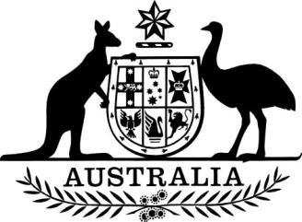

Australian Charities and Not-for-profits Commission (Acting Commissioner) Appointment (No. 2) 2022

I, Andrew Leigh, Assistant Minister for Charities and Treasury, under section 115-15 of the Australian Charities and Not-for-profits Commission Act 2012 appoint Anna Longley as the acting Commissioner of the Australian Charities and Not-for-profits Commission (ACNC), on a full-time basis, from the period beginning on 21 September 2022 until 7 October 2022.

The remuneration and allowances payable, and arrangements for leave of absence, are those that would apply to a Commissioner of the ACNC as at the date this instrument is made.

Dated 1 September 2022

Dr Andrew Leigh
Assistant Minister for Competition, Charities and Treasury
Parliamentary Secretary to the Treasurer

