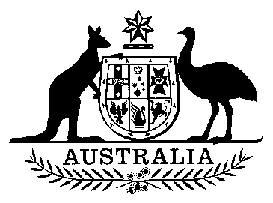

EXPORT MARKET DEVELOPMENT GRANTS ACT 1997

Determination
(3/2022)

Determination of the Balance Distribution Date for Grant Year 2020-21

I, Don Farrell, Minister for Trade and Tourism, pursuant to paragraph 68(1)(b) of the Export Market Development Grants Act 1997, determine the balance distribution date for grant year 2020-21 to be 14 June 2022.

This instrument commences on 10 June 2022.

Dated: 24 October 2022

Signed:

Minister for Trade and Tourism

