

**Food Standards (Application A1251 – 2′-FL combined with galacto-oligosaccharides and/or inulin-type fructans in infant formula products) Variation**

The Board of Food Standards Australia New Zealand gives notice of the making of this variation under section 92 of the *Food Standards Australia New Zealand Act 1991*. The variation commences on the date specified in clause 3 of this variation.

Dated 23 February 2023

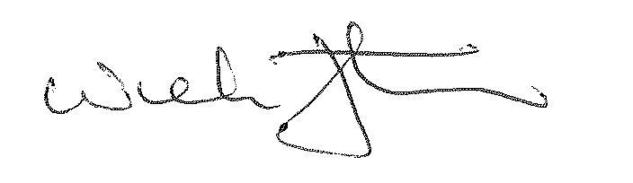

Dr Nick Fletcher

Delegate of the Board of Food Standards Australia New Zealand

**Note:**

This variation will be published in the Commonwealth of Australia Gazette No. FSC 156 on 2 March 2023. This means that this date is the gazettal date for the purposes of clause 3 of the variation.

1 Name

This instrument is the *Food Standards (Application A1251 – 2′-FL combined with galacto-oligosaccharides and/or inulin-type fructans in infant formula products) Variation*.

2 Variation to a Standard in the *Australia New Zealand Food Standards Code*

The Schedule varies a Standard in the *Australia New Zealand Food Standards Code*.

3 Commencement

The variation commences on the date of gazettal.

**Schedule**

Standard 2.9.1—Infant formula products

[1] Subsection 2.9.1—7(2)

Repeal the subsection, substitute:

(2) An infant formula product to which an inulin-type fructan and/or a galacto-oligosaccharides is added must not contain lacto-N-neotetraose as an added substance.

(3) During the exclusive use period, an infant formula product which contains the following added substances may only be sold if the infant formula product is a prescribed infant formula product:

(a) 2′- fucosyllactose; and

(b) an inulin-type fructan, a galacto-oligosaccharides, or both.

(4) For the purposes of subsection (3):

(a) **exclusive use period** means the period commencing on the date of gazettal of the *Food Standards (Application A1251 – 2ʹ-FL combined with galacto-oligosaccharides and/or inulin-type fructans in infant formula products) Variation* and ending 15 months after that date; and

(b) **prescribed infant formula product** means an infant formula product that:

(i) is manufactured by Nutricia Australia Pty. Ltd.; and

(ii) contains, as a nutritive substance, 2′-fucosyllactose sourced from *Escherichia coli* BL21 containing the gene for alpha-1,2-fucosyltransferase from *Escherichia coli* O126; and

(iii) contains Nutricia Australia Pty Ltd’s blend of *short-chain* *galacto-oligosaccharides and long chain fructo-oligosaccharides, namely scGOS/lcFOS (9:1)*.