

Radiocommunications (Unacceptable Levels of Interference – 2.5 GHz Mid Band Gap) Determination 2023

The Australian Communications and Media Authority makes the following determination under subsection 145(4) of the *Radiocommunications Act 1992*.

Dated: 16 March 2023

Chris Jose

[signed]

Member

Linda Caruso

[signed]

~~Member~~/General Manager

Australian Communications and Media Authority

1 Name

This is the *Radiocommunications (Unacceptable Levels of Interference – 2.5 GHz Mid Band Gap) Determination 2023*.

2 Commencement

This instrument commences at the start of the day after the day it is registered on the Federal Register of Legislation.

Note: The Federal Register of Legislation may be accessed free of charge at [www.legislation.gov.au](http://www.legislation.gov.au).

3 Authority

This instrument is made under subsection 145(4) of the Act.

4 Repeal of the *Radiocommunications (Unacceptable Levels of Interference – 2.5 GHz Mid-band Gap) Determination 2012*

The *Radiocommunications (Unacceptable Levels of Interference – 2.5 GHz Mid-band Gap) Determination 2012* [F2012L02553] is repealed.

5 Definitions

(1) In this instrument, unless the contrary intention appears:

***2.5 GHz mid band gap*** means the frequency band 2570 MHz to 2620 MHz.

***2.5 GHz mid band gap spectrum licence*** means a spectrum licence that authorises the operation of radiocommunications devices in the 2.5 GHz mid band gap.

***Act*** means the *Radiocommunications Act 1992*.

***Australian Spectrum Map Grid*** means the Australian Spectrum Map Grid 2012, published by the ACMA.

Note: The Australian Spectrum Map Grid is available, free of charge, from the ACMA’s website at [www.acma.gov.au](http://www.acma.gov.au).

***Australian territorial sea baseline*** means the baseline from which the breadth of the territorial sea, or any part of the territorial sea, is to be measured under section 7 of the *Seas and Submerged Lands Act 1973*.

***centre frequency***, in relation to a radiocommunications transmitter, means the frequency midway between the lower and upper frequency limits of the transmitter’s occupied bandwidth.

***DEM-3S*** means the dataset:

(a) with the citation “Gallant, J., Wilson, N., Tickle, P.K., Dowling, T., Read, A. 2009. 3 Second SRTM Derived Digital Elevation Model (DEM) Version 1.0. Record 1.0. Geoscience Australia, Canberra”; and

(b) given the persistent identifier <http://pid.geoscience.gov.au/dataset/ga/69888>;

published by Geoscience Australia.

Note: DEM-3S is available, free of charge, from Geoscience Australia using the persistent identifier. More information about DEM-3S is available, free of charge, from the Geoscience Australia website at [www.ga.gov.au](http://www.ga.gov.au).

***DEM-3S cell*** means an individual height element of the DEM-3S.

***device boundary***: see item 1 of Schedule 2.

***device boundary criterion***: see item 2 of Schedule 2.

***effective antenna height***: see Schedule 3.

***EIRP***, in relation to a radiocommunications device, means the equivalent isotropically radiated power of the device.

***emission designator***: see section 7.

***fixed receiver*** means a radiocommunications receiver:

(a) located at a fixed point on land or sea; and

(b) not designed or intended for use while in motion.

***fixed transmitter*** means a radiocommunications transmitter:

(a) located at a fixed point on land or sea; and

(b) not designed or intended for use while in motion.

***GDA94*** means the geodetic datum designated as the “Geocentric Datum of Australia (GDA)”, gazetted in the Commonwealth of Australia *Gazette* No. GN 35 on 6 September 1995, as existing on that date.

Note: *Gazette* No. GN 35 is available, free of charge, from the Federal Register of Legislation at [www.legislation.gov.au](http://www.legislation.gov.au).

***geographic area***, for a spectrum licence, means the area within which operation of a radiocommunications device is authorised under the licence.

***group of radiocommunications receivers***: see section 9.

***group of radiocommunications transmitters***: see section 8.

***HCIS*** means the cell grouping hierarchy scheme used to describe areas in the Australian Spectrum Map Grid.

Note: HCIS stands for hierarchical cell identification scheme.

***HCIS identifier*** means an identifier used to describe an area in the HCIS.

***horizontally radiated power***, for a radiocommunications device, means the sum of:

(a) the maximum true mean power, in dBm per specified rectangular bandwidth, at the antenna connector, that is located within the frequency band of the spectrum licence authorising the operation of the radiocommunications device; and

(b) the antenna gain relative to an isotropic antenna in a specified direction in the horizontal plane containing the phase centre of the antenna used with the radiocommunications device, in dBi.

***ITU-R Recommendation*** means a recommendation made by the Radiocommunication Sector of the International Telecommunication Union.

Note: ITU-R Recommendations are available, free of charge, from the website of the International Telecommunication Union at [www.itu.int](http://www.itu.int).

***location***: see Schedule 1.

***maximum true mean power*** means the true mean power measured in a specified rectangular bandwidth that is located within a specified frequency band, such that the true mean power is the maximum of the true mean powers produced.

Note: The power within the specified rectangular bandwidth is normally established by taking measurements using either an adjacent channel power meter or a spectrum analyser. Estimation of the accuracy of the measuring equipment, the measurement protocol and any adjustments made to measurements to take account of practical filter shape factors should be in accordance with good engineering practice.

***mean power*** means the average power measured during an interval of time that is at least 10 times the period of the lowest modulation frequency.

***occupied bandwidth***, in relation to a radiocommunications transmitter, means the width of a frequency band having upper and lower limits that contain 99% of the true mean power of the transmitter’s emission at any time.

***Radio Regulations*** means the document titled ‘Radio Regulations’, published by the International Telecommunication Union.

Note 1: The Radio Regulations are not regulations made by the Governor-General under the Act.

Note 2: The Radio Regulations are available, free of charge, from the International Telecommunication Union’s website at [www.itu.int](http://www.itu.int).

***Recommendation ITU-R P.525-4*** means the ITU-R Recommendation “P.525-4 Calculation of free-space attenuation”.

Note: The ITU-R Recommendations are available, free of charge, from the International Telecommunication Union’s website at [www.itu.int](http://www.itu.int).

***Recommendation ITU-R P.526-15*** means the ITU-R Recommendation “P.526-15 Propagation by diffraction”.

Note: The ITU-R Recommendations are available, free of charge, from the International Telecommunication Union’s website at [www.itu.int](http://www.itu.int).

***Recommendation ITU-R P.2108-0*** means the ITU-R Recommendation “P.2108-0 Prediction of clutter loss”.

Note: The ITU-R Recommendations are available, free of charge, from the International Telecommunication Union’s website at [www.itu.int](http://www.itu.int).

***true mean power*** means:

(a) if an unmodulated carrier is present – the mean power measured while the unmodulated carrier is present; or

(b) if an unmodulated carrier is not present – the mean power measured while transmitted information is present.

Note: A number of other expressions used in this instrument are defined in the Act, including the following:

(a) ACMA;

(b) core condition;

(c) frequency band;

(d) interference;

(e) radiocommunications device;

(f) radiocommunications receiver;

(g) radiocommunications transmitter;

(h) radio emission;

(i) Register;

(j) spectrum licence.

(2) In this instrument, unless otherwise specified, a reference to a part of the spectrum or a frequency band includes all frequencies that are greater than but not including the lower frequency, up to and including the higher frequency.

Note: This subsection means the lower number in a part of the spectrum or a frequency band is not included in the part of the spectrum or the frequency band.

6 References to other instruments

In this instrument, unless the contrary intention appears:

(a) a reference to any other legislative instrument is a reference to that other legislative instrument as in force from time to time; and

(b) a reference to any other kind of instrument or writing is a reference to that other instrument or writing as in force or existence from time to time.

Note 1: For references to Commonwealth Acts, see section 10 of the *Acts Interpretation Act 1901*; and see also subsection 13(1) of the *Legislation Act 2003* for the application of the *Acts Interpretation Act 1901* to legislative instruments.

Note 2: All Commonwealth Acts and legislative instruments are registered on the Federal Register of Legislation.

Note 3: See section 314A of the Act.

7 Emission designator

(1) For the purpose of this instrument, the designation of a radiocommunications transmitter’s emission (***emission designator***) is determined using the methods specified in the Radio Regulations.

(2) For the purpose of determining the emission designator of a radiocommunications transmitter using the methods specified in the Radio Regulations, references in the Radio Regulations to “necessary bandwidth” for a given class of emission are taken to be references to the occupied bandwidth of the transmitter.

Note: At the time the ACMA made this instrument, Appendix 1 of the Radio Regulations set out the method to be used for determining the designation of a radiocommunications transmitter’s emission.

8 Group of radiocommunications transmitters

(1) For the purposes of this instrument, and subject to subsection (2), two or more fixed transmitters are a ***group of radiocommunications transmitters*** if:

(a) each transmitter has the same centre frequency and emission designator; and

(b) each transmitter is operated for the purpose of communicating with the same radiocommunications receiver or group of radiocommunications receivers; and

(c) each transmitter has an antenna of the same type, model and manufacture; and

(d) the antenna used with each transmitter is located on the same structure and within 20 metres of the phase centre of all antennas for the other transmitters within the group of radiocommunications transmitters; and

(e) the identification number assigned by the ACMA to the antenna used with each radiocommunications transmitter is the same.

Note: See section 144 of the Act, and any instrument made under that section, for the information that must be included in the Register about a spectrum licence and each radiocommunications device operated under a spectrum licence.

(2) A radiocommunications transmitter must not belong to more than one group of radiocommunications transmitters.

Note: If a radiocommunications transmitter is capable of belonging to more than one group of radiocommunications transmitters, the spectrum licensee or authorised third party may nominate one group for the transmitter.

9 Group of radiocommunications receivers

(1) For the purposes of this instrument, and subject to subsection (2), two or more fixed receivers are a ***group of radiocommunications receivers*** if:

(a) each receiver is operated for the purpose of communicating with the same radiocommunications transmitter or group of radiocommunications transmitters; and

(b) each receiver has an antenna of the same type, model and manufacture; and

(c) the antenna used with each receiver is located on the same structure and within 20 metres of the phase centre of all antennas for the other receivers within the group of radiocommunications receivers; and

(d) the identification number assigned by the ACMA to the antenna used with each radiocommunications receiver is the same.

Note: See section 144 of the Act, and any instrument made under that section, for the information that must be included in the Register about a spectrum licence and each radiocommunications device operated under a spectrum licence.

(2) A radiocommunications receiver must not belong to more than one group of radiocommunications receivers.

Note: If a radiocommunications receiver is capable of belonging to more than one group of radiocommunications receivers, the spectrum licensee or authorised third party may nominate one group for the receiver.

10 Unacceptable level of interference

(1) A level of interference caused by a radiocommunications transmitter operated under a 2.5 GHz mid band gap spectrum licence is unacceptable if:

(a) the operation of the transmitter results in a contravention of a core condition of the licence relating to the maximum permitted level of radio emission from the transmitter:

(i) outside the parts of the spectrum the use of which is authorised under the licence; or

(ii) outside the geographic area of the licence; or

(b) subject to subsection (2), any part of the device boundary of the transmitter lies outside of the geographic area of the licence; or

(c) the device boundary of the transmitter cannot be calculated in accordance with item 1 of Schedule 2.

(2) A level of interference mentioned in paragraph (1)(b) is not unacceptable in relation to a part of the device boundary of the radiocommunications transmitter that:

(a) lies outside the geographic area of the licence; and

(b) is connected to a radial that:

(i) is mentioned in item 1 of Schedule 2; and

(ii) does not cross over land outside the geographic area of the licence that is permanently above the Australian territorial sea baseline; and

(iii) does not cross into any of the following HCIS identifiers: IW3E, IW3I, IW3M, IW6A, IW6E, KX9, LX7, LX8, LX9.

Note: The HCIS identifiers beginning with IW describe an area near Adelaide. The HCIS identifiers beginning with KX and LX describe an area in Bass Strait.

(3) A level of interference caused by a radiocommunications transmitter operated under a 2.5 GHz mid band gap spectrum licence is unacceptable if the operation of the transmitter results in emissions above the horizontal plane greater than 45 dBm/30 kHz EIRP.

(4) This section does not apply in relation to a radiocommunications transmitter to which section 12 applies.

Note Subsection 145(1) of the Act provides that the ACMA may refuse to include in the Register details of a radiocommunications transmitter if the ACMA is satisfied that operation of the transmitter could cause an unacceptable level of interference to the operation of other radiocommunications devices. However, some radiocommunications transmitters are exempt from the requirement to be registered in the Register under their 2.5 GHz mid band gap spectrum licence – see subsection 69(2) of the Act.

11 Accuracy

Unless otherwise specified, the value of a parameter in Schedules 2 and 3 must be estimated with a level of confidence not less than 95 percent that the true value of the parameter will always remain below the requirement specified in this instrument.

12 Transitional – radiocommunications transmitter registered before commencement of this instrument

(1) If a radiocommunications transmitter was included in the Register in relation to a 2.5 GHz mid band gap spectrum licence before the commencement of this instrument (***relevant transmitter***), this section applies in relation to that transmitter.

(2) Subject to subsection (3), for the purposes of subsection 145(4) of the Act, a level of interference caused by a relevant transmitter is unacceptable if it would have been unacceptable under the *Radiocommunications (Unacceptable Levels of Interference – 2.5 GHz Mid-band Gap) Determination 2012*, as in force at the time the relevant transmitter was included in the Register.

Note: The *Radiocommunications (Unacceptable Levels of Interference – 2.5 GHz Mid-band Gap) Determination 2012* is available, free of charge, from the Federal Register of Legislation at [www.legislation.gov.au](http://www.legislation.gov.au).

(3) For the purposes of subsection 145(4) of the Act, if:

(a) after the commencement of this instrument, both:

(i) a detail of a relevant transmitter changes (***relevant change***); and

(ii) the change to the detail is recorded in the Register; and

(b) the distance of the new device boundary of the relevant transmitter is, on each radial mentioned in item 1 of Schedule 2, equal to or less than the distance of the old device boundary of the relevant transmitter on that radial; and

(c) but for the effect of this subsection, a level of interference caused by the relevant transmitter, immediately after the change time, would be unacceptable;

the level of interference caused by the relevant transmitter, immediately after the change time, is not unacceptable because of the relevant change.

(4) In subsection (3):

***change time***, for a relevant transmitter, means the time the relevant change is recorded in the Register.

***new device boundary***, of a relevant transmitter, means the device boundary of the transmitter established immediately after the change time, in accordance with this instrument as in force at the change time.

***old device boundary***, of a relevant transmitter, means the device boundary of the transmitter established immediately before the change time, in accordance with the *Radiocommunications (Unacceptable Levels of Interference – 2.5 GHz Mid-band Gap) Determination 2012*, as in force at the registration time.

***registration time***, for a relevant transmitter, means the time the transmitter was included in the Register.

# Schedule 1 Location

(subsection 5(1))

1 Location

(1) The ***location*** of a radiocommunications transmitter (*lt*, *Lt*) is the location (by latitude and longitude with reference to GDA94) of the phase centre of the radiocommunications transmitter’s antenna.

(2) The ***location*** of a group of radiocommunications transmitters (*lt*, *Lt*) is the location (by latitude and longitude with reference to GDA94) of the centre point between the phase centre of each radiocommunications transmitter antenna within the group.

(3) In determining the location of a radiocommunications transmitter, or a group of radiocommunications transmitters, the measurement error must be less than 10 metres.

Note: The ACMA issues site identifiers for established radiocommunications locations available in the Register.

# Schedule 2 Device boundary and device boundary criterion

(subsections 5(1), 10(1) and (2), section 11 and subsection 12(3))

1 Device boundary of a radiocommunications transmitter

(1) The ***device boundary*** of a single radiocommunications transmitter is established as follows:

Step 1: Calculate the device boundary criterion at each *m*×100 metre increment along each of the *n*-degree radials, where:

***m*** is each of the integers from 1 through 500; and

***n*** is each of the integer degrees from 0 (true north) through 359.

Step 2: For each radial, find the latitude and longitude of the first point on the radial, moving away from the location of the radiocommunications transmitter (that is, with the lowest value of *m*) where either:

(a) the device boundary criterion, RP-MP, is less than or equal to 0; or

(b) *m* is equal to 500.

This point is the ***end point*** of the radial.

Step 3: The end point of each radial is the ***device boundary*** of the radiocommunications transmitter connected to that radial.

Note: RP – MP (the device boundary criterion) is calculated under item 2 of this Schedule.

(2) For a group of radiocommunications transmitters the ***device boundary*** is calculated as if for a single radiocommunications transmitter. However, the radiated power (***RP***) for a group of radiocommunications transmitters is taken:

(a) to be equal for each bearing *σn*; and

(b) to have a value that is equal to the maximum horizontally radiated power, in any direction, of any of the radiocommunications transmitters in the group.

Note: σ*n* is the bearing of the *nth*-degree radial for the group of radiocommunications transmitters.

2 Device boundary criterion

The ***device boundary criterion*** is the value of the mathematical expression:

RP – MP

where:

|  |  |  |
| --- | --- | --- |
| ***MP*** | : | is *PL*(*lmn, Lmn*) *+ LOP – Gr* ; |
| ***RP*** | : | is the horizontally radiated power, measured in dBm EIRP per 30 kHz, for each bearing, *σn*; |
| Note: |  | For ***RP***for a group of radiocommunications transmitters, see subitem 1(2). |
| ***LOP*** | : | is the level of protection. The ***LOP*** is -80.4 dBm per 30 kHz; |
| ***Gr*** |  | is the nominal radiocommunications receiver antenna gain, including feeder loss set at 18 dBi; |
| ***PL(lmn, Lmn)*** | : | is the propagation loss (dB) (calculated under item 3 of this Schedule) of the *mth* increment on the *nth* radial. |

3 Calculation of propagation loss for device boundary criterion

(1) Subject to this item, the propagation loss for a radiocommunications transmitter, at the *mth* increment on the *nth* radial (*PL(lmn, Lmn)*) is calculated using:

(a) for a transmitter connected to an antenna that is located more than 6 metres above ground level – the method and parameters set out in section 2.2 of Recommendation ITU-R P.525-4 and section 4.5.2 of Recommendation ITU-R P.526-15;

(b) for a transmitter connected to antenna that is located 6 metres above ground level, or lower – the method and parameters set out in section 2.2 of Recommendation ITU-R P.525-4 and section 3 of Recommendation ITU-R P.2108-0.

(2) For the purposes of using the method set out in section 4.5.2 of Recommendation ITU-R P.526-15:

(a) the height of the nominal receiver is taken to be 5 metres above ground level;

(b) the height of the transmitter above ground level is worked out in accordance with item 1 of Schedule 3; and

(c) the height of a profile point is the average ground height of that point, worked out in accordance with item 2 of Schedule 3.

(3) For the purposes of using the method set out in section 4.5.2 of Recommendation ITU-R P.526-15:

(a) the path profile in that method must be developed by sampling the DEM-3S at 100 metre increments along each radial; and

(b) at each increment along the path profile, the average ground height is worked out in accordance with item 2 of Schedule 3.

(4) For the purposes of using the method set out in section 3.2 of Recommendation ITU-R P.2108-0:

(a) the percentage of locations is 0.08%, and the correction is applied at only one end of the path;

(b) if the loss calculated using the method is less than 0 dB, the calculated loss value is taken to be 0 dB; and

(c) if the loss calculated using the method is greater than 8 dB, the calculated loss value is taken to be 0 dB.

# Schedule 3 Effective antenna height and average ground height

(subsection 5(1) and section 11)

1 Effective antenna height of a fixed transmitter

(1) If:

(a) subject to subitem (2), *hgt* is the vertical height in metres of the phase centre of a fixed transmitter’s antenna measured with an error of less than 5 parts in 100 and relative to the point:

(i) located on the line of intersection between the external surface of the structure supporting the antenna and the surface of the ground or sea; and

(ii) having the lowest elevation on that line; and

(b) subject to subitem (3), *hs* is the sum of:

(i) the DEM-3S cell height of the location of the fixed transmitter as defined in Schedule 1; and

(ii) *hgt*; and

(c) Start formula h subscript a g subsubscript m open bracket sigma n close bracket end formula is the average ground height of the DEM-3S cell at each m-increment on each n-radial as calculated in accordance with item 2;

then the ***effective antenna height*** Start formula h subscript e subsubscript m open bracket sigma subscript n close bracket end formula of the fixed transmitter is:

(d) except where paragraph (e) applies: Start formula h subscript s minus h subscript a g sub subscript m open bracket sigma n close bracket end formula (as shown in Diagram 1);

(e) if Start formula h subscript s minus h subscript a g sub subscript m open bracket sigma n close bracket end formula is less than *hgt : hgt*.

(2) For a group of radiocommunications transmitters, *hgt* is the greatest of the *hgt* for each individual transmitter in the group, calculated in accordance with this item.

(3) If the seconds component of the latitude or longitude of the fixed transmitter as defined in Schedule 1, plus 1.5, has a modulus of zero when divided by 3, then *hs* is the sum of:

(a) *hgt*; and

(b) the maximum height of the adjacent DEM-3S cells.

**Diagram 1 Calculating effective antenna height**

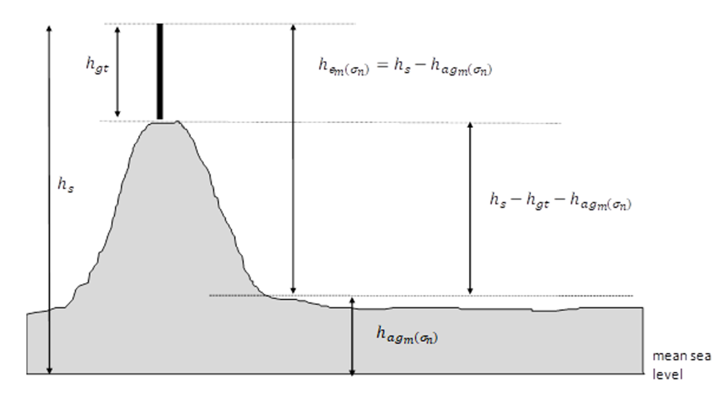

2 Average ground height

(1) The ***average ground height*** at the *mth*increment on the *nth* radial is calculated as follows:

Step 1: Determine the associated latitude and longitude of the *mth* increment on the *nth* radial *(lmn, Lmn)* as calculated in item 3 of this Schedule.

Step 2: Identify the DEM-3S cell represented by (*lmn, Lmn*).

Note: See subitem (2) below for identifying the DEM-3S cell in a particular case.

Step 3: Bound the identified DEM-3S cell with the 8 adjacent DEM-3S cells in a 3 x3 matrix and obtain each DEM-3S cell height attribute (as shown in Diagram 2).

Step 4: Determine the average value of the 9 DEM-3S cell heights for each cell in the the 3 x 3 matrix.

**Diagram 2 Calculating average ground height**

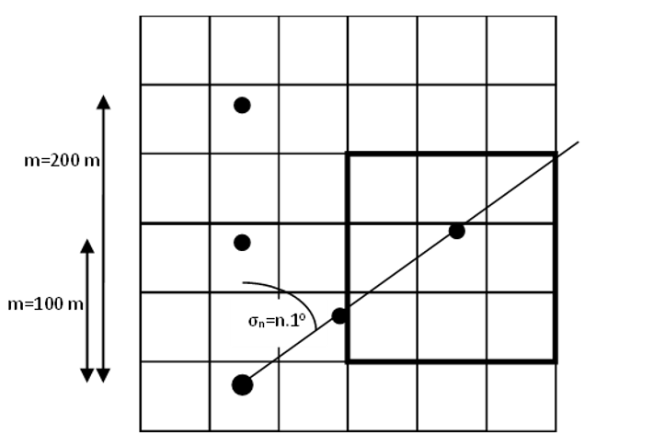

(2) If the seconds component of (*lmn, Lmn*), plus 1.5, has a modulus of zero when divided by 3, then the corresponding DEM-3S cell, for the purposes Step 2 in subitem (1), is the adjacent DEM-3S cell with the minimum height.

3 Vincenty’s Direct Formulae

Note: This implementation of Vincenty’s Direct Formulae uses the parameters *{a, fl, b}* from the GRS80 ellipsoid as referenced by GDA94.

(1) In calculating (*lmn, Lmn*):

|  |  |  |
| --- | --- | --- |
| ***lt*** |  | is the latitude of the fixed transmitter (decimal radians) |
| ***Lt*** |  | is the longitude of the fixed transmitter (decimal radians) |
| ***α*** |  | is the azimuth angle (decimal radians) |
| ***d*** |  | is the separation distance to required point (m×100 metres) |
| ***a*** |  | is the semi-major axis with value 6378137 metres |
| ***fl*** |  | is the flattening of the value 1/298.25722210 |
| ***b*** |  | is the semi-minor axis of (*a×(1-fl)*) |

start formula e superscript 2 equals open bracket a superscript 2 minus b superscript 2 close bracket forward over b superscript 2 end formula

start formula U subscript 1 equals arctan open bracket 1 minus f subscript l close bracket times tan open bracket l subscript t close bracket close bracket end formula

start formula phi subscript 1 equals arctan open bracket tan open bracket U subscript 1 close bracket over cos open bracket alpha close bracket close bracket end formula

start formula alpha subscript n equals arcsin open bracket cos open bracket U subscript 1 close bracket times sin open bracket alpha close bracket close bracket end formula

start formula u superscript 2 equals cos superscript 2 open bracket alpha subscript n close bracket times e superscript 2 end formula

start formula A equals 1 plus open bracket u superscript 2 over 16384 close bracket times open bracket 4096 plus u superscript 2  times open bracket -768 plus u superscript 2 times open bracket 320 minus 175 times u superscript 2 close bracket close bracket close bracket end formula

start formula B equals open bracket u superscript 2 over 1024 close bracket times open bracket 256 plus u superscript 2 times open bracket -128 plus u superscript 2 times open bracket 74 minus 47 times u superscript 2 close bracket close bracket close bracket end formula

(2) Using an initial value start formula phi equals d over open bracket b times A close bracket end formula, iterate the following three equations until the change in *φ* is less than 10-12.

Components of Vicenty's Formulae for calculating phi subscript m

Components of Vicenty's Formulae for calculating sigma phi

Components of Vicenty's Formulae for calculating phi

(3) Then:

Components of Vicenty's Formulae for calculating l subscript mn

Note: Use the four-quadrant inverse tangent, *atan2*.

Components of Vicenty's Formulae for calculating lambda

Note: Use the four-quadrant inverse tangent, *atan2*.

Components of Vicenty's Formulae for calculating C; components of Vicenty's Formulae for calculating L and Components of Vicenty's Formulae for calculating L subscript mn