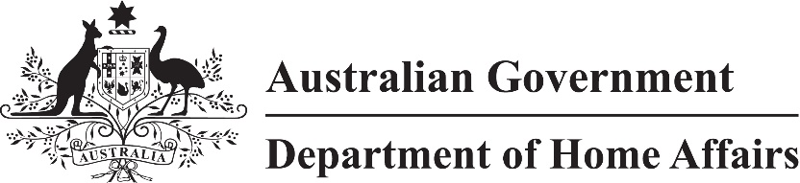

LIN 23/004

Migration (Payment of visa application charges and fees in foreign currencies) Instrument (LIN 23/004) 2023

I, Stephanie Cargill, delegate of the Minister, under paragraph 5.36(1A)(a) of the *Migration Regulations 1994*:

(a) specify the Australian dollar; and

(b) specify the exchange rate for the currency mentioned in paragraph (a) is 1.00000; and

(c) repeal *Migration (Payment of visa application charges and fees in foreign currencies) Instrument (LIN 22/003) 2022 (No. 2)*.

This instrument commences on 1 July 2023.

Dated 19 June 2023

Stephanie Cargill

Chief Finance Officer

Department of Home Affairs