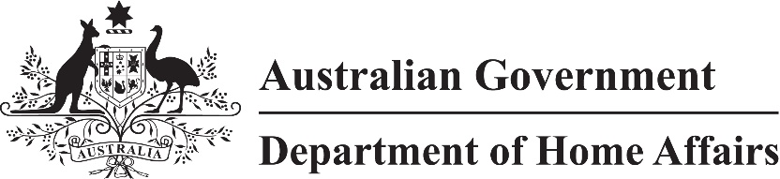

LIN 23/005

Migration (Places and currencies for paying of fees) Instrument (LIN 23/005) 2023

I, Stephanie Cargill, delegate of the Minister, under paragraphs 5.36(1)(a) and (b) of the *Migration Regulations 1994*:

(a) specify that payment of a fee in Australia or a foreign country be made in the Australian dollar; and

(b) repeal *Migration (Places and currencies for paying of fees) Instrument (LIN 22/004) 2022 (No. 2)*.

This instrument commences on 1 July 2023.

Dated 19 June 2023

Stephanie Cargill

Chief Finance Officer

Department of Home Affairs