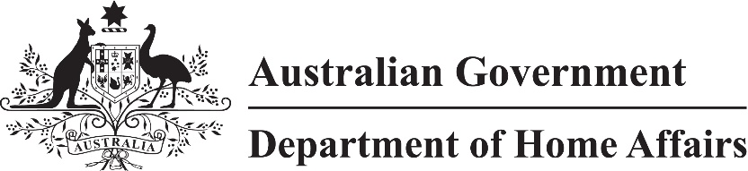

LIN 23/047

Migration (Arrangements for subclass 417 visa applications) Amendment Instrument (LIN 23/047) 2023

I, Karin Maier, delegate of the Minister, make this instrument under subregulation 2.07(5) of the *Migration Regulations 1994* (the Regulations), paragraph 417.211(2)(a) of Schedule 2 to the Regulations, and subparagraph 417.211(2)(b)(ii) of Schedule 2 to the Regulations*.*

Dated 27 July 2023

Karin Maier

Senior Executive Service Band 1

Immigration Programs Division

Department of Home Affairs

1 Name

This instrument is the Migration (Arrangements for subclass 417 visa applications) Amendment Instrument (LIN 23/047) 2023.

2 Commencement

This instrument commences on 1 July 2023.

3 Amendment

Schedule 1 amends Migration (Arrangements for subclass 417 visa applications) Instrument (LIN 22/051) 2022.

Schedule 1 Amendment

(s.3)

[1] Schedule 1, item 19

substitute

|  |  |  |  |
| --- | --- | --- | --- |
| 19 | United Kingdom | Passport must indicate that the applicant’s nationality is British Citizen or British National (Overseas). | - |