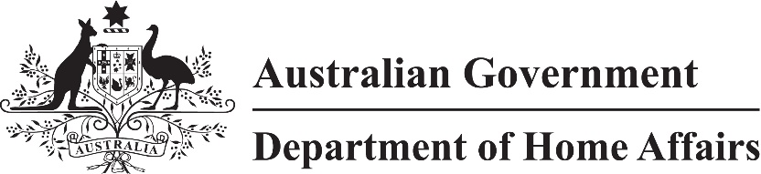

LIN 23/034

Migration (Arrangements for Work and Holiday (Subclass 462) Visa Applications) Amendment (Papua New Guinea) Instrument (LIN 23/034) 2023

I, Karin Maier, delegate of the Minister, make this instrument under subregulation 2.07(5) of the *Migration Regulations 1994* (the ***Regulations***) and paragraph 462.221(c) of Schedule 2 to the Regulations.

Dated 29 June 2023

Karin Maier

Senior Executive Service Band 1

Immigration Programs Division

Department of Home Affairs

1 Name

This instrument is the Migration (Arrangements for Work and Holiday (Subclass 462) Visa Applications) Amendment (Papua New Guinea) Instrument (LIN 23/034) 2023.

2 Commencement

This instrument commences on 1 July 2023.

3 Amendment

Schedule 1 amends Migration (Arrangements for Work and Holiday (Subclass 462) Visa Applications) Instrument (LIN 21/019) 2021 (F2022C00702).

Schedule 1 Amendment

(s.3)

[1] Subsection 4(2), table, after Mongolia

insert

|  |
| --- |
|  |
| Papua New Guinea |

[2] Schedule 2, table, after item 12A

insert

|  |  |  |
| --- | --- | --- |
| 12B | Papua New Guinea | (a) successful completion of at least 2 years of post-secondary study |