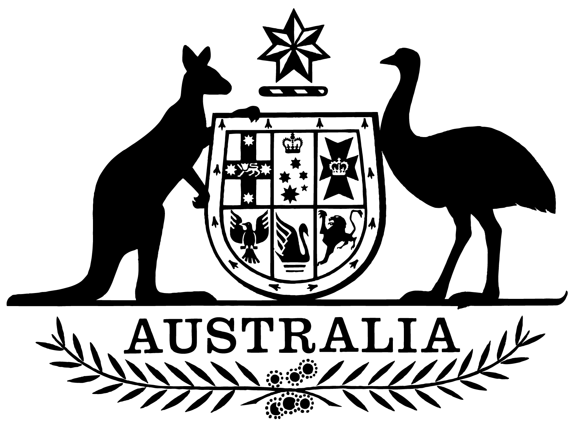

Civil Aviation Act 1988
Statement of Expectations for the Civil Aviation Safety Authority from 1 July 2023 to 30 June 2025
I, Catherine King, Minister for Infrastructure, Transport, Regional Development and Local Government, make the following instrument.
Dated: 13 June 2023

Catherine King
Minister for Infrastructure, Transport, Regional Development and Local Government

- Overview
This instrument is the Statement of Expectations for the Civil Aviation Safety Authority from 1 July 2023 to 30 June 2025.
This Statement of Expectations (SoE) applies from 1 July 2023 to 30 June 2025, and replaces the current SoE issued on 13 January 2022.
This SoE serves as a notice to the Civil Aviation Safety Authority (CASA) under section 12A of the Civil Aviation Act 1988 (the Act) and sets out my expectations on CASA’s strategic direction and the manner in which it should perform its functions.

- Governance
I expect the Board of CASA (the Board) and the Director of Aviation Safety (DAS) to continue to enable and enhance the effective operation of CASA as Australia’s aviation safety regulator.
I expect the Board to be responsible for the matters set out in the Act, including CASA’s strategic direction, risk management and corporate planning.
I also expect the Board to facilitate effective interaction between CASA and all stakeholders. I expect the CASA Board to be transparent in carrying out its functions, for example by publishing on the CASA website a communique of matters discussed at each Board meeting.
Subject to the Act, I expect the DAS, as the CEO of CASA, to be responsible for managing CASA’s operations, and the performance of its statutory functions, including developing and implementing effective and efficient regulatory, operational, financial, personnel and administrative activities.
I expect CASA to keep me and the Department of Infrastructure, Transport, Regional Development, Communications and the Arts (the Department) fully informed of its activities, and to promptly advise of any events or issues that may materially impact on its operations, including through providing quarterly progress reports on adherence to its Corporate Plan and compliance with this SoE.
I expect the Board to undertake a regular assessment of its own skills and capabilities and to advise me and the Department on any gaps or enhancements required, as well as on forthcoming Board vacancies.
I expect the Board to manage both perceived and actual conflicts of interest, and to publish its procedures for the management of conflicts of interest on its website.
I expect CASA to perform its functions consistent with Australia’s international obligations, particularly those connected with the International Civil Aviation Organization.

- Strategic direction and manner of performance
I expect CASA to regard the safety of air navigation as the most important consideration.
I expect CASA to perform its functions in accordance with the Act, the Airspace Act 2007 and the Public Governance, Performance and Accountability Act 2013, as well as all other applicable legislation.
I expect CASA’s resources to be used in a proper manner, following best practice principles and guidelines.
I expect that the conduct and values of CASA’s Board and staff will be consistent with those of the Australian Public Service.
I expect that CASA will continue to be a world leading aviation safety regulator and will help to fulfil Australia’s commitments to the Asia-Pacific region.
I expect CASA to keep me informed about its public submissions, media releases, major speeches and other details for which the Government is accountable to the Parliament and the community. I further expect CASA to cooperate with Parliamentary Committees and other Commonwealth public accountability mechanisms.
I expect CASA to have a publicly available document setting out its regulatory philosophy, and to implement its regulatory approach in accordance with that philosophy.

- Key Initiatives
I expect CASA to:
- release an exposure draft of proposed regulations for industry and stakeholder consultation before draft regulations are submitted to me for consideration, unless the matter is urgent, and/or any delay would impact on aviation safety;
- by 30 September each year, provide me with a forward annual regulatory program, including a report on how industry and stakeholder views have been considered;
- fully consider the impact of new regulations on general aviation, and rural and remote regions;
- work with Airservices Australia and the Department of Defence to develop and implement the OneSKY project, through timely approval and certification, in addition to the continuing regulatory oversight of Australia’s existing air traffic management system;
- work with the Department and Airservices Australia to enable the integration of Remotely Piloted Aircraft Systems (RPAS) and Advanced Air Mobility (AAM) into Australian airspace by providing regulatory oversight of the safety aspects of unmanned aviation operations;
- support the development and implementation of a new Flight Information Management System (FIMS) to underpin Australia’s Unmanned Traffic Management (UTM) ecosystem, through regulatory oversight and review;
- provide regulatory oversight for major aerodrome infrastructure projects, including significant new runway projects, as well as advising me and the Department on leased federal airport developments;
- apply sufficient resources to the regulatory oversight of the development of Western Sydney Airport and associated airspace, noting the Government’s stated intent of having the airport open to traffic by the end of 2026;
- share safety information consistent with the Safety Information Policy Statement agreed with the Australian Transport Safety Bureau (ATSB);
- work with the Department and Airservices Australia to modernise airspace management, and lead the development of the Australian Future Airspace Framework;
- work with Geoscience Australia and Airservices Australia to implement satellite-based augmentation systems in the aviation environment;
- work with the Australian Space Agency to advance Australia’s space policies and industries;
- work closely and constructively with the Department on the Review of Operations and Financial Sustainability of Australia’s Transport Safety and Investigatory Bodies announced in the 2023-24 Budget and to advise the Government on CASA’s long-term funding with a view to ensuring CASA’s ongoing financial viability, while minimising the aviation industry’s regulatory costs;
- work with the Department to pursue appropriate mutual recognition and bilateral arrangements to support the recognition of Australian designs, innovation and certification internationally, and to minimise red tape in transitioning between jurisdictions, such as the automatic recognition of licences and approvals;
- identify ways to promote the provision of flight instruction and related services, including in remote and regional areas of Australia, and as an export industry;
- support the Department in preparing and implementing the Government’s Aviation White Paper to set the long-term policies to guide the next generation of growth and innovation in the aviation industry;
- apply sufficient resources to the Office of the Industry Complaints Commissioner within CASA, and give due consideration to all findings and recommendations made by that Commissioner; and
- undertake regular surveillance activities pursuant to paragraph 9(1)(f) of the Act, and provide regular summaries of surveillance activities to me and the Department.

- Stakeholder Engagement
I expect CASA to:
- engage clearly, transparently and regularly with stakeholders regarding CASA’s activities and functions, including regulatory development;
- engage effectively with Government and each of the various sectors which comprise the Australian aviation community; and
- work closely with the Department and other agencies, including the ATSB, Airservices Australia and the Department of Defence, to deliver integrated and comprehensive safety advice to Government, the aviation industry and the community.

