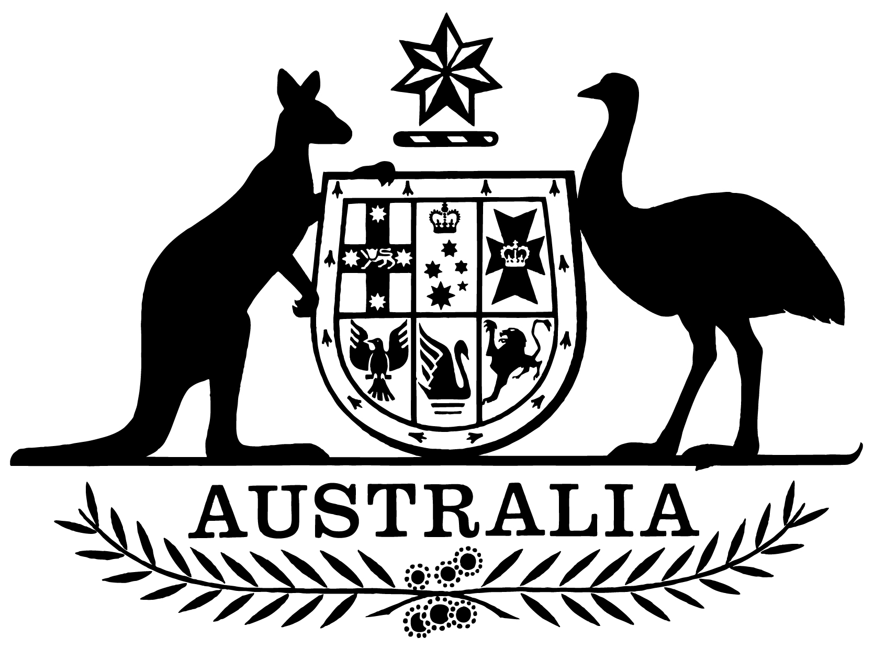

***Air Services Act 1995***

***Statement of Expectations for Airservices Australia from 1 July 2023 to 30 June 2025***

I,Catherine King, Minister for Infrastructure, Transport, Regional Development and Local Government, make the following instrument.

Dated 30 June 2023

Catherine King

Minister for Infrastructure, Transport, Regional Development and Local Government

1. **Overview**

This instrument is the Statement of Expectations for Airservices Australia for the period 1 July 2023 to 30 June 2025.

This Statement of Expectations (SoE) applies from 1 July 2023 until 30 June 2025, and replaces the SoE issued on 21 June 2021.

This SoE serves as a notice to Airservices Australia (Airservices) under section 17 of the *Air Services Act 1995* (the Act) and sets out my expectations for Airservices’ appropriate strategic direction and the manner in which Airservices should perform its functions.

1. **Governance**

I expect the Board and Chief Executive Officer (CEO) of Airservices to ensure Airservices has the necessary resources and capabilities in place:

1. to effectively manage Airservices’ strategic direction, risks, corporate planning in accordance with section 21 of the Act, and
2. to provide Air Traffic Services and Aviation Rescue Fire Fighting Services to the service level articulated in this SoE.

I expect the CEO to be responsible for managing the operations of Airservices, its organisational capacity and the exercise of its functions in accordance with section 35 of the Act.

I expect Airservices to keep the Department of Infrastructure, Transport, Regional Development, Communications and the Arts (the Department) and myself informed of Airservices’ actions in relation to the requirements of this SoE, and to promptly consult on any risks, events or issues that may materially impact upon Airservices.

I expect Airservices to provide myself and the Department with quarterly progress reports against the Corporate Plan, this SoE and reasonable additional reporting requested by me or the Department, including financial and performance metrics.

I expect the Board of Airservices to invite me or my delegate, or a nominated department official, to an annual strategic meeting to discuss Airservices’ performance.

1. **Strategic direction and Manner of performance**

I expect Airservices to:

1. operate as a world-best-practice provider of Air Traffic Services and Aviation Rescue Fire Fighting Services delivered in a safe, efficient and effective manner;
2. perform its functions and manage its finances in an efficient, economic and ethical manner, in accordance with the Act, the *Public Governance, Performance and Accountability Act 2013*, best practice principles and guidelines, other applicable legislation and relevant accounting standards;
3. comply with this SoE and all Ministerial Directions issued under the Act, and for Airservices to demonstrate it is on track to return to profitability and pay a dividend to Government in the 2027-28 financial year, or sooner;
4. arrange and pay for independent biennial reviews to assess Airservices’ capital structure; and
5. function in conformity with Australia’s international obligations, including the requirements of the International Civil Aviation Organization (ICAO).
6. **Service Level**

I expect Airservices to:

1. resolve Safety Findings issued by the Civil Aviation Safety Authority (CASA), including self-reported deficiencies, within a time period acceptable to CASA;
2. provide Air Traffic Services commensurate with the airspace classification as determined by CASA, during the baseline hours of service determined by CASA unless there is an unforeseeable contingency;
3. ensure it has in place sufficient, competent staff resources available to provide Air Traffic Services without regular use of demand management practices due to staff availability or competency, unless specified by regulations or legislation;
4. provide Aviation Rescue Fire Fighting Services to the category listed on the CASA-issued ARFFS Provider Certificate; in accordance with the provisions of Part 139H (Aerodrome rescue and firefighting services) of the Civil Aviation Safety Regulations and other relevant legislation, unless there is an unforeseeable contingency;
5. ensure it has in place sufficient, competent staff resources to provide rescue and firefighting services without a reduction of category due to staff availability or competency, unless this reduction is required in the delivery of services specified by applicable legislation; and
6. implement long-term strategies to maintain continuity of service, ensuring Air Traffic Services and Aviation Rescue Fire Fighting Services are delivered in accordance with the expectations outlined at 4 (b), (c), (d) and (e), and communicate these strategies to stakeholders in a frank and timely manner.

Should Airservices be unable to meet the Expectations under sections 4a), 4b), 4c), 4d), 4e) and 4f), Airservices should communicate these clearly and transparently to CASA, including its plans for remediation, and include a report on these issues in its quarterly progress reports to the Minister.

1. **Key Initiatives**

I expect Airservices to:

1. work with the Department of Defence (Defence) to progress the implementation of the OneSKY Australia Program and the Civil Military Air Traffic Management System, including by:

* advising my Department on the progress of the project, including early identification of risks to delivery and supporting reporting to Government;
* achievement of program milestones; and
* providing information as requested by me or my Department.

1. continue to work closely with the Department and CASA on implementing and supporting the development of the Government’s approach to address Aviation Rescue Fire Fighting Services issues, consistent with relevant regulations and policies articulated by the Government;
2. work with the Department and CASA to:

* develop and implement services to support emerging aviation technologies (including Remotely Piloted Aircraft Systems and Advanced Air Mobility) consistent with relevant regulations and policies articulated by the Government;
* provide technical advice on emerging aviation technologies to support policy and regulatory development by the Government; and
* to promote the integration of the above into Australian airspace.

1. develop and implement a Flight Information Management System consistent with the policy objectives articulated by the Government, including those concerning Unmanned Aircraft System Traffic Management.
2. work with the Department and CASA on Airspace Management Modernisation, consistent with the *Australian Airspace Policy Statement*, including by:

* regularly reviewing instrument flight procedures to ensure suitability and relevance;
* enhancing the safety and efficiency of Australian controlled airspace, including at major regional airports; and
* applying sufficient resources to support the opening of the Western Sydney International (Nancy-Bird Walton) Airport in 2026, including but not limited to: air traffic control; rescue and firefighting services; navigational aids; and airspace planning, design, and implementation.

1. advance the Government’s environmental objectives, including by:

* minimising the impact of aircraft operations on communities where practicable;
* applying sufficient resources to the Airservices Noise Complaints and Information Service, so that noise-affected communities can access needed information;
* applying sufficient resources to independent Aircraft Noise Ombudsman, and give due consideration to all findings and recommendations made by the Aircraft Noise Ombudsman; and
* continuing the commitment to the Sydney Airport Long Term Operating Plan as required by the Ministerial Direction dated 30 July 1997 (Federal Register of Legislation reference: F2009B00158);

1. work with the Department, other Government agencies and industry to identify, manage and, where appropriate, remediate per- and poly-fluoroalkyl substances (PFAS) contamination arising from Airservices’ operations on Airservices-impacted sites, in line with the Government expectations on this issue, including by:

* advising the Department on risks of liability and damages arising from PFAS contamination at impacted sites, for both the Government and for Airservices;
* providing the Department with regular updates on:
  + investigations by Airservices of PFAS contamination;
  + Airservices’ current management of PFAS; and
  + future management options and remediation costs; and
* working with the Department collaboratively on PFAS policy and implementation activities;

1. work with the Department, and other Government agencies as appropriate, in providing assistance and advice in relation to the Government’s Asia Pacific aviation capacity and capability building initiatives.
2. **Stakeholder Engagement**

I expect Airservices to:

1. undertake effective and productive engagement with the community and industry based on mutual understanding and respect;
2. communicate clearly and regularly with the Department, CASA, industry and the community on the development and implementation of significant changes to air navigation and Aviation Rescue Fire Fighting Services;
3. keep stakeholders informed about Air Traffic Services disruptions and actions being taken to address the causes of disruption, including through transparent and regular reporting and frank and timely communication;
4. proactively provide information, assistance and advice to Government agencies for policy formulation, implementation activities and regulation purposes;
5. contribute to the coordinated approach to airport planning, including appropriate participation in planning coordination forums, community aviation consultation groups and the National Airports Safeguarding Advisory Group; and
6. work closely with the Department and other Government agencies, including the Australian Transport Safety Bureau, CASA and Defence to deliver integrated and comprehensive advice to the Government, the aviation industry and the community.