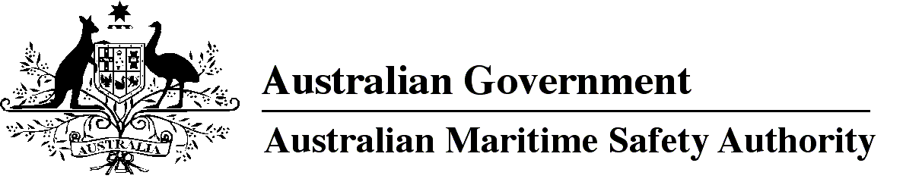

AMSA MO 2023/4

Marine Orders Amendment (Marine Order 501 — consequential changes) Order 2023

I, Michael Kinley, Chief Executive Officer of the Australian Maritime Safety Authority, (the National Marine Safety Regulator under section 9 of the *Marine Safety (Domestic Commercial Vessel) National Law*), make this Marine Order under subsection 163(1) of the *Marine Safety (Domestic Commercial Vessel) National Law.*

7 August 2023

Michael Kinley  
Chief Executive Officer

1 Name of Order

This Marine Order is *Marine Orders Amendment (Marine Order 501 — consequential changes) Order 2023*.

2 Commencement

This Marine Order commences immediately after the commencement of *Marine Order 501 (Administration — national law) 2023.*

3 Amendment of *Marine Order*

Each Marine Order mentioned in the name of a Division in Schedule 1 to this Marine Order is amended in accordance with that Division.

Schedule 1

(section 3)

Division 1 *Marine Order 502 (Vessel identifiers — national law) 2017*

[1] Sections 2 and 6

omit each mention of

*2013*

insert

*2023*

Division 2 *Marine Order 503 (Certificates of survey — national law) 2018*

[2] Section 21, definition of *Marine Order 501*

omit

*2013*

insert

*2023*

Division 3 *Marine Order 504 (Certificates of operation and operation requirements — national law) 2018*

[3] Section 15, definition of *Marine Order 501*

omit

*2013*

insert

*2023*

Division 4 *Marine Order 505 (Certificates of competency — national law) 2022*

[4] Section 4, definition of *Marine Order 501*

omit

*2013*

insert

*2023*

Division 5 *Marine Order 507 (Load line certificates — national law) 2018*

[5] Section 17, definition of *Marine Order 501*

omit

*2013*

insert

*2023*

**Note**

1. All legislative instruments and compilations of legislative instruments are registered on the Federal Register of Legislation under the *Legislation Act 2003.* See https://www.legislation.gov.au.