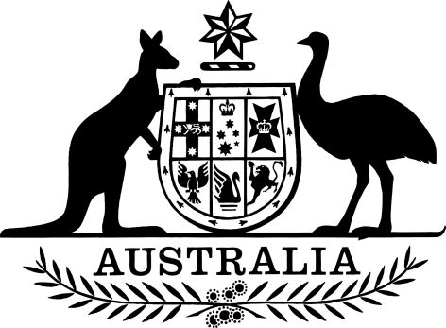

Torres Strait Fisheries (Quotas for Tropical Rock Lobster (Kaiar)) (Total Allowable Catch) Determination 2023
I, Murray Watt, Minister for Agriculture, Fisheries and Forestry, make the following Determination.
Dated 10 November 2023
Senator the Hon. Murray Watt
Minister for Agriculture, Fisheries and Forestry.

1 Name
This instrument is the Torres Strait Fisheries (Quotas for Tropical Rock Lobster (Kaiar)) (Total Allowable Catch) Determination 2023.

2 Commencement
This instrument commences on the day after it is registered on the Federal Register of Legislation.

3 Repeal
This instrument is repealed on the day after 30 September 2024 unless revoked earlier.

4 Authority
This instrument is made under section 13 of the Torres Strait Fisheries (Quotas for Tropical Rock Lobster (Kaiar)) Management Plan 2018.

5 Definitions
Note: A number of expressions used in this instrument are defined in the definitions section of the Management Plan, including the following:
      - fishing season;
      - total allowable catch;
      - TRL fishery; and
      - tropical rock lobster.
(1) In this instrument:
Management Plan means the Torres Strait Fisheries (Quotas for Tropical Rock Lobster (Kaiar)) Management Plan 2018.

6 Determination of total allowable catch
(1) For the purposes of subsection 13(1) of the Management Plan, the total allowable catch of tropical rock lobster in the TRL fishery for the fishing season commencing 1 December 2023 and ending 30 September 2024, is 200,000 kilograms (unprocessed weight).

