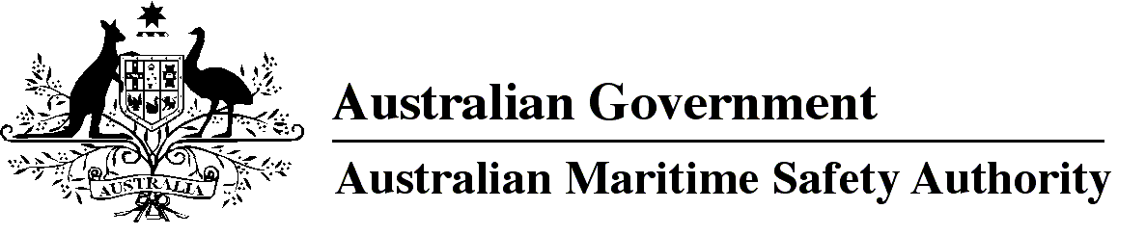

AMSA MO 2023/6

Marine Orders Amendment (Marine Order 71 — consequential changes) Order 2023

I, Michael Kinley, Chief Executive Officer of the Australian Maritime Safety Authority, make this Marine Order under subsection 342(1) of the *Navigation Act 2012*.

Dated   16 November 2023

Michael Kinley  
Chief Executive Officer

1 Name of Marine Order

This Marine Order is *Marine Orders Amendment (Marine Order 71 — consequential changes) Order 2023*.

2 Commencement

This Marine Order commences immediately after the commencement of *Marine Order 71 (Masters and deck officers) 2023*.

3 Amendment of *Marine Orders*

Each Marine Order mentioned in the name of a Division in Schedule 1 to this Marine Order is amended in accordance with that Division.

Schedule 1 Amendment

Division 1 Marine Order 70 (Seafarer certification) 2014

[1] Subsection 10(1), note 2

omit

*Marine Order 71 (Masters and deck officers) 2014*

insert

*Marine Order 71 (Masters and deck officers) 2023*

[2] Section 16, note 2

omit

*Marine Order 71 (Masters and deck officers) 2014*

insert

*Marine Order 71 (Masters and deck officers) 2023*

[3] Section 31

omit

*Marine Order 71 (Masters and deck officers) 2014*

insert

*Marine Order 71 (Masters and deck officers) 2023*

Division 2 Marine Order 74 (Masters and deck officers — yachts) 2015

[4] Paragraph 7(b)

omit

*Marine Order 71 (Masters and deck officers) 2014*

insert

*Marine Order 71 (Masters and deck officers) 2023*

**Note**

1. All legislative instruments and compilations of legislative instruments are registered on the Federal Register of Legislation under the *Legislation Act 2003.* See https://www.legislation.gov.au.