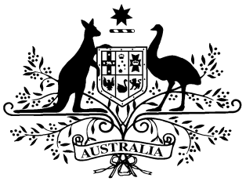

**National Health (Supplies of out-patient medication) Amendment Determination 2023**

**PB 134 of 2023**

___________________________________________________________________________

I, Nikolai Tsyganov, Assistant Secretary, Pricing and PBS Policy Branch, Technology Assessment and Access Division, Department of Health and Aged Care, delegate of the Minister for Health and Aged Care, make this instrument under section 84BA of the *National Health Act 1953.*

Dated 21 December 2023

Nikolai Tsyganov

Assistant Secretary

Pricing and PBS Policy Branch

Technology Assessment and Access Division

Department of Health and Aged Care

___________________________________________________________________________

Contents

1 Name 3

2 Commencement 3

3 Authority 3

4 Schedules 3

Schedule 1—Amendments 4

National Health (Supplies of out-patient medication) Determination 2019 (No. 2) 4

1 Name

This instrument is the *National Health (Supplies of out-patient medication) Amendment Determination 2023.*

This instrument may also be cited as PB 134 of 2023.

2 Commencement

This Determination commences on 1 January 2024.

3 Authority

This instrument is made under section 84BA of the *National Health Act 1953*.

4 Schedules

Each instrument that is specified in a Schedule to this instrument is amended or repealed as set out in the applicable items in the Schedule concerned, and any other item in a Schedule to this instrument has effect according to its terms.

**Schedule 1—Amendments**

National Health (Supplies of out-patient medication) Determination 2019 (No. 2)

1 Section 8(1)

Repeal the paragraph, substitute:

1. The maximum value of the supply of out-patient medication to a person who is a general patient and who is not the holder of a concession card is $25.30.