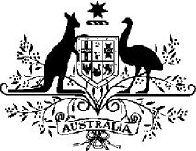

***Acts Interpretation (Ministerial Acting Arrangements for the Home Affairs Portfolio) Authorisation (No. 1) 2022***

I, the Hon Clare O’Neil MP, Minister for Home Affairs and Minister for Cyber Security, acting in accordance with sections 19 and 34AAB of the *Acts Interpretation Act 1901*, and all other powers thereunto enabling, as the case requires, hereby authorise the Hon. Mark Dreyfus KC MP, Attorney-General,  
to exercise, on my behalf, all my powers and functions, including powers and functions conferred on me by any law of the Commonwealth.

This instrument commences on Saturday 24 December 2022 and ceases to have   
effect at the end of Friday 13 January 2023.

[signed]

Dated 6 December 2022  
The Hon Clare O’Neil MP   
Minister for Home Affairs   
Minister for Cyber Security

Note: The name of this instrument was amended on registration as the instrument as lodged did not have a unique name (see subsection 10(2), *Legislation Rule 2016*).