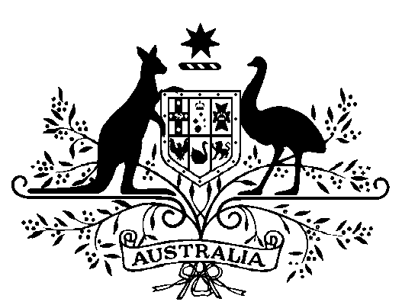

**COMMONWEALTH OF AUSTRALIA**

*Public Service Act 1999*

**Appointment of the Secretary of the Department of the Prime Minister and Cabinet**

I, General the Honourable David Hurley AC DSC (Retd), Governor-General of the Commonwealth of Australia, acting with the advice of the Federal Executive Council and under subsection 58(1) of the *Public Service Act 1999*, appoint Professor Glyn David AC as the Secretary of the Department of the Prime Minister and Cabinet for a period of five years commencing on 6 June 2022.

Dated 30 May 2022

[SIGNED]

David Hurley

Governor-General

By His Excellency’s Command

[SIGNED]

Anthony Albanese  
Prime Minister