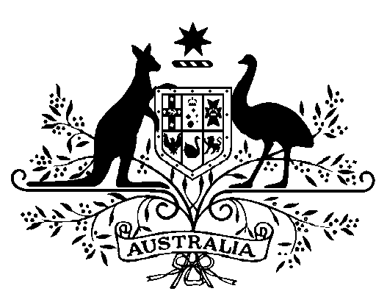

COMMONWEALTH OF AUSTRALIA
Public Service Act 1999

Appointment of the Secretary of the
Department of Finance

I, General the Honourable David Hurley AC DSC (Retd), Governor-General of the Commonwealth of Australia, acting with the advice of the Federal Executive Council and under subsection 58(1) of the Public Service Act 1999, appoint Jenny Wilkinson as the Secretary of the Department of Finance for a period of five years commencing on 9 August 2022.

Dated 23 June 2022

[SIGNED]
David Hurley
Governor-General
By His Excellency’s Command

[SIGNED]
Anthony Albanese
Prime Minister

