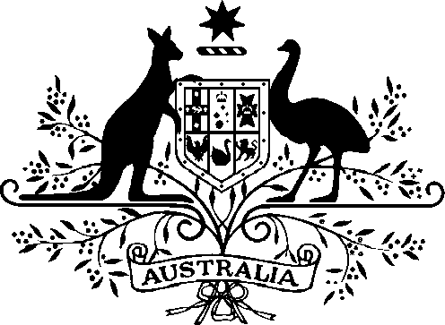

Acts Interpretation (Ministerial Acting Arrangements for the Foreign Affairs and Trade, and Defence Portfolios) Authorisation (No. 1) 2022

I, Patrick Conroy, Minister for International Development and the Pacific and Minister for Defence Industry, acting in accordance with sections 19 and 34AAB of the Acts Interpretation Act 1901, and all other powers thereunto enabling, as the case requires, hereby authorise the Hon Matthew Keogh MP, Minister for Defence Personnel and Minister for Veterans’ Affairs, to exercise, on my behalf, all my powers and functions, including powers and functions conferred on me by any law of the Commonwealth.

This instrument commences on Wednesday 11 January 2023 and ceases to have effect at the end of Wednesday 25 January 2023.

Dated 2 December 2022

Patrick Conroy
Minister for International Development and the Pacific Minister for Defence Industry

Note: The name of this instrument was amended on registration as the instrument as lodged did not have a unique name (see subsection 10(2), Legislation Rule 2016).

