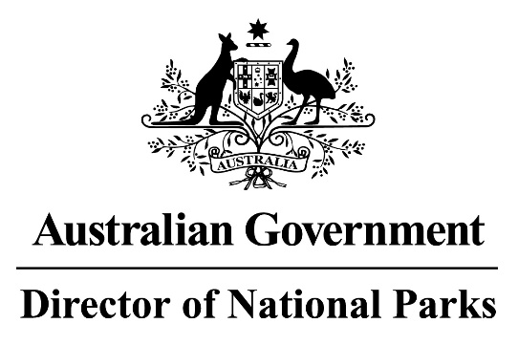
Environment Protection and Biodiversity Conservation Regulations 2000

Sub-regulation 12.56 (2)

SOUTH-EAST MARINE PARKS

DETERMINATION PROHIBITING USE OF VESSELS ENGAGED IN CAGE TOWING

I, BARBARA MUSSO, Branch Head, Parks Australia, Department of Climate Change, Energy, the Environment and Water, delegate of the Director of National Parks pursuant to sub-regulation 12.56(2) of the Environment Protection and Biodiversity Conservation Regulations 2000 HEREBY DETERMINE that Marine National Park (IUCN II) zones in each of the South-East Marine Parks listed in the Schedule to this determination, are areas of water where the use of vessels engaged in cage towing is prohibited unless done in accordance with a permit or approval issued by the Director.

AND I HEREBY REVOKE the previous determination prohibiting the use of vessels engaging in cage towing in the area, notified in the Gazette (F2018N00011) and published on 2 February 2018.

In this determination:

cage towing means a vessel towing a cage that is suitable for caging fish.

This determination will come into effect on 1 July 2023 and, unless sooner revoked or amended.
Dated 29 June 2023

Barbara Musso
Branch Head, Parks Australia
Delegate of the Director of National Parks

SCHEDULE

LISTED MARINE PARKS*

Apollo Marine Park
Beagle Marine Park
Boags Marine Park
East Gippsland Marine Park
Flinders Marine Park
Franklin Marine Park
Freycinet Marine Park
Huon Marine Park
Murray Marine Park
Nelson Marine Park
South Tasman Rise Marine Park
Tasman Fracture Marine Park
Zeehan Marine Park

