Instrument number CASA 65/23

I, DAVID STEVEN THOMAS, Acting Branch Manager, Emerging Technologies & Regulatory Change, a delegate of CASA, make this instrument under regulations 11.056 and 101.030 and subregulation 101.065(1) of the *Civil Aviation Safety Regulations 1998*.

**[Signed D. Thomas**

David Steven Thomas  
Acting Branch Manager, Emerging Technologies & Regulatory Change

15 November 2023

CASA 65/23 – Approval and Permission for Operation of RPA within Sydney Harbour Restricted Airspace R405A/B Instrument 2023

1 Name

This instrument is *CASA 65/23 – Approval and Permission for Operation of RPA within Sydney Harbour Restricted Airspace R405A/B Instrument 2023*.

2 Duration

The instrument:

(a) commences on 16 November 2023; and

(b) is repealed at the end of 15 November 2024.

3 Definitions

*Note*In this instrument, certain terms and expressions have the same meaning as they have in the *Civil Aviation Act 1988* and the regulations. These include: ***RPA***.

In this instrument:

***airspace authorisation*** means the text and graphical depiction provided to a person by a CASA-verified drone safety app authorising the person to operate an RPA in the operating area.

***approved area*** has the meaning given by regulation 101.236 of CASR.

***Australian territory*** has the meaning given by subsection 3(1) of the *Air Services Act 1995*.

***CASA-verified drone safety app*** means a software application that is connected to the CASA RPAS digital platform, verified by CASA to provide airspace authorisations and listed as a verified app on the CASA website.

*Note*The CASA website address is <https://www.casa.gov.au/drones/safety-apps>.

***operating area*** means the segment of airspace described in the airspace authorisation, defined with reference to horizontal and vertical limits within an approved area, in which an RPA may operate.

***restricted area*** has the meaning given by regulation 3 of the *Airspace Regulations 2007*.

***R405A*** means the area of Australian territory declared as a restricted area and designated as “YMMM/R405A Sydney”.

***R405B*** means the area of Australian territory declared as a restricted area and designated as “YMMM/R405B Sydney”.

*Note*   At the time of making this instrument, R405A and R405B are declared as restricted areas under instrument *CASA OAR 048/23 – Declarations and Directions in relation to Prohibited, Restricted and Danger Areas etc. – Permanent Instrument 2023*.

***RPA operator*** means the holder of a certificate as an RPA operator under Division 101.F.4 of CASR.

4 Approval

(1) For regulation 101.030 of CASR, each of the following areas below 500 feet above mean sea level is approved for the operation of RPA, the coordinates for which are specified in the file R405_23116.json dated 16 November 2023 on a CASA-verified drone safety app:

(a) the area within R405A represented in Schedule 1 as the area within the yellow line;

(b) the area within R405A represented in Schedule 2 as the area within the yellow line;

(c) the area within R405A represented in Schedule 3 as the area within the yellow line;

(d) the area within R405B represented in Schedule 4 as the area within the yellow line;

(e) the area within R405B represented in Schedule 5 as the area within the yellow line;

(f) the area within R405B represented in Schedule 6 as the area within the yellow line.

(2) The approval is subject to the conditions mentioned in section 6.

*Note 1*The areas approved by CASA are for the purpose of trialling the operation of RPA in restricted areas using a CASA-verified drone safety app.

*Note 2*RPA, as defined in regulation 101.021 of CASR, does not include model aircraft.

5 Permission

(1) An RPA operator who has obtained an airspace authorisation provided by a CASA-verified drone safety app in respect of R405A and R405B is permitted to operate the RPA in the approved areas mentioned in section 4.

(2) The permission is subject to the conditions mentioned in section 6.

6 Conditions

(1) A person operating an RPA (the ***pilot***) in an approved area mentioned in section 4 must:

(a) obtain, or be employed by or work for an RPA operator that has obtained, an airspace authorisation provided by a CASA-verified drone safety app; and

(b) comply with any operating limitations mentioned in the airspace authorisation.

*Note*The pilot may only operate an RPA in an approved area if they, or the RPA operator for whom they work, have sought and obtained an airspace authorisation using a CASA-verified drone safety app. The airspace authorisation sets out the horizontal and vertical limitations applicable to their particular RPA operations, allocated as the operating area, the times of day that operations may be carried out, and has a time expiry.

(2) The pilot may only operate an RPA in the operating area.

(3) The pilot must ensure that the airspace authorisation has not expired.

(4) The pilot must hold, or must be inducted into an organisation that holds, certification as an RPA operator.

(5) The pilot operating an RPA in an approved area mentioned in section 4 may only conduct aerial work operations.

(6) The pilot operating an RPA in an approved area mentioned in section 4 must ensure that:

(a) only one RPA is being controlled at a time; and

(b) a listening watch is maintained at all times on frequency 120.8 MHz, from 15 minutes before flight until the RPA has landed; and

(c) reliable mobile phone coverage exists in the operating area.

(7) The pilot operating an RPA in an approved area mentioned in section 4 must ensure that the RPA is equipped and operated with an active fail-safe mode that will ensure, in the event of a data link loss with the RPA, that the RPA will:

(a) adjust altitude to the minimum safe level to provide obstacle clearance and minimum potential for collision with other aircraft; and

(b) transit to a pre-defined safe landing or flight termination area; and

(c) land or otherwise terminate the flight.

(8) The pilot operating an RPA in an approved area mentioned in section 4 must ensure that RPA operations are conducted in accordance with the RPA operator’s operations manual.

Schedule 1 — R405A land (East) approved area

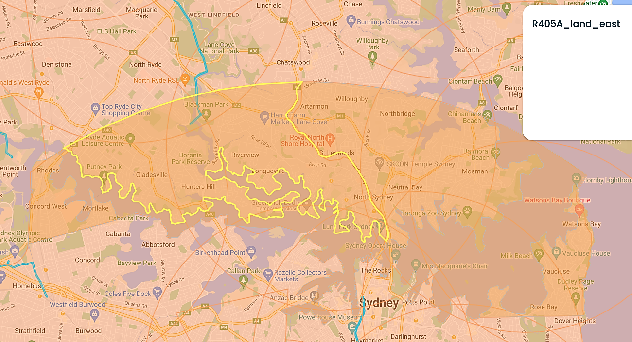

*Note*   This approval is an operational approval only. It does not confer any rights as against the owner or occupier of any land on or over which RPA operations are conducted, or prejudice, in any way, the rights and remedies which any person may have in law in respect of any injury to persons or damage to property resulting directly or indirectly from RPA operations.

Schedule 2 — R405A land (West) approved area

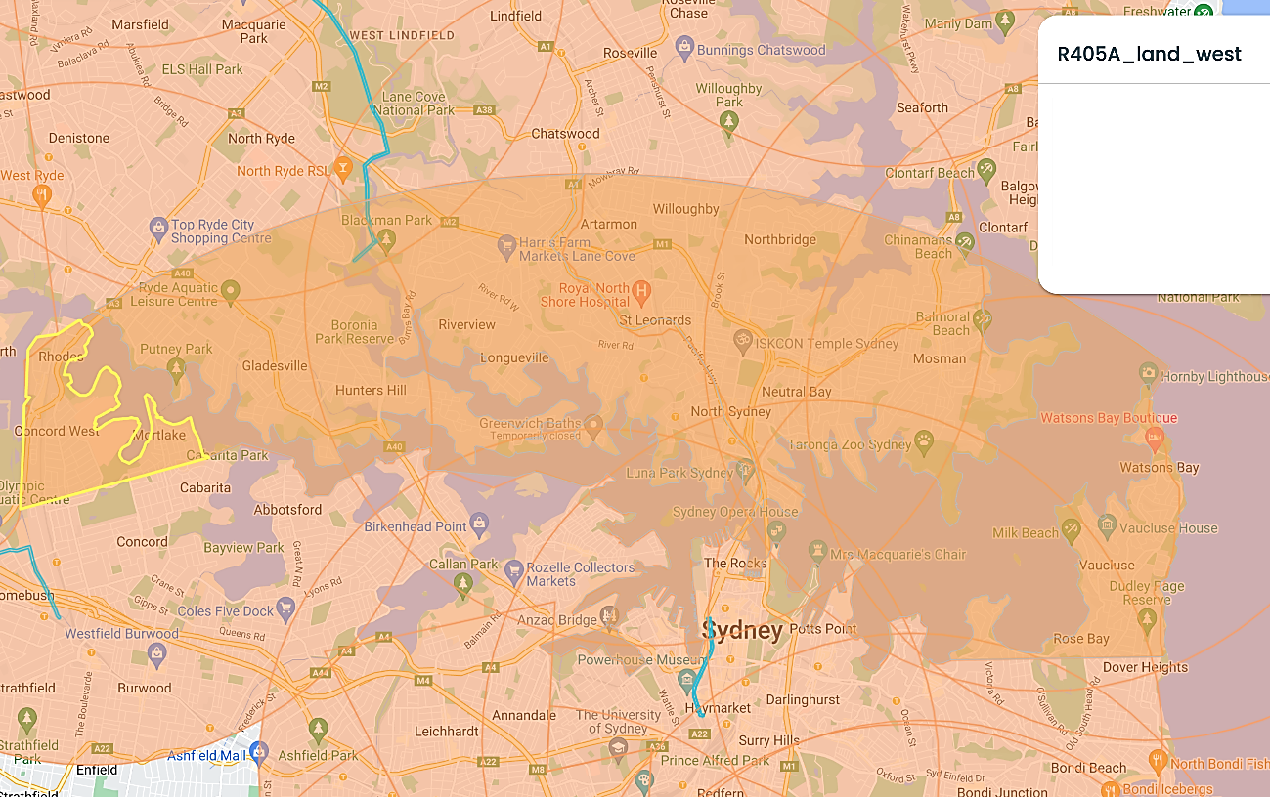

*Note*This approval is an operational approval only. It does not confer any rights as against the owner or occupier of any land on or over which RPA operations are conducted, or prejudice, in any way, the rights and remedies which any person may have in law in respect of any injury to persons or damage to property resulting directly or indirectly from RPA operations.

Schedule 3 — R405A water approved area

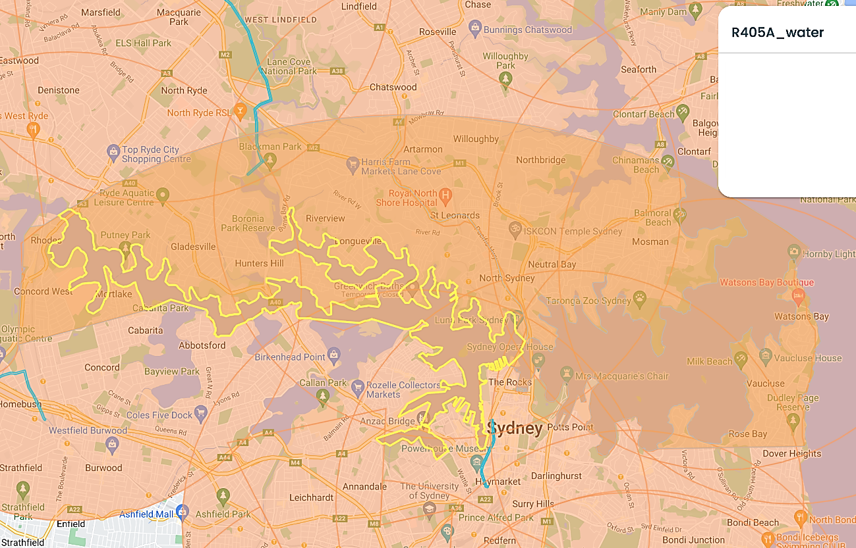

*Note*This approval is an operational approval only. It does not confer any rights as against the owner or occupier of any land on or over which RPA operations are conducted, or prejudice, in any way, the rights and remedies which any person may have in law in respect of any injury to persons or damage to property resulting directly or indirectly from RPA operations.

Schedule 4 — R405B land (East) approved area

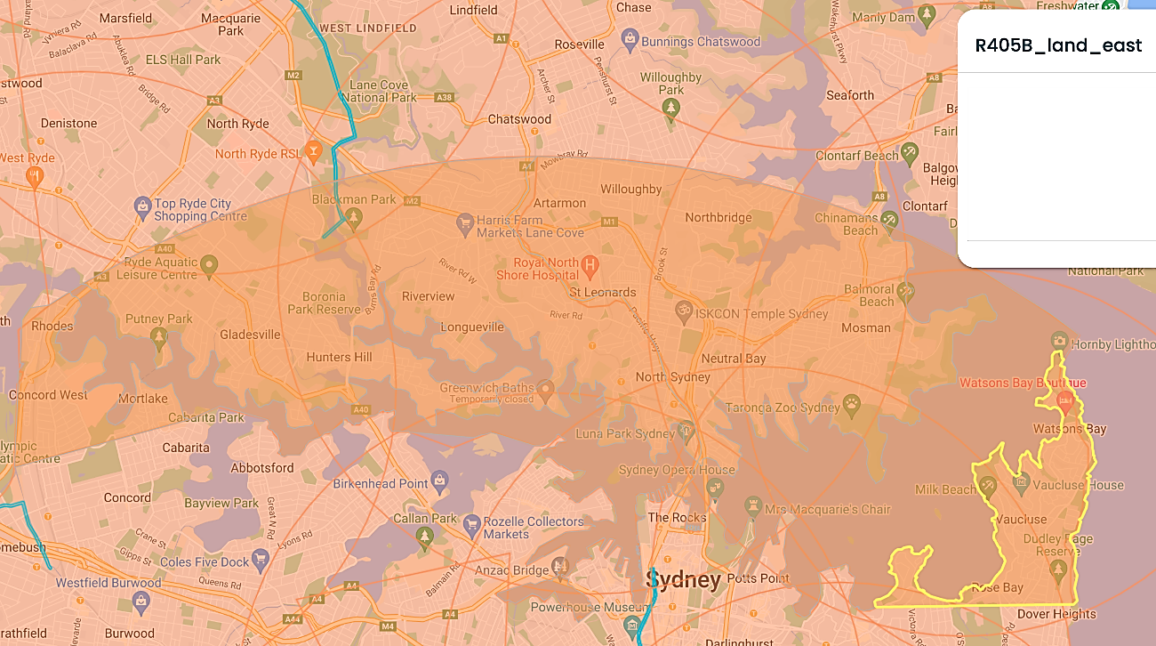

*Note*This approval is an operational approval only. It does not confer any rights as against the owner or occupier of any land on or over which RPA operations are conducted, or prejudice, in any way, the rights and remedies which any person may have in law in respect of any injury to persons or damage to property resulting directly or indirectly from RPA operations.

Schedule 5 — R405B land (West) approved area

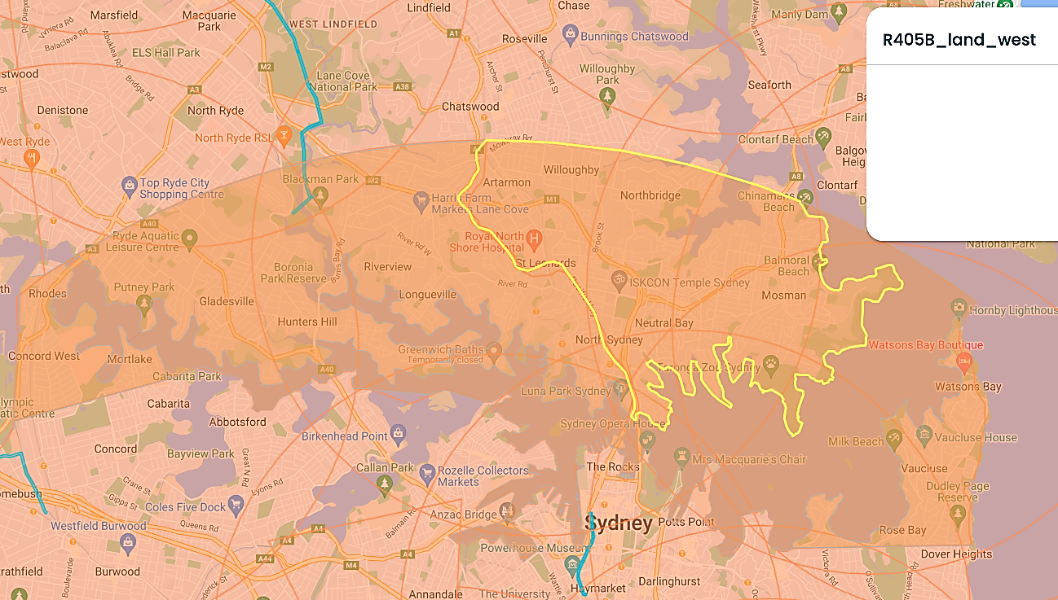

*Note*This approval is an operational approval only. It does not confer any rights as against the owner or occupier of any land on or over which RPA operations are conducted, or prejudice, in any way, the rights and remedies which any person may have in law in respect of any injury to persons or damage to property resulting directly or indirectly from RPA operations.

Schedule 6 — R405B water approved area

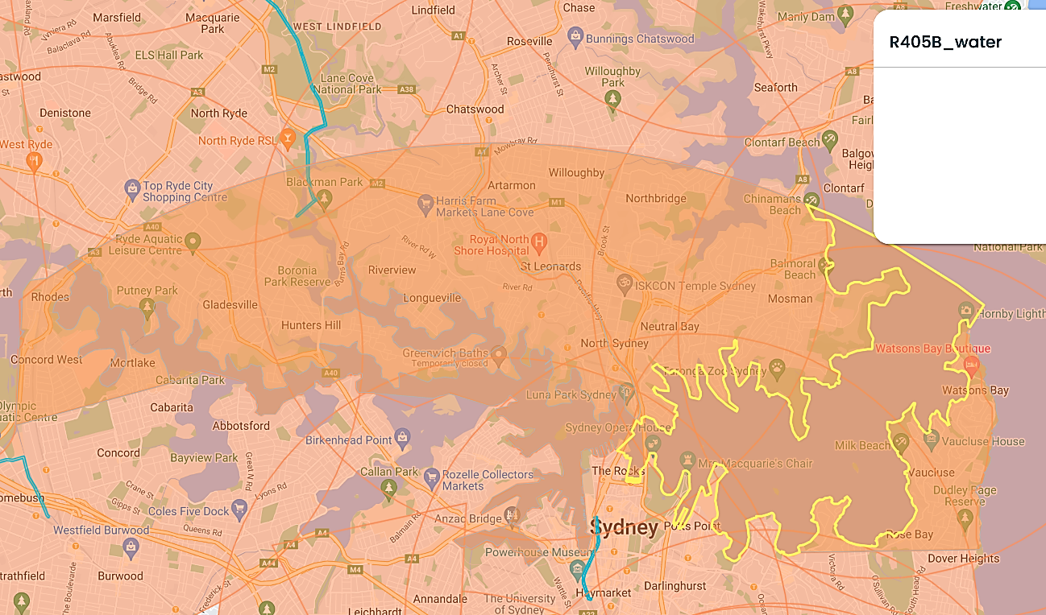

*Note*This approval is an operational approval only. It does not confer any rights as against the owner or occupier of any land on or over which RPA operations are conducted, or prejudice, in any way, the rights and remedies which any person may have in law in respect of any injury to persons or damage to property resulting directly or indirectly from RPA operations.