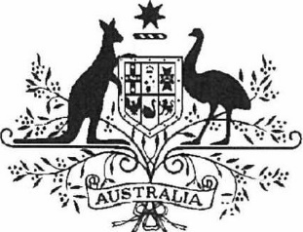

***Acts Interpretation (Ministerial Acting Arrangements for the Foreign Affairs and Trade Portfolio) Authorisation (No. 2) 2023***

**I,** SENATOR THE HON PENNY WONG, Minister for Foreign Affairs, acting in accordance with sections 19 and 34AAB of the *Acts Interpretation Act 1901,* and all other powers thereunto enabling, as the case requires, hereby authorise THE HON MARK DREYFUS KC MP, Attorney-General, to exercise, on my behalf, all my powers and functions, including powers and functions conferred on me by any law of the Commonwealth.

This instrument commences on Sunday 17 December 2023 and ceases to have effect at 2359h on Sunday 7 January 2024.

Dated 15 December 2023

Penny Wong

Minister for Foreign Affairs

Note: The name of this document was amended on registration as the document as lodged did not have a unique name (see subsection 10(2), *Legislation Rule 2016*).